NAME ……………………………………..………INDEXNO.…………….……….……..…
CANDIDATE’S SIGNATURE …………..…..………..
DATE …………………………………

443/2
AGRICULTURE
PAPER 2 (THEORY)
TIME: 2 HOURS

Pre Kcse Trial 1 2016

Kenya Certificate of Secondary Education

443/2
AGRICULTURE
PAPER 2 (THEORY)
JULY/AUGUST 2016
TIME: 2 HOURS

INSTRUCTIONS TO CANDIDATES
- Write your name and index number in the spaces provided above.
- This paper has THREE sections: A , B and C
- Answer ALL the questions in section A and B and any TWO questions in section C
- ALL answers MUST be written in the spaces provided.
- Do not remove any pages from this booklet.
- This paper consists of 11 printed pages. Candidates should check to ensure that all pages are printed as indicated and no questions are missing

FOR EXAMINER’S USE ONLY

 | Questions | Maximum score | Candidate’s score
A | 01 - 23 | 30 marks
B | 24 - 27 | 20 marks
C | 28 - 30 | 40 marks
 |  | Total score

© 2016,
443/2
Agriculture
Paper 2 (theory)

SECTION A (30 MARKS)
Answer all the questions in this section in the spaces provided.
- Name the breed of goat that produces high quality wool. (1mark)
................................................................................................................................................................................................................................................................................................................................................
- State two advantages of using wood in the construction of a farm building (1mark)
................................................................................................................................................................................................................................................................................................................................................
- State two functional differences between petrol and diesel engines. (2marks)
Petrol | Diesel engine

- Name the intermediate host of the following parasites (1mark)
- Tapeworm
................................................................................................................................................................................................................................................................................................................................................
- Liver fluke
................................................................................................................................................................................................................................................................................................................................................
- Differentiate between (1mark)
- Drift lambing
................................................................................................................................................................................................................................................................................................................................................
- Pen lambing
................................................................................................................................................................................................................................................................................................................................................
- Give two reasons why the walls of the dairy shed should be white washed instead of painting with water or oil paints. (1 marks)
................................................................................................................................................................................................................................................................................................................................................................................................................................................................................................................................................................................................................................................................................................
- Mention four pre-disposing factors of scours in calves. (2marks)
................................................................................................................................................................................................................................................................................................................................................................................................................................................................................................................................................................................................................................................................................................
- Outline three reasons why calves should be fed on colostrums. (1½ marks)
........................................................................................................................................................................................................................................................................................................................................................................................................................................................................................................................
- State two functions of a queen bee in a colony (1mark)
................................................................................................................................................................................................................................................................................................................................................
- List two groups of vitamin as applied to livestock nutrition. (1mark)
........................................................................................................................................................................................................................................................................................................................................................................................................................................................................................................................
- Give four advantages of using a spray in tick control in livestock. (2 mark)
........................................................................................................................................................................................................................................................................................................................................................................................................................................................................................................................
........................................................................................................................................................................
- Give three importance of flushing in sheep management. (1½ marks)
........................................................................................................................................................................................................................................................................................................................................................................................................................................................................................................................
- State three adjustments that should be carried out on a tractor-mounted mould board plough in preparation for ploughing (1½ marks)
........................................................................................................................................................................................................................................................................................................................................................................................................................................................................................................................

- State two demerits of live fences. (1mark)
................................................................................................................................................................................................................................................................................................................................................
- Give two ideal conformation features of beef cattle (1mark)
........................................................................................................................................................................................................................................................................................................................................................................................................................................................................................................................
- State three factors that dictate livestock distribution in Kenya. (1½ marks)
........................................................................................................................................................................................................................................................................................................................................................................................................................................................................................................................
- Name three reasons that necessitate handling of livestock in the farm. (1½ marks)
........................................................................................................................................................................................................................................................................................................................................................................................................................................................................................................................
- List three non chemical control measures in livestock production. (1½ marks)
........................................................................................................................................................................................................................................................................................................................................................................................................................................................................................................................
- Under what condition would a farmer prefer to use an ox- cart instead of a tractor-drawn trailer? Give three reasons (1½ marks)
........................................................................................................................................................................................................................................................................................................................................................................................................................................................................................................................
- State four grades into which Kenya Meat Commission may classify the carcasses (2marks)
........................................................................................................................................................................................................................................................................................................................................................................................................................................................................................................................
........................................................................................................................................................................

- Why is it not recommended to use saw dust in an incubator (1 marks)
........................................................................................................................................................................................................................................................................................................................................................................................................................................................................................................................

- List two tools used in closed castration (1mark)
........................................................................................................................................................................................................................................................................................................................................................................................................................................................................................................................
- State four qualities of good creep feed. (2marks)
........................................................................................................................................................................................................................................................................................................................................................................................................................................................................................................................
........................................................................................................................................................................
SECTION B (20 MARKS)
Answer all the questions in this section in the spaces provided.
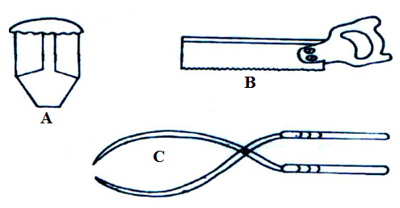
- The diagram below represents farm tools.

- Identify the tools labeled A and B (1mark)
A
........................................................................................................................................................................
B
........................................................................................................................................................................
- Give one use of each tools mentioned in (i) above. (2marks)
A
........................................................................................................................................................................B
........................................................................................................................................................................

- Give the two maintenance practices which should be carried out on tool C (2marks)
................................................................................................................................................................................................................................................................................................................................................
- A farmer in Makueni County owns 16 milking cows. In addition to feeding these animals with nippier grass, the farmer prepares home mixed ratio in them. During this dry season, the farmer has decided to mix 600kg of the ratio using oats DCP 40% and sim sim cake DCP 60% using the Rearsons square method.
- Determine the quantities of each feed the farmer will need to make a ratio containing 20% DCP for the animals. (4 marks)
................................................................................................................................................................................................................................................................................................................................................................................................................................................................................................................................................................................................................................................................................................................................................................................................................................................................................................................................................................................................................................................................................................................................................................................................................................................................................................................................................................................................
- State two factors affecting feed digestibility. (1mark)
........................................................................................................................................................................................................................................................................................................................................................................................................................................................................................................................
- The diagram below shows an animal drawn implement. Use it to answer the following questions
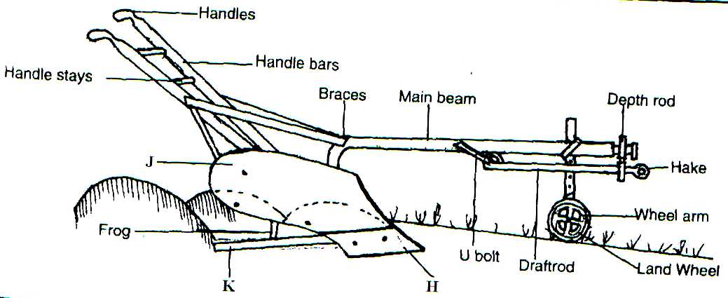

- Label parts
H
........................................................................................................................................................................
J
........................................................................................................................................................................
K (1½ marks)
........................................................................................................................................................................
- Name the part that requires regular sharpening (1½ marks)
....................................................................................................................................................................................................................................................................................
- State three advantages of using animal power (1½ marks)
.......................................................................................................................................................................................................................................................................................................................................................................................................................................................................................................................

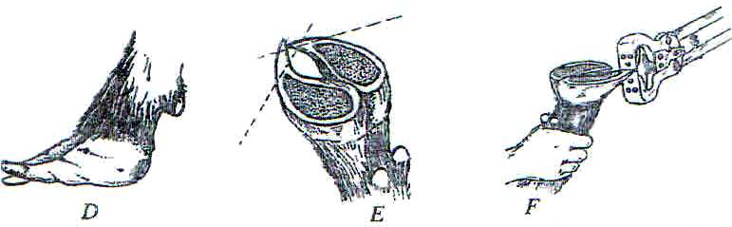
- Below are illustrations of animal hooves and activity being done

i)
- What activity is going on in diagram F (1mark)
................................................................................................................................................................................................................................................................................................................................................
- Which of the above hooves is likely to predispose foot rot infection? (1mark)
................................................................................................................................................................................................................................................................................................................................................
- Name an appropriate tool for carrying out the above activity (1mark)
................................................................................................................................................................................................................................................................................................................................................

- Other than protecting animals from foot rot give another one reason for carrying out the activity. (1mark)
................................................................................................................................................................................................................................................................................................................................................
ii Give three reasons for seasoning timber before use (1½ marks)
................................................................................................................................................................................................................................................................................................................................................................................................................................................................................................................................................................................................................................................................................................
SECTION C (40 MARKS)
Answer only two questions from this section in the spaces provided
- a) Describe the features of ideal calf pen. (10marks)
b) Distinguish between cropping and harvesting as used in fish farming (2marks)
c) Describe the maintenance practices on a fish pond or describe management practices that would ensure maximum fish harvest from a fish pond. (8marks)
- a) Discuss coccidiosis disease under the following headings
- Causal organism (1mark)
- Livestock species attacked (4marks)
- Symptoms of attack (4marks)
- Control measures. (3marks)
b) Describe the procedure of obtaining clean milk from a cow (10marks)
- a)
i) Describe the life cycle of a two host tick (6marks)
- Describe digestion in a rumen of ruminant (8marks)
- Explain three methods of acaricide application (6marks)

................................................................................................................................................................................................................................................................................................................................................
................................................................................................................................................................................................................................................................................................................................................ ................................................................................................................................................................................................................................................................................................................................................ ................................................................................................................................................................................................................................................................................................................................................ ................................................................................................................................................................................................................................................................................................................................................ ................................................................................................................................................................................................................................................................................................................................................ ................................................................................................................................................................................................................................................................................................................................................ ................................................................................................................................................................................................................................................................................................................................................ ................................................................................................................................................................................................................................................................................................................................................ ................................................................................................................................................................................................................................................................................................................................................ ................................................................................................................................................................................................................................................................................................................................................ ................................................................................................................................................................................................................................................................................................................................................ ................................................................................................................................................................................................................................................................................................................................................ ................................................................................................................................................................................................................................................................................................................................................ ................................................................................................................................................................................................................................................................................................................................................ ................................................................................................................................................................................................................................................................................................................................................ ................................................................................................................................................................................................................................................................................................................................................ ................................................................................................................................................................................................................................................................................................................................................ ................................................................................................................................................................................................................................................................................................................................................ ................................................................................................................................................................................................................................................................................................................................................ ................................................................................................................................................................................................................................................................................................................................................ ................................................................................................................................................................................................................................................................................................................................................ ................................................................................................................................................................................................................................................................................................................................................ ................................................................................................................................................................................................................................................................................................................................................ ................................................................................................................................................................................................................................................................................................................................................ ................................................................................................................................................................................................................................................................................................................................................ ................................................................................................................................................................................................................................................................................................................................................ ................................................................................................................................................................................................................................................................................................................................................ ................................................................................................................................................................................................................................................................................................................................................ ................................................................................................................................................................................................................................................................................................................................................ ................................................................................................................................................................................................................................................................................................................................................ ................................................................................................................................................................................................................................................................................................................................................ ................................................................................................................................................................................................................................................................................................................................................ ................................................................................................................................................................................................................................................................................................................................................ ................................................................................................................................................................................................................................................................................................................................................ ................................................................................................................................................................................................................................................................................................................................................ ................................................................................................................................................................................................................................................................................................................................................ ................................................................................................................................................................................................................................................................................................................................................ ................................................................................................................................................................................................................................................................................................................................................ ................................................................................................................................................................................................................................................................................................................................................ ................................................................................................................................................................................................................................................................................................................................................
................................................................................................................................................................................................................................................................................................................................................ ................................................................................................................................................................................................................................................................................................................................................ ................................................................................................................................................................................................................................................................................................................................................
................................................................................................................................................................................................................................................................................................................................................
................................................................................................................................................................................................................................................................................................................................................
................................................................................................................................................................................................................................................................................................................................................ ................................................................................................................................................................................................................................................................................................................................................ ................................................................................................................................................................................................................................................................................................................................................
................................................................................................................................................................................................................................................................................................................................................
................................................................................................................................................................................................................................................................................................................................................
................................................................................................................................................................................................................................................................................................................................................ ................................................................................................................................................................................................................................................................................................................................................ ................................................................................................................................................................................................................................................................................................................................................
................................................................................................................................................................................................................................................................................................................................................ ................................................................................................................................................................................................................................................................................................................................................
................................................................................................................................................................................................................................................................................................................................................ ................................................................................................................................................................................................................................................................................................................................................

