NAME: ……………………………………..…… DATE: ………………………………………..............

ADM NO: .…………….……….……..…..…….. CANDIDATE’S SIGNATURE: …………..………..

443 / 2
AGRICULTURE PAPER TWO
FORM THREE
TIME: 2 HOURS
TERM TWO

MID TERM TWO

INSTRUCTIONS TO CANDIDATES
- Write your name and admission number in the spaces provided above.
- This paper has THREE sections: A , B and C.
- Answer ALL the questions in section A and B and any TWO questions in sectionC.
- ALL answers MUST be written in the spaces provided.

FOR EXAMINERS USE ONLY
SECTION | QUESTIONS | MAXIMUM SCORE | CANDIDATES SCORE
A | 1 – 19 | 30
B | 20 – 23 | 20
C |  | 20
 |  | 20
TOTAL |  | 90

SECTION A: (30 MARKS)

Answer all questions in this section in the spaces provided.
- Differentiates between apiculture and aquaculture. (1mk)
………………………………………………………………………………………………………………
………………………………………………………………………………………………………………
………………………………………………………………………………………………………………

- State three ways of preventing predation in a fish pond. (1½mk)
………………………………………………………………………………………………………………
………………………………………………………………………………………………………………
………………………………………………………………………………………………………………

- Name one livestock disease that is transmitted by each of the following parasites.
- Brown ear tick. (½mk)
…………………………………………………………………………………………………………..

- Tse-tsefly. (½mk)
…………………………………………………………………………………………………………..

- Define the following terms as used in livestock production;
- Vaccination. (½mk)
…………………………………………………………………………………………………………..

- Tupping (½ mk)
…………………………………………………………………………………………………………..
- State the intermediate host for liverflukefasciola (spp) (½mk)
………………………………………………………………………………………………………………

- State two roles of drones in a bee colony. (1mk)
………………………………………………………………………………………………………………
………………………………………………………………………………………………………………

- State four breeds of rabbit. (2mks)
………………………………………………………………………………………………………………
………………………………………………………………………………………………………………
………………………………………………………………………………………………………………
………………………………………………………………………………………………………………

- State four importance of keeping animals healthy (2mks)
………………………………………………………………………………………………………………
………………………………………………………………………………………………………………
………………………………………………………………………………………………………………
………………………………………………………………………………………………………………

- State four major routes of administering vaccines to livestock. (2mks)
………………………………………………………………………………………………………………
………………………………………………………………………………………………………………
………………………………………………………………………………………………………………
………………………………………………………………………………………………………………

- State four factors considered by farmers when sitting a beehive in the farm. (2mks)
………………………………………………………………………………………………………………
………………………………………………………………………………………………………………
………………………………………………………………………………………………………………
………………………………………………………………………………………………………………

- Give two examples of arachnids parasites (2mks)
………………………………………………………………………………………………………………
………………………………………………………………………………………………………………

- State four characteristics of Aberdeen Angus class of cattle. (2mks)
………………………………………………………………………………………………………………
………………………………………………………………………………………………………………
………………………………………………………………………………………………………………
………………………………………………………………………………………………………………

- State fourimportances of farm buildings. (2mks)
………………………………………………………………………………………………………………
………………………………………………………………………………………………………………
………………………………………………………………………………………………………………
………………………………………………………………………………………………………………

- State two causes of bloat in ruminants. (1mk)
………………………………………………………………………………………………………………
………………………………………………………………………………………………………………

- Name four exotic breeds of cattle. (2mks)
………………………………………………………………………………………………………………
………………………………………………………………………………………………………………
………………………………………………………………………………………………………………
………………………………………………………………………………………………………………

- State four characteristics of roughage feedstuff. (2mks)
………………………………………………………………………………………………………………
………………………………………………………………………………………………………………
………………………………………………………………………………………………………………
………………………………………………………………………………………………………………

- List four causes of livestock diseases. (2mks)
………………………………………………………………………………………………………………
………………………………………………………………………………………………………………
………………………………………………………………………………………………………………
………………………………………………………………………………………………………………

- State two ways of improving tool efficiency in work (1mk)
………………………………………………………………………………………………………………
………………………………………………………………………………………………………………
- Name the tools used to for;
- Carrying out open method of castration of livestock. (1mk)
…………………………………………………………………………………………………………..

- Cutting thick sheets of metal. (1mk)
…………………………………………………………………………………………………………..

SECTION B: (20 MARKS)

Answer all questions in this section in the spaces provided.

- The diagram below shows a routine operation on sheep. Study it carefully and use it to answer the questions that follow below.
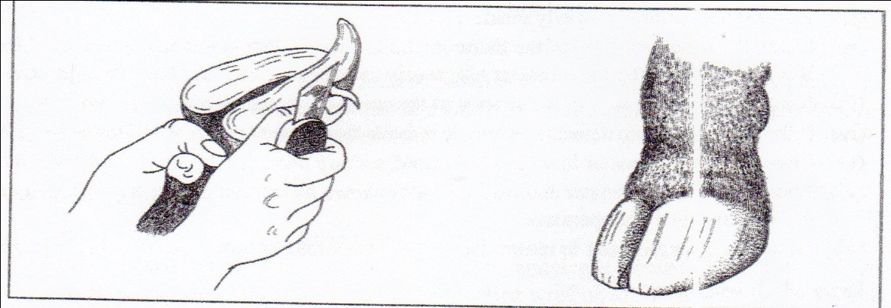
- Identify the operation. (1mk)
…………………………………………………………………………………………………………..

- Give two reasons for the operation. (2 mks)
…………………………………………………………………………………………………………..
…………………………………………………………………………………………………………..
- Name tools used to carry out the operation. (2mks)
…………………………………………………………………………………………………………..
………………………………………………………………………………………………………..
- The diagram below shows poultry digestive system. Use it to answer the questions that follows.
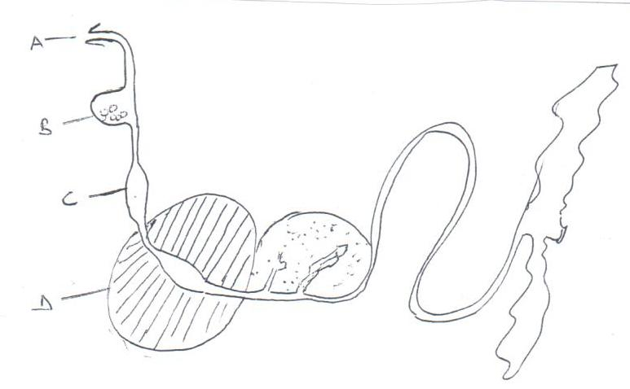

- State the function of part labeled B. (1mk)
…………………………………………………………………………………………………………..
- Why is part C known as the true stomach? (1mk)
…………………………………………………………………………………………………………..
- State two advantages of part labelledD to its functions. (2mks)
…………………………………………………………………………………………………………..
…………………………………………………………………………………………………………..
- What management practice is carried out on part A? (1mk)
…………………………………………………………………………………………………………..

- The diagram below is of an illustration of a farm structure. Study it and answer the questions that follow.
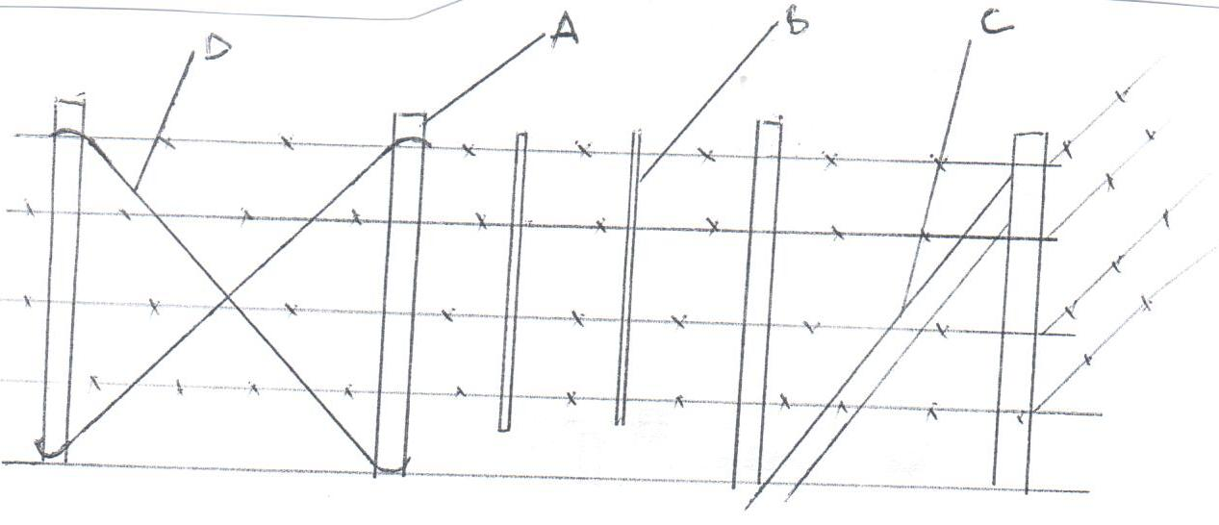

- State the type of the fence. (1mk)
…………………………………………………………………………………………………………..

- Name the parts labeled: (2 mks)
…………………………………………………………………………………………………………..
…………………………………………………………………………………………………………..

- State two reasons why the above fence is not recommended for sheep production. (2mks)
…………………………………………………………………………………………………………..
…………………………………………………………………………………………………………..

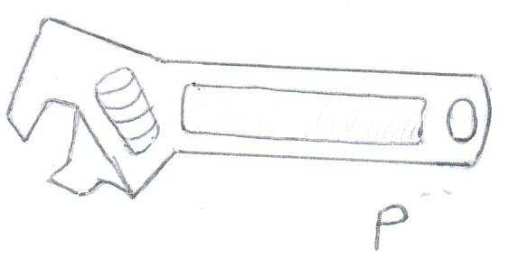
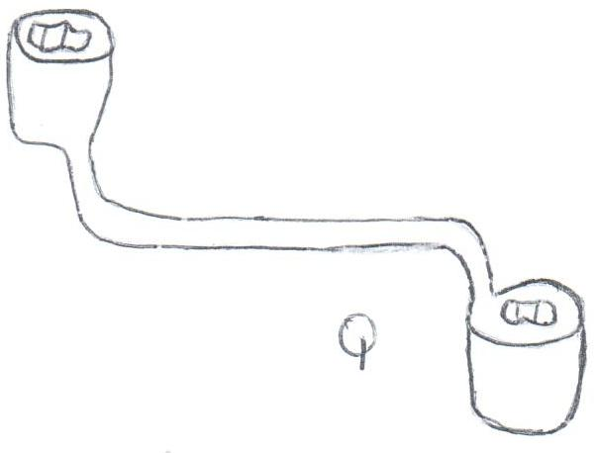
- Below are illustrations of farm tools. Study them and answer the question that follows:

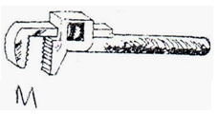
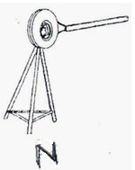

- Identify P and M. (1mk)
…………………………………………………………………………………………………………..
…………………………………………………………………………………………………………..

- State one advantage of P over Q. (1mk)
…………………………………………………………………………………………………………..
…………………………………………………………………………………………………………..

- State the function of tool labeled N and M. (2mks)
…………………………………………………………………………………………………………..
…………………………………………………………………………………………………………..

- Give two maintenance practices that can be carried out on tool P. (1mk)
…………………………………………………………………………………………………………..
…………………………………………………………………………………………………………..

SECTION B: (20 MARKS)

Answer only two questions in this section.

- State ten advantages of artificial insemination in dairy production. (10mks)
- Give five signs of lambing in sheep (5mks)
- Give five signs of infestation by internal parasites in sheep (5mks)

- Briefly discuss the management of a pig from birth up to weaning. (10mks)
- List four examples of two host tick. (2mks)
- Briefly discuss the life cycle of two host tick. (8mks)

- Describe the procedure for collecting semen from a proven sire (5mks)
- Give seven management practices carried out in a crush (7mks)
- Explain the various methods of controlling diseases on the farm (8mks)

END OF PRINTED PAGE

