Name: …………………………………………………………… Adm No …......…..........................

School: ………………………………………………….....……. Sign …………………

Date: ……………………………………………………………
443/2
AGRICULTURE
PAPER 2
TIME: 2 HOURS
JULY/ AUGUST 2016

TOP EVALUATION TEST – 2016
FORM 3
Agriculture
Paper 2
2 hours
INSTRUCTIONS TO CANDIDATES:
- Write your name, admission number and school in the spaces provided.
- Sign and write the date of the examination in the spaces provided.
- This paper consists of three sections; A, B and C.
- Answer all questions in section A and B.
- Answer any two questions in section C.
- All answers must be written in the spaces provided.
For Examiner’s Use Only;
SECTION | QUESTION | MAXIMUM SCORE | CANDIDATES’ SCORE
A | 1 - 15 | 30
B | 16 – 18 | 20
C | 19-22 | 20
 |  | 20
 | TOTAL SCORE | 90

- Mention four factors affecting livestock industry in Kenya. (2 marks)
………………………………………………………………………………………………………………………………………………………………………………………………………………………………………………………………………………………………………………………………………………………………………………………………………………………………………….
2. Give four reasons for keeping camel by Kenyan farmers. (2 marks)
………………………………………………………………………………………………………………………………………………………………………………………………………………………………………………………………………………………………………………………………………………………………………………………………………………………………………….
3. Name the four pig breeds kept in Kenya. (2 marks)
………………………………………………………………………………………………………………………………………………………………………………………………………………………………………………………………………………………………………………………………………………………………………………………………………………………………………….

4. mention four characteristics of exotic cattle breeds. (2 marks)
………………………………………………………………………………………………………………………………………………………………………………………………………………………………………………………………………………………………………………………………………………………………………………………………………………………………………….

5. Why is it important to keep livestock healthy? (2 marks)
………………………………………………………………………………………………………………………………………………………………………………………………………………………………………………………………………………………………………………………………………………………………………………………………………………………………………….
6. Identify four ways in which livestock diseases are categorized. (2 marks)
………………………………………………………………………………………………………………………………………………………………………………………………………………………………………………………………………………………………………………………………………………………………………………………………………………………………………….
7. List four examples of ecto-parasites. (2 marks)
………………………………………………………………………………………………………………………………………………………………………………………………………………………………………………………………………………………………………………………………………………………………………………………………………………………………………….
8. Mention four factors that determine the requirements of water by livestock. (2 marks)
………………………………………………………………………………………………………………………………………………………………………………………………………………………………………………………………………………………………………………………………………………………………………………………………………………………………………….
9.Give four roles of proteins in the body of livestock. (2 marks)
………………………………………………………………………………………………………………………………………………………………………………………………………………………………………………………………………………………………………………………………………………………………………………………………………………………………………….
10. Identify four sources of minerals needed by livestock. (2 marks)
………………………………………………………………………………………………………………………………………………………………………………………………………………………………………………………………………………………………………………………………………………………………………………………………………………………………………….

11. State four characteristics of roughages. (2 marks)
………………………………………………………………………………………………………………………………………………………………………………………………………………………………………………………………………………………………………………………………………………………………………………………………………………………………………….
12. Identify four factors to consider when selecting a goat for breeding. (2 marks)
………………………………………………………………………………………………………………………………………………………………………………………………………………………………………………………………………………………………………………………………………………………………………………………………………………………………………….
13. Mention four signs of heat in pigs. (2 marks)
………………………………………………………………………………………………………………………………………………………………………………………………………………………………………………………………………………………………………………………………………………………………………………………………………………………………………….
14. Define the following terms. (2 marks)
(a) Castration
……………………………………………………………………………………………………………………………………………………………………………………………………………………………..
(b) Caponisation
………………………………………………………………………………………………………………………………………………………………………………………………………………………………………………………...
15. List four types of farm fences. (2 marks)
………………………………………………………………………………………………………………………………………………………………………………………………………………………………………………………………………………………………………………………………………………………………………………………………………………………………………….

SECTION B: (20 MARKS)

Answer all the questions in this section in the spaces provided.

16. (a) The diagram below represents roof of a building.

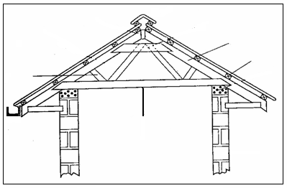
A
D
C
B

(i) Identify the parts labeled A, B, C and D. (4 marks)

………………………………………………………………………………………………………………………………………………………………………………………………………………………………………………………………………………………………………………………………………………………………………………………………………………………………………….
(ii) Give four factors considered when sitting farm buildings and structures. (2 marks)
………………………………………………………………………………………………………………………………………………………………………………………………………………………………………………………………………………………………………………………………………………………………………………………………………………………………………….

(b) Give four advantages of using synthetic materials in construction of farm structure. (2 marks)
………………………………………………………………………………………………………………………………………………………………………………………………………………………………………………………………………………………………………………………………………………………………………………………………………………………………………….

17. Below is reproductive system in a bull. Use it to answer questions that follow.
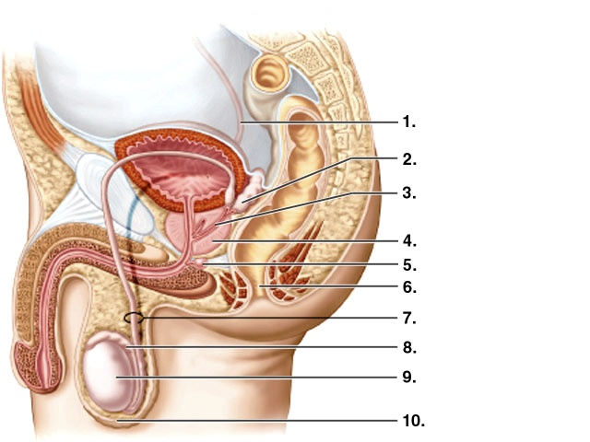
- Name the parts labeled: (2 marks)
- …………………………………………………………………….
- ……………………………………………………………………

- Give the function of the parts labeled: (5 marks)
1 – ………………………………………………………………………………………………………………
2 – ……………………………………………………………………………………………………………..
8 – ………………………………………………………………………………………………………………
9 – ……………………………………………………………………………………………………………..
10 – …………………………………………………………………………………………………………….
18. The pictures below show dairy breeds of cattle. Use it to answer questions that follow.
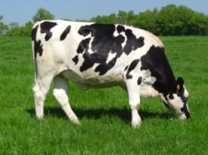
Breed A 1
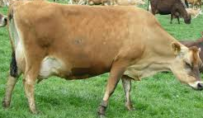
Breed A 2
- Identify: (2 marks)
- Breed A1
…………………………………………………………………………………………………..
- Breed A2
………………………………………………………………………………………………….
- Give three advantages of keeping breed A2 over bread A1. (3 marks)
………………………………………………………………………………………………………………………………………………………………………………………………………………………………………………………………………………………………………………………………………………………………………………………………………………………………………….
SECTION C (40 MARKS)
Answer any two questions from this section in the spaces provided.
19. Using appropriate illustration, describe the process of egg formation in a layer. (20 marks)
………………………………………………………………………………………………………………………………………………………………………………………………………………………………………………………………………………………………………………………………………………………………………………………………………………………………………….………………………………………………………………………………………………………………………………………………………………………………………………………………………………………………………………………………………………………………………………………………………………………………………………………………………………………….………………………………………………………………………………………………………………………………………………………………………………………………………………………………………………………………………………………………………………………………………………………………………………………………………………………………………….………………………………………………………………………………………………………………………………………………………………………………………………………………………………………………………………………………………………………………………………………………………………………………………………………………………………………….………………………………………………………………………………………………………………………………………………………………………………………………………………………………………………………………………………………………………………………………………………………………………………………………………………………………………….………………………………………………………………………………………………………………………………………………………………………………………………………………………………………………………………………………………………………………………………………………………………………………………………………………………………………….………………………………………………………………………………………………………………………………………………………………………………………………………………………………………………………………………………………………………………………………………………………………………………………………………………………………………….……………………………………………………………………………………………………………………………………………………………………………………………………………………
20. (a) State five advantages Artificial insemination. (5 marks)
……………………………………………………………………………………………………………………………………………………………………………………………………………………………………………………………………………………………………………………………………………………………………………………………………………………………………………………………………………………………………………………………………………………………..……………………………………………………………………………………………….
b) Describe how gilt is reared from the time of weaning to the time it farrows. (15 marks)
………………………………………………………………………………………………………………………………………………………………………………………………………………………………………………………………………………………………………………………………………………………………………………………………………………………………………….………………………………………………………………………………………………………………………………………………………………………………………………………………………………………………………………………………………………………………………………………………………………………………………………………………………………………….………………………………………………………………………………………………………………………………………………………………………………………………………………………………………………………………………………………………………………………………………………………………………………………………………………………………………….………………………………………………………………………………………………………………………………………………………………………………………………………………………………………………………………………………………………………………………………………………………………………………………………………………………………………….………………………………………………………………………………………………………………………………………………………………………………………………………………………………………………………………………………………………………………………………………………………………………………………………………………………………………….…………………………………………………………………………………………………………………………………………………………………………………………………………………………………………………………………………………………………………………………………………………………………………………………………………………………………………………………………………………………………………………………………………………….
20. (a) Describe the life-cycle of a tapeworm. ( 8 marks )
………………………………………………………………………………………………………………………………………………………………………………………………………………………………………………………………………………………………………………………………………………………………………………………………………………………………………….……………………………………………………………………………………………………………………………………………………………………………………………………………………………………………………………………………………………………………………………………………………………………………………………………………………………………………………………………………………………………………………………………………………………………………………….…………………………………………………………………….
b) Describe the digestion of grass in the rumen of a ruminant. (6 marks)
………………………………………………………………………………………………………………………………………………………………………………………………………………………………………………………………………………………………………………………………………………………………………………………………………………………………………….………………………………………………………………………………………………………………………………………………………………………………………………………………………………………………………………………………………………………………………………………………………………………………………………………………………………………………………………………………………………………………………………………………………………………………………………………………………………………………………………………………..………………………………………………………………………………………………………………………………………………………………………………………………….
c) Give six ways of controlling ticks. (6 marks)
………………………………………………………………………………………………………………………………………………………………………………………………………………………………………………………………………………………………………………………………………………………………………………………………………………………………………….………………………………………………………………………………………………………………………………………………………………………………………………………………………………………………………………………………………………………………………………

