DARAJANI SECONDARY SCHOOL,
P.O. BOX 20-90129, NGWATA.

MID_TERM 2, 2015_ EXAMINATION
FORM 3
AGRICULTURE PAPER 1
443/1
TIME: 2HRS

NAME…………………………………………………………………………………………ADM. NO……………….. CLASS:…………….
SECTION A: 30 MARKS
Instructions to candidates
- This paper consists of three sections A, B and C.
- Do all the questions in section A and B and two questions in section C.

- Name method used in propagating each of the following crops. (1 ½ marks)
- Carrots
……………………………………………………………………………………………………………………………………………………
- Sugar cane
……………………………………………………………………………………………………………………………………………………
- Pineapple
……………………………………………………………………………………………………………………………………………………
- Name two methods of farming considered outdated. (1 mark)
………………………………………………………………………………………………………………………………………………………………………………………………………………………………………………………………………………………………………………………....................................................................................................................................................................
- Distinguish between:-
- Soil sampling and soil testing (1 mark)

………………………………………………………………………………………………………………………………………………………………………………………………………………………………………………………………………………………………………………………......................................................................................................................................................................................................................................................................................................................................
- Soil structure and soil texture (1 mark)

…………………………………………………………………………………………………………………………………………………………………………………………………………………………………………………………………………………………………………………………………………………………………………………………………………………………………………………………………………………….…………………………………………………………………………………………………………………………………………………………...
- Give four influences that soil depth has in crop production. (2 marks)

………………………………………………………………………………………………………………………………………………………………………………………………………………………………………………………………………………………………………………………...
…………………………………………………………………………………………………………………………………………………………...
……………………………………………………………………………………………………………………………………………………………

- Highlight any four deficiency symptoms that will be observed in crops leaking potassium. (2 marks)

………………………………………………………………………………………………………………………………………………………………………………………………………………………………………………………………………………………………………………………...
………………………………………………………………………………………………………………………………………………………………………………………………………………………………………………………………………………………………………………………...
……………………………………………………………………………………………………………………………………………………………

- State how the following conditions in carrot production can be prevented. (1 ½ marks)
- Forking
………………………………………………………………………………………………………………………………………
- Cracking
………………………………………………………………………………………………………………………………………
- Greening
………………………………………………………………………………………………………………………………………

- Outline four causes of poor drainage. (2 marks)

………………………………………………………………………………………………………………………………………………………………………………………………………………………………………………………………………………………………………………………...
………………………………………………………………………………………………………………………………………………………………………………………………………………………………………………………………………………………………………………………...
……………………………………………………………………………………………………………………………………………………………

- State four advantages of overhead irrigation. (2 marks)

………………………………………………………………………………………………………………………………………………………………………………………………………………………………………………………………………………………………………………………...
………………………………………………………………………………………………………………………………………………………………………………………………………………………………………………………………………………………………………………………...
……………………………………………………………………………………………………………………………………………………………

- State two reasons for earthing up in a field of maize. (1 mark)

………………………………………………………………………………………………………………………………………………………………………………………………………………………………………………………………………………………………………………………...
……………………………………………………………………………………………………………………………………………………………
- How much fertilizer labelled 20:20:0 should be applied to a plot which requires 30kgs P₂O₅? (2 marks)

………………………………………………………………………………………………………………………………………………………………………………………………………………………………………………………………………………………………………………………...
………………………………………………………………………………………………………………………………………………………………………………………………………………………………………………………………………………………………………………………...
……………………………………………………………………………………………………………………………………………………………

- State two reasons why a farmer should intercrop maize and beans. (2 marks)

………………………………………………………………………………………………………………………………………………………………………………………………………………………………………………………………………………………………………………………...
……………………………………………………………………………………………………………………………………………………………
- State three importances of parent material in the soil profile. (1 ½ marks)

………………………………………………………………………………………………………………………………………………………………………………………………………………………………………………………………………………………………………………………...
……………………………………………………………………………………………………………………………………………………………
……………………………………………………………………………………………………………………………………………………………

- Define the term soil capping. (1 mark)
………………………………………………………………………………………………………………………………………………………
- Name three macro nutrients that can be used as limiting elements. (1 ½ marks)

………………………………………………………………………………………………………………………………………………………………………………………………………………………………………………………………………………………………………………………...
…………………………………………………………………………………………………………………………………………………………...
……………………………………………………………………………………………………………………………………………………………

- State four ways in which plant nutrients are lost from the soil. (2 marks)

………………………………………………………………………………………………………………………………………………………………………………………………………………………………………………………………………………………………………………………...
………………………………………………………………………………………………………………………………………………………………………………………………………………………………………………………………………………………………………………………...
……………………………………………………………………………………………………………………………………………………………
- List down factors influencing soil formation. (2 ½ marks)

………………………………………………………………………………………………………………………………………………………………………………………………………………………………………………………………………………………………………………………...
………………………………………………………………………………………………………………………………………………………………………………………………………………………………………………………………………………………………………………………...
……………………………………………………………………………………………………………………………………………………………

- List down four advantages of practising minimum tillage. (2 marks)

………………………………………………………………………………………………………………………………………………………………………………………………………………………………………………………………………………………………………………………...
………………………………………………………………………………………………………………………………………………………………………………………………………………………………………………………………………………………………………………………...
……………………………………………………………………………………………………………………………………………………………

- Define soil sampling. (1 mark)

………………………………………………………………………………………………………………………………………………………………………………………………………………………………………………………………………………………………………………………...

SECTION B: 20 MARKS

Answer all questions in this section
19. The diagrams labeled A_{1,} A₂, A_{3,} and B below illustrate materials and methods of vegetative propagation. Study them and answer the questions that follow.

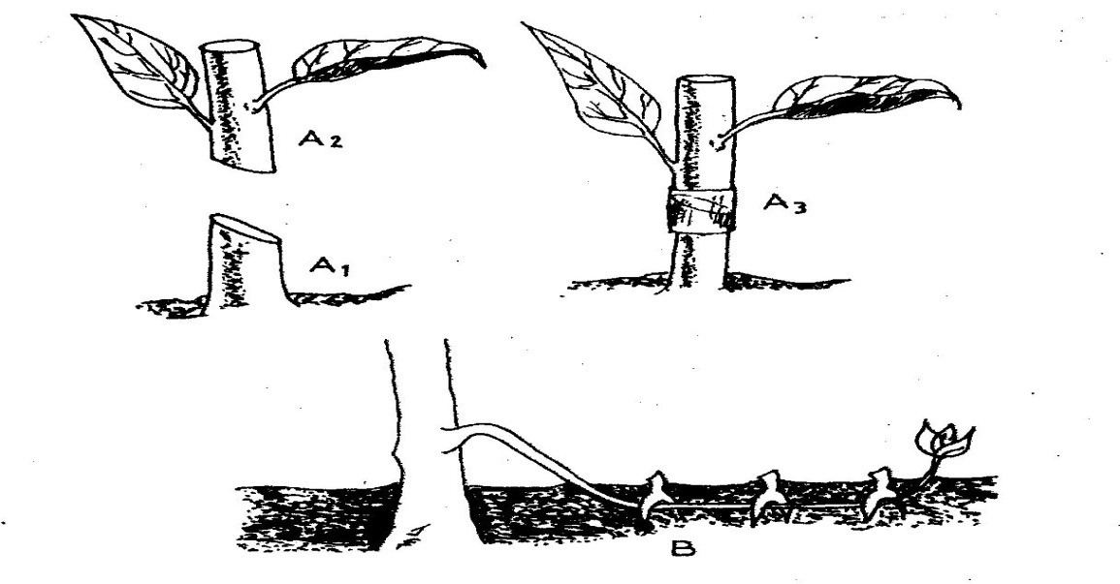

(a) Name the parts labeled A₁, and A₂ ( 2 mks)
A₁
A₂
(b) Name the methods of propagation illustrated in diagrams A₃ and B ( 2 mks)
A₃
B
20. A member of young farmers club was advised to apply a complete fertilizer 30: 20:10 in a tomato plot measuring 10m long by 5m wide at the rate of 300kg per hectare
(a) State the percentage of P₂0₅ in the complete fertilizer ( 1 mk)

(b) Calculate the amount of fertilizer the member would require for the plot (2 mks (Show your working)

21. The diagrams labeled D and E below are illustrations of coffee established using two different formative pruning systems. Study them and answer the questions that follow.
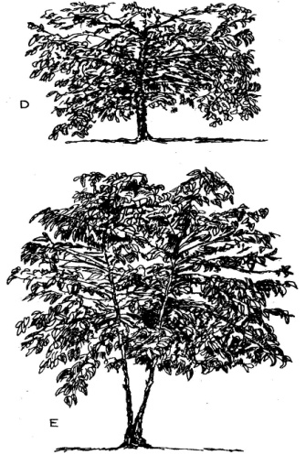

- Name the system of pruning illustrated in diagram D above ( 1mk)

(b) Outline how the pruning system illustrated in diagram E is carried out ( 2 mks)

22. Diagram below illustrates a feature observed after digging the soil several metres deep. Study the diagram carefully and answer the questions that follow.
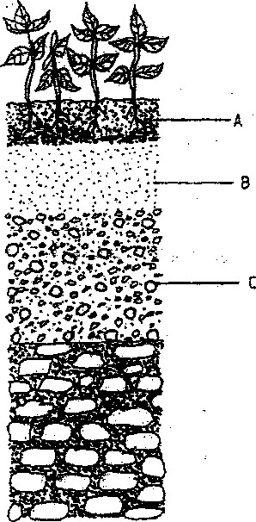

(a) Identify the feature that the diagram above represents in the study of soil. (1mark)

b) Name the parts of the diagram labelled A, B and C (1¹/₂marks)

(c) State two ways in which the knowledge of the above feature would be of benefit to a farmer, (2 marks)

23 The diagrams below show a set up of an experiment to study an aspect of soil. The set up was left undisturbed for five hours. Study it and answer the questions that follow

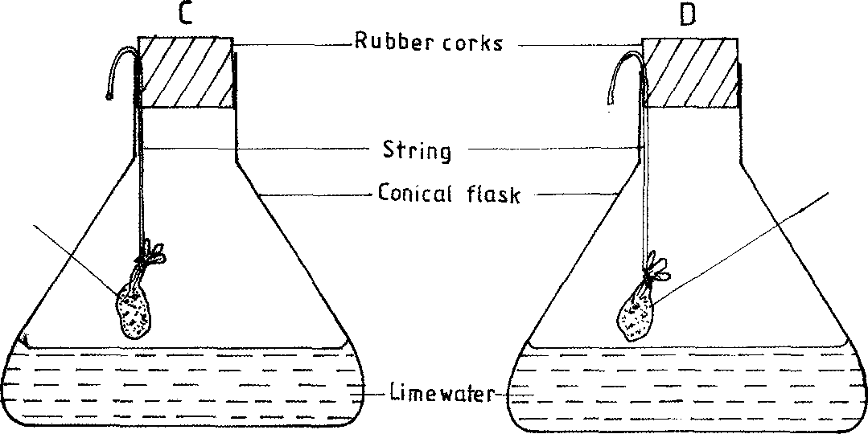
Fresh garden soil in muslin bag
Strongly heated garden soil
inmuslin bag

(1 mark)
- What was the aim of the experiment?

(b) State one observation that was made in each of the flasks labelled C and D.
C....................................................................................................................... ( ½ mark)
D....................................................................................................................... (1mark)
(c) Give a reason for each of your answers in (b) above.
C....................................................................................................................... (1 mark)
D................................................................................................................... (1mark)
SECTION C: 40 MARKS)
Answer two questions only in this section
24. (a) Explain the uses of water on a farm. (8 marks)
……………………………………………………………………………………………………………………………………………………………………………………………………………………………………………………………………………………………………………………………………………………………………………………………………………………………………………………………………………………………………………………………………………………………………………………………………………………………………………………………………………………………………………………………………………………………………………………………………………………………………………………………………………………………………………………………………………………………………………………………………………………………………………………………………………………………………………………………………………………………………………………………………………………………………………………………………………………………………………………………………………………………………………………………………………………………………………………………………………………………..
- Explain reasons for pruning in crops. (7 marks)
……………………………………………………………………………………………………………………………………………………………………………………………………………………………………………………………………………………………………………………………………………………………………………………………………………………………………………………………………………………………………………………………………………………………………………………………………………………………………………………………………………………………………………………………………………………………………………………………………………………………………………………………………………………………………………………………………………………………………………………………………………………………………………………………………………………………………………………………………………………………………………………………………………………………………………………………………………………………………………………………………………………………………………………………………………………………………………………………………………………………..
- Describe the procedure of sowing vegetable seeds in a nursery. (5 marks)

……………………………………………………………………………………………………………………………………………………………………………………………………………………………………………………………………………………………………………………………………………………………………………………………………………………………………………………………………………………………………………………………………………………………………………………………………………………………………………………………………………………………………………………………………………………………………………………………………………………………………………………………………………………………………………………………………………………………………………………………………………………………………………………………………………………………………………………………………………………………………………………………………………………………………………………………………………………………………………………………………………………………………………………………………………………………………………………………………………………………..

25. (a) Explain five factors that influence soil productivity. (10 marks)

……………………………………………………………………………………………………………………………………………………………………………………………………………………………………………………………………………………………………………………………………………………………………………………………………………………………………………………………………………………………………………………………………………………………………………………………………………………………………………………………………………………………………………………………………………………………………………………………………………………………………………………………………………………………………………………………………………………………………………………………………………………………………………………………………………………………………………………………………………………………………………………………………………………………………………………………………………………………………………………………………………………………………………………………………………………………………………………………………………………………..
(b) Outline five factors that a farmer would consider before deciding on the type of irrigation in crop production. ( 5 marks)

………………………………………………………………………………………………………………………………………………………………………………………………………………………………………………………………………………………………………………………………………………………………………………………………………………………………………………………………………………………………………………………………………………………………………………………………………………………………………………………………………………………………………………………………………………………………………………………………………………………………………………………………………………………………
(c) Describe the qualities of the mother plant that should be considered when selecting material for planting. (5 marks)
………………………………………………………………………………………………………………………………………………………………………………………………………………………………………………………………………………………………………………………………………………………………………………………………………………………………………………………………………………………………………………………………………………………………………………………………………………………………………………………………………………………………………………………………………………………………………………………………………………………………………………………………………………………………
26. (a) Describe the production of carrot under the following sub-headings.
- Land preparation. (2 marks)

…………………………………………………………………………………………………………………………………………………………………………………………………………………………………………………………………………………………

- Harvesting. (3 marks)

…………………………………………………………………………………………………………………………………………………………………………………………………………………………………………………………………………………………

- Explain five advantages of mulching. (5 marks)

………………………………………………………………………………………………………………………………………………………………………………………………………………………………………………………………………………………………………………………………………………………………………………………………………………………………………………………………………………………………………………………………………………………………………………………………………………………………………………………………………………………………………………………………………………………………………………………………………………………………………………………………………………………………………………………………………………………………………………………………………………………………………………………………………………………………………………………………………………………………………………………………………………………………………………………………………………………………………………………………………………………………………………………………………………………………………..

- Identify and explain five factors determining spacing of a particular crop. (10 marks)

……………………………………………………………………………………………………………………………………………………………………………………………………………………………………………………………………………………………………………………………………………………………………………………………………………………………………………………………………………………………………………………………………………………………………………………………………………………………………………………………………………………………………………………………………………………………………………………………………………………………………………………………………………………………………………………………………………………………………………………………………………………………………………………………………………………………………………………………………………………………………………………………………………………………………………………………………………………………………………………………………………………………………………………………………………………………………………………………………………………………………………………………………………………………………………………

***************************LAST PAGE***************************

