GATITU MIXED SECONDARY SCHOOL
END OF TERM TWO EXAM 2015
GEOGRAPHY FORM 3

1. (a) State two theories associated with the origin of the Earth and Solar system. (2 mks)

(b) State three effects of the revolution of the Earth. (3mks)

2. (a) Give two components of soils. (2 mks)

(b) The diagram below shows a simple soil profile. Name the horizontal A, B, C(3 mks)
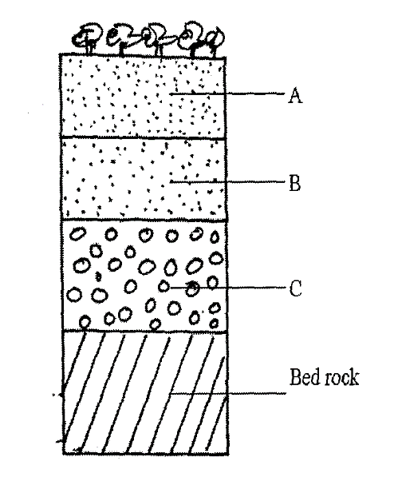
3. (a) Give two ways through which minerals ores occur. (2 mks)

(b) Explain two factors influencing the exploitation of minerals. (4 mks)

4. (a) Give three processes by which the atmosphere is heated. (3 mks)

(b) State two factors that influence the amount of insolation received by Earth (2 mks)

5. (a) Differentiate between Earthquakes and Earth tremors. (2 mks)

(b) State two human causes of Earthquakes. (2 mks)

6 (a) (i) Givetwo ways through which ice moves outwards from the area of accumulation. (2 mks)

(ii) State three factors influencing Glacial erosion. (6 mks)

(b) (i) The diagram below shows types of moraine carried by glacier.
Name the parts labeled W, X, Y. (3 mks)
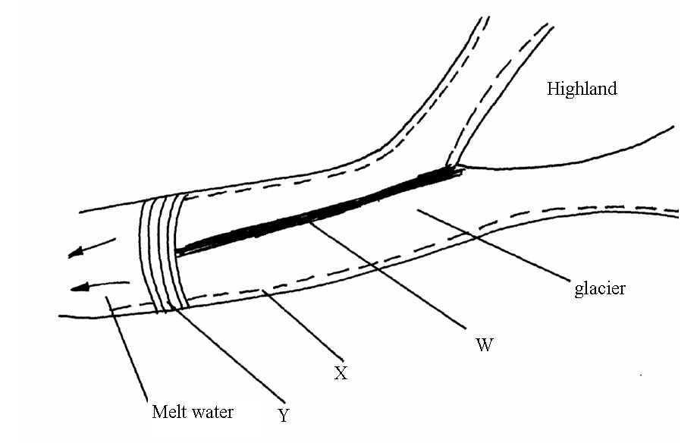

(ii) Describe two ways through which glacial erosion takes place. (4mks)

c) Define the following terms (3mks)

- Glacier

- Ice sheet

- Cirque

