FORM 3 TERM II
EXAMS
MARKING SCHEMES.
312 /1 GEOGRAPHY PP2

1.a) i) a mineral is an organic substance which occurs naturelly at or beneath the surface of the earth.

ii) Types of minerals
-metal eg iron, aluminium.
- non metalic eg. potash, sulphur
-fuels eg coal, oil, natural gas
- rocks .such as the one used in building

iii) Formation of minerals
-Veins and nodes
-seams or layers
-Alluvial deposits
-weathering products
2.
a) Types of field work.
-field excursion
-field research
-field study / field teaching

b). Disadvantages of using content analysis
-may be difficult to verify the accuracy of the available data.
-the data may be irrelevant to current trends
-upto date information may not be readily available

3.a)A hypothesis is a idea , guess or suggestion from which reasoning or explanation is sought.
or It is a statement of an outcome which is anticipated.

b).Importance of reconnaissance.
-Help one decide on appropriate method of data collection.
-familiarize with the and safe time during the actual study
-determine the appropriate routes to be taken
-Helps in identifying the appropriate equipment or instruments to be used during the study
-helps one gather general information and relevant document and relevant documents from the officials
-Helps in assessing suitability of the area as a source of information
- Helps in identifying problems that are likely to be experienced.\
-Assessing the cost of the study
-Helps in general planning and preparation of the working schedule

4. Species of coniferous forests
-Pine, Fir, Spruce, Larch

5. characteristics of coniferous forests.
-Tall straight and evergreen trees
-Needle like leaves
-soft and light wood
-Simple root pattern
-moderate density
cone-shaped trees

6.a) 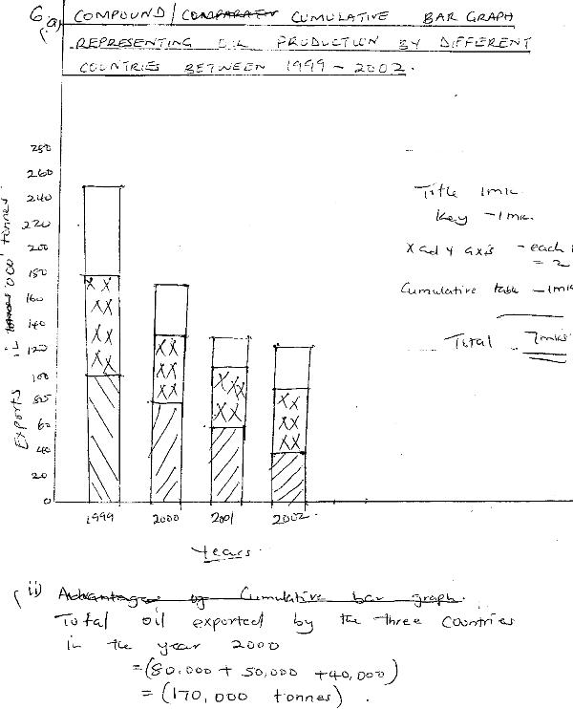

b).Advantages of using cumulative bar graphs.
-Provides clear visual impression of the tatol values
-Easy to read and interprete
-Increase or decrease in grand totals are easy to see
-Comparison can only be done in different years

c).Technique of collecting data
-Observation
-Interview
-Administering questionaire
-Taking measurement
-Carrying out experiments
-Counting
-Content analysis
b) Advantages of using cumulative bar graphs.
-Provides clear visual impression of the total values
-Easy to read and interpret
-increase or decrease in grand totals are easy to see.
-Comparison can easily be done in different years

c).i) Techniques of collecting data.
-observation -interviewing
-Administering questionaire -taking measurements
-carrying out experiments -counting
content analysis
ii) Significance of statistics
-The relationship between two varying quantities can easily be illustrated.
-Geographical information can be summarized in different forms.
-Statistical data enables us to explain geographical phenomenon
--Statistical data enables us to make comparisons and draw meaningful conclusions.
-climatic data can be used to predict future trends in weather or climatic pattern
-statistical information is useful in planning at level and national level.
-statistics show charges of commodities through time
-statistics helps one to get precise and specific data rather than generalized data i.e figures are used instead of words like moderate.

Q.7. a) i) Re-newable natural resources are those which can be used over and over again by man
ii) Non-renewable are those that cannot be replaced once they have been utilized.

b).Factors influencing exploitation of minerals in Africa
-the mining cost.
-The size of the deposits
-The grade and the value of the mineral ore
-Transport and communication
-Inadequate specialised skills
-Inadequate capital

c) .The effect of mining on the natural economies of countries are:-
i)Provide employment opportunities to many people.
ii)give rise to towns which attracts social amenities
iii)Earn foreign exchange
iv)Earn revenue which can be used to develop other sectors.
v)Damage landscape and environment which leads to land dereliction
vi) Destroys the land surface exposing it to dangers of soil erosion
vii)Wastes agricultural land
viii).Pollutes the Atmosphere.

8..a) i) Afforestation is the planting of trees on regions which previosly had non.
ii)Agro-forestry is where there is the integration of Agrinomy and Forestry.

b) Importance of Agro-forestry
i)Provides wood that can be used as fuel.
ii)Proved timber for building
iii)Enables farmers to rehabilitates areas prone to flooding.
IV)Provide a layer of soil through falling leaves which also allows other shallow root crops to grow.
`v)Controls soil erosion since the tree roots hold soil together at the top and stop it from being washed.
vi) Encourage planting trees which are leguminous
an d fixes nitrogen.
Vii)Reduces the level of alkalinity in soil eg.in hot areas the trees will check the capillary action.
viii)Provides fodder crops for animals and particularly where where the densities of population are high

c).i) Characteristics of equatorial rainforest.
-trees of over 40 m height
-Thick canopy of plants
-two third of the trees trunk has no branches
-No undergrowth as a result of lack of sunlight beneath
-Lianas which grow between big trees supported by huge trees.
-Epiphytes eg. moses,lichen fern,
-Evergreen nature due to trees shedding their leaves at different times.
-Broad leaves
-Trees of the same species.

ii)The exploitation of equatorial rain forest has been hindered by:
-Large continuous jungle that scare away foresters
-Transportation of large logs through thro the
impassible forest is very hard
-The poor qualities of the tree species in the equatorial forest which are not good for exploitation.
-The large sizes of trees that do allow for traditional methods like use of axes.
-Absence of pure stands

Q.9. (a).five characteristics of minerals
-Minerals have different degrees of hardness
-Minerals aggregate into distinct shapes
-Some minerals have more elements while the others have more than one .
-Minerals can be Opaque, transparent or translucent
-Minerals have different texture .eg A gold is yellow
-Minerals have luster .ie it surface appearance.
-Minerals have different degrees of tenacity.
-Some minerals have ability to split or break along specific lines.

b).i)Open cast mining is a kind of mining where the minerals to be extracted lies a few metres below the surface ,While underground mining is where the metres below the surface.
ii).Mining is regarded as a robber because man extracts mineral without replacing .

c).i)The Zambia copper mines extends. from Ndola - Luanshya area north Westward to Bencroft .The copper deposit Continue to Zaire into Katanga region.The Zambia copper belt ores are mined from the folded marine sedimentary rocks believed to have been deposited some 600millions years ago.
ii)The problems associated with mining of copper are
-Zambia is landlocked and has no outlets for her copper to the outlets market.
-Political instability in Mozambique has created a bottle-neck.
Fluctuations of World Market prices

d) Two Minerals which provide
-coal -petroleum

