Form 3
TERM II EXAMS
MARKING SCHEMES.
312 /2 GEOGRAPHY PP 2

1.a). Reasons why the earth is flattened at the pole and bulges at the equator.
-Gravitational force
-Centrifugal force
-Centripetal force

b).Characteristics of the core
-Average density of 10.5- 17.0 gm / cm3
-Temperature very high from 37000c - 45000c
-Composed of very hot molten rock materials
-Contains minerals iron and Nickel
-The rocks are of high density

2.a).The main line of longitude
-Greenwhich Meridian/Prime meridian / Longitude 00

b). 400E x
2.00pm 4.00pm
place X is ahead in time by (4.00-2.00) = 2hrs
1hr = 150
2 hrs = 2 x 15 = 300
1

Since place x is a head its longitude
=(300 + 400 ) = 700 E

3.(a)Fold mountains is formed during Alpine Orogeny
-Atlas in Africa
-Alps in Europe
-Himalayas in Asia
-Rockies in North America
-Aridest in South America

b)Plates boundaries mention in plate tectonic theory.
-Extension / constructive / Diverging boundary
-Compression / Destructive / converging
-Transform faults / conservative

4. Causes of soil creep 3mks
a).-Alternating cooling and heating shift soil particles
- Moisture in soil and its loose soil particles
- Earthquakes triggers off soil creep
- Freenzing and Twawing

b) Measures to check mass wasting
-proper agricultural particles eg.terracy, planting cover crops
-Afforestation and reaforestation
-Redulating livestock and controlled grazing
-Building gabions and cutoffs

5.(a) Conditions for delta
-The river’s load should be deposited faster than it can removed by current and tides
-Velocity should be sufficiently low to allow
deposition to take place
- The rivers load should be large
-The re should be no obstacles like lakes or swamps in the river’s course which would act as filters.
b) Scales used to measure earthquakes
-Mercalli scale
-Ritcher scale
\ -Rossi forren scale
(ii) Causes of earthquake
-Violent volcanic eruption
-Magma movement within crust
-Gravitational pressure
-Collision of tectonic plate/energy release in the mantle
MAP WORK
6. a (i) Magnetic variation 2o 23’
(ii) Manmade features found in arid square 9078
-Schools
-dams
-Loose surface road

6. a) A rectangle measuring 8cm by 16cm representing the area enclosed by eastings 9 and 13 and northing 76 and 84.
.
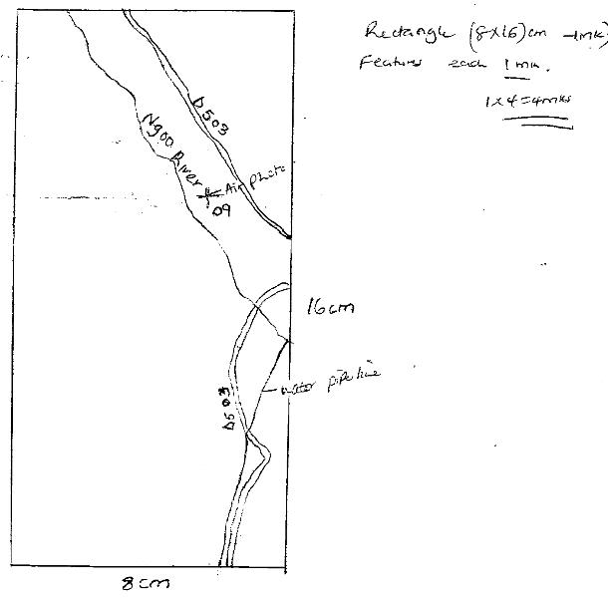

Rectangle ( 8x 16) cm 1mk
features each 1mk
1x4= 4mks
b) i Distribution of settlements in the area covered by the map Nuclear settlements - dense settlement in market areas eg Gwani mkt,Mutitu Ndooa
Linear Settlement - Among the dry weather road and the loose surface roads Sparse Settlement - The hills and mountainous areas are sparsely populated
(ii) Drainage of the area covered by the map
-Most rivers are flowing from the northern part of the area covered by the map
-Most of the rivers are forming a deotritic river pattern
-There are dams on most of the rivers eg the dams at grid square 9078,9478
-Some rivers are permanent eg Ngoi while others are temporal they are disappearing.

six grid reference of the trigonometric station
d) i) 922643
ii)District bordering Migwani to the south -Tiva

e) Distance of the dry weather road from the junction to the reference 970789
= 6.8km I 1

7.(a) i) Biological weathering is the disintegration of rocks due to the action of living organisms namely plants, animals and people.

ii) Agents of biological weathering.
-plants
-man 2 x 1
-animals

b) Processes involved in chemical weathering
-Oxidation- a process in which oxygen in the air reacts with iron compounds in rocks .The ferrous state of iron change into ferric state which weaker the rocks
State equations can be used Fe + O2 -- Fe2O

-Carbonation - Is the process by which rain water dissolves CO2 forming weak carbonic acid .When this acid falls on limestone rock it forms calcium bicarbonate leaving behind a weaker rock.
- Solution - Is where some rock minerals dissolve in water and are washed away in solution leaving behind a weaker rock.
- Hydration - Is where some minerals in rocks Take up water and expand causing stress in the rock leading to their fracture.
-Hydrolysis - Is the process where chemical reaction takes place between hydrogen ions in water and minerals in a rock .eg fluorspar rocks

c) i) Factors affecting mass wasting
-Angle of slope / Gradient
-Nature of the underlying rock / material.
-Tectonic movements
- Climate
-Human activities
a). Soil creep
-Occurs on areas of gentiles slopes
- Involves slow movement of fine soils
-Soil particles change position as a result of
gravitational pull.

b). Avalanche
- avalanche are rocks embedded in masses of ice and snow in the humid area
-Thawing / melting of snow cause the movement of rock material down the mountain side
-The materials fall rapidly as a results of gravitational pull
d).Effects of mass wasting on environment.
-Materials washed down slope from fertile soil from the site of deposit.
- Form tourist attraction features
-may cause damage to property and loss of life.
-Facilitates soil erosion on the steep slopes.
-May render farmlands into waste.
Leave permanent scars on the landscape.
8.a) Vulcanicity is the process by which liquid, solid and gas material from the earth’s interior are intruded into the earth’s surface or extruded onto the earth’s surface while volcanicity is the process by which gaseous liquid and solid materials from the earth’s interior cool and solidity on the external part of the earth’s surface.

Lapolith.
- A very large saucers shaped mass of igneous intrusion.
- Formed when fluid magma forces its way between the bedding planes.
-The magma spreads, cools and solidarity within the upper surface forming a shallow basin.

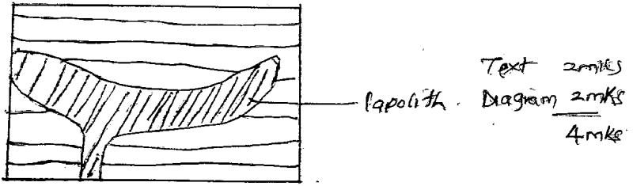

Lapolith.
-Is the largest mass of plutonic magma which is intruded in the country rock.
-The magma is so hot that it metamorphosis’s the country rock thereby replacing it.

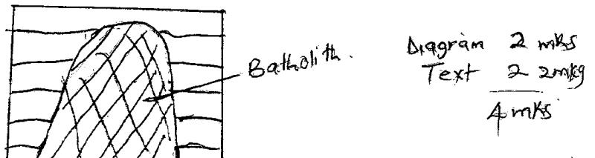

8.(b) i) Features resulting from extrusive vulcanicity.
-Volcanoes.
-Lava plateau.
-Caldera / crater.
-Volcanic neck.
-Hot springs and geysers.
-Ash and cinder cones.

ii) Significance of vulcanicity.
-Volcanic rocks weather to form fertile soils suitable for agriculture.
-Geysers are a source of thermal power.
-Hot water from hot springs is pumped through pipes into houses for heating.
-Volcanicity results into beautiful scenery which attract tourists.
-Volcanic mountains are catchment areas of water.
-Crater lakes are formed which provide water for domestic use.
-Fishing is carried out in some of the crater e.g katwe lakes.
-Results in the formation of minerals e.g diamond in Tanzania.

(c) i) A fold is a bend in the rocks of the earth’s crust.
ii)Areas in Africa where folding has taken place.
-Atlas in North Africa (Morocco, Tunisia, Algeria).
-Cape Ranges in South Africa.

iii)

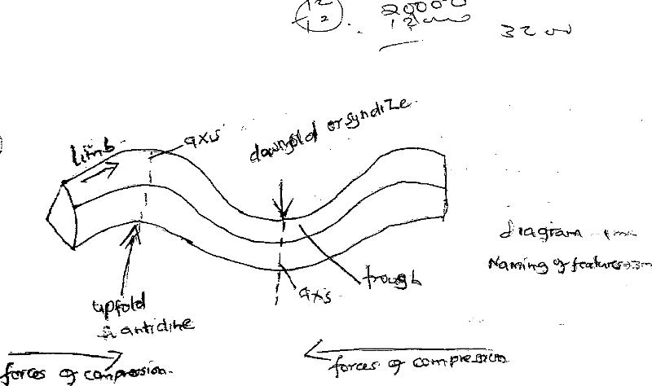

9.(a) i) a hydrological cycle is the endless circulation of water from oceans into atmosphere through evaporation, back to the land in form of rain and again to the ocean in form of surface run-off. or Its the endless interchange of water between the sea, the atmosphere and the land.

ii).Factors affecting evapotranspiration.
-Availability of moisture at the surface of the earth.
-Temperature to change liquid water to vapour.
-Wind to remove moisture from the surface of the earth to the atmosphere.
-Enough hours of sunshine to increase evaporation rate.
-Water characteristics e.g saline water reduces water pressure hence reducing evapotranspiration.
iii).Factors influencing surface run-off.
-High rainfall/high amount/high intensity.
-Low rate of evaporation.
-Sloping ground/steep slopes.
-Presence of impervious rocks/soil surface.
-Bare surface/absence of vegetation.

c.i) A rivers load is all matter transported down stream.
ii) Types of River erosion.
-Headward erosion-When a river cuts back at its source thus increasing its length.
-Vertical erosion- A river digs into its bed through hydrolic action, solution and erosion process
increasing its depth.
-Lacteral erosion- This is when a river erodes its sides widening its channel.
iii) How a river transports its load.
-Suspension- small particles swirl along in suspension.
-Siltation- The larger particles proceed in a series of hops touching the bed at intervals.
-Traction- The pebbles are rolled along by gravity and by the pushing power of water. The big stones and boulders are moved along the bed.
-Solution- Materials are dissolved and transported in solution form.

d.i)A river capture is whereby a river loses its water to a more powerful one flowing adjacent to it.
ii) Occurance of a river capture.
Before a river capture.

The more powerful river flows at a lower level and erodes its channel both head ward and vertically at a faster rate than its neighbour.
-The pirate river captures the adjacent less powerful river (misfit).

RIVER AFTER CAPTURE.

-The misfit will continue flowing in its former valley at the lower parts, but since its water sources are diverted into the pirate river, it will be a smaller river flowing through a bigger valley.
10.a) i)P- desert climate of the central northern area.
Q- Tropical climate of the North-western border.
ii) Characteristics of the climatic region marked R.
-High temperatures throughout the year.
-Annual rainfall of between 1000-1600mm/yr.
-Small annual range of temp. (20c)
-Double maximum rainfall.
-Convectional type of rainfall.
-Humidity is high through the year.
-Mean annual temperature (220 c-320 c)
b.i) warm ocean currents.
Leads to warming effects that increases evaporation and humidity of the adjacent lands.

Deforestation.
Interfers with the hydrological cycle and leads to inadequate rainfall.
c.i) Types of vegetation.
-Natural vegetation.
-Secondary/Derived vegetation.
-Cultivated/planted/manmade vegetation.
ii) Characteristics of hot-desert vegetation.
-Have thorny leaves to reduce evapotranspiration during high temperatures.
-Some plants have deep roots to absorb water during drought.
-Some plants store water in their fleshy stems.
-Most vegetation exists in a dormant state.
-Some plants stems have thick waxy cuticle to reduce venticulcur respiration.
-Some have few number of leaves.
-Some have superficial roots to absorb water during torrential rains.

d.i)Temperature inversion is the increase in temperature with increasing altitude.

ii) Reasons for heat at the equator than the poles.
-At the equator sun rays strike the surface at right angle and at acute angle at the poles.
-Sun rays travel shorter distances at the equator and longer distances at the poles.
-The equatorial surface exposed to the sun rays is smaller than at the poles.
e.i) ITCZ is the Inter Tropical Convergence Zone ; the area where tropical maritime air masses converge.
ii) Influence of ITCZ on climate.
-It influences temppeline eratures.
-It influences wind patterns.
-Influences rainfall amounts and patterns.
iii) Factors affecting the behaviour of ITCZ.
-Apparent movement of the sun.
-Altitude.
-Latitude.
-Changing pressure systems.
-Presence of large water bodies.
-Coastal configuration.

