GATITU MIXED SECONDARY SCHOOL
GEOGRAPHY FORM 3 OPENER TERM 2 2015

1a) List two types of igneous rocks based on rock depth. (2 marks)

b) State two economic uses of rocks today. (3 marks)

2a)Briefly state why warm air cools as it rises. (2 marks)

b) State three different ways in which air may be made to rise. (3 marks)

3a) Name two local winds. (2marks)

b) State three factors influencing wind blow. (3mks)

c) Explain FOUR causes of forest depletion in Kenya today. (8 marks)

4a) Define the term endogenic processes. (2marks)

b) State three effects of horizontal earth movements. (3marks)

c) Name any two leaching processes that leads to soil formation. (2marks)

5) a) The diagram below shows some intrusive volcanic features. Use it to answer the questions that follow.

i) Name the features marked W, X, Y, Z.
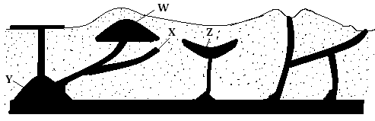

ii) Explain how a sill is formed. (4marks)

c) Distinguish between vulcanicity and volcanicity (2marks)

6) State three characteristics of inter- tropical convergence zone (ITCZ) (3mks)

7) Compare coffee growing in Kenya and Brazil under the following:-
(i) Size of farms. (2mks)

(ii) Labour (2mks)

(iii) Marketing (2mks)

8)Study the map of Africa provided and answer the questions that follow.
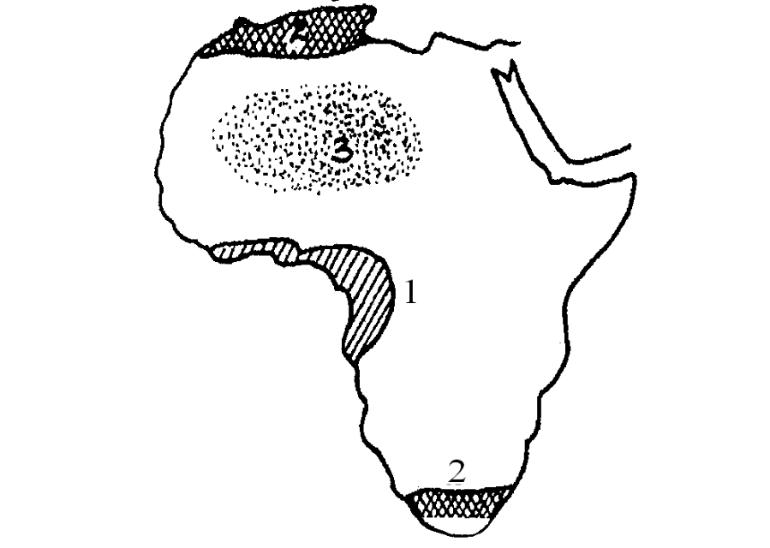
a) Name the climatic regions marked 1,2 and 3. (3mks)

b) Give two characteristics of climate marked 3. (2mks)

