GATITU MIXED SECONDARY SCHOOL
GEOGRAPHY FORM 3 TERM 2 2015 MID TERM EXAM
GEO FORM 3
(1) Describe the following chemical weathering processes.
(i) Hydration (3mks)

(ii) Oxidation (3mks)

(iii) Carbonation (3mks)

2 (a) i. What is a desert? (2mark)

ii. Explain two processes of wind erosion in deserts. (4marks)

(b) With the aid of well labeled diagrams, describe how the following features are formed
  - Rock pedestals (6marks)

ii.Yardangs (6marks)

3. Name three features resulting from wind deposition in deserts. (3marks)

Explain two negative effects of desert land forms (4marks)

3 Study the diagram below and use it to answer the questions that follow.
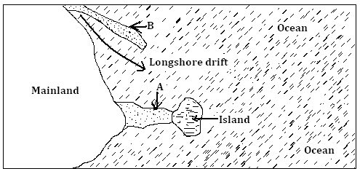

Name the features marked A and B (2marks)

Describe how the feature marked B is formed. (4marks)

(a) (i) What is faulting. (lmk)

(ii) With an aid of well labeled diagrams explain how a rift valley is formed through compression forces (8mks)

