1. Evaluate without using tables or calculators

 (4mks)

1. Simplify ½ of 3½ + 1½ (2½ - 2/3) (4mks)

¾ of 2½ ÷ ½

1. Express the recurring decimal 5.72as a fraction leaving your answer in the form

**a/b** where **a** and **b** are whole numbers (3mks)

1. A number n is such that when it is divided by 27, 30, or 45, the remainder is always 3. Find the smallest value of n. (2 mks)
2. The GCD of two numbers is 7and their LCM is 140. if one of the numbers is 20, find the other number (2mks)
3. A two digit number is such that the sum of the ones and the tens digit is ten. If the digits are reversed, the new number formed exceeds the original number by 54.

Find the number. (3mks)

1. Five year ago, a mother’s age was four times that of her daughter. In four years to come,

she will be 2 ½ times the age of her daughter. Calculate the sum of their present ages. (3mks)

1. A rectangular field measures 63.9m by 104.6metres find the minimum number of poles to be

erected for fencing if they are to be at most 2.4meters apart.(3mks)

(a) Divide 100cm3 in the ratio to the nearest whole number. (3mks)

(b) In a chemistry experiment, a boy mixed some acid solution of 45% concentration with an acid solution of 25% concentration. In what proportion should the two acids be mixed in order to get 100cm3 of solution of 30% concentration. (3mks)

1. If 5 men can erect 2 cottages in 21days, how many more men, working at the same rate will be needed to erect 2 cottages in the same period? (3mks)

1. The scale of a map is 1:50000. A lake on the map is 6.16cm2. find the actual area of the lake in hactares. (3mks)

1. A rectangular water tank measures 2.6m by 4.8m at the base and has water to a height

of 3.2m. Find the volume of water in litres that is in the tank (3mks)

1. Three litres of water (density1g/cm3) is added to twelve litres of alcohol (density 0.8g/cm3.

What is the density of the mixture? (3mks)

1. A sphere has a surface area 18cm2. find its density if the sphere has a mass of 100g. (3mks)
2. A watch which loses a half-minute every hour was set to read the correct time at 0445h

on Monday. Determine the time in 12-hour system, the watch will show on the following

Friday at 1845h (3mks)

1. Determine the inequalities that represent and satisfies the unshaded region (3 mks)

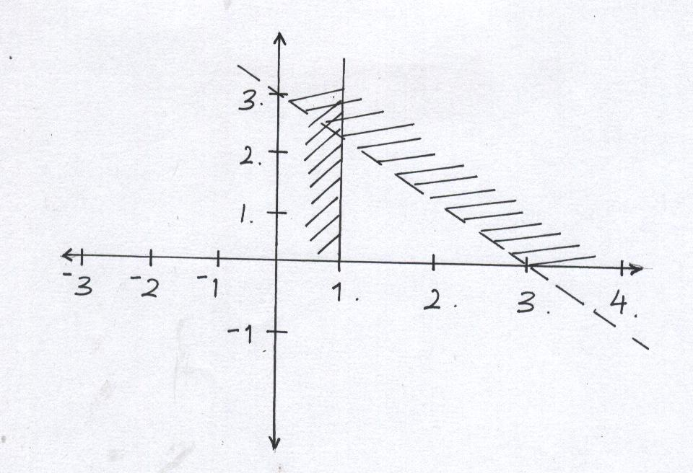

a) Find the range of values x which satisfied the following inequalities simultaneously. (2 mks)

4x – 9 < 6 + x

8 – 3x < x + 4

b) Represent the range of values of x on a number line. (1 mark)

1. Solve for x and y in. (4mks)



1. Solve for x in the given equation. (3mks)

64x – 121 = 7 – 43x

1. Hamisi arrived in Nairobi from USA with 40 travelers cheques each with 75 US dollars. How

much does she receive in Kshs from the bank on a day when 1 US dollar was equivalent to Kshs

81.40 and the bank charges commission at the rate of Kshs.100 per travelers cheque (4mks)

1. The sum of interior angles of two regular polygons of sides n and n + 2 are in the ratio 3:4.

Calculate the sum of the interior angles of the polygons with n sides (2mks)

1. The sum of angles of a triangle is given by the expression (2a+b)0 while that of a quadrilateral is given by . Calculate the values of a and b (3 mks)
2. A straight line passes through A(-2,1) and B(2,-k). The line is perpendicular to a line 3y + 2x = 5. Determine the value of k. (3mks)
3. Given that cos A = 5/13 and angle A is acute, find the value of:-

2 tan A + 3 sin A (3mks)

1. The sides of a triangle are in the ratio 3:5:6. If its perimeter is 56 cm, use the Heroes formula to find its area (4mks)