NAME…………………………………………………….ADM ………………………..
GATITU MIXED SECONDARY SCHOOL
MATHEMATICS FORM 3 CAT 2 2013

- Without using mathematical tables or calculators, evaluate 3mks
$√$5184

6× -18 ÷ 9 + (5 - ⁻3)

- Find, without using mathematical tables, the value of x which satisfy the equation 4mks
Log₂ (x ² - 9) =3log ₂2 + 1

- Simplify 4 - 3 3mks

√ 5 +√ 2 √5 -√2

- Mr. Ngenya borrowed sh. 560,000 from a bank to buy a piece of land. He was required to repay the loan with simple interest for a period of 48 months. The repayment amounted to sh. 21,000 per month. Calculate
- The interest paid to the bank 2mks

- The rate per annum of the simple interest 2mks

- The table below shows monthly income tax rate
Monthly taxable pay Rate of tax
k£ ksh per k£
1 – 342 2
343 -684 3
685 -1026 4
1027 -1368 5
1369 -1710 6
Over 1710 7
A civil servant earns a monthly salary of ksh. 20,000 and is provided with a house at a nominal rent of ksh. 700 per month
- Taxable pay is the employee’s salary, plus 15 % of salary , less nominal rent
Calculate the civil servant’s taxable pay in k£ 3mks

- Calculate the total tax 4mks

- If the employee is entitled to a personal relief of sh. 600 per month, what is the net tax 1mk

- In the figure below, BT is a tangent to the circle at B. AXCT and BXD are straight lines. AX=6cm, CT =8cm BX =4.8cm and XD =5CM

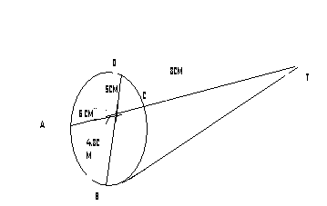

find the length of
- XC 2mks

- BT 2mks

- The fig. Represent a circle of diameter 28 cm with a sector subtending an angle of 75 at the centre. Find the area of the shaded segment to 4 significant figures 4mks

