DARAJANI BOYS’ SCHOOL,P.O BOX 20,90129 NGWATA
PHYSICS CAT 1 TERM 2 2015
FORM THREE

NAME………………………………………… ADM.NO…………….. CLASS…………

ANSWER ALL THE QUESTIONS IN THE SPACES PROVIDED

- A small object lies at the bottom of a water pond at a depth of 2.4m.Given that the refractive index of water is 1.3, determine the apparent depth of the object. Give your answer to 1 decimal place. (3mks)

2. State why a pin floating on water sinks when detergent is added. (2mks)

- Give a reason why the weight of a body varies from place to place. (2mks)

- The figure below shows a non-uniform log of mass 100kg balanced on a pivot by 2kg mass placed as shown below.
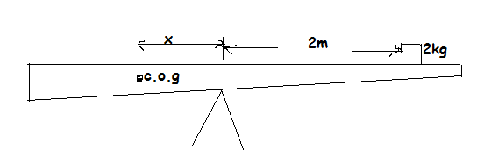
Calculate distance x. (3mks)

- State two ways in which stability of a body can be increased.(2mks)

6. (a) The figure below shows a hydraulic 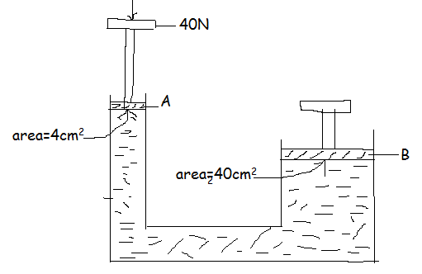
- Calculate the pressure exerted on A in N/M² . (3mks)

(ii) What is the pressure exerted on B. (1mk)

- Find the load lifted at piston B. (3mks)

(b) In an experiment, one drop of oil was allowed to fall from a burette onto the surface of water sprinkled with lycopodium powder.
i) It was found that the readings on the burette changed from 10.5ml after 50 drops had fallen from the burette. Find the volume of one drop. (2mks)

- The drop formed an oil patch of 18cm diameter. Assuming that the oil patch is a monolayer of oil molecules, find the diameter of the oil molecule. (3mks)

- A liquid flows through a pipe of varying cross-sectional area. If the liquid enters one end of the pipe of cross-sectional area $5 x {10}^{-3 }m^{2}$ at 0.3m/s and flows into a different cross-sectional area at this 1m/s. determine the cross-sectional area at this end. (3mks)

- The figure below shows uniform U-tube containing water and a liquid L .Both separated by mercury. The water rises to a height of 15 cm while L to a height of 18.75 cm from the mercury edge.
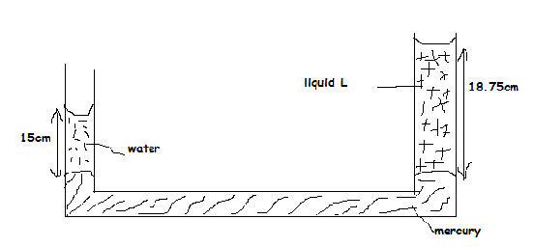
Calculate the density of liquid L. (3mks)

- The figure below shows a tape made from a ticker tape timer. The frequency of the ticker timer was 100Hz.
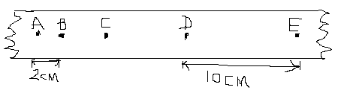
Find;
- Time taken for 1 tick interval. (1mk)

ii) Velocity at AB and DE. (2mks)

iii) Acceleration of the body. (3mks).

