Name: ------------------------------------------------------------------------------------------ADM No: ---------------------

School: ------------------------------------------------Candidate’s Signature: ---------------------------------------------

Date: -------------------------------------------------------------

**232/3**

**PHYSICS PAPER 3**

**PRACTICAL**

**JULY/AUG/2015**

**MARKING SCHEME**

**MARKING SCHEME**

**232/3**

**PHYSICS**

**PAPER 3**

**JULY/AUGUST/2015**

**MARKING SCHEME**

**INSTRUCTIONS TO CANDIDATES:**

* *Write your* ***name*** *and* ***index number*** *in the spaces provided above.*
* *Sign and write the* ***date*** *of the examination in the spaces provided above.*
* *You are supposed to spend the first 15 minutes of the 2 ½ hours allowed for this paper reading the whole paper carefully.*
* *Marks are given for a clear record of the observation actually made, their suitability, accuracy and the use made of them.*

**FOR EXAMINER’S USE ONLY**

|  |  |  |  |  |  |
| --- | --- | --- | --- | --- | --- |
| Question1 | (a) | (h) | (i) | (j) | (k) |
| Marks score | 01 | 09 | 05 | 03 | 02 |
| Candidate’s score |  |  |  |  |  |

|  |  |  |  |  |  |
| --- | --- | --- | --- | --- | --- |
| Question2 | (a) | (h) | (i) | (j) | (k) |
| Marks score | 01 | 10 | 05 | 03 | 01 |
| Candidate’s score |  |  |  |  |  |

Thickness of glass block  **1.82cm**2d.p(1mk)

**RESULTS**

|  |  |  |  |  |  |  |
| --- | --- | --- | --- | --- | --- | --- |
| Number of glass blocks used | 1 | 2 | 3 | 4 | 5 | 6 |
| P (cm) | 1.82 | 3.64 | 5.46 | 7.28 | 9.1 | 10.92 |
| Q (cm) | 1.2 | 2.3 | 3.5 | 4.7 | 5.9 | 7.1 |

(9mks)



i) Draw a graph p against q (5mks)

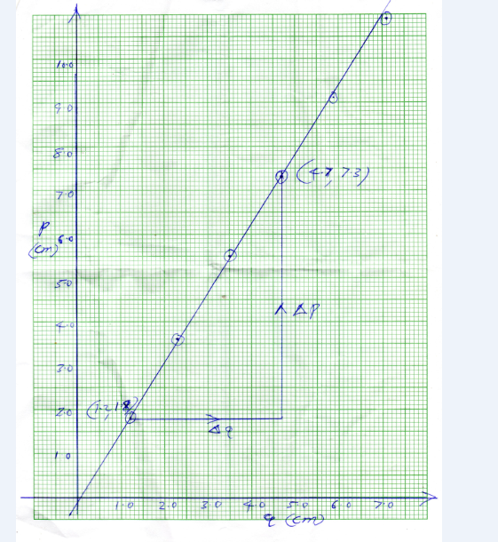

j) Determine the slope of the graph (3mks)

**=ΔP/ΔQ**

**= (7.3-1.8)/(4.7-1.2)**

**=1.57**

k) State the significant of the value in (j) above (2mks)

* **Is the relative refractive index of glass with respect to air**
* **Award 1mk for those who state it as refractive index of glass**



Mass of wooden block X= **0.2N** (1mk)

**RESULTS**

|  |  |
| --- | --- |
| **Weight of wooden block plus the masses on it(W1) in Newtons (N)** | **Weight of paper bag plus sand (W2) in Newtons** |
| 0.2 + 0.5 =0.7 | 0.4 |
| 0.2 +1.0 =1.2 | 0.6 |
| 0.2 +1.5 =1.7 | 0.8 |
| 0.2 +2.0 =2.2 | 1.1 |
| 0.2 + 2.5 =2.7 | 1.4 |

(10mks)

1. Draw a graph of weight of paper bag plus sand (W2) against weight of wooden block plus the masses place on it(W1) (5mks)

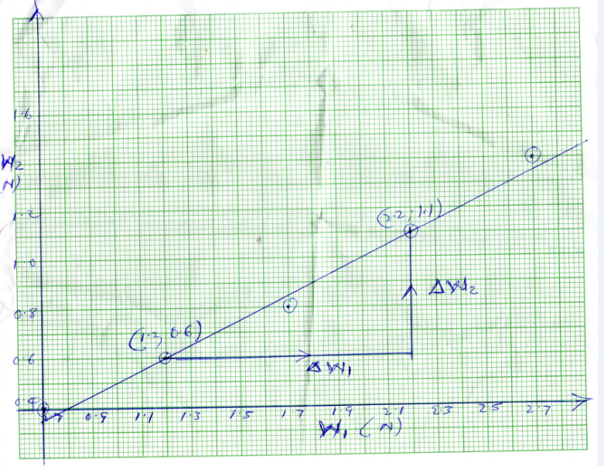

1. Determine the gradient of the graph (3mks)

**=ΔW2/ΔW1**

**= (1.1-06)/(2.2-1.2)**

**= 0.5**

1. State the significance of the value obtained in (j) above (1mk)

* **It is the coefficient of friction between the paper fixed on wooden block and the glass surface**