Name……………………………………………….Adm No………..Class……
Index No……………………….. Signature…………………………

121/1
Mathematics Paper 1
Form 4
2 ½ Hours
Term 2, 2018
KASSU JET EXAMINATIONS
Kenya Certificate of Secondary Education (K.C.S.E)
INSTRUCTIONS TO CANDIDATES
- Write your name and Admission number in the spaces provided at the top of this page.
  - This paper consists of two sections: Section I and Section II.
  - Answer ALL questions from section I and ANY FIVE from section II
  - All answers and workings must be written on the question paper in the spaces provided
beloweach question.
  - Show all the steps in your calculation, giving your answer at each stage in the spaces
below each question.
  - Non – Programmable silent electronic calculators and KNEC mathematical tables may be
used, except where stated otherwise.

FOR EXAMINERS USE ONLY

SECTION I
1 | 2 | 3 | 4 | 5 | 6 | 7 | 8 | 9 | 10 | 11 | 12 | 13 | 14 | 15 | 16 | TOTAL

SECTION II
17 | 18 | 19 | 20 | 21 | 22 | 23 | 24 | TOTAL

GRAND TOTAL

SECTION I 50 MARKS
- Without using tables, evaluate $\frac{0.51x5700}{6.8x0.0095}$ giving the answer in standard form. (3mks)

- Find the value of t in the following equation ${81}^{-1}×{\left(\frac{1}{27}\right)}^{t}=\frac{1}{{243}^{-1}}$ (3mks)

- Simplify the expression (3mks)
$\frac{×^{2}- {9y}^{2}}{{2x}^{2}- 7×y+ {3y}^{2}}$

- Evaluate using tables of reciprocals and cubes only expressing your answer to 4 significant figures
(3mks)

- Simplify; $\frac{2}{3}$ of 5$\frac{2}{5}$ - 2$\frac{3}{10}$ (3mks)

$\frac{3}{5}÷4\frac{1}{2}$ + 1$\frac{3}{5}$

- Find the equation of a line which passes through the point (2, 3) and is perpendicular to
$y = 3x -1$. Giving your answer in the double intercepts form (3mks)

- George received 1O,OOO Euros from his brother who stays in France .He sent to his sister who stays in Japan 10,000 Yen .In addition George bought a car worth sh.200,000. Exchange rates :
Buying Selling
1 Euro 73.4226 73.52953
100 Japanese yen 62.8011 62.8822

How much was left. (3marks).

- Write down four inequalities which fully describe the unshaded region R in the figure S
below (4mks)
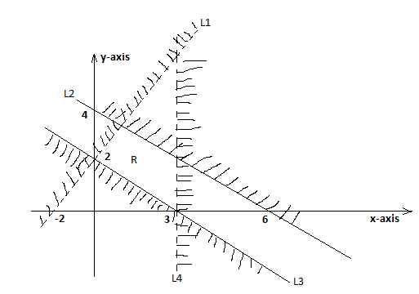

- A line PQ = 12.5cm. By using another line, divide PQ into nine equal parts. (3mks)

- The sum of the interior angles of a polygon is 1980⁰. Find the number of sides the polygon has. (3mks)

- The diagram below is a sketch of a rice field (not drawn to scale), use it to generate a surveyor’s field book. (All measurements are in metres) (4mks)
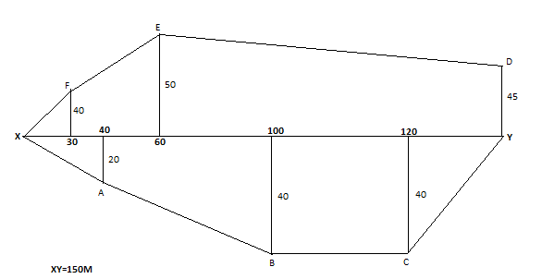

- A boy walk directly from point Q towards the foot of a vertical flag post 200m away. After conveying a distance of 140m, he observes the angle of elevation of the top of the flag post is 75$°$. Calculate the angle of depression of point Q from the top of the flag post. (3mks)

- Two similar blocks have masses of 729g and 216g respectively. If the surface area of the smaller block is 300cm², calculate the surface area of the larger block. (3mks)

- Using trapezoidal rule with 6 ordinates, find the area bounded by the curve y=2x³ – 5,
the x-axis and the lines x=2 and x=8. (3mks)

- Kassim has a money box containing 100 mixed shs 5 and shs 10 coins with a total value of shs 600. How many of each type of coin does the box contain. (3mks)

- The figure below shows a regular tetrahedron PQRS of edges 4cm.
Draw its net and measure the length of the straight path of PS through the midpoint T over the edge QR. (3mks)
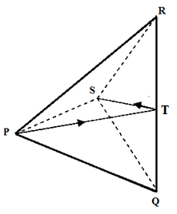

SECTION II (50 MARKS)
(Answer ANY FIVE questions in the spaces provided)

- Complete the table below for the equation y=2x²+2x-8 by filling the blank space. (2mks)
x | -5 | -4 | -3 | -2 | -1 | 0 | 1 | 2 | 3 | 4
y | 32 |  |  | -4 |  | -8 |  |  | 16
a). On the graph provided below, plot the graph of y=2x²+2x-8. (4mks)
(use the scale: y-axis=1unit, x-axis=1unit)
b) Use your graph to solve:
i) 2x²+2x-8=0 (1mk)

ii) 2x²+x+2=0 (3mks)
- a) a bus left Kisumu at 9.30 am towards Nairobi at an average speed of 81km/hr. A matatu left Nairobi for Kisumu at 10.10 a.m at an average speed of 72km/hr. The distance between Kisumu and Nairobi is 360km. Determine:
(i) The time taken before the two vehicles met. (3mks)

(ii) The distance between two vehicles 40 minutes after meeting. (2mks)

(iii) A car left Kisumu towards Nairobi at 9.50am at an average speed of 90km/hr. Determine the time the car caught up with the bus. (3mks)

(b) The figure below shows speed time graph of a journey. If total distance travelled in 80 seconds is 920m. Find the distance travelled in the final 40 seconds. (2mks)
16m/s
speed

0 15 time (seconds)

- The Figure shows a frustum of a right pyramid open container for storing water.
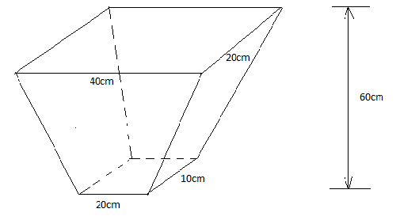

Calculate:
- The height of the pyramid from which the frustum was cut from. (2mks)

- The surface area of the frustum (4mks)

- The capacity of the frustum in litres (4mks)

- The table below represent marks in percentage scored by 50 students in a class
Marks | Frequency
40-44 | 6
45-49 | 4
50-54 | 7
55-59 | 6
60-64 | 12
65-69 | 4
70-74 | 5
79-79 | 3
80-84 | 3

- State the modal class (1mk)

- Estimate:
- The mean mark (2mks)

- The median (3mks)

- On the grid provided draw a frequency polygon to represent the above information. (4mks)

- Given that the column vectors
$$\underbrace{p}=\left(\begin{matrix}-3 \\ 4\end{matrix}\right), \underbrace{q}=\left(\begin{matrix}16 \\ -4\end{matrix}\right), \underbrace{r}=\left(\begin{matrix}9 \\ 6\end{matrix}\right)and that \underbrace{a}=2\underbrace{p}- \frac{3}{4}\underbrace{q}+ \frac{2}{3}\underbrace{r}$$
Express a as column vector and hence calculate its magnitude (4mks)

b) Given that the midpoints of PQ is (-3,1) and Q (7,5), obtain the co-ordinates of P (3mks)

c) A translation T$\left(\begin{matrix}2 \\ 1\end{matrix}\right)$. maps triangle ABC onto triangle A¹B¹C¹. Given the co-ordinates A(2,3) , B(2,5) and C(4,4). Find the co-ordinates of A¹B¹ and C¹. (3mks)

- The coordinates of triangle ABC are A(1, 1), B(3, 1) and C(1, 3).
- Plot the triangle ABC. (1mk)
- Triangle ABC undergoes a translation vector $\left(\begin{matrix}2 \\ 2\end{matrix}\right)$. Obtain the image of A’B’C’ under the transformation, write the coordinates of A’B’C. (2mks)

- A’B’C undergoes a reflection along the line X=0, obtain the coordinates and plot on the graph points A”B”C” under the transformation. (2mks)

- The triangle A”B”C” undergoes an enlargement scale factor -1, centre origin. Obtain the coordinates of the image A”’B”’C”’. (2mks)

- The triangle A”’B”’C”’ undergoes a rotation centre (1, -2) angle 120⁰. Obtain the coordinates of the image A”B”C”. (2mks)

- Which triangles are directly congruent? (1mk)

- A particle moves along a straight line such that its displacement s metres from a given
point is s = t³ – 5t² + 3t + 4 where t is time in seconds.
Find:
(a) The displacement of the particle at t = 8. (2mks)

(b) The velocity of the particle when t = 10. (3mks)

(c ) The values of t when the particle is momentarily at rest. (3mks)

- A pilot intends to fly from A to D through B and C, B is 750km from A and on a bearing of N50$°E. C is on a bearing of N$ 40$°$W from B and their distance apart is 600km. D is on a bearing of S 85$°$ W from C and at a distance of 1050km.
a) Using the scale of 1cm for 100km, show the flight route. (4mks)

b) If the pilot on its way back decides to fly directly from D to A;
i) By use of compass bearing find the direction of A from D (1mk)

ii) Find the distance from D to A in kilometers. (1mk)

- The plane flies at 500km/h. If it leaves D at 9.00a.m at what time did it arrive at A.(2mks)

d) i)Using your diagram in (a) above, (i) find the distance between A and C (1mk)

ii) Find the compass bearing of A from point C (1mk)

