NAME........................................................................................................CLASS..........................INDEX NO..........................................ADM NO……………DATE....................SIGN...............
231/2
BIOLOGY
PAPER 2
JULY 2018
TIME: 2 HOURS
MOKASA II EXAMINATIONS

Biology
Paper 2
INSTRUCTIONS TO CANDIDATES:
- Write your name and index number in the spaces provided.
- Answer all the questions in Section A in the spaces provided.
- In section B answer questions 6 (compulsory) and either question 7 or 8 in the spaces provided

For Examiner’s Use Only:
SECTION | QUESTIONS | MAXIMUM SCORE | CANDIDATES SCORE
A | 1 | 8
 | 2 | 8
 | 3 | 8
 | 4 | 8
 | 5 | 8
B | 6 | 20
 | 7 | 20
 | 8 | 20
 | TOTAL | 80

This paper consists of 10 printed pages. Candidates should check to ascertain that all papers are printed as indicated and that no questions are missing
1. In humans, premature baldness is a sex linked gene on the Y chromosome.
(a) Letter Y^{B} represent the chromosome carrying the gene for premature baldness, using a punnet square work out a cross between a man with premature baldness and his wife. (4 marks)

(b)(i) What is the probability of the girls having the trait in (a) above? (1 mark)

………………………………………………………………………………………………………

(ii) Give a reason for your answer in (b) (i) above. (1 mark)
………………………………………………………………………………………………………………………………………………………………………………………………………………………………………………………………………………………………………………………
(c) Give the significance of the following genetically modified organisms:
(i) Genetically modified maize. (1 mark) ………………………………………………………………………………………………………………………………………………………………………………………………………………………………………………………………………………………………………………………

(ii) Genetically modified Escherichia coli. (1 mark)
………………………………………………………………………………………………………………………………………………………………………………………………………………………………………………………………………………………………………………………

2. Diagram below shows a stem of a plant growing round a tree trunk.

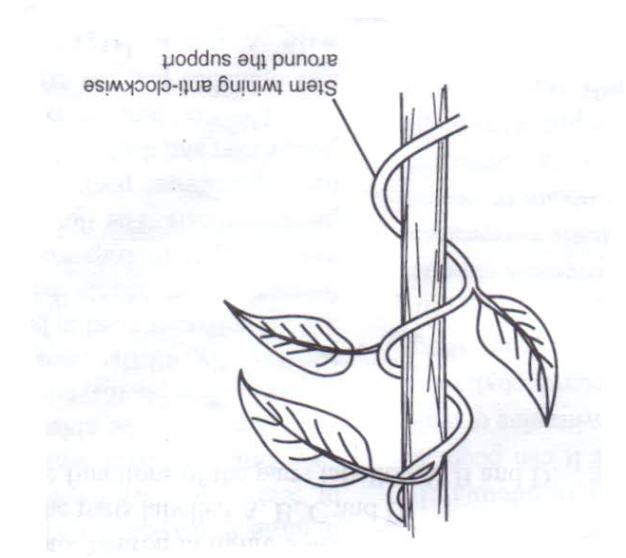
(a) What is the name of the response which causes such a twisted growth? (1 mark
……………………………………………………………………………………………………..
(b) Name the stimulus involved in the process. (1 mark)
………………………………………………………………………………………………………
(c) Explain how the process is occurs. (4 marks)
………………………………………………………………………………………………………………………………………………………………………………………………………………………………………………………………………………………………………………………………………………………………………………………………………………………………………………………………………………………………………………………………………………………………………………………………………………………………………………………………………………………………………………………………………………………………………………………………………………………………………………………………

(d) State the significance of the process above. (2 marks)
………………………………………………………………………………………………………………………………………………………………………………………………………………………………………………………………………………………………………………………………………………………………………………………………………………………………………………………………………………………………………………………………………
3. The diagram below illustrates an experiment to determine the rate of a certain process in a small insect.
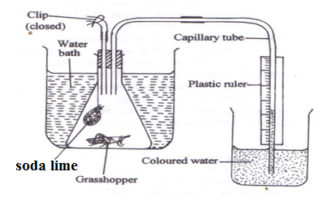

(a) State the changes observed after the experiment has run for five minutes. (1 mark)

………………………………………………………………………………………………………
(b) Account for the changes observed in (a) above. (4 marks)
………………………………………………………………………………………………………………………………………………………………………………………………………………………………………………………………………………………………………………………………………………………………………………………………………………………………………………………………………………………………………………………………………………………………………………………………………………………………………………
(c) Why is it necessary to place the flask in a water bath? (1 mark)
………………………………………………………………………………………………………………………………………………………………………………………………………………………………………………………………………………………………………………………
(d) Name the organelle involved in the process under investigation and the significance of this process. (2 marks)
………………………………………………………………………………………………………………………………………………………………………………………………………………………………………………………………………………………………………………………

4. Examine the drawings of the various organisms and the dichotomous key shown below.
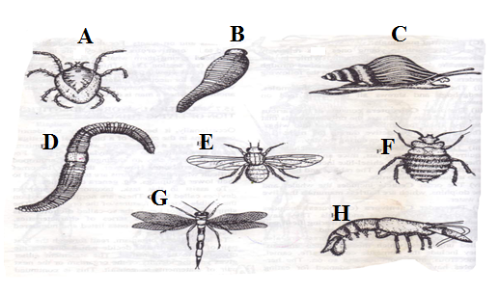
1. a Jointed legs present…………………...………….…….…………..……….…Go to 2
b Jointed legs absent………………….………………………….…..……..…...Go to 6
2. a Three pairs of legs………………………………...……………..……………Go to 3
b More than three pairs of legs………………………...………….....……..…..Go to 5
3. a Wings present…………………………………………...……….………....…Go to 4
b Wings absent…………………………………………….……….……….…..Bedbug
4. a Two pairs of wings……………………………………………….…………Dragonfly
b One pair of wings............................................................................................Housefly
5. a Antennae present…………………………………………………………...…Crayfish
b Antennae absent……………….……………………………………………...…...Mite
6. a Shell present………………………………………………………………………Snail
b Shell absent……………………………………………………………………..go to 7
7. a Prominent clitellum visible…………………………………………...….…Earthworm
b No clitellum visible…………………..…………………………………….……..Leech

Fill in the steps necessary for identification of the organisms.
Organism | Steps | Identity | Marks
A |  |  | 1 mark
B |  |  | 1 mark
C |  |  | 1 mark
D |  |  | 1 mark
E |  |  | 1 mark
F |  |  | 1 mark
G |  |  | 1 mark
H |  |  | 1 mark

5.The diagram below shows part of a longitudinal section of a young root.
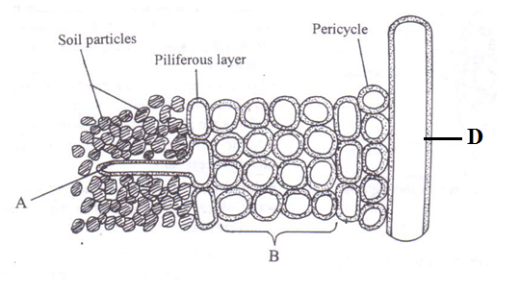
(a) Describe how the structure labeled A is structurally modified to perform its function. (4 marks)
............................................................................................................................................................................................................................................................................................................................................................................................................................................................................................................................................................................................................................................................................................................................................................................................................
(b) Explain how water molecules enter the structure labeled A. (2 marks)
………………………………………………………………………………………………………………………………………………………………………………………………………………………………………………………………………………………………………………………………………………………………………………………………………………………………........................................................................................................................................................................................................................................................................................................................
(c) State two forces that maintain a continuous column of water in the structure D. (2 marks)
………………………………………………………………………………………………………………………………………………………………………………………………………………………………………………………………………………………………………………………........................................................................................................................................................................................................................................................................................................................

SECTION B: 40 (MARKS)
Answer question 6 (Compulsory) and either question 7 or 8 in the spaces provided after question 8.
6. The graph below shows the effect of temperature on the rate of enzyme reaction
.
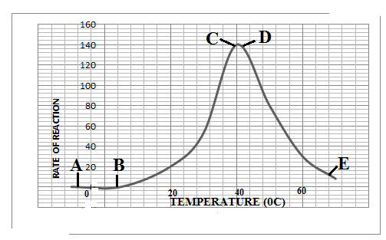
(a) Account for rate of reaction between:
(i) A to B. (3 marks)
………………………………………………………………………………………………………………………………………………………………………………………………………………………………………………………………………………………………………………………………………………………………………………………………………………………………
(ii) B to C. (4 marks)
………………………………………………………………………………………………………………………………………………………………………………………………………………………………………………………………………………………………………………………………………………………………………………………………………………………………

(iii) C to D. (3 marks)
………………………………………………………………………………………………………………………………………………………………………………………………………………………………………………………………………………………………………………………………………………………………………………………………………………………………………………………………………………………………………………………………………
(iv) D to E. (4 marks)
………………………………………………………………………………………………………………………………………………………………………………………………………………………………………………………………………………………………………………………………………………………………………………………………………………………………………………………………………………………………………………………………………
(v) Explain what would happen to a population of yeast cells exposed to boiling water with temperatures beyond 40⁰C. (3 marks)
………………………………………………………………………………………………………………………………………………………………………………………………………………………………………………………………………………………………………………………………………………………………………………………………………………………………………………………………………………………………………………………………………
(vi) Explain the following observations
(a) Digestion of starch stops in the stomach. (1 mark)
………………………………………………………………………………………………………………………………………………………………………………………………………………………………………………………………………………………………………………………
(b) Mercury stops enzyme reaction. (1 mark)
………………………………………………………………………………………………………………………………………………………………………………………………………………………………………………………………………………………………………………………
(c) Pepsin is produced in its inactive form. (1 mark)
………………………………………………………………………………………………………………………………………………………………………………………………………………………………………………………………………………………………………………………

7. (a) Explain how a person restores an upright posture when falling down . (8 marks)
(b) Discuss the factors necessary for germination of seeds. (12 marks)
8. (a) Describe the mechanism of gaseous exchange in a bony fish. (12 marks)
(b) Describe the photosynthetic theory of opening and closing the stomata. (8 marks)
………………………………………………………………………………………………………………………………………………………………………………………………………………………………………………………………………………………………………………………………………………………………………………………………………………………………………………………………………………………………………………………………………………………………………………………………………………………………………………………………………………………………………………………………………………………………………………………………………………………………………………………………………………………………………………………………………………………………………………………………………………………………………………………………………………………………………………………………………………………………………………………………………………………………………………………………………………………………………………………………………………………………………………………………………………………………………………………………………………………………………………………………………………………………………………………………………………………………………………………………………………………………………………………………………………………………………………………………………………………………………………………………………………………………………………………………………………………………………………………………………………………………………………………………………………………………………………………………………………………………………………………………………………………………………………………………………………………………………………………………………………………………………………………………………………………………………………………………………………………………………………………………………………………………………………………………………………………………………………………………………………………………………………………………………………………………………………………………………………………………………………………………………………………………………………………………………………………………………………………………………………………………
………………………………………………………………………………………………………………………………………………………………………………………………………………………………………………………………………………………………………………………………………………………………………………………………………………………………………………………………………………………………………………………………………………………………………………………………………………………………………………………………………………………………………………………………………………………………………………………………………………………………………………………………………………………………………………………………………………………………………………………………………………………………………………………………………………………………………………………………………………………………………………………………………………………………………………………………………………………………………………………………………………………………………………………………………………………………………………………………………………………………………………………………………………………………………………………………………………………………………………………………………………………………………………………………………………………………………………………………………………………………………………………………………………………………………………………………………………………………………………………………………………………………………………………………………………………………………………………………………………………………………………………………………………………………………………………………………………………………………………………………………………………………………………………………………………………………………………………………………………………………………………………………………………………………………………………………………………………………………………………………………………………………………………………………………………………………………………………………………………………………………………………………………………………………………………………………………………………………………………………………………………………………

