PAPER 3
BIOLOGY
PRACTICAL

QUESTION 2 PHOTOGRAPHS
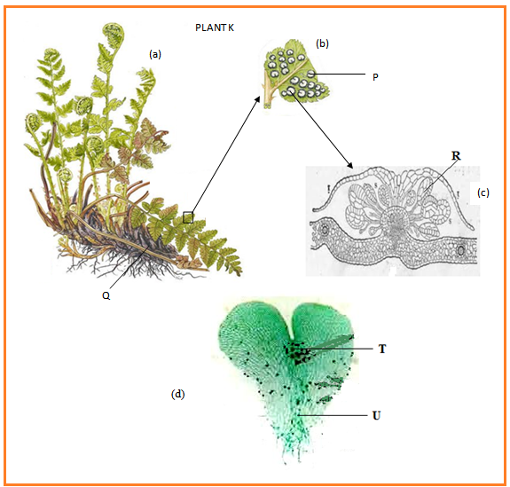

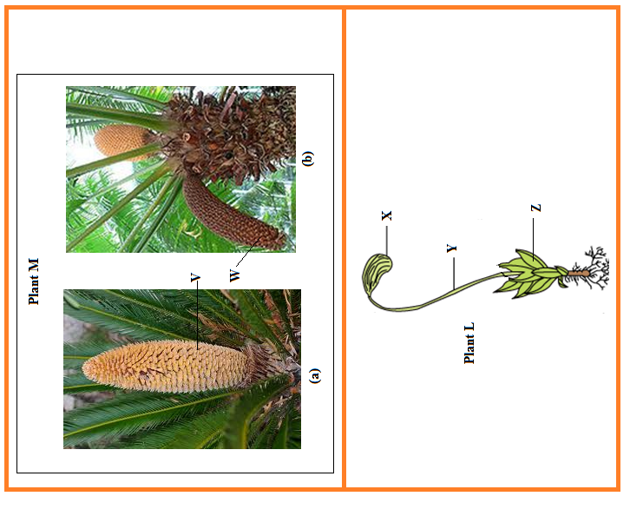

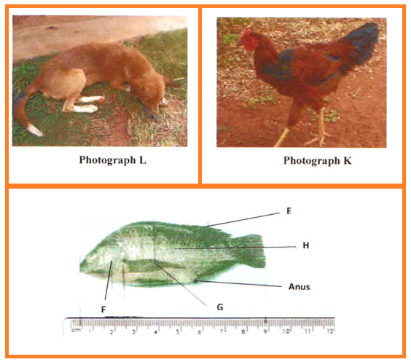
QUESTION 3 PHOTOGRAPHS

