MARKING SCHEME
BIOLOGY 231/2
PAPER II
JULY/AUGUST 2016
- (a) Detoxification;
(b) Liver;
(c) Prevents ammonia from accumulating to toxic levels;
(d) Urea;
(e) Excess amino acids are broken down/deaminated to form amino group; which is combined with
hydrogen atom to form ammonia;
(f) It is transported to the kidney; where it is excreted;
- (a) Increase in breathing rate;
(b) (i) Lower concentration of oxygen in high attitude area; raises the demand of oxygen by body cells;
(ii) Number of red blood cells has increased hence enough oxygen is reaching all body Cells adequately;
(c) Has a higher capacity of transporting oxygen to body cells; due to higher number of redblood cells in the body;
(d) (i) Muscle crumps;
Muscle fatigue
(ii) It is completely oxidized by oxygen into water, Carbon (IV) oxide and energy/is converted into glycogen for storage;
- (a) (i) A – Biceps
B – Triceps
(ii) A (Biceps) relaxes; as B (Triceps) contracts;
(b) Hinge joint;
(c) D – Olecranon process; E – Ulna, F - Radius.
- (a)
Genotype Rr X rr ;
Gametes R r r r

Offspring Rr Rr rr rr

(b) Incomplete;
(c) (i) Ribonucleic acid; Rej. RNA
(ii) Has uracil base
(iii) Three (3);
Reason – Has three codons.
- (a) X – Villus; Rej. Villi
Y – Lacteal
(b) X – Increase surface area for absorption;
Y – Absorption of fatty acids and glycerol;
(c) Digestion;
Absorption of end products of digestion;
(d) – Produce bile juice which contain bile salts for emulsification of fat/bile salts provide
alkaline medium suitable for enzymes present in pancreatic juice;
(e) Produce hormones insulin and glycogen;
Reject of one hormone is mentioned

- (a)
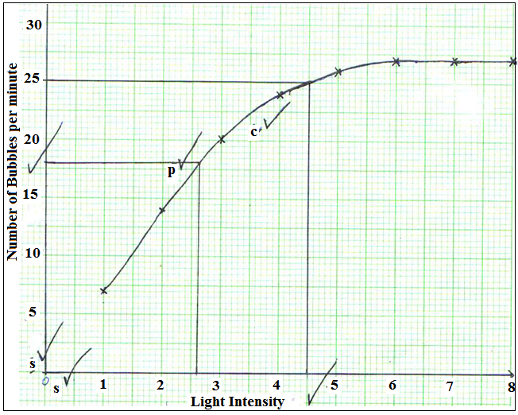

Labelling of axis – 2 each 1
Plotting – 1
Curve – 1
Scale – 2 each 1
Scale – Should have origin necessarily zero
(b) (i) 2.6 ± 0.1
(ii) 4.5± 0.1
(c) Volume of CO₂ consumed/volume of O₂ liberated;
- Change in dry mass
(d) Photolysis of water
ATP synthesis
(e) (i) 4⁰C – Rate of photosynthesis is very low; because enzymes are inactive;
(ii) 34⁰C –Rapid rate of photosynthesis; because of the optimum temperature for enzyme reaction.
(iii) 60⁰c_very low /no photosynthesis; because high temperatures denature enzymes;
(f) Carbon (IV) oxide concentration;
Water availability;
- (a) Has numerous alveoli; that provide large surface area for efficient gaseous exchange;
- Epithelial lining between alveoli wall and blood capillaries is thin; to provide a shorter diffusion distance for easy gaseous exchange;
- It is highly supplied with blood capillaries; that transport oxygen and carbon (IV) oxide to and from the body tissues respectively;
- Lungs are covered with pleural membrane; which is gas tight thus changes in pressure within the lungs can occur without external interference;
- Lungs is spongy & has numerous alveoli; that accumulate large volume of gases.
(b) Opening
- In the guard cells there are chloroplasts; which carry out photosynthesis in the presence of light;
- During the day glucose is produced in the guard cells; this increases osmotic pressure; compared to the neighbouring epidermal; water is drawn from the epidermal cell cells into the guard cells by osmosis; their turgidity increases;
- The inner walls of guards cells are thicker than the other wall; so outer walls stretch more than the inner walls causing guard cells to bulge outwards; causing stomata to open;
Closing
- During the night there is no light; no photosynthesis takes place in the guard cells; Glucose in the guard cells is converted into starch. This lowers the osmotic pressure of the guard cells than the neighbouring cells;
- Water is then drawn from the guard cells by osmosis into the epidermal cells making them to be flaccid
- Thinner outer wall shrink and the curvature of the thicker inner wall reduces; the stomata close;
- (a) Water dispersal
- Such seeds and fruits enclose air in them to lower their density for buoyancy;
- They have fibrous/spongy to lower the density for buoyancy;
- Have impermeable seed coat or epicarp to prevent water from entering during floatation so as to avoid rotting;
- The seeds can remain viable while in water and only germinate while on a suitable medium;
Wind dispersal
- They are light; and small; to be easily carried by wind currents due to lower density;
- Have developed extension which create a larger surface area; so as to be kept afloat in wind currents e.g. Parachute like structures, Wing like surface;
Animal dispersal
- Brightly coloured to attract animals
- Fleshy to attract animals;
- Some have hook like structures to attach on animals fur
Self-dispersal
- They have weak lines on the fruit wall along which they burst open to release seeds, which get scattered. This occurs when temperature changes suddenly.
(b) Inner and outer integuments develops into the seed testa.
- The ovary wall forms fruit wall
- The ovule develops into seed (s)
- The corolla dries and withers away.
- The calyx may persist or dries and wither away
- Stigma and style shrivels, dries and wither away.
- The androecium (male part) shrivels dries and withers away.
- Triploid nuclei develop into primary endosperm of the seed.
- The zygote formed develops into embryo.

