Name…………………………………………………………… Index No…………................

Candidates Signature................................

Date.....................................

**231/3**

**Biology**

**Practical**

**Paper 3**

**Time 1 ¾ hours**

# Form 4 evaluation examination, 2017

**231/3**

**Biology**

**Practical**

**Paper 3**

**Time 1 ¾ hours**

**INSTRUCTIONS TO CANDIDATES**

* *Write your name and index number in the spaces provided at the top of this page.*
* *Answer* ***all*** *questions.*
* *You are required to spend the first 15 minutes of the1 ¾ hours allowed for this paper reading the whole paper carefully before commencing your work.*
* *Answers must be written in the spaces provided in the question paper. Additional pages must not be inserted.*
* *Candidate may be penalized for recording irrelevant information and for incorrect spelling especially of technical terms*

**For Examiners Use Only**

|  |  |  |  |
| --- | --- | --- | --- |
| **Question** | | **Maximum Score** | **Candidate’s Score** |
| **1** | | **6** |  |
| **2** | | **18** |  |
| **3** | | **16** |  |
| **Total score** | **40** |  |



***This paper consists of 6 printed pages. Candidates should check the question paper to ensure that all pages are printed as indicated and no questions are missing*.**

1. The photographs below represent twigs from various plant species. Study them and answer the questions that follow

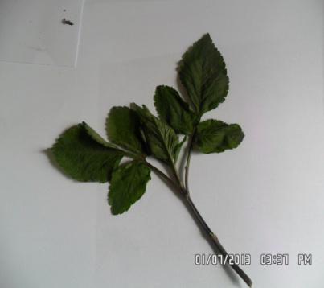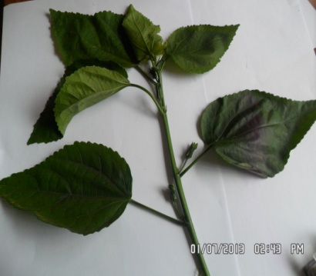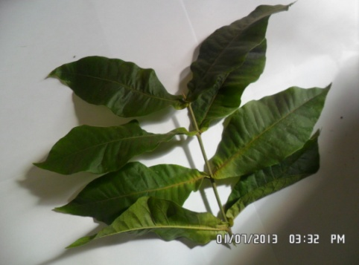

**P Q R**

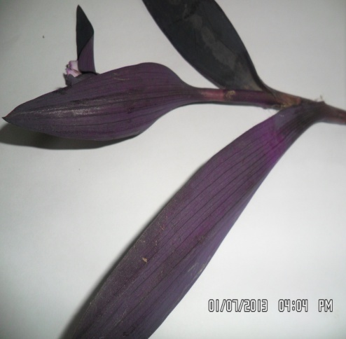 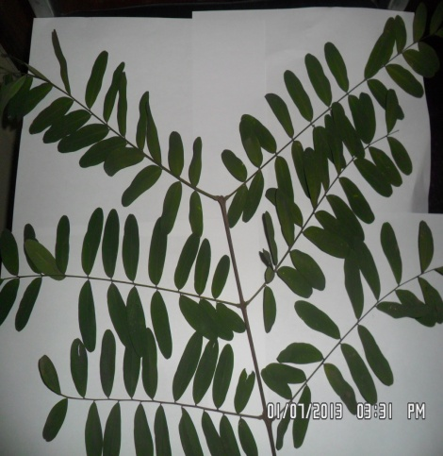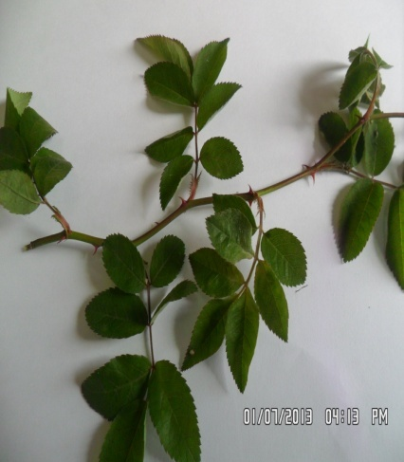

**S T U**

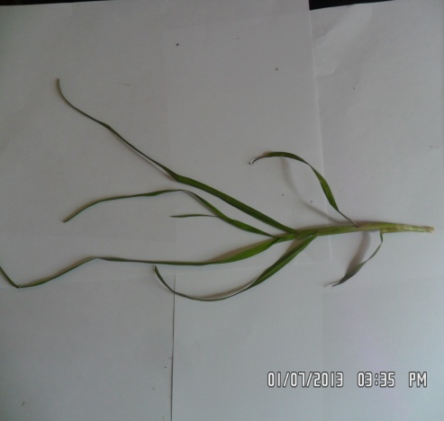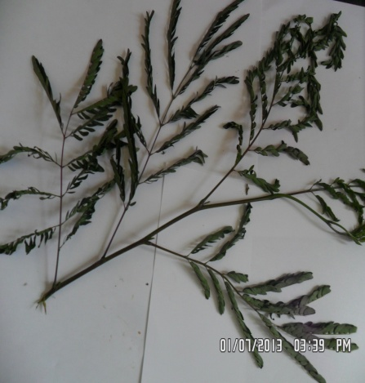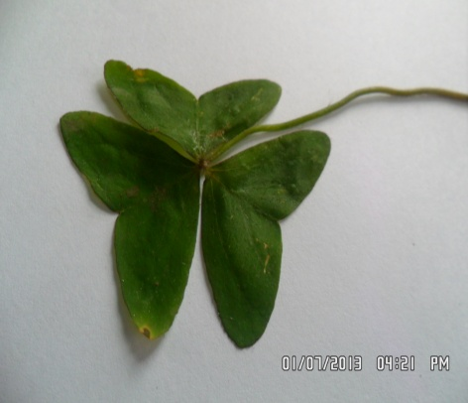

**V W X**

1. Complete the dichotomous key below using observable features

1(a) Twigs with simple leaves …………………………………………………..go to 2

(b) Twigs with compound leaves……………………………………………go to 5

2(a) Leaves with parallel venation…………………………………………..go to 3

(b) Leaves with network venation ………………………………………..go to 4

3(a) Purple leaves…………………………………………………………………..Tradescantia

(b) Green leaves…………………………………………………………………..Kikuyu grass

4(a) Leaves with opposite arrangement………………………………… Verbenaceae

(b)Leaves with alternate arrangement …………………………………Hibiscus

5(a) Leaves trifoliate…………………………………………………………......go to 6

(b)…………………………………………………………………………………………go to 7

6(a) Leaves with serrated margin……………………………………………*Bidens bilosa*

(b) Leaves with lobed margin……………………………………………….Oxalis

7(a) Pinnate leaves………………………………………………………………..go to 8

(b)………………………………………………………………………………………..Acacia

8(a) Leaflets with rounded apex……………………………………………Papilionaceae

(b) Leaflets with pointed apex……………………………………………..Rose

(2mks)

1. Using the completed dichotomous key identify the twigs and show the steps followed (4mks)

Identity steps followed

**P**…………………………………………….. …………………………………………………

**Q**……………………………………… …………………………………………

**T**……………………………………….

**U**………………………………………..

1. You are provided with specimen labeled **E**, examine specimen **E**
2. Giving reasons, identify the type of the fruit? (2mks)

………………………………………………………………………………………………………………………………………………………………………………………………………………………………………………………………………………………………………………

1. Cut a transverse section through **specimen** **E**, make a well labeled diagram (4mks)
2. State the type of placentation of **E** (1mk)

………………………………………………………………………………………………………………………………………………..

1. i) Name the agent of dispersal for **E** (1mk)

…………………………………………………………………………………………………………………………………………………

ii) State how **E** is adapted to its mode of dispersal (2mks)

……………………………………………………………………………………………………………………………………………………………………………………………………………………………………………………………………………………………………………………………………………………………………………………………………………………………………………………..

1. Squeeze out the juice from **specimen E** into test tubes and fill in the table below (6mks)

|  |  |  |  |
| --- | --- | --- | --- |
| **Food test** | **Procedure** | **Observation** | **Conclusion** |
| Ascorbic acid |  |  |  |
| Reducing sugars |  |  |  |
| Protein |  |  |  |

1. i) Suggest the expected result if the juice of **E** was boiled for 10 minutes, cooled then **DCPIP**

Solution added drop by drop (1mk)

………………………………………………………………………………………………………………………………………………

ii) Explain your answer in f(i) above (1mk)

……………………………………………………………………………………………………………………………………………………………………………………………………………………………………………………………………………………………………

1. Study the kidney diagrams below

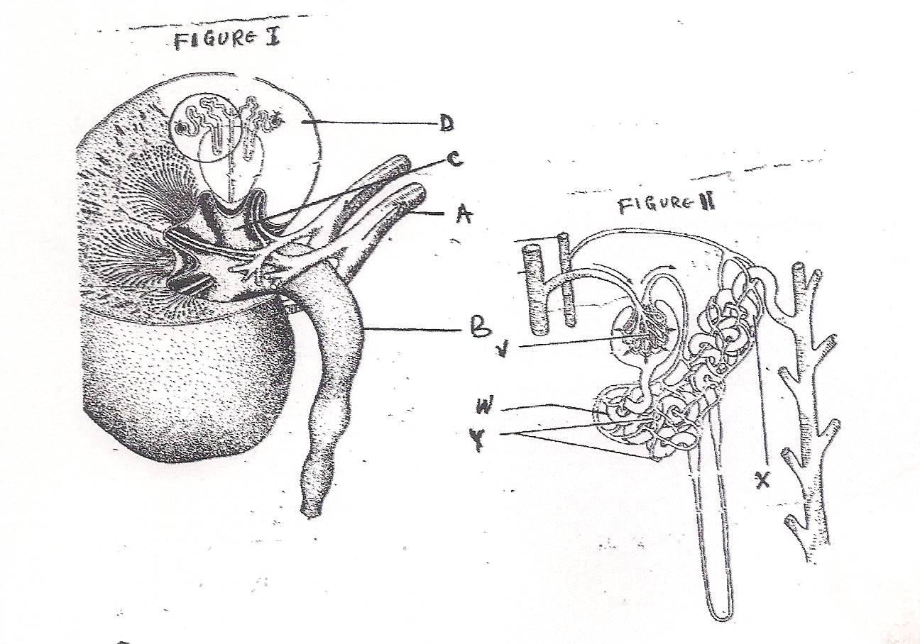

1. i) Name the parts labeled **A**, **B**, **C** and **D** in figure 1 (4mks)

**A**………………………………………………………………………………………..

**B**………………………………………………………………………………………..

**C**………………………………………………………………………………………..

**D**……………………………………………………………………………………….

ii) Name the processes that take place in the parts labeled (2mks)

**V**……………………………………………………………………………………..

**X**………………………………………………………………………………………

1. State three adaptations of the part labeled **W** (3mks)

……………………………………………………………………………………………………………………………………………………………………………………………………………………………………………………………………………………………………………………………………………………………………………………………………………………………………………………..

1. On the diagram name the part where counter current flow occurs (1mk)

…………………………………………………………………………………………………………………………………………………

1. State two homeostatic functions of the diagram above (2mks)

……………………………………………………………………………………………………………………………………………………………………………………………………………………………………………………………………………………………………

1. Explain what will happen to the process of urine formation in absence of vasopressin hormone. (4mks)

………………………………………………………………………………………………………………………………………………………………………………………………………………………………………………………………………………………………………………………………………………………………………………………………………………………………………………………………………………………………………………………………………………………………………………………………………..