**PHYSICS 232/2**

**JULY/AUGUST 2016**

**MARKING SCHEME**

1.The object is repelled

2. Cells in B has a low effective internal resistance √

This is so because the cells are arranged in parallel√ 2mks

*Object at point of intersection of produced rays*

*11cm ±0.5*

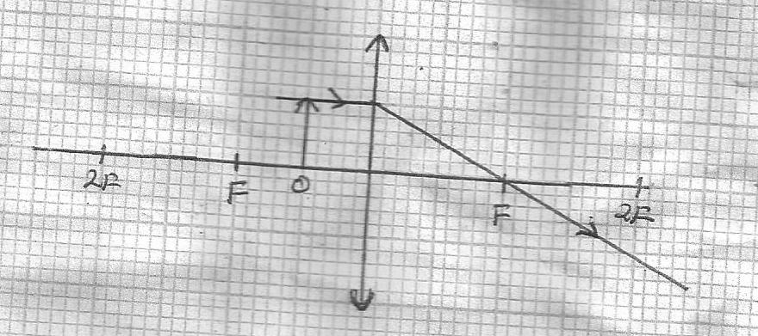3.

(b) Used in magnifying glasses/microscope obtain erect, virtual and magnified image

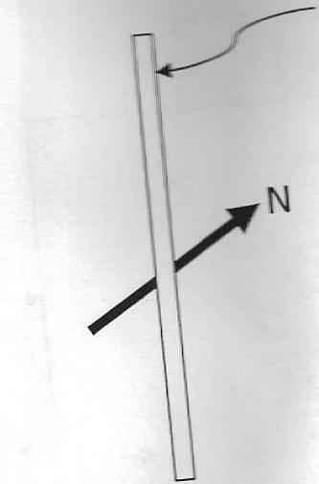4(a)

**Conductor**

√1

(b) Soft magnetic is easily magnetized and demagnetized while a hard magnetic material is difficult to magnetize and demagnetize√1

5.(a) The spreading out of waves past an apparture or barrier√1

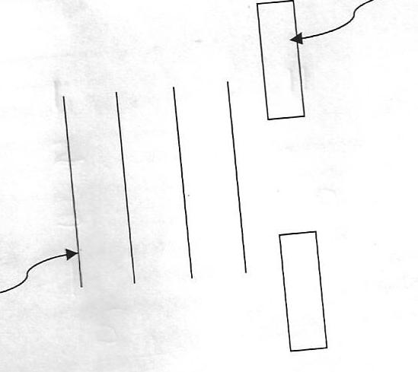(b)

**Barrier**

**Wave front**

***Straight wave fronts-1mk***

***Spreading out (enlarging of wave fronts -1mk***

6. Observation-: No sound /reduced volume √1

Explanation:- steam drives out air and later condenses creating a partial vacuum i.e sound requires a medium for preparation√1

7. (a) P=V2 = 2202√ =60.5w√

R 800

(b) I=P = 600√

V 220

=0.7563A

=1A

8. (i) Ultra violet, infared, micro waves short radio waves, FM waves√

(ii) Used in ……m

For ccoking in ovens (…..cooler)

9.

|  |  |  |  |  |  |  |
| --- | --- | --- | --- | --- | --- | --- |
|  |  |  |  |  | **1cm** | **1cm** |
|  |  |  |  |  |  |  |
|  |  |  |  |  |  | *Peak voltage -1mk*  *Correct period -1mk* |
|  |  |  |  |  |  |  |
|  |  |  |  |  |  |  |
|  |  |  |  |  |  |  |
|  |  |  |  |  |  |  |

10. £=

11.(a) (i) Light moving from C a lower medium to a higher medium

Angle of medium in dense medium to be ……from the critical angle

(ii)



(b)(i) Long sight

(ii) Using converging lens to shortly converge he rays from a near object on the retina

(iii)

**O**

**I**

**√**

**√**

(c) Eye lens is variable, camera is fixed

Cameras with zoom lens have variable image ….which to eyes is …

By forms constantly ……picture, camera ……….photograph at a time

12. (a)Amount of current passing when a charge of one contains flows in one second

(b)(i) Real dioxide √1

(ii) Hydrometer ids immersed in to sulphuric acid solution to measure the speed the gravity of to cell

(iii) solution –occur which impedes recharging

©

(i)  3mks

(ii) Total current = 

Current 3Ω= 2/5 x1.818=0.7272A

13.(a) A charging magnetic flux √in the primary coil induces e.m.f in the secondary coil√

(b)Rate of change of magnetic flux√2

Number of turns in the secondary coil√

(c)(i) A-primary coil √

B- Capacitor –for minimizing of sparking

1. When switch is closed the core is magnetized hence pulls the armature thereby opening the contact(i.e opening the circuit) √1
2. Current dies off at a very fast rate hence including large e.m.f in the secondary coil, resulting in sparking at the gap

(d) Secondary power=VI=12x 120=1440w

Primary power = 100 x 1440=1800w

80

∴1800=240I√

Ip= 1800 = 7.5A√

240

14(a) A semiconductor that contains impurities to boost its electrical conductivity

(b) (i) half -…

(ii) During first half cycle, diode is found blood√, current flows in the second half cycle, diode is blazed no current flow. The cycle is …process repels itself

(iii)-Output cycle is not smooth√

-Power loss at the half-cycle is eliminated√

(iv)

**Voltage**

**Time in (s)**

15. (a)(i) The minimum energy required to dislodge an electron from a metal surface√1

(b) (i) UV light dislodges electrons but they are attracted back by thee highly positive zinc √place (hence no electron loss)

Given that KMmax=hf-Ǿ, determine the values

(I) Constant h√



(II) Constant Ǿ=

Ǿ=hfo

√

16. Background radiation√

From cosmic rays etc √2

4t

3t

2t

t

(b) 32g 16g 8g 4g 2g

Amount of B=32-2√=30g√

Or

N= No( ½ ) I/t

=32( ½ ) 124/31

=32x 1/16

=2g√

B=32-2=30g√

(c)(i) Copper is a good conductor of heat hence discipation heat away fast √1 heat away fast √1

(ii) By increasing the accelerating voltage

1. Kt=RV

t=1.6x10-19 x 1000000√

=1.6x10-13 Joules √