NAME………………………………………………….INDEX NO…………………………
CANDIDATES’ SIGNATURE………………………
DATE……………………………….

232/3
Physics
Paper 3
JULY August 2016
Time: 2 hours 30 min

PRE KCSE 2016
Kenya certificate of secondary Education ( K.C.S.E)
Physics
Practical

INSTRUCTIONS TO CANDIDATES
- Write your name and index in the spaces provided above.
- Answer all the questions in the spaces provided in the question paper
- You are supposed to spend the first 15 minutes of the 2¹/₂ hours allowed for this paper reading the whole paper carefully before commencing your work.
- Marks are give for a clear record of the observations actually made, their suitability, accuracy and the use made of them
- Candidates are advised to record their observations as soon as they are made.
Question 1
For examiners use only
M | a | d | e | g | A (ix) | (iii) | (iv) | Total
Maximum score | 1 | 6 | 5 | 1 | 1 | 1 | 3 | 20
Candidates score
Question 2
 | a | e | F(i) | (ii) | a | B(i) (ii) (iii) |  |  | Total

- PART A
You are provided with the following apparatus
- Concave mirror and a holder
- Meter rule
- Candle ( about 7cm)
- White screen
- Determine the focal length of the mirror by focusing a distant object
f = ……………………………………………………………………………………(1mk)
- Arrange the apparatus as shown in figure 1 below
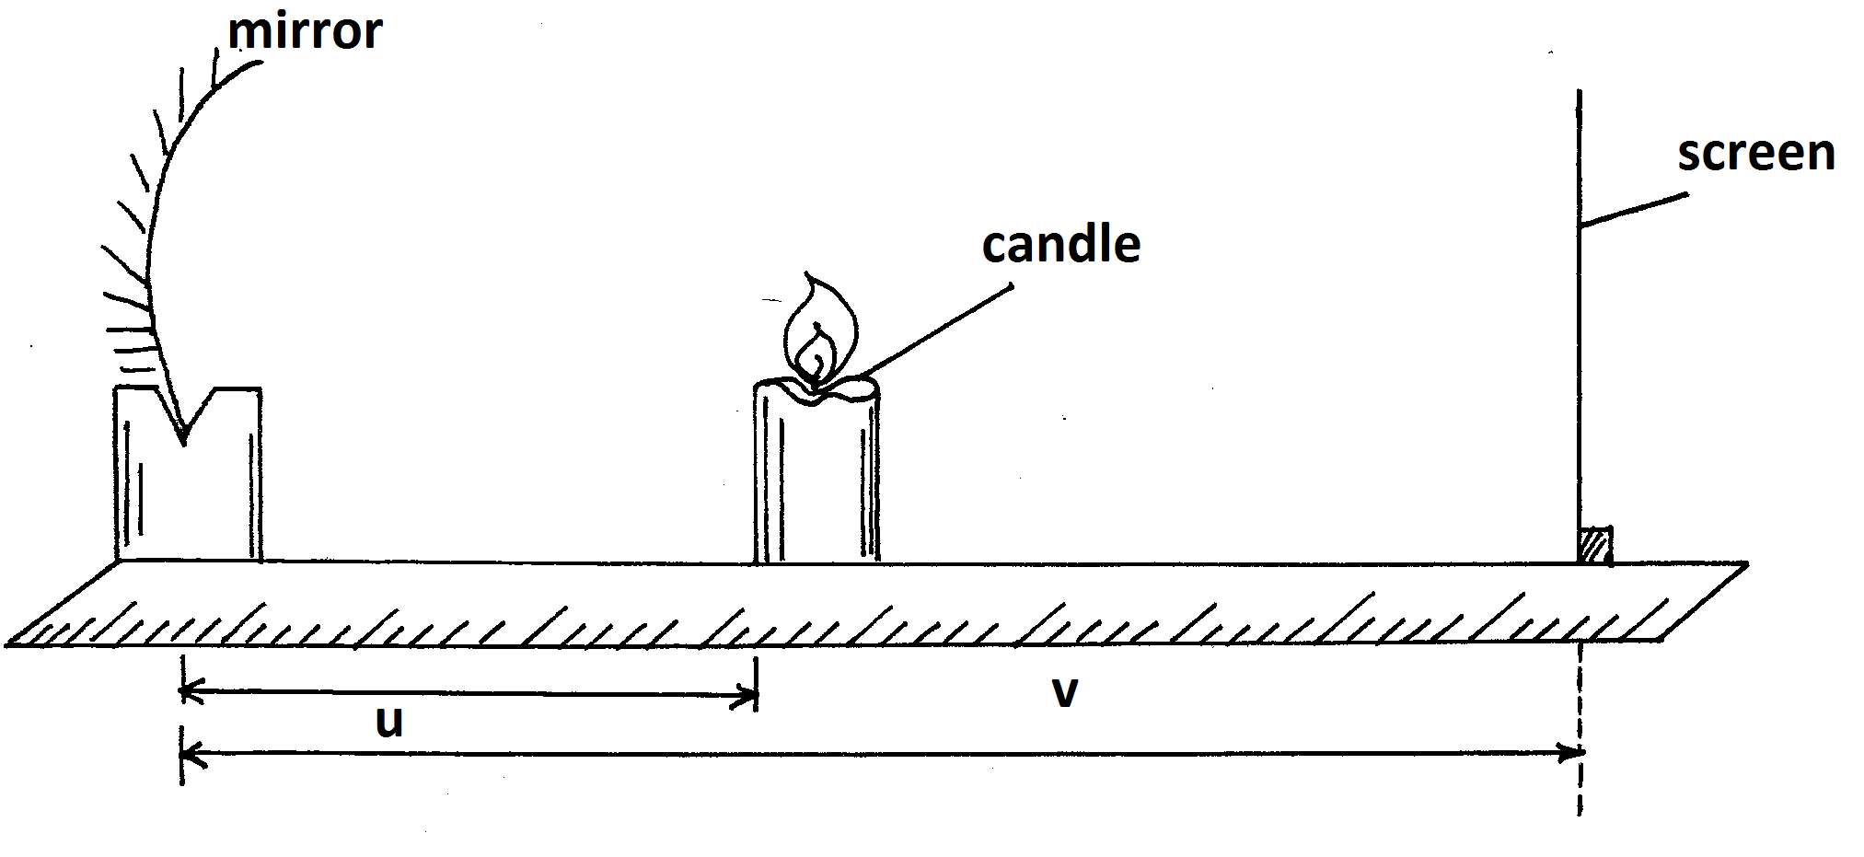
- Place the candle at a distance u =22cm from the mirror. Move the screen along the meter rule until a sharp image is formed on the screen. Measure and record the image distance V.
- Repeat the experiments for other values of u and record your result in table 1 below..

Object distance u(cm) | 22 | 24 | 26 | 28 | 30 | 32 | 34
Image distance V ( cm)
Magnification (v/u)

( 6mks)

- Plot a graph of magnification , m(y-axis)against image distance v ( 5mks)
- Given that m = ^{v}/_{f}-1. Determine the focal length, f.
(3mks)
Part B
You are provided with the following apparatus
- A voltmeter 0-3 or 0-5v
- An ammeter ( 0-1A)
- 10Ω resister ( fixed)
- A switch
- One dry cell and a cell holder
- Six connecting wires
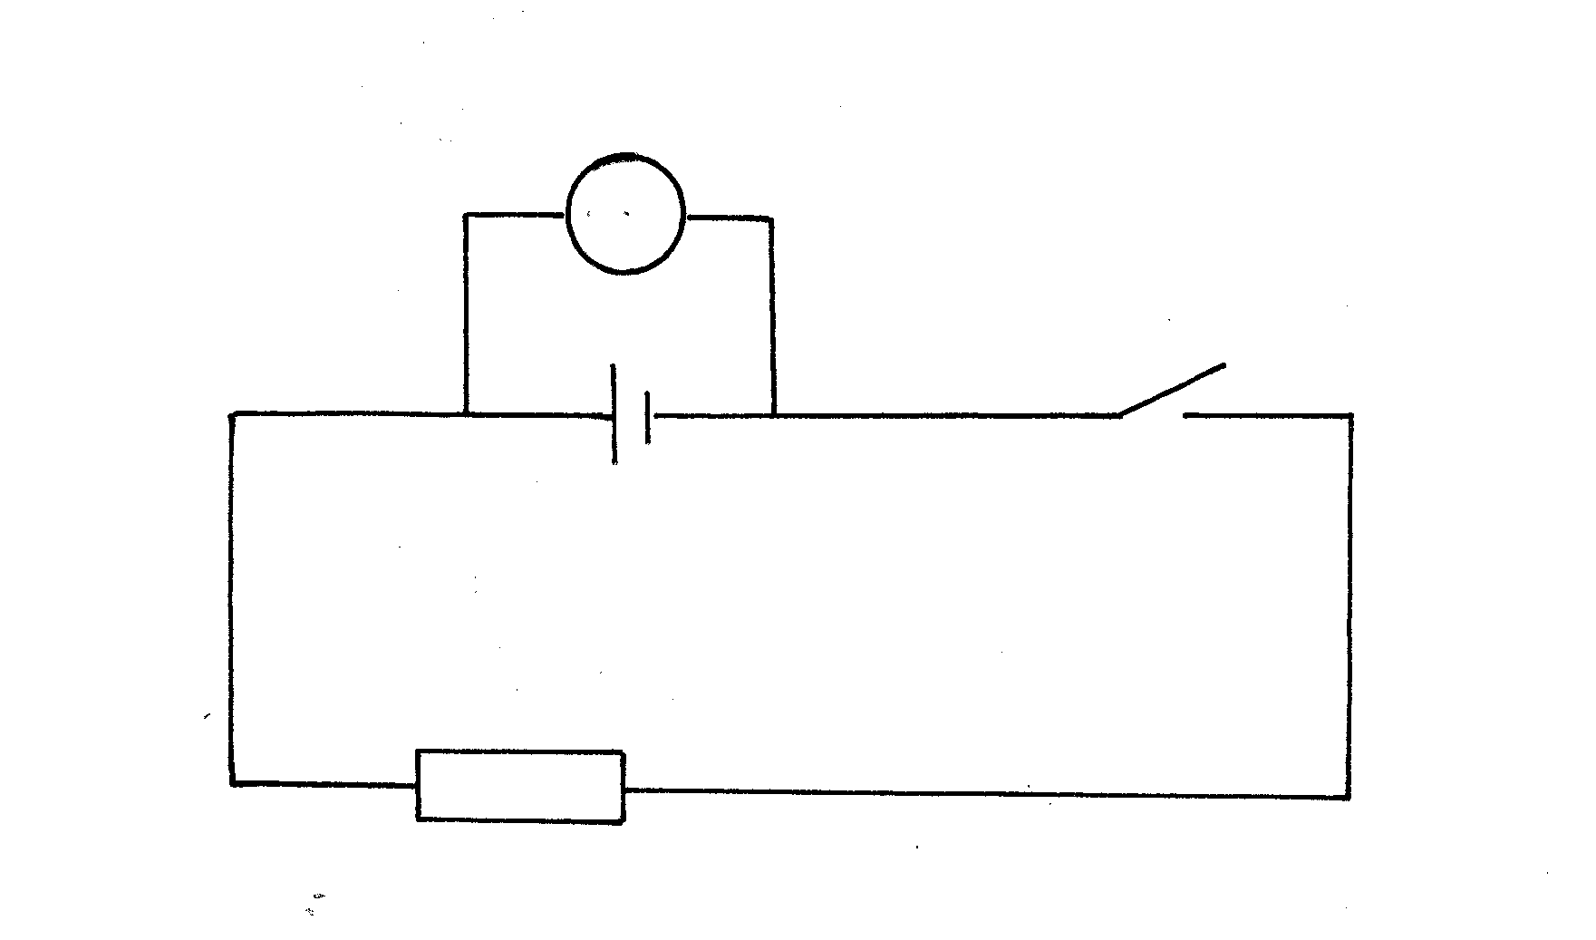
- (i) Connect the above apparatus as shown in the circuit diagram below with the switch s open.
V

S
A
10Ω

Figure 2
ii) With the switch S open, record E the voltmeter reading (1 mk)
E = ……………………………………………………………………………………….
iii) Close the switch and record V, the voltmeter reading and I the ammeter reading
v = (1mk) ………………………………………………………………………………………..
I =…………………………………………………………………………………………
iv) Given that E –V = Ir, Find r the fro the dry cell. ( 2mks)

Queston 2
Part A
You are provided with the folowng
- A triangular prism
- A piece of soft board
- Four ( 4) optical pins
- A sheet of plain paper
- Thumb pins
Proceed as follows:
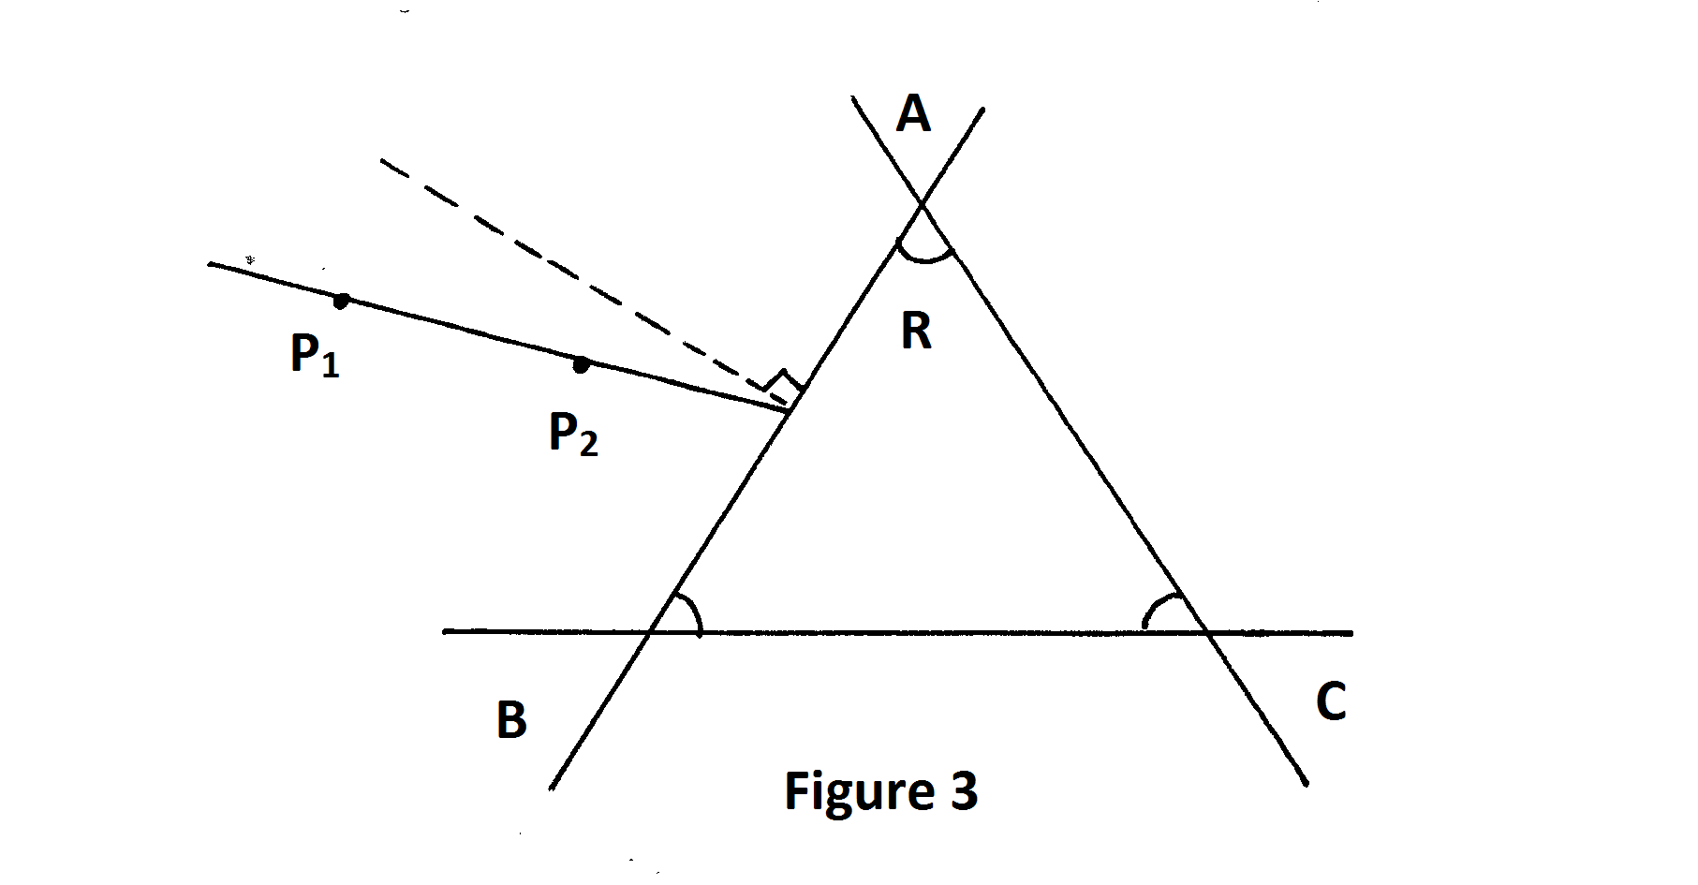
- Place the plain sheet of paper on the soft board . Trace the triangular outline of the prism on the sheet of paper. Remove the prism and use a ruler to extend the three sides of the outline

Use a protractor to measure the refracting angle R of the prism.
R =…………………………………………………………………………………………( 1mk)
- On the side AB of the triangular prism outline,. Draw a normal at a point half-way between A and B. ( This normal will be used for the rest of the experiment).
- Draw a line at an angle i-30⁰ to the normal. Stick two pins P₁ and P₂ vertically on this line. See figure 3 above.
- Place the prism accurately on the outline. By viewing through the prism from side AC. Stick two other pins P₃ and P₄ vertically such that they are in line with the images of pins P₁ and P₂
Remove the prism and the pins. Draw a line joining marks made by P₃ and P4 . Extending this line to meet AC. See figure 4 below.
Measure and record in tale 2 below the value of angle o

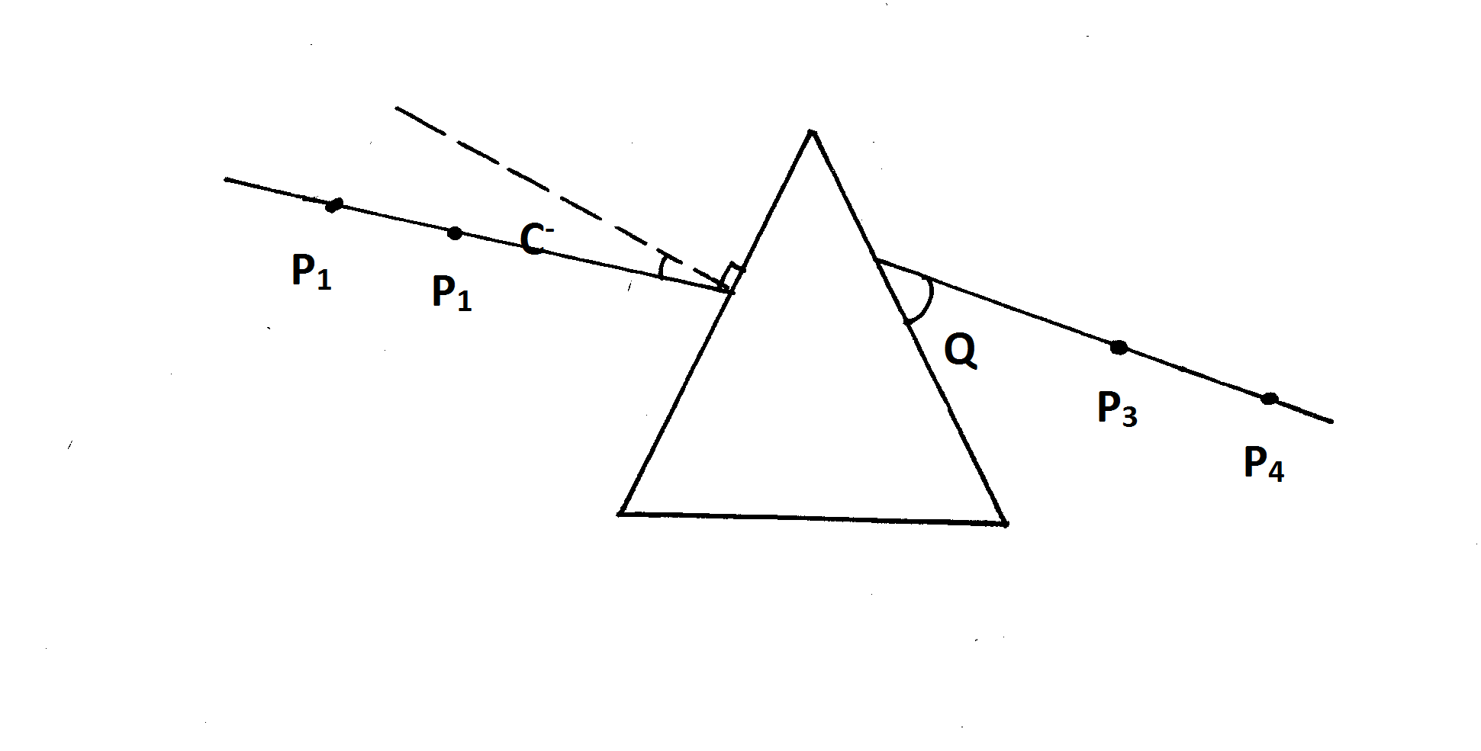

Figure 4.

- Repeat the procedures in © and (d) above for other values of I shown in table 2. Complete the table.
Table 2

Angle of incidence i(degree)
Angle ø ( degree
Angle f emergence
E =90- ø(deg)

( 6mks)
F) On the grid provided plot the graph of the angle of the emergency E(yaxis) against the
Angle of incidence i
(5mks)
ii) Use the graph to find i(the angle of incidence at which i=E) ( 1mk)
( The teacher to collect the plane papers used for this experiment showing how the
øis got.).
PART B
You are provided with the following
- Meter rule
- Report stand, clamp and boss
- 500ml beaker ¾ full of water
- 100g mas
- 50g mass
- Three pieces of thread
Proceed as follows
- Balance the meter rule horizontally by suspending it from the stand and clap with one of the threads . Record the balance point G.
G =…………………………………………………….(cm) ( 1mk)
- 9i) Suspend the 100g mass from the meter rule at a point x such that x = 10cm from pont G. With l00g mass completely immersed in water in the beaker, hang the 50 g mass from the meter rule and adjust its position until the system is in equilibrium as shown in the diagram below.
Note the point of suspensuion P of the mass ( 50g)
P =……………………………………………………………. ( 1mk)

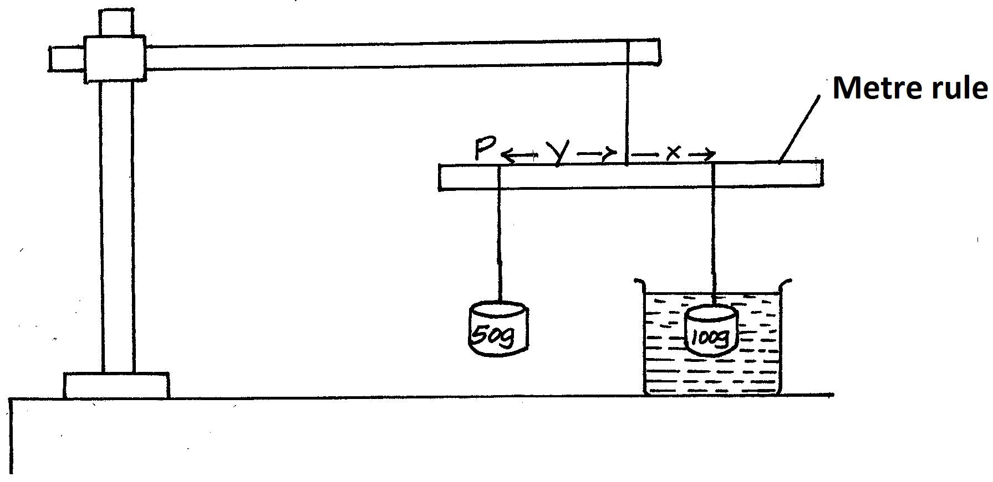

ii) Find the value of Y.
Y……………………………………………………………………………………..(1mk)
(iii) Using the information above, calculate the up thrust on the 100g mass if the density of water is 1000kg/m³. (3mks)

