Ms p2

SECTIONtiotion A (25 MARKS)
Answer all the questions in the spaces provided
1. Differentiate between a vector and a scalar quantity (1mark)
----------------vector---------------------------------scalar--------------------------------------
Has b both mag and dir Has only magnitude

2. The figure below shows a circuit consisting of a battery of 2 of cells ,a 1.5Afuse F, a switch S and two identical lamps L₁ and L₂. A current of 1.5A flows through lamp L₂ when the switch is open.
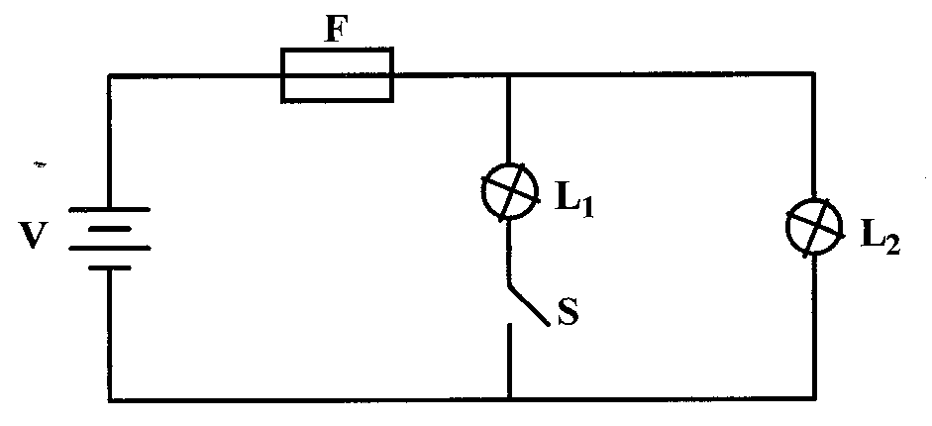

Explain why the fuse may blow when the switch,L₁ is closed..
- reduced effective resistance ;
- INCREASED CURRENT ;
3. When a highly negatively charged rod is brought near the cap of a positively charged leaf electroscope, the leaf first falls and then rises .. Explain this observation. (2marks)
- neutralization takes place ;
- then , induction of + charge;
4. The figure below shows two plane mirrors inclined at an angle of 40⁰ to one another. A ray of
light strikes the bottom mirror at an angle of 50⁰ to the horizontal as shown on the diagram.
40⁰
50⁰

L1
A1

(2 marks)
- A charge of 90 coulombs flows through a circuit for one minute. Determine the amount of current
that flows through the circuit. (3marks)

I = Q/t
= 90/60
= 1.5 A
- State two methods of charging an electroscope. (2marks)
- INDUCTION
- CONTACT
- The figure below shows two bar magnets placed close to each other.

N
S

N
S

Sketch the magnetic field pattern around the two magnets. (2 marks)
- An electric heater is rated 5000W, 250V. Determine its resistance. (3marks)
R= V²/P ;
= 250²/5000 ;
= 12.5 Ω ;

- The figure below shows the magnetic field pattern round a current-carrying conductor. Indicate
on the conductor the direction of the current . (1mark)

Direction ;
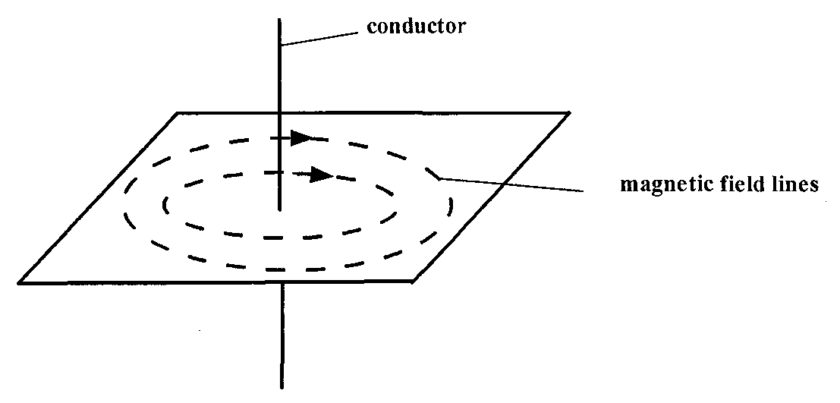
- Explain how polarization of a cell increases the cell’s internal resistance. (2mks)
- Bubbles insulate the electrode ;
- Insulation increases internal ;
- Figure below shows a ray of light incident on an air bubble which is inside water,

Complete the ray to show the path it follows through the air bubble. (1mk)

- A battery is rated 40Ah. Determine the time in hours it would work steadily supplying a current
of 2A.
P = It ;
40 = 2(t) ;
t = 20 hours ;
- The figure below is that of a dry cell. Name parts labeled A and B

A

B A= CARBON ROD/GRAPHITE ;
B = AMMONIUM CHLORIDE PASTE ;

SECTIION B (55MARKS)
Answer all the questions in the spaces provided
- a) Define frequency . (1mark)
Number of oscillations made per given time ;
b) The figure below represents a displacement time graph wave.

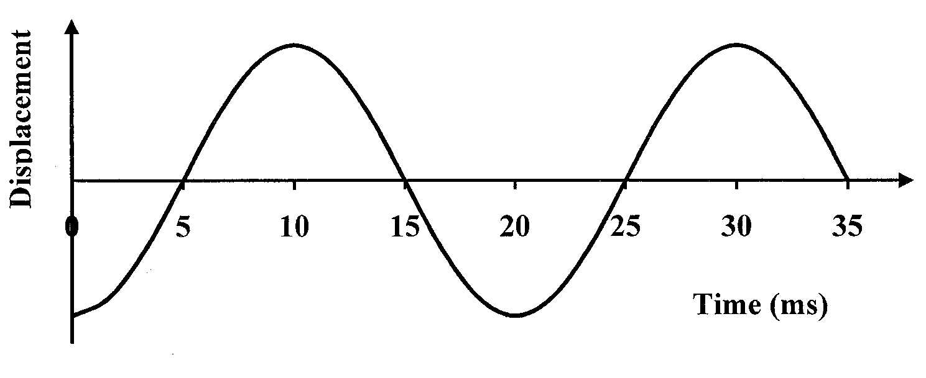 At least one oscillation , one mark.

- On the graph draw a line marking the amplitude of the wave . (1mark)
- Determine the period of the wave. ( 1mark)
T = 20 S ;
- Calculate the frequency of the wave. (3marks)
F = 1/T ;
= 1/20x10⁻³ ;
= 50 Hz ;

(iii) Given that the wavelength of the wave is 0.2m, find the speed of the wave. (3marks)
V = F٨
= 50X0.2 ; ;
= 10m/s ;
c) On the same axes in (b) above, sketch another wave with double the frequency and half the
amplitude. (2marks)

- a) State Ohm's law. (1 mark)
The current through a conductor is directly proportional to the pd across the conductor
provided the temperature and other conditions remain constant.

b) Differentiate between Pd and EMF . (2marks)

Pd | EMF
Voltage across cell when supplying current ; | Voltage across cell when not supplying current ;

The figure shows a graph drawn from data obtained in an experiment to verify Ohm's law.

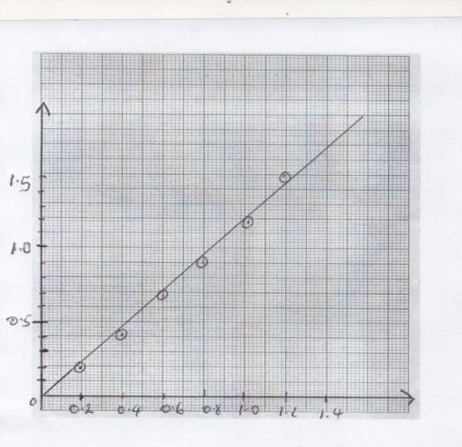
Voltage(v)

Current(A)

c) Draw an electric circuit diagram that can be used to verify Ohm's law . (1mark)

A

V

d) Use the graph to determine the resistance of the conductor used in the circuit . (3 marks)

R = $∆V/∆I$ ;

= 1.3/1.1;

= 1.18 Ω ; (± 0.15 )

e) The figure below shows resistors connected in a circuit diagram.

7ΩΩ
1Ω
3 Ω
6Ω

10V

    - Calculate the effective resistance in the circuit . (2 marks)

R_{P =} 2Ω ;
R_{T} = 2+7+1 ;
R_{T} = 10Ω ;

    - Determine the current through the 6Ω resistor. ( 3marks)
I_{T} = 1A ;
V = IR ;
V =2V ;

- a) Define capacitance of a capacitor (1mk)
Charge per unit volt ;

b)In fig below, a sharp pin is fixed on a cap of a leaf of the electroscope. The electroscope is
highly charged and then left for sometime.
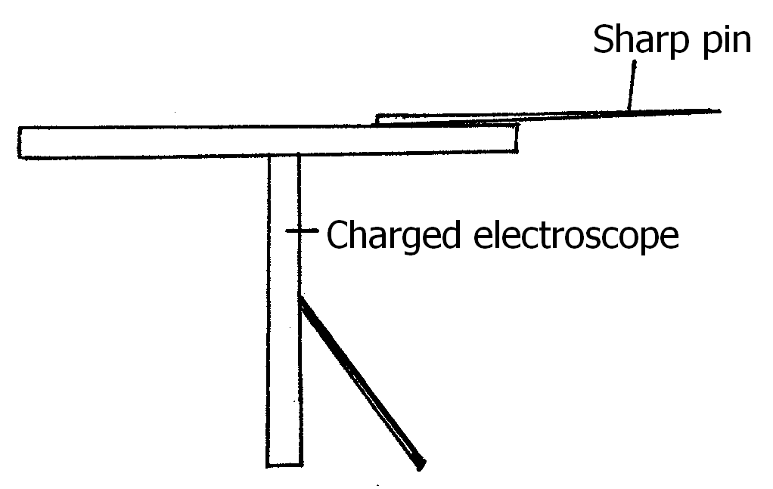

State and explain the observation made after sometime. (3marks)
- leaf falls ;
- sharp pin ionizes air ;
- discharging takes PLACE ;
c)Figure below shows a circuit where a battery of e.m.f. 4.5 V, switches A and B, two
capacitors C₁ = 0.6F and C₂ = 1.0 F and a voltmeter are connected.
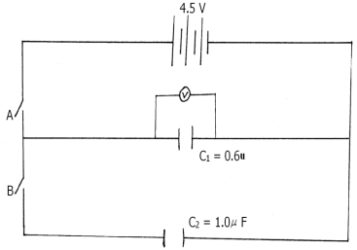

- Determine the charge on C₁ when switch A is closed and switch B is open.(2marks) Q = CV ;
Q = 0.6x10⁻⁶ x 4.5 ;
Q = 2.7x10⁻⁶C ;
ii) State and explain what is observed on the voltmeter when switch A is closed and switch B is
open. (2marks)
- Voltage rises gradually and then stops ;
- capacitor charges until it is fully charged at 4.5 V ;

d) The Figure bellow shows a pair of parallel plates of capacitors connected to a battery. The upper plate
is displaced slightly to the left.

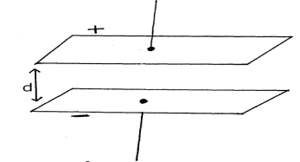

Suggest two adjustments that can be made to so as to reduce the effective capacitance.(2marks)
- Move upper plate further to the left ;
- Increase distance d ;

- (a) State two differences between light and sound waves (2mark)

Light | sound
Are transverse | Are longitudinal ;
Travel through vacuum | Don’t travel through vacuum ;

(b) A boy standing in front of a cliff blows a whistle and hears the echo after 0.5s. He then moves
7 meters away from the cliff and blows the whistle again. He now hears the echo after 0.6s.
Determine the speed of the sound in air. (3 marks)
V = S/t ;
V = 34/0.1 ;
V = 340m/s ;
( c) Thunder is heard long after lightning has been seen. Explain. (2marks)
Light travels faster than sound ;;

(d) State 2 factors that affect the speed of sound in a material. (2marks)
- Temperature ;
- density ;
- a) State Snell’s law (1mark)
The ratio of sine i to sine r is constant ;
(b)A coin is placed beneath a transparent block of thickness 10cm and refractive index
1.56 .Calculate the vertical displacement of the coin. (3marks)
n = real depth/apparent depth
1.56 = 10/A.D
A.D = 6.41 cm
(c)The speed of green light in a prism is 1.94×10⁸m/s
(i)Determine the refractive index of the Prism material (speed of light in air = 3 x 10⁸ m/s). (3marks)
n = C/V ;
n = 3x10⁸/1.94x10^{8 ;}
n = 1.55 ;
(ii) Determine the critical angle of the prism material (3marks)
Sin C = 1/Sin n
Sin C = 0.6452
C = 40.2⁰
(e) The refractive indices of glass and water are 3/2 and 4/3 respectively. Find the value of angle Ф in
the figure below. (3marks)

42

Ф

n₁sinФ₁ ₌ n₂SinФ₂ ;
8/9sin42 = sin Ф_{2 ;}
Ф₂ = 36.5⁰ ;

