**Name…………………………………………………………Index No…………………………….**

**Candidates Signature.........................................**

**Date.......................................................**

232/1

**PHYSICS PAPER 1**

**(Theory)**

2 Hours

**Kenya Certificate of Secondary Education 2017**

**Form four evaluation examination**

232/1

**PHYSICS PAPER 1**

**(Theory)**

2 Hours

***INSTRUCTIONS TO CANDIDATES***

1. *Write your name and index number in the space provided at the top of this page.*
2. *This paper has two section* ***A*** *and section* ***B****.*
3. *Answer all the questions in the two sections.*
4. *Working of numerical questions must be clearly shown.*
5. *Marks may be given for correct working even if the answer is wrong*
6. *Mathematical tables or scientific calculators may be used.*

**FOR OFFICIAL USE ONLY**

|  |  |  |  |
| --- | --- | --- | --- |
| **SECTION** | **QUESTION** | **MAX SCORE** | **STUDENT’S SCORE** |
| **A** | 1 – 13 | 25 |  |
| **B** | 14 | 11 |  |
| 15 | 11 |  |
| 16 | 11 |  |
| 17 | 12 |  |
| 18 | 10 |  |
| **GRAND TOTAL** | | **80** |  |



*This paper consists of 13 printed pages*

***SECTION A ( 25 MARKS)***

*Attempt all the questions in this section in the spaces provided*

1. Give the reading ,*L*,on the micrometer screw gauge if it has negative zero error of 0.02mm

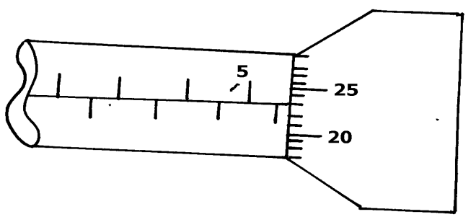

*L* ……………………………………………………………………………… (2 marks)

1. Define force (1 mark)

…………………………………………………………………………………………………

1. The figure below shows a uniform metre rule in equilibrium under the forces shown.

400g

100cm

40cm

20cm

200g

Frictionless pulley

Determine the weight of the metre rule

………………………………………………………………………………………………

……………………………………………………………………………………………….

………………………………………………………………………………………………

………………………………………………………………………………………………

1. Define momentum

……………………………………………………………………………………………..

1. Explain why a needle can be carefully made to float in pure water but sinks when a detergent is added. (2 marks)

………………………………………………………………………………………………

………………………………………………………………………………………………

1. State **two** factors that affect the boiling point of water. (2 marks)

……………………………………………………………………………………………………

1. The figure below shows a system of pulleys.

Effort=200N

load = 300N

Determine the mechanical advantage of the system. (1mark)

………………………………………………………………………………………………

1. Water of density 1200kg/m3 has a mass of 8400g. Determine the volume of the water in SI units giving your answer in standard form. (3marks)

………………………………………………………………………………………………

………………………………………………………………………………………………

………………………………………………………………………………………………

1. Passengers in a double deck bus are advised not to stand . Explain (2 marks)

………………………………………………………………………………………………

………………………………………………………………………………………………..

1. Give the first equation of linear motion . (1mark)

…………………………………………………………………………………………………..

1. The figure below shows a velocity –time graph of a ball bouncing vertically upward from

the ground. The upward velocity is taken positive.

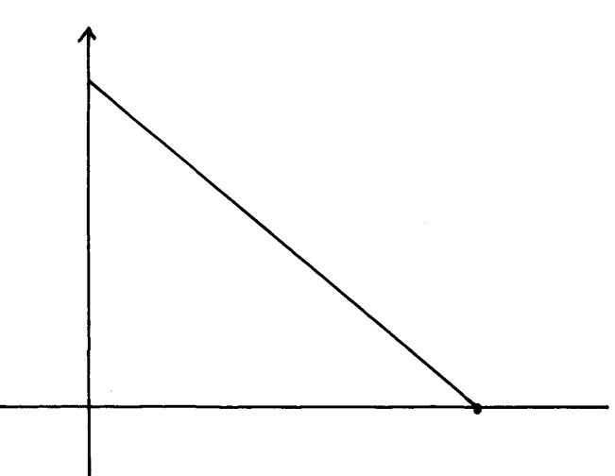

Velocity

(m/s)

1.6

Time(s)

Determine the maximum height the ball rises from the ground. (3 marks)

……………………………………………………………………………………………...

………………………………………………………………………………………………

………………………………………………………………………………………………

………………………………………………………………………………………………

1. An elephant weighs 5000kg. Determine the pressure it exerts on the ground if its area of contact with the ground is 0.00025m3. (3 marks)

…………………………………………………………………………………………………..

…………………………………………………………………………………………………..

………………………………………………………………………………………………….

1. State Hooke’s law. (1 mark)

……………………………………………………………………………………………………

……………………………………………………………………………………………………

***SECTION B (55 MARKS***)

Attempt all the questions in this section in the spaces provided

1. a) Define matter . (1mark)

…………………………………………………………………………………………………….

…………………………………………………………………………………………………….

b) Smoke particles in air when strongly illuminated were observed to describe continuous, random

haphazard movements.State and explain what would be observed when the air temperature is

decreased. (2 marks)

…………………………………………………………………………………………………….

……………………………………………………………………………………………………

c) The figure below shows an arrangement to demonstrate diffusion through solids:-

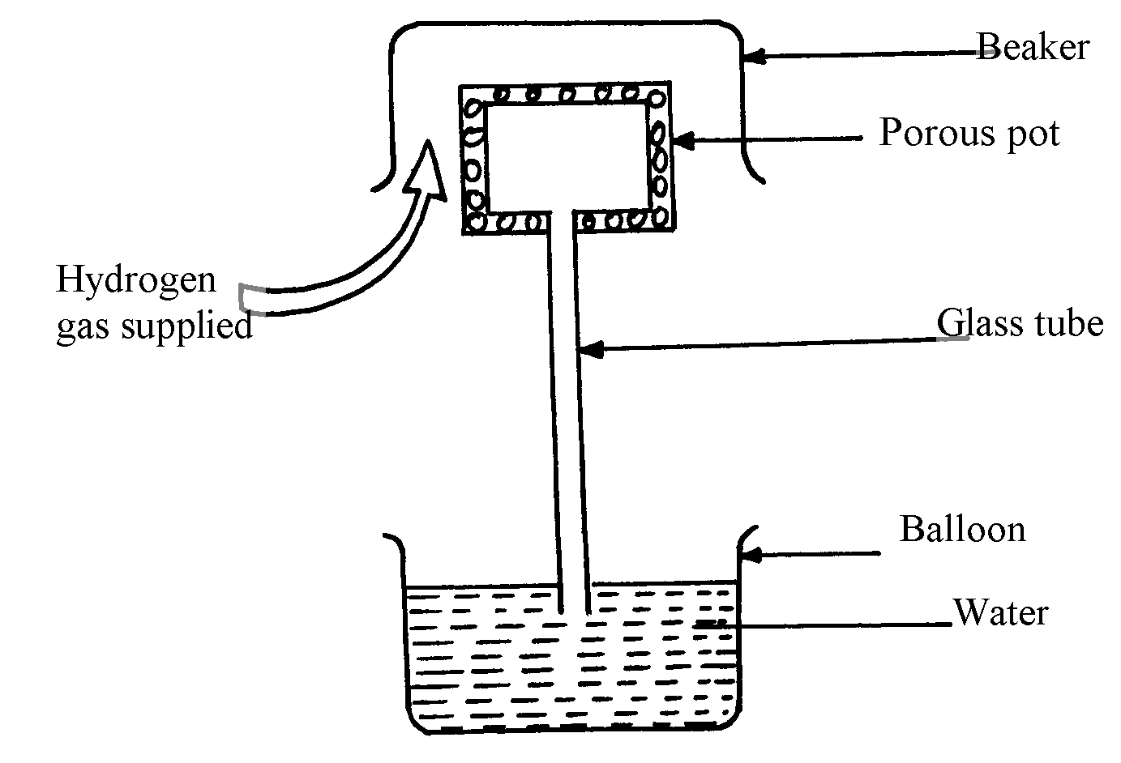

Beaker

The hydrogen gas is supplied for sometimes then stopped. State and explain what is likely

to be observed when the hydrogen gas supply is;

1. turned on (2 marks)

…………………………………………………………………………………………………..

…………………………………………………………………………………………………

1. turned off . (2 marks)

………………………………………………………………………………………………

…………………………………………………………………………………………………

d) ) An oil drop of average diameter 0.21mm spreads out into a circular patch of diameter 84cm on

the surface of water in a ripple tank.

(i) Determine the thickness of one molecule of oil . (3 marks)

………………………………………………………………………………………………

…………………………………………………………………………………………………

………………………………………………………………………………………………..

(ii) State *one* assumptions made in (i) above. (1 mark)

………………………………………………………………………………………………….

1. a) State the pressure law. ( 1mark)

………………………………………………………………………………………………………..

…………………………………………………………………………………………………………

1. The figure below shows a simple set up for pressure law apparatus.

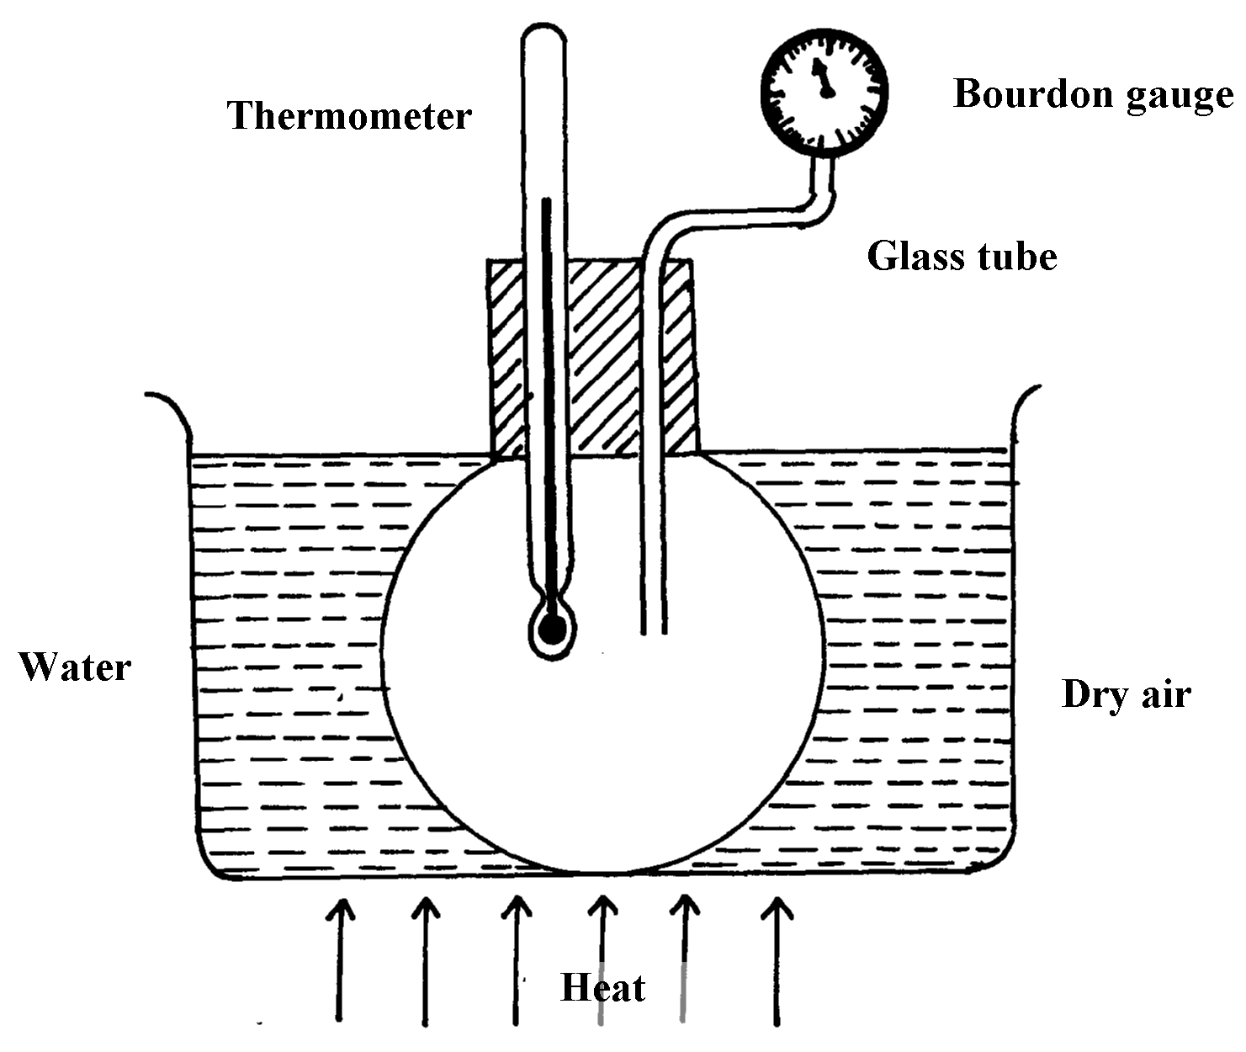

i) Briefly describe how the apparatus may be used to verify pressure law . (4 marks)

………………………………………………………………………………………………..

………………………………………………………………………………………………...

………………………………………………………………………………………………..

………………………………………………………………………………………………

ii) The graph in the figure below shows the relationship between the pressure and temperature

for a fixed mass of an ideal gas at constant volume

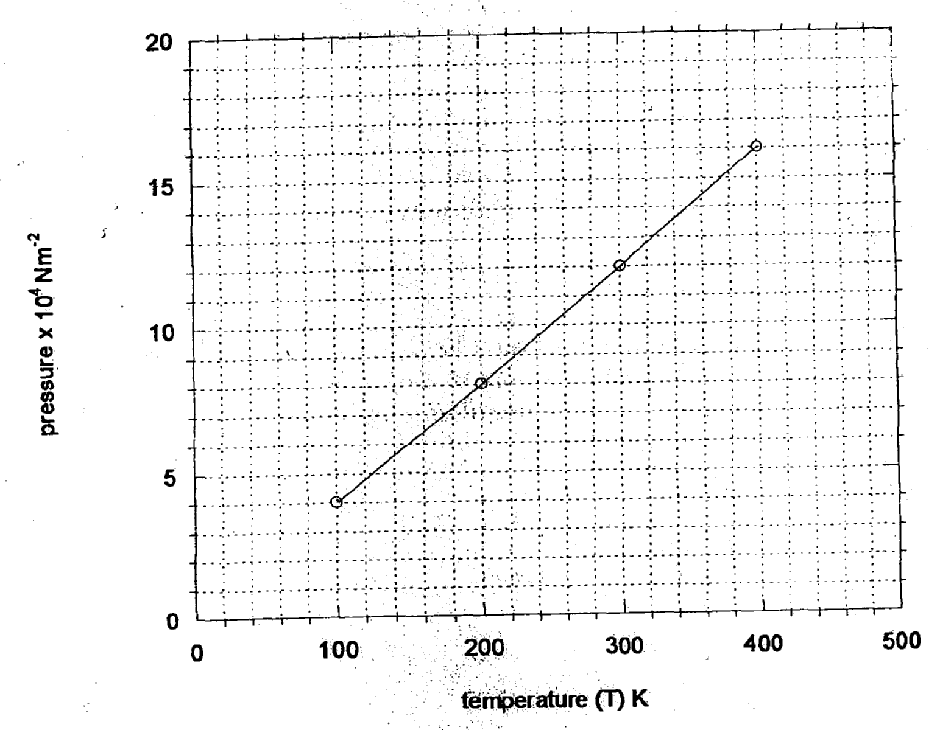

Given that the relationship between pressure, **P** and temperature, **T** in Kelvin is of the form

***P = MT + N*** determine :

1. The value of *M*. (2 marks)

………………………………………………………………………………………………….

…………………………………………………………………………………………………

…………………………………………………………………………………………………

II) The value of *N*. (1 mark)

………………………………………………………………………………………………….

…………………………………………………………………………………………………

c) A gas is put into a container of fixed volume at a pressure of 1.75 x 105 Nm-2 and

temperature 22°C. The gas is then heated to a temperature of 487°C. Determine the

new pressure. (3 marks)

…………………………………………………………………………………………………….

……………………………………………………………………………………………………...

……………………………………………………………………………………………………...

1. a) Define relative density . (1 mark)

………………………………………………………………………………………………………

……………………………………………………………………………………………………….

b) In an experiment to determine the density of sand using a density bottle, the following

measurements were recorded.

Mass of empty density bottle = 54.5g

Mass of density bottle full of water = 77.7g

Mass of density bottle with some sand = 78.8g

Mass of bottle f illed up with water and sand = 93.6g

Use the above information to determine the;

(i) Mass of the water that completely fill the bottle (2mks)

……………………………………………………………………………………………………..

……………………………………………………………………………………………………..

(ii) Volume of water that completely filled the bottle (1mk)

……………………………………………………………………………………………………..

……………………………………………………………………………………………………..

(iii) Volume of the density bottle (1mk)

……………………………………………………………………………………………………..

…………………………………………………………………………………………………….

(iv) Mass of sand (1mk)

……………………………………………………………………………………………………..

……………………………………………………………………………………………………..

(v) Mass of water that filled the space above the sand (1mk)

……………………………………………………………………………………………………..

……………………………………………………………………………………………………..

(vi) Volume of the sand (2mks)

……………………………………………………………………………………………………..

……………………………………………………………………………………………………..

(vii) Density of the sand (2mks)

……………………………………………………………………………………………………..

……………………………………………………………………………………………………..

1. a) State the principle of transmission of pressure. (1mark)

……………………………………………………………………………………………………….

……………………………………………………………………………………………………….

……………………………………………………………………………………………………….

b) The figure below demonstrates the principle of hydraulic jack.

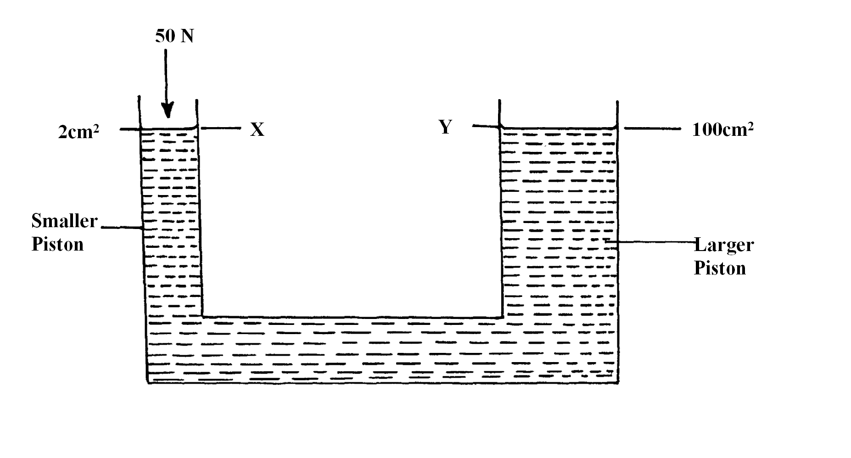

i)A force of 50N is applied on the smaller piston X. Calculate the pressure at Y. (3marks)

……………………………………………………………………………………………………….

……………………………………………………………………………………………………….

………………………………………………………………………………………………………

ii) Show that the velocity ratio is given by V.R = **(2** ( 2marks)

……………………………………………………………………………………………………….

……………………………………………………………………………………………………….

………………………………………………………………………………………………………

……………………………………………………………………………………………………..

iii)Hence calculate the velocity ratio of the hydraulic jack. ( 2marks)

……………………………………………………………………………………………………….

……………………………………………………………………………………………………….

……………………………………………………………………………………………………….

1. (i) Define the term machine. (1 mark)

…………………………………………………………………………………………………….

……………………………………………………………………………………………………..

The figure below shows a set-up used to find the mechanical advantage of a pulley system.

Use the figure to answer questions (i) and (ii) below.

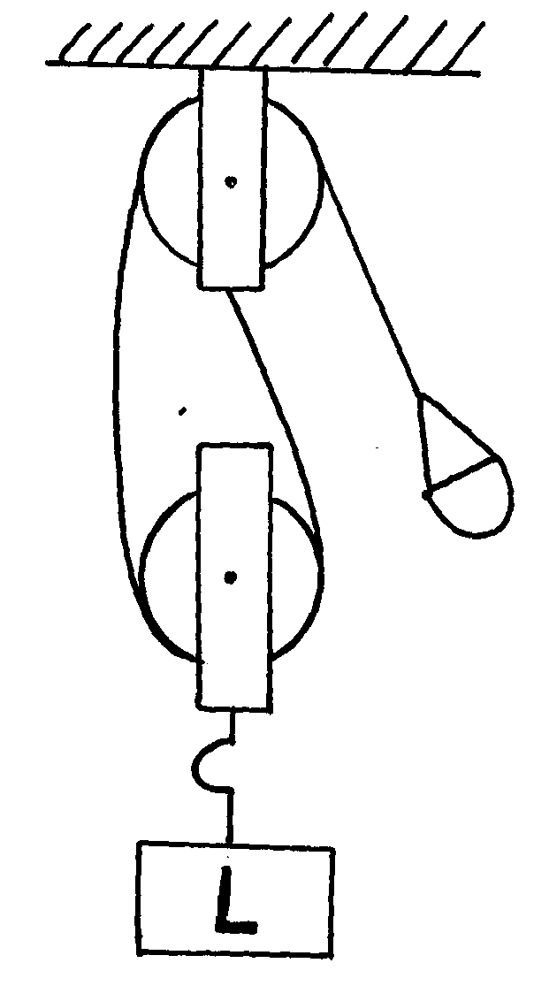

E

ii) Determine the VR of the pulley system. (1 mark)

…………………………………………………………………………………………………….

……………………………………………………………………………………………………..

iii) On the axes provided sketch a graph of mechanical advantage (M.A) against load (L). (2 marks)

***Mechanical Advantage***

***Load (N)***

0

1

2

3

1. (a)Explain why water is a good coolant liquid in a car’s engine cooling system. (2marks)

……………………………………………………………………………………………………..

……………………………………………………………………………………………………..

……………………………………………………………………………………………………..

(b) Water of mass 5kg initially at 180C is heated in an electric kettle rated 2.5kw. The

water is heated until it boils at 980C. Taking specific heat capacity of water to be 4200Jkg-1 K-1,

heat capacity of kettle = 438J/kg, specific latent heat of vaporization of water = 2.28MJ/kg

calculate;

(i)The heat absorbed by the water. (2marks)

……………………………………………………………………………………………………..

……………………………………………………………………………………………………..

…………………………………………………………………………………………………….

(ii)Heat absorbed by the electric kettle. (2marks)

……………………………………………………………………………………………………..

……………………………………………………………………………………………………..

……………………………………………………………………………………………………..

(iii)The time taken for the water to boil. (2marks)

……………………………………………………………………………………………………..

……………………………………………………………………………………………………..

……………………………………………………………………………………………………..

(iv)How much longer it will take to boil away all the water into vapour. (2marks)

……………………………………………………………………………………………………..

……………………………………………………………………………………………………..

………………………………………………………………………………………………...........

***THIS IS THE LAST PRINTED PAGE***