MARKING SCHEME

PHYSICS PRACTICAL
PAPER 3
2 ½ Hours

You are provided with the following;
- A pendulum bob
- Two pieces of wood
- A retort stand
- A boss
- A clamp
- A ctop watch
- A metre rule/or half metre rule
- A piece of thread
Proceed as follows;
a) Suspend a pendulum bob on a retort stand as shown below.
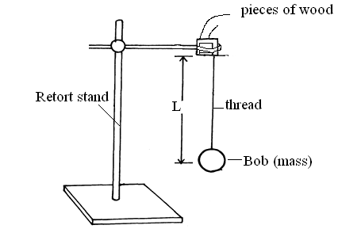

b) Displace the bob for a small angle. As it is oscillating time ten oscillations for every length of the string shown in the table below (9 marks)
3
2
1
2
1
Length, l(m) | 0.4 | 0.6 | 0.8 | 1.0 | 1.2 | 1.4
Time ,t, for 10 oscillations(s) | 13.00 | 15.20 | 18.11 | 20.01 | 22.00 | 24.14
Periodic time, T(s) | 1.100 | 1.520 | 1.811 | 2.001 | 2.200 | 2.414
F=$1/{T }$(Hz) | 0.9091 | 0.6579 | 0.5522 | 0.4998 | 0.4545 | 0.4143
F²(Hz²) | 0.8265 | 0.4328 | 0.3049 | 0.2498 | 0.2066 | 0.1716
$1/L$(m⁻¹) | 2.500 | 1.667 | 1.250 | 1.000 | 0.8333 | 0.7143

C) Plot a graph of F² against 1/L. (5 marks)

A1
S1
P2
L1

F² (Hz²)

1/L (m⁻¹)

d) Determine the slope ,S, of the graph. (3 marks)
Change in F² ; = 0.25 ;
Change in 1/L
= 4.0 x 10⁻¹ ;
1.6
e) Given that the relationship between F and L is given by , F² = $\frac{g}{4π²L}$ ,use the graph to determine the value of g giving its units . ( 3marks)
s= g/4π² ;
g= 4 x π² x 0.2486 ;
= 9.814m/s² ;

QUESTION 2
PART A
You are provided with the following apparatus:
- A voltmeter (0 – 3 V)
- An ammeter (0 – 1A)
- A 10Ω carbon resistor
- A switch.
- One dry cell and a cell holder
- Six connecting wires ( 4 with crocodile clips)

(a) (i) Connect the above apparatus as shown in the circuit diagram below with
the switch open.
A
10Ω

V

- With the switch open record E. the voltmeter reading.

E = ………………1.6 V ;……………………………….(1 mark)
- Close the switch and record V, the voltmeter reading and I, the ammeter
reading.
V = ………………1.4 V……………………………….(1 mark)
I = …………………0.08 A………………………………(1 mark)
- Given that E = Ir + V , determine r. (1mark)

r = 2.5 Ω (±0.1)

PART B
b) You are provided with the following:
- A complete retort stand
- An optical pin
- A concave mirror and a mirror holder
- A cork
- A candle
- A white screen
- A metre rule
You are required to estimate the focal length of the concave mirror. Arrange the apparatus as shown in the figure below:
Eye

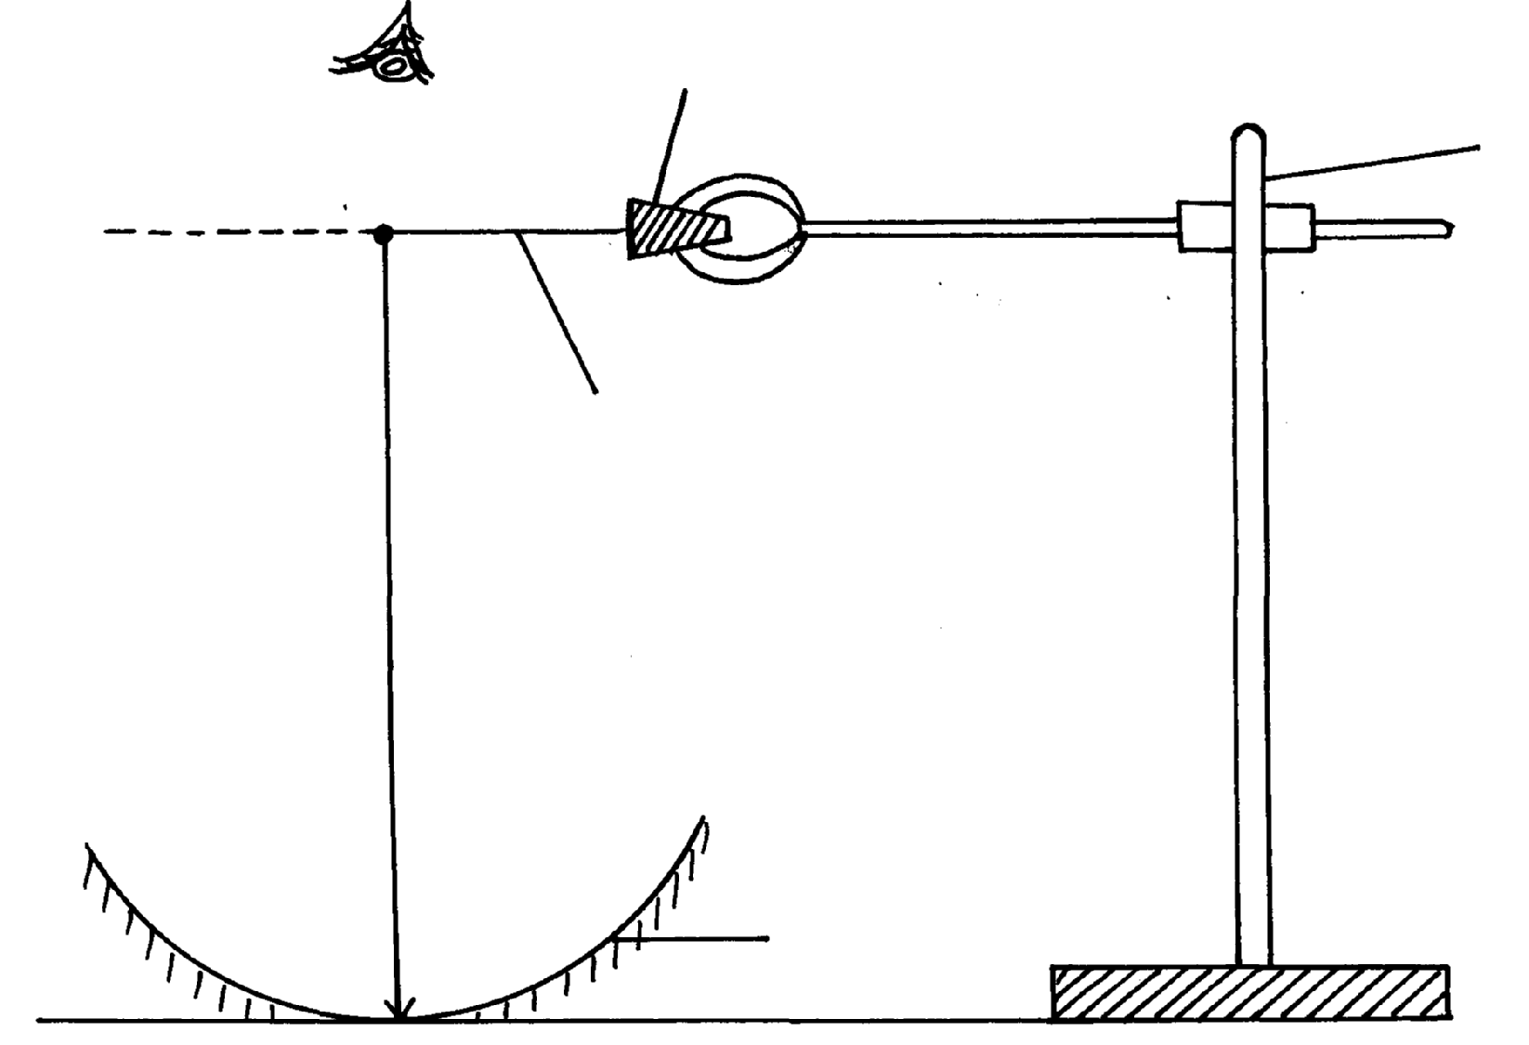
Stand
Cork
Image

Object pin
h

Mirror
- By adjusting the clamp on the stand, move the object pin up and down until the inverted image and the pin itself appear to coincide (use – no- parallax method). Measure the distance, h .

h = …………40.0……(± 0.5cm)………………… cm ( 1mark)

- Calculate the value f given that ; f= $\frac{h}{2}$

f= ……………………20.0…………(±0.5cm)……………………………cm (1mark)
- Arrange the apparatus as shown in figure 2 below
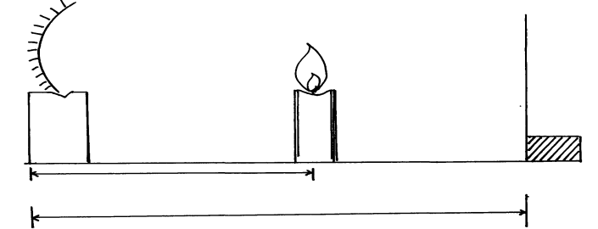

- Place the candle at a distance u = 28cm from the mirror. Move the screen along the ruler
until a sharp image is focused on the screen. Measure and record the image distance V .
- Repeat the procedure for values of u = 30cm, 32cm, 34cm and 36cm. Record your values
in the table below hence complete the column for values of M. ( 5marks)
Object distance u (cm) | Image distance V (cm) | Magnification M= v/u
28.0 | 78.0 | 2.7857
30.0 | 64.0 | 2.1333
32.0 | 54.0 | 1.6875
34.0 | 49.5 | 1.4559
36.0 | 45.5 | 1.2639
1dp At least 3 dp
1 mark for each correct row

- Plot a graph of magnification, M against image distance, v. (4 marks)

m
A1
S1
P1
20 v(cm) L1
_1

S = $\frac{∆m}{∆v}$ ;
= $\frac{20}{1}$ ;
= 20cm ; ( ±1.0 cm)

- Given that M = $\frac{v}{f }$ - 1 , Determine, f, the focal length of the mirror. (2 marks)

F = slope ; OR F = V _intercept ;
= 20cm ; (±1.0cm) = 20cm ; (±1.0cm)

