NAME____________________________ INDEX NO____________________
DATE___________________________ SIGNATURE ___________________
3KNT FRATERNITY 2017
TERM II FORM IV EXAM
BIOLOGY PAPER 2
TIME: 2HOURS
Instructions
SECTION A: (40MKS)
- Answer all the questions in the spaces provided
- Question 6 is compulsory
- Select either question 7 or 8

FOR EXAMINERS USE ONLY
QUESTION NUMBER | MAXIMUM SCORE | CANDIDATES SCORE
1 | 8
2 | 8
3 | 8
4 | 8
5 | 8
6 | 20
7 | 20
8 | 20
TOTAL SCORE | 80

Paper 2
1. The diagram below shows the longitudinal section of a maize grain

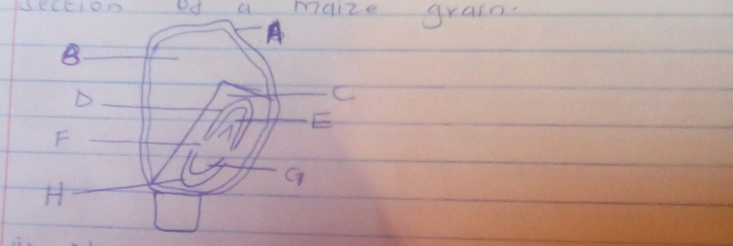

ai.Name the parts labeled B and H (2mks)
B

H

ii.State the function of the part labeled D (1mk)

b.Account for the observation made in each of the part labeled B and C when iodine solution is applied on the cut surfaces (2mks)
B
C
ci.Name the type of germination exhibited by the maize grain (1mk)

ii.Explain how the type of germination you have named in c( i) above is achieved (2mks)

2.In a certain variety of cattle, some individuals may have red, white or roan (a mixture of red and white) fur colour. A cross between a cow with red fur and a bull with white fur produced a calf with roan fur. Using letter R to represent the gene for red colour and W for white colour, answer the following questions
9i.What were the parental genotype (1mk)

ii.Work out a cross between F1 generation (4mks)

iii.Give the phenotypic ratio of F2 generation (1mk)

iv.Give the genotypic ratio of F2 generation (1mk)

b.Name a characteristics in human which is controlled by multiple alleles (1mk)

3ci.A wild beasts in maasai mara national park was found to be infested with a lot of ticks. State the trophic level occupied by the following organisms.
- Wild beast

- Ticks

b.Study the foodweb below representing a certain ecosystem and use it to answer the questions that follow

Locust Guinea fowl

Grass caterpillars hawk

Antelopes lion vulture

- Write down a food chain in which the vulture is a tertiary consumer (1mk)

- What would be the effect of introducing gazelles and termites into the ecosystem (1mks)

c.During an ecology field work, students collected and marked 140 ants and then released them. After 2 days the students captured another 100 ants, 40 of which had been marked previously.
- Calculate the population of the ants. Show your working (2mks)

- Give two assumptions of this method in sampling animal population (2mks)

4.Outline the muscular movements that occur during
- Inhalation (3mks)

- Exhalation (3mks)

b.What are the respiratory structures in the following organisms
- Tadpole (1mk)

- Fish (1mk)

5.The diagram below represents passage of a meal through the human digestive system
Digestive juice A
Mouth cavity
Ugali+meat stew
\
Digestive juice B
stomach

Digestive juice C
Ileum
a.Give reason for
The physical process that occurs in the mouth cavity (1mk)

b.Name the digestive juice B and C (2mks)
B
C
c.Explain two ways in which the digestive system is protected from corrosive effects of digestive juices (2mks)

d.Name the hormone that stimulates secretion of juice B

e.Identify two contents of digestive juice A

SECTION B
COMPLUSORY QUESTION
6.The mean dry weight in milligrams of germinating barley grains was worked out for the whole grain, endosperm and the embryo.
The mean were determined at two day intervals for twelve days
The results are as shown in the table below.
Time in days | Dry weight of whole grain (mg) | Dry weight of endosperm | Dry weight of embryo (mg)
2 | 49 | 45 | 6
2 | 46 | 42 | 6
4 | 44 | 35 | 9
6 | 42 | 24 | 17
8 | 40 | 12 | 25
10 | 41 | 8 | 32
12 | 45 | 8 | 40

- Using the same axes, draw graphs of dry weights of endosperm, embryo and total dry weight (whole grain) against time (7mks)
- What was the average dry weight of the embryo on day 9(1mk)
- Account for the dry weight of:
- Endosperm from day 0 to day 12 (3mks)

- Whole grain from day 0 to day 12 (3mks)

d.What is the role of then following on seed germination
- Oxygen (1mk)

- Optimum temperature (1mk)

- Water (3mks)

e.What are the limitations of dry mass measurements in assessing growth (2mks)

7. Explain how the mammalian eye is adapted to its functions (20mks)

8.Describe how various environmental in flowering plants (20mks)

