3KNT FRATERNITY 2017
TERM II FORM IV EXAM
MARKING SCHEME CHEMISTRY PAPER I
Upper solvent front
1.
Lower solvent front

- x and z
- y
- Check on the diagram
2i.Mass will increase due to oxidation of copper
ii.The mass will reduce due to the formation of gaseous product that escape in air
iii.The mass will reduce due to the decomposition of the nitrate to gaseous products.
3a. Pink
Pink
b.0.1m sodium hydroxide has a higher pH than that of 0.1M aqueous ammonia. This is because sodium hydroxide dissociate fully to release hydroxyl ions while ammonia solution dissociates partially to release hydroxyl ions in a reaction
4a. Crystals will turn from white to blue
b.Determine the melting point and boiling point
Sharp when pure
c.Causes global warming, climate change and green house effect
5a. 3H_{2(g)} + Fe2O_{3(s)} ___________2Fe_{(s)} + 3H₂O_{(l)}
b. A grey solid was formed
A colourless liquid on cooler parts of the tube
c.The excess hydrogen gas is burning in air
6.Heat the mixture \dry ice will sublime
Add water to the mixture
Filter
Filtrate is CaCl(l) residue BaSO₄
Heat the filtrate and allow crystals to grow
7a. S-2.8
T=2.8.4
b.Atoms are covalently bonded together to form giant atomic structure
Atoms of U are bonded covalently to form molecule. The molecule are then held together by weak vander waal forces to form simple molecular structure
8a. 16
b.
Ion | Number of protons | No of electrons | Mass number | Electron arrangement
A⁻ | 17 |  | 37
B⁴⁺ |  | 14 |  | 2.8.4

9ai.

i) 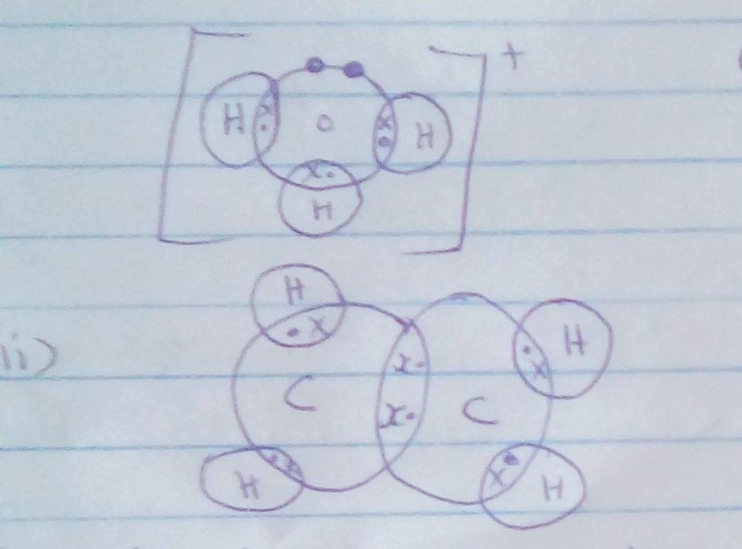
ii
i

b. blue turns red
Red remains red
10.Diamond has higher boiling point than graphite. Because atoms in diamond are bonded together by strong covalent bonds throughout the structure while in graphite, atoms are joined together by covalent bond to form layers.
These layers are joined by weak vander wall forces to form graphite structure.
11. Heat ZnCO3 solid in a test tube to obtain ZnO. Add a certain volume of dilute HNO3 the ZnO little at a time while stirring till in excess.
Filter the unreacted ZnO, add aqeous NaOH
12i. Kerosene floats on water, therefore the kerosene continues to burn, CO₂ cuts off the supply of oxygen.
ii. CO
13a. No heating
b.Solid melts and the ions become mobile
c. Q²⁺ + 2^{e-}__________Q_{(s)}
14. At constant temp, volume mass of a gas is inversely proportion to pressure
b.
TSO₂= √MMSO₂
TO₂ MMO₂

TSO₂ = 64
50 32
TSO₂=70.7sec
15. Mass of H in H2O = ²/₈x14.4=1.6g
Mass of C in CO₂=¹²/₄₄x23.466=6.4g
C | H
6.4 | 1.6
6.4/2=0.535 | 1.6/1=1.6
Ration 1 | 3
CH₃
16. P₁V₁/T₁=P₂V₂/T₂ 770x²/₂₉₈=⁷⁶⁰/₂₇₃xV₂
V₂= ^{270x770}/_{760x298}
_{17.}
2NaOH H₂SO₄  Molarity of NaOH  Moles of NaOH that reacted  0.1----1000 = ^{20x0.1}/₁₀₀₀ =0.002mol  ?.......20  Moles of H₂SO₄ = 0.001  Molarity of H₂SO₄= 0.001x1000/₈ | NaSO₄ + H₂O  ⁴/₄₀=0.1m  =0.125

18a. Loss of water of crystallization when salts are exposed to air
b.Pellet absorb water from the atmosphere forming a solution because pellets are deliquescent.
19a. 1-brom-1chloro 222-try-fluoro ethane
b.Deplete the ozones layer allowing dangerous ray to penetrate.
20a.The higher solubility of ammonia gas
b. OH-
c. To increase the surface area of dissolving thus prevent the sucking back
- Oxygen gas
- Nitric gas

22.

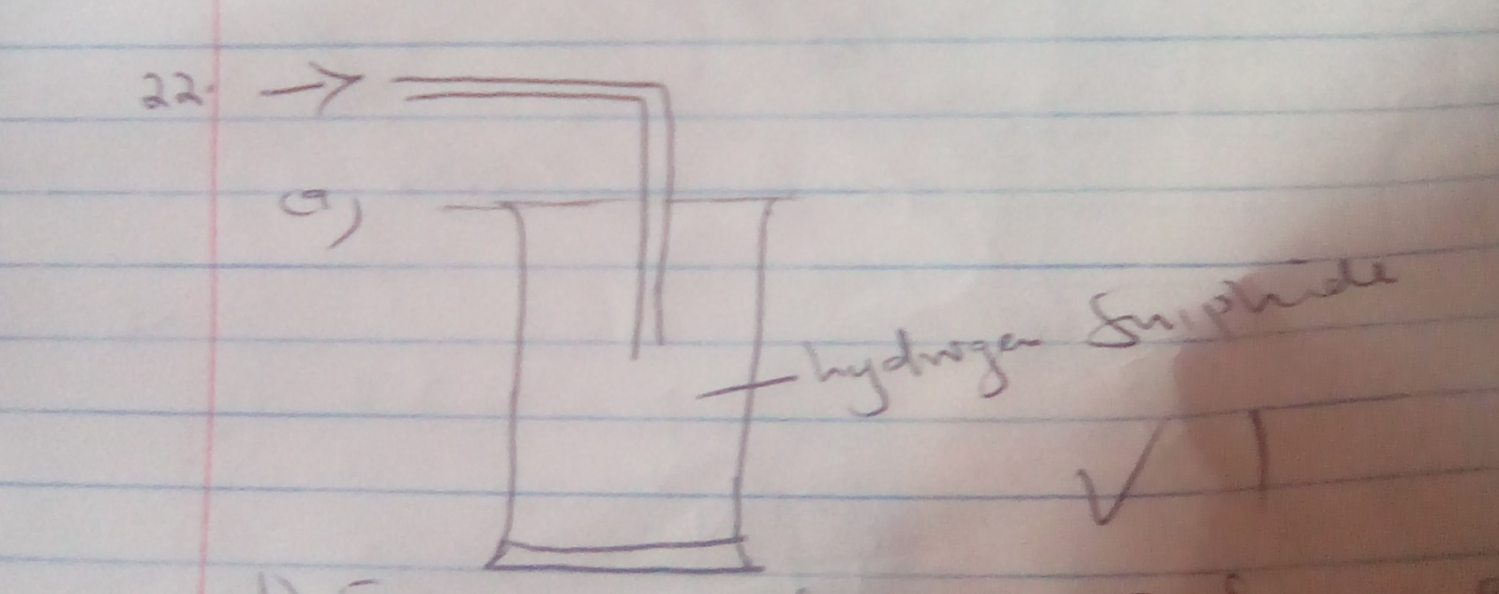

b.FeS_{(s)} + 2HCl_{(aq)} __________FeCl_{(aq)} + H₂S _{(g)}
c.Dry the gas
23a. Hydrogen gas
b.Increase the surface area of dissolving
c.Manufacture of drugs
Sewage treatment
Generation of iron resin.
24. By reacting them with Mg, Na₂CO₃ separately.
HCl reacts vigourously than ethanoic acid
b. CH₃COOH + NaOH______CH3COONa+H₂O

25b.

a.This is a molecule that has a partially negatively charged end and a partially positively charged end within its structure

DH⁺
26i 2C _{s} + 3H2 C₂H₆
2O₂ 3/2O₂ 7/2O₂

2 CO₂ + 3H₂O

ii.ΔHf=ΔH₁+ΔH₂-ΔH₃
=(2x-394) + (3x-286) – 1560
= -86g/mol
27i.It will favour the forward reaction
More product will be formed
ii. It will favour the backward reaction
More of the reactant is formed.

