NAME____________________________ INDEX NO____________________
DATE___________________________ SIGNATURE ___________________
3KNT FRATERNITY 2017
TERM II FORM IV EXAM
312/2
GEOGRAPHY PAPER 2
Instructions to candidates
- This paper has two sections A and B
- Answer all the questions in section A
- Answer questions 6 in section B and two questions
- Candidates should check the questions paper to ascertain that all the pages are printed as indicated and that no questions are missing.
- Candidates should answer all questions in ENGLISH

SECTION A 25MKS
1. Use the map of east Africa below to answer question a
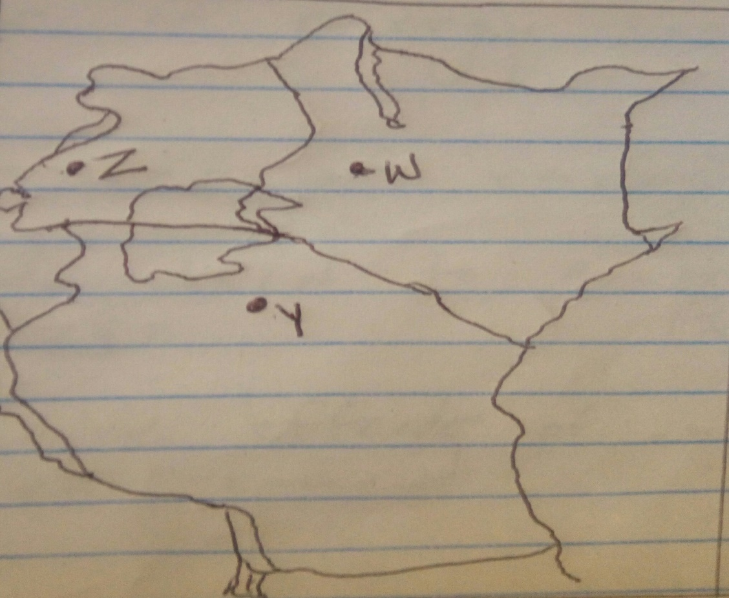

- Name the minerals mined in the area marked WYZ (3mks)
- State two formations in which mineral ores occur (2mks)
2a.Name two types of dairy cattle reared in Kenya (2mks)
b .State 3 physical factors that favour dairy farming in Kenya (3mks)
3 )a.Give two examples of primary sources of population data (2mks)
b).State three reasons why it is necessary to carry out a population census (3mks)
4a.Identify two types of energy sources (2mks)
b.State three causes of energy crisis (3mks)
5a.Identify two methods used to control tsetse fly in Kenya (2mks)
b.State three negative effects of uncollected garbage on the environment (3mks)

SECTION B 75MKS
6a.The table below shows 4 principal crops produced in Kenya in the years 2000 and 2001.
Use it to answer question a and b
Crop | Amount in metric tons
 | 2000 | 2001
Wheat | 70,000 | 130,000
Maize | 200,000 | 370,000
Coffee | 98,000 | 55000
Tea | 240,000 | 295,000
ai.Using a scale of 1cm represent 50,000 metric tons, draw a simple comparative bar graph based on the data above (8mks)
ii.State 2 advantages of using comparative bar graphs (2mks)
b.Calculate the percentage increase in wheat production between the year 2000 and 2001 (2mks)
c.State 5 physical conditions that favour growing of tea in Kenya (5mks)
d.Explain 4 problems experienced in small scale tea farming in Kenya (8mks)
7ai.What is forestry (2mks)
ii.Explain three factors favouring growth of forests on mt. Kenya (6mks)
iii.State five factors that have led to the reduction of the area under forest on the slopes of mt. Kenya (5mks)
b.Explain four measurements that the government of Kenya is taking to conserve forests in the country. (8mks)
c.Give the difference in the exploitation of softwood forests in Kenya and Canada under the following headings
- Period of harvesting (2mk)
- Transportation (2mks)
8ai.Name any two major fresh water fisheries in Kenya (2mks)
ii.Give three methods used to preserve fish (3mks)

iii.Explain three problems experienced by fishermen while fishing in Lake Victoria (6mks)
b) i.Explain four factors that favour fishing in the north west pacific fishing ground (8mks)
ii.State six ways in which the Kenya government is promoting the fishing industry in the country (6mks)
9.ai.Differentiate between light and heavy and heavy industries (2mks)
ii.Name 2 agricultural non food manufacturing industries in Kenya (2mks)
bi.State 3 reasons why Kenya should become industrialized by 2030 (3mks)
ii.State 3 ways in which the government of Kenya encourages development of jua kali industries (3mks)
iii.State 4 problems in Kenya associated with industrialization (4mks)
c) i.Name 2 car manufacturing zones in japan (2m,ks)
ii.Name 3 types of industries found in the Ruhr region (3mks)
d.Explain 3 factors that led to the growth of the iron and steel industries in the Ruhr region of Germany (6mks)
10.The map below shows distribution of irrigation scheme in Kenya

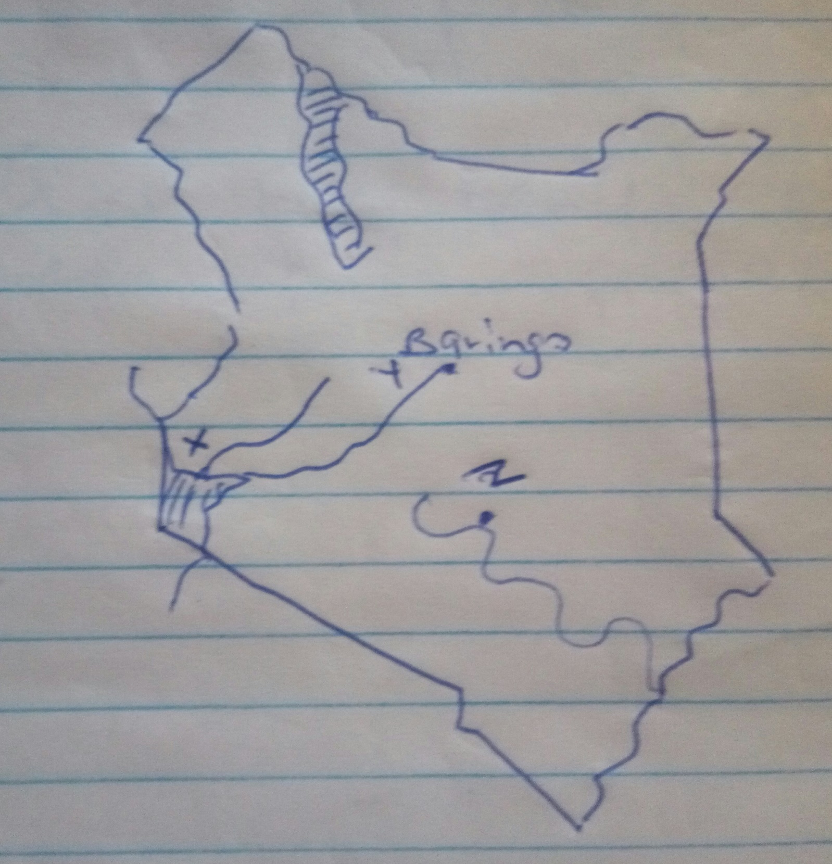
Use the above map of Kenya to answer questions
a (i) and (ii)
a i. Identify the irrigation schemes marked x. y. z and in each case the main crop grown (6mks)
ii. Explain four factors that led to the location of irrigation scheme marked Y (8mks)
iii.State four problems that are experienced in the irrigation marked z (4mks)
b .What is a polder (2mks)
c.Give five benefits of the Zayder zee project (5mks)

