3KNT ALLIANCE JOINT EXAMINATIONS – 2017 FORM FOUR
BIOLOGY PP 2 MARKING SCHEME
1.a)i) B – Endosperm
B – Radicle sheath

ii) Protect the plumule during germination

b) B – Turns blue black sine iodine reacts with the stored starch.
C – Remains brown; there is no starch.

c) i) Hypogeal

ii) The epicotyls grows faster than the hypocotyl; making the seed to remain below the ground.

2.i) Red cow – R R
White bull – W W

ii)

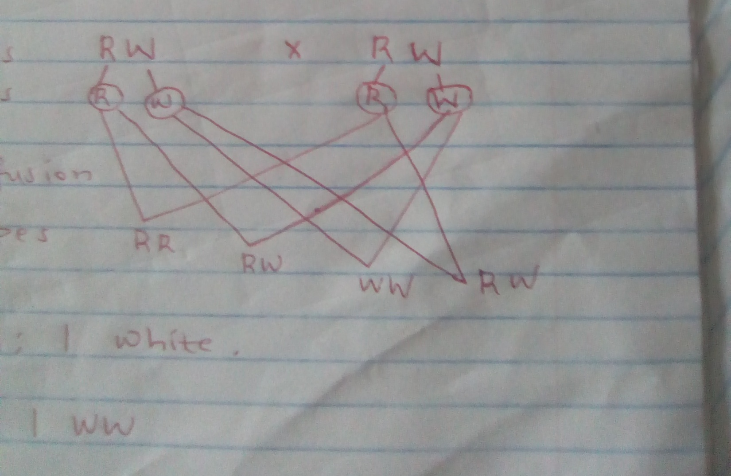

iii) 1 Red: 2 Roan: 1 White

iv) 1 RR: 2 RW: 1 WW

b) ABO blood group system.

3.a)i) Primary consumers
ii) Secondary consumers

b)i) Grass Antelope Lion Vulture

ii) There would be increased competition for grass leading to decrease in plant population.

c)i) P = FM x SC
MR

= 140 x 100
40
= 350ants
iii)- There is no migration of organisms into and out of the study area.
- There is no effect of the paint used in marking the animal.
- Released animals mix freely with the remaining population.

4.a)i) Inhalation
- External intercostals muscles contract.
- Internal intercostals muscles relax.
- Diaphragm muscles contract and it flattens.

ii) Exhalation
- Internal intercostals muscles contract
- External intercostals muscles relax.
- Diaphragm muscles relax and it assumes a dome shape.

b)i) External gills.

ii) Gills

5.a) Increases surface areafor the activity of the enzymes in the mouth.

b) B – Gastric juice
C – Pancreatic Juice

c)- Protein digestive enzymes being secreted in an active form.
- Secretion of mucus.

d) Gatrin

e) Mucus; water; digestive enzyme/ptyalin/salivary amylase.

6.a) On graph paper.

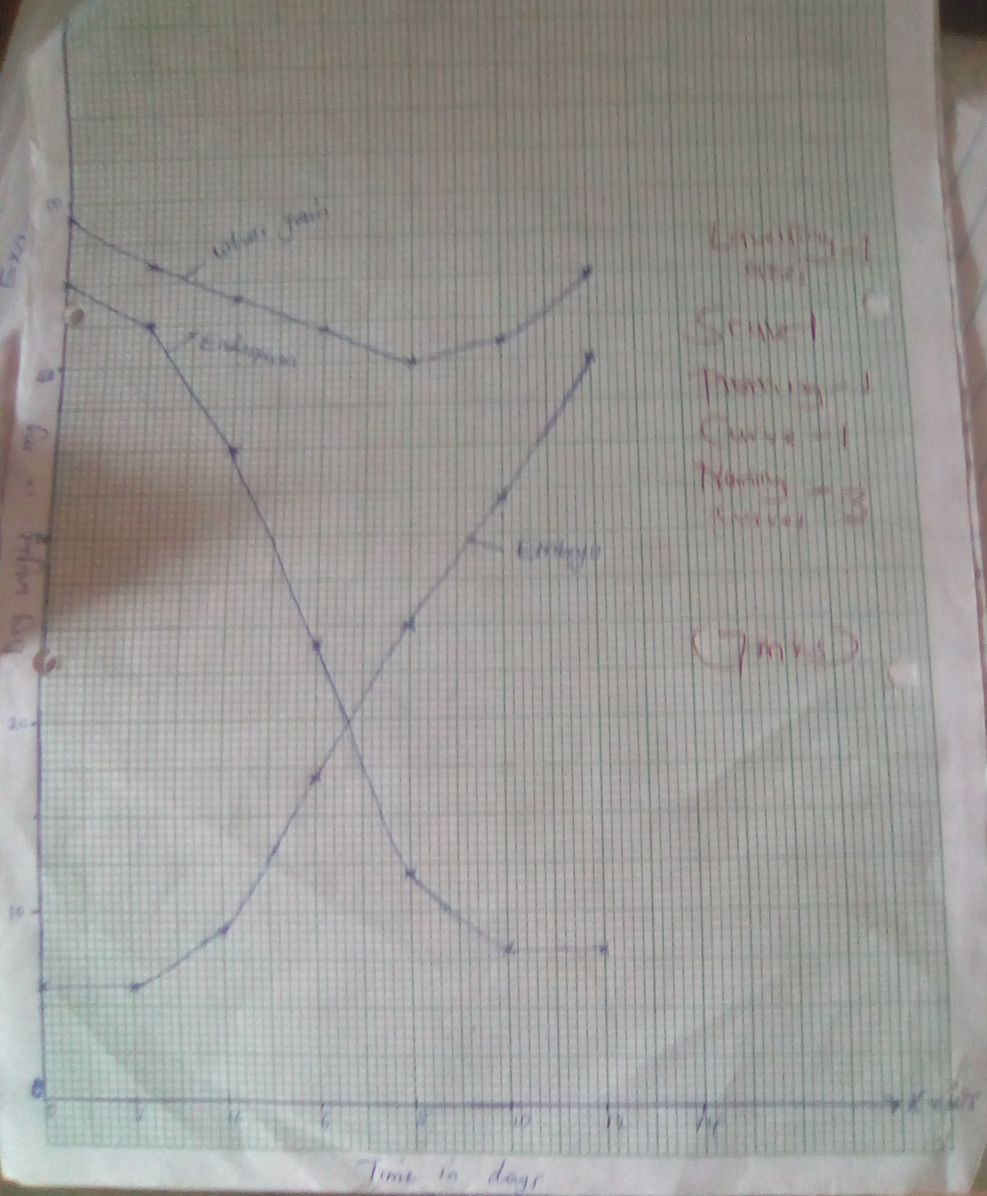

b) 28.5g ± 0.5

i) Endosperm dry weight decreased due to hydrolysis of stored starch into simple sugars; which are translocated to the embryo to be used for growth.

ii) The average dry weight decreased from the start to day 8 because some of the simple sugars are used in respiration to release energy and carbon (IV) oxide is released and water is not accounted in dry weight. After day 8 the dry weight starts to increase as the first leaves develop and start to carry out photosynthesis whose rate get s higher than respiration.

d)i) Oxygen – is necessary for respiration which provides energy for germination process.

ii) Optimum temperature – is necessary for the action of enzymes involved in the mobilization of food reserves.

iii) Water
- Activates the enzymes
- Softens the seed coat
- Hydrolyses and dissolves food materials
- Provides medium for enzymes to act.
- Acts as a medium for transport of soluble food materials to the growing points of the embryo.

e) Drying an organism kills it. Therefore; the same organism cannot be used over a period of time to assess growth.

7. The presence of:
- The sclerotic layer which contains tough connective tissue fibres which help it to support and protect the other parts of the eye ball.
- The choroid which contain many blood capillaries which supply oxygen and nutrients to the retina and removes waste metabolic waste from the eye.
- The retina contains photoreceptor cells call roods & cones. It is light sensitive part of the eye.
- The cornea is transparent and curved; thus allows light to pass through and reflects light rays.
- The yellow spot has high concentration of cones for acute vision.
- Blind spot which is the place where the optic nerve has sensory nerve fibres for transmission of impulses to the brain for interpretations.
- Lens is made up of elastic and transparent materials and is biconvex. It adjusts to focus for far or near objects, allows light to pass through and refracts light rays.
- Cilliary body has muscle fibres that contract and relax to change the shape of the lens bringing about accommodation.
- Suspensory ligaments are inelastic to hold the lens in position and attach it to ciliary body.
- Iris has radial and circular muscles which control the size of the pupil.
- Aqueous humour – is a clear fluid through which oxygen and nutrients pass to the cornea and lens and maintains the shape of the eyeball and refracts light rays.
- Vitrous humour is a fluid which creates hydrostatic pressure and thus maintains the shape of the eye and refracts the rays.
- Conjuctiva – is a thin, transparent and tough membrane that protects the eye and allows light to pass through.

8.i) Water supply/availability of water – for transpiration to take place; the cellulose cell walls of spongy mesophyll cells must be fully saturated with water. This requires that the cells are kept fully turgid. An adequate supply of water ensures a high rate of transpiration. When water supply is inadequate; the walls of mesophyll cells are not saturated and hence little water evaporated into the intercellular air spaces. This results to a decrease in the rate of transpiration.

ii) Atmospheric pressure – A reduction in atmospheric pressure causes an increase in evaporation from a wet surface. Plants in high altitude where atmosphere pressure is low have a high rate of transpiration while plants in low altitude areas have low rate of transpiration because the atmospheric pressure is high.

iii) Wind/Air currents (Movements) – In windy conditions; air removes water vapour around the leave. This increases the diffusion gradient leading to high rate of transpiration. When the air is still. Water vapour is lee carried away; thus it accumulates on the leaves leading to low rate of transpiration.

iv) Environmental temperature – An increase in environmental temperature raises the temperature of the leaf; thus increasing the rate of evaporation of water from the mesophyll cells of the leaf. This increase the water vapour diffusion gradient between the inside and outside the leaf, thus an increase in transpiration r ate. Low temperature leads to low rate of transpiration due to decreased evaporation.

vi) Light Intensity – Increase in light intensity stimulates the opening of the stomata due to the uptake of water into the guard cells; thus increasing the rate of transpiration. Low light intensity causes partial closure of the stomata leading to low rate of transpiration. An increase in light intensity also causes an increase in the internal temperature of the leaf thus increasing the rate of evaporation and consequently an increase in transpiration.

vi) Humidity – When the humidity of the atmosphere is low; the diffusion gradient between the inside and outside of the leaf is high. This results in an increase in the rate of transpiration. If the humidity of the atmosphere is high the diffusion gradient is low and the rate of transpiration is low.

