NAME…………………………………………………………………………………….. INDEX NO…………………………………..
DATE………………………………. CANDIDATE SIGNATURE………………………………………….
CHEMISTRY 233/1
THEORY PAPER
TIME 2 HOURS
3KNT ALLIANCE JOINT EXAMINATION 2017
FORM FOUR
INSTRUCTIONS TO CANDIDATES
Write your name and index number in the space provided above.
Sign and write the date of examination in the space provided.
Answer all the questions in the spaces provided.
All working must be cleary shown where necessary
Mathematical tables and electrical calculators may be used.
FOR EXAMINERS USE ONLY
QUESTION | MAXIMUM SCORE | CANDIDATE SCORE
1 – 27 | 80

- The diagram below shows a chromotograph of substances X, Yand Z. Study it and answer the questions which follows
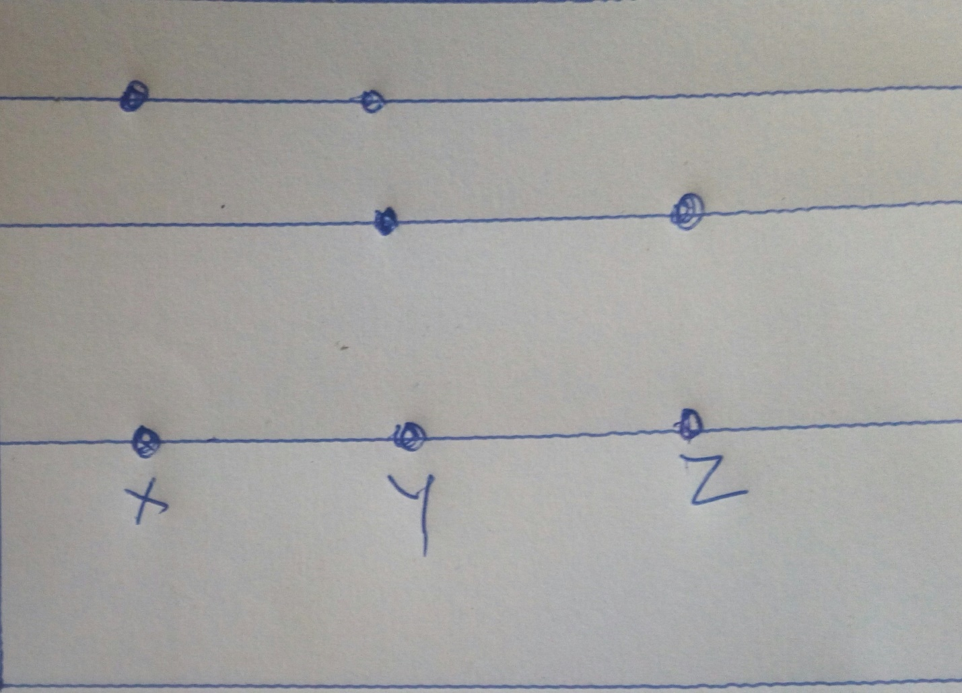

- identity the pure substances (1mk)

- Which substance is a mixture (1mk)

- On the diagram show the lower and the upper solvent front (1mk)
- State and explain the changes in mass of the following substances when they separately heated in a open crucible.
- copper metal (1mk)

- Sulphur powder (1mk)

- copper(ll) nitrate (1mk)

3(a) Complete the table below to show the colour of given indicators in the basic and acidic solutions (1mk)
Indicator phenolphthalein | Colour in
 | Basic solution | Acidic solution
 |  | Colourless
Methyl orange | Yellow
b) how does the PH value of O1.M sodium hydroxide solution compare with that of O.1M aqueous ammonia? Explain (2mks)

4. A form four student set up the apparatus as shown below
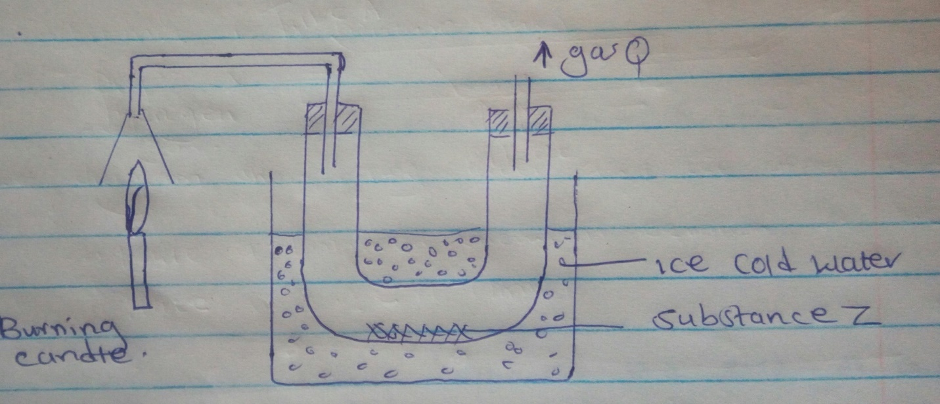
Burning candle
Gas Q
Substance Z
Ice cold water

- What would be observed if three drops of substance Z are added to anhydrous copper(1) sulphate in a test tube. (1mk)

- How can you confirm the purity of substance Z. (1mk)

- State one environmental effects of gas Q when it get into the environment (1mk)

5. Hydrogen gas was passed over heated iron(111) oxide as shown in the set up below
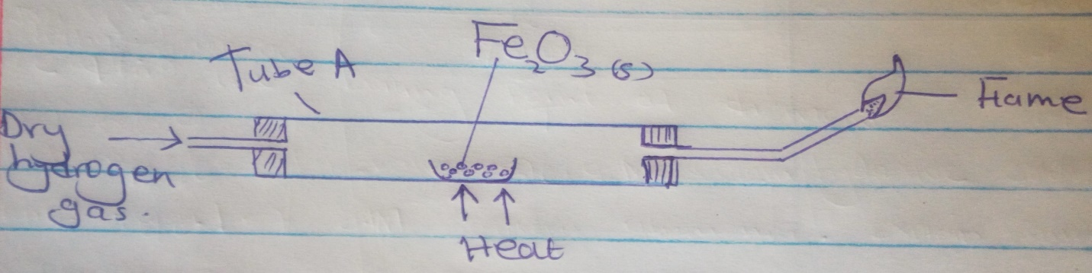
DRY hydrogen gas

Tube A
Heat
Fe ₂ O ₃ (S)
Flame

- Write a balanced chemical equation for the reaction taking place in tube A (1mk)

- Give one observation made in tube A (1mk)

- Which gas is being burnt at the end of the outlet tube. Explain (1mk)

6. A mixture containing Barium sulphate calcium chloride and dry ice. Describe how calcium chloride can be obtained from the mixture. (3mks)

7. Use the information in the table below to answer the questions that follow.
Melting point | Element | Atomic number
97.8 | R | 11
660 | S | 13
1440 | T | 14
-40.1 | U | 17
63.1 | v | 19
- Write the electron arrangement of (1mk)
- Ion of S
- atom of T

- Explain why the melting point of T is higher than that of U (2mks)

8. Study the structure below and answer the questions that follow
CL CL CL
AL AL
CL CL CL
- What is the total number of electrons used for bonding in the above structur(1mk)

- study the table below and complete it (A ⁻and B⁴⁺ ) are not the actual symbols of the ions (2mks)

Ion | Number of protons | Number of electrons | Mass no. | Electron arrangement
A- |  | 20 |  | 2.8.8
B⁴⁺ | 124 |  | 28

9. Using electrons in the outermost energy level draw dot (.) cross (x) diagram for
i) H₃ O⁺ (1mk)

II) C ₂H₄ (1mk)

b) What would be the effect of dipping litmus paper in aqueous solution of H₃ O⁺ (1mk)

10. Explain the difference in the boiling point of diamond and graphite (3mks)
11. Starting with zinc carbonate solid describe how Zn(OH)2 can be prepared in the laboratory. (3mks)

12. i) When extinguishing fire caused by burning kerosene, C0₂is preferred to water. Explain (2mks)

ii)Write the formula of the oxide of carbon which is silent killer (1mk)

13. In an experiment to investigate the conductivity of substances a student used the set up shown below
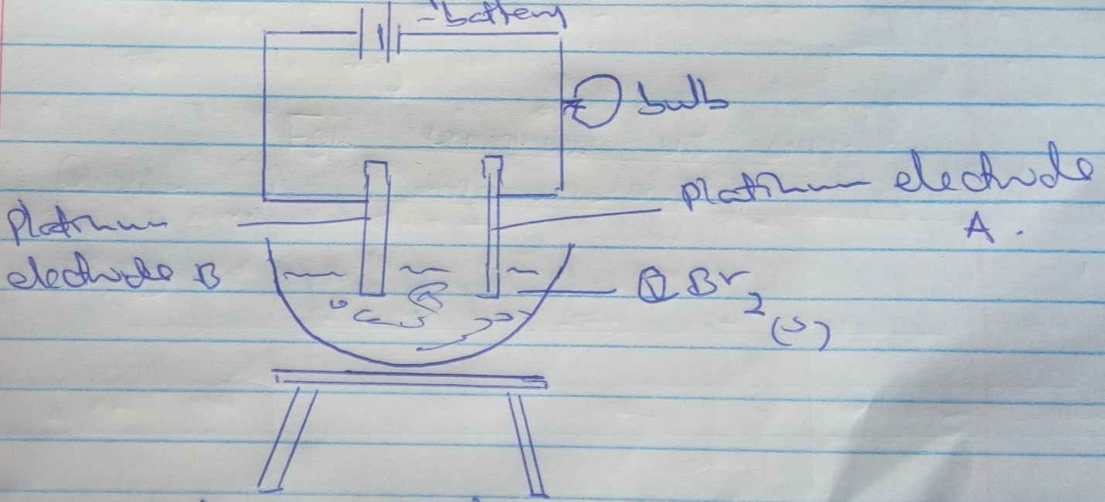

The student noted that the bulb did not light.
- What had been omitted in the set –up. (1mk)

- Explain why the bulb lights when the omission is corrected. (1mk)

- Write the equation for the reaction that takes place at the cathode (1mk)

14. The graph below shows the behavior of a fixed mass of a gas at constant temperature.

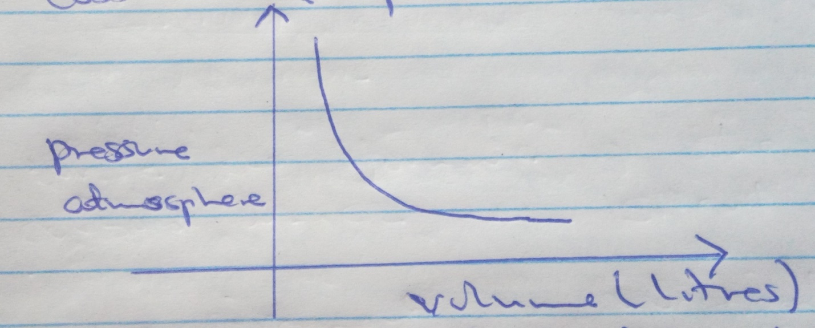

- What is the relationship between the volume and pressure of the gas. (1mk)

- 60cm3 of oxygen gas diffuses through a porous paddle in 50 seconds. How long would it take for sulphur(IV) oxide gas to diffuse through the same plate under the same conditions. (2mks)

15. When 8.8g of hydroxide Z was burnt in excess air. 1.44g of water and 11.95dm3 of carbon(IV) oxide were obtained. Determine the empirical formula of Z. (3mks)

16. 2cm³ of a gas was collected at a pressure of 770mmhg and at 25 ºC . Calculate the volume of the gas at s.t.p (s.t..p. temp = 0º c pressure 760mmHg)

17. 20cm³ of a solution containing 4g per litre of sodium hydroxide was neutralized by 5.0cm³ of aqueous sulphuric acid. Determine the concentration of sulphuric acid in moles dm⁻³

18. a) Define the term efflorescence (1mk)

b)State and explain the observation that you would make if your left sodium hydroxide pellets in a watch glass overnight. (2mks)

19. A certain compound has structural formula shown below
Br F
H - C - C - F
CL F
- Name the compound (1mk)
- the above compound belongs to a group of compounds known as CFC(S) . Briefly explain the dangers of these CFC(s) (2mks)

20. Ammonia gas was passed into water as shown below.

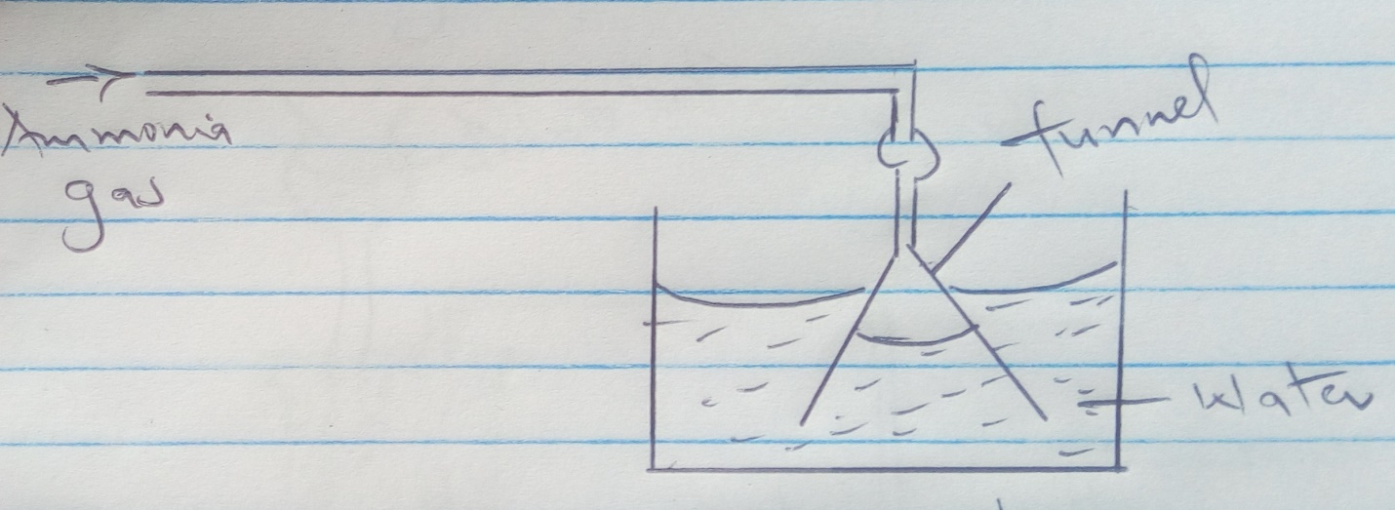

- State the physical property demonstrated by the above set up. (1mk)

- When red litmus paper is dropped into the resulting solution it turns blue. Identify the ion responsible for this observation. (1mk)

- What is the function of the funnel. (1mk)

21. The diagram below shows a set up used to prepare gas Z.
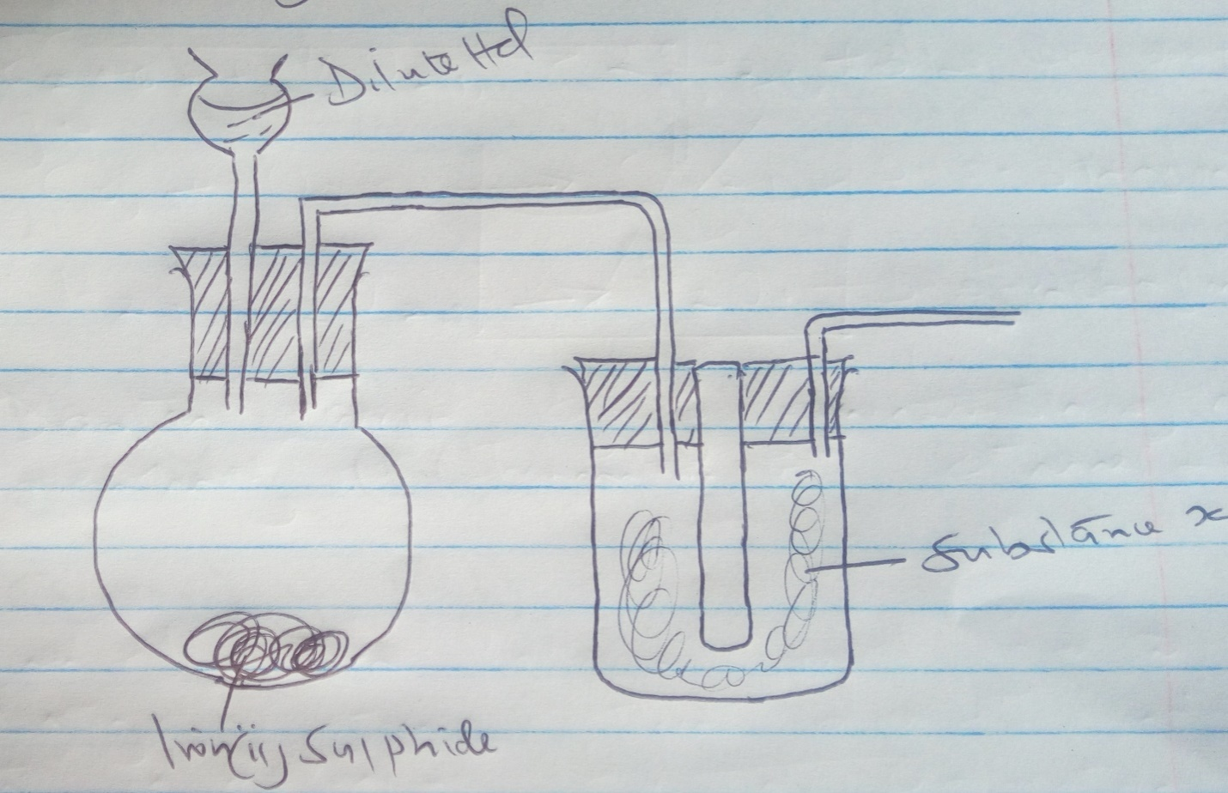

- Complete the diagram to show how gas Z is collected. (1mk)
- Write an equation for the reaction between iron(11) sulphide and dilute hydrochloric acid (1mk)

- What is the purpose of substance X (1mk)

22. Study the chart below and answer the questions that follows
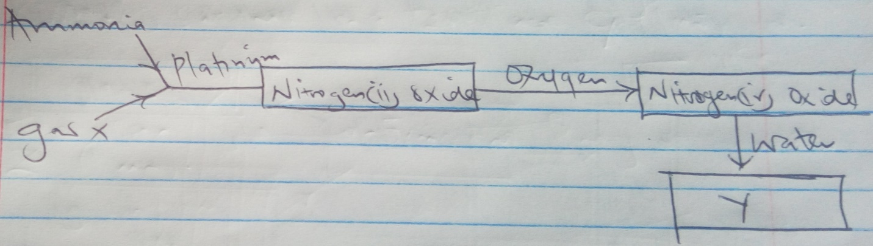

Identity
- gas x (1mk)
- compound y (1mk)

23. The scheme below represents steps for large scale manufacture of hydrochloric acid. Study it and answer the questions that follow.
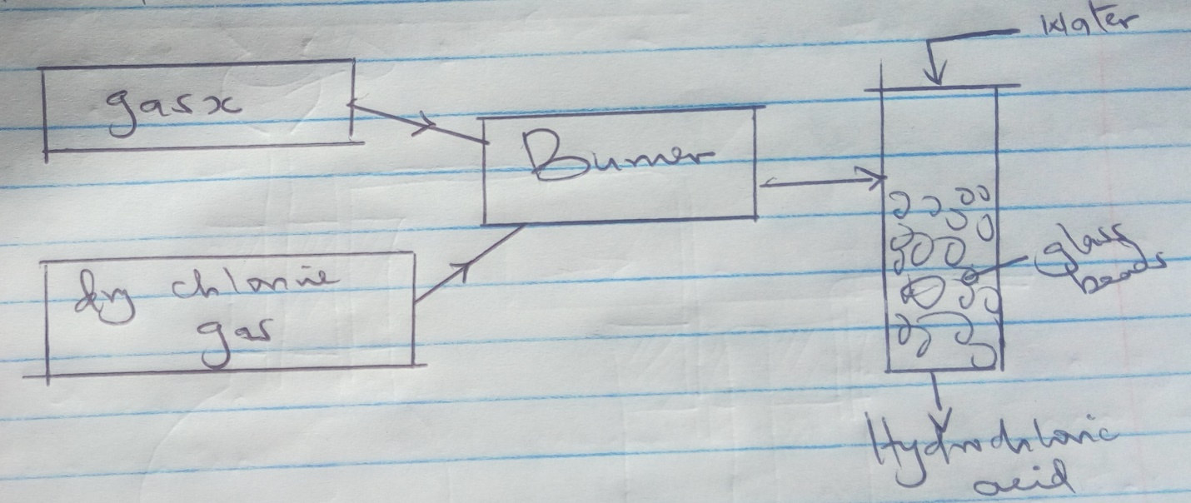

a) Name gas X (1mk)
b) What is the purpose of the glass beads (1mk)

c) State two uses of hydrochloric acid. (1mk)

24. A form four student set up the apparatus as shown below

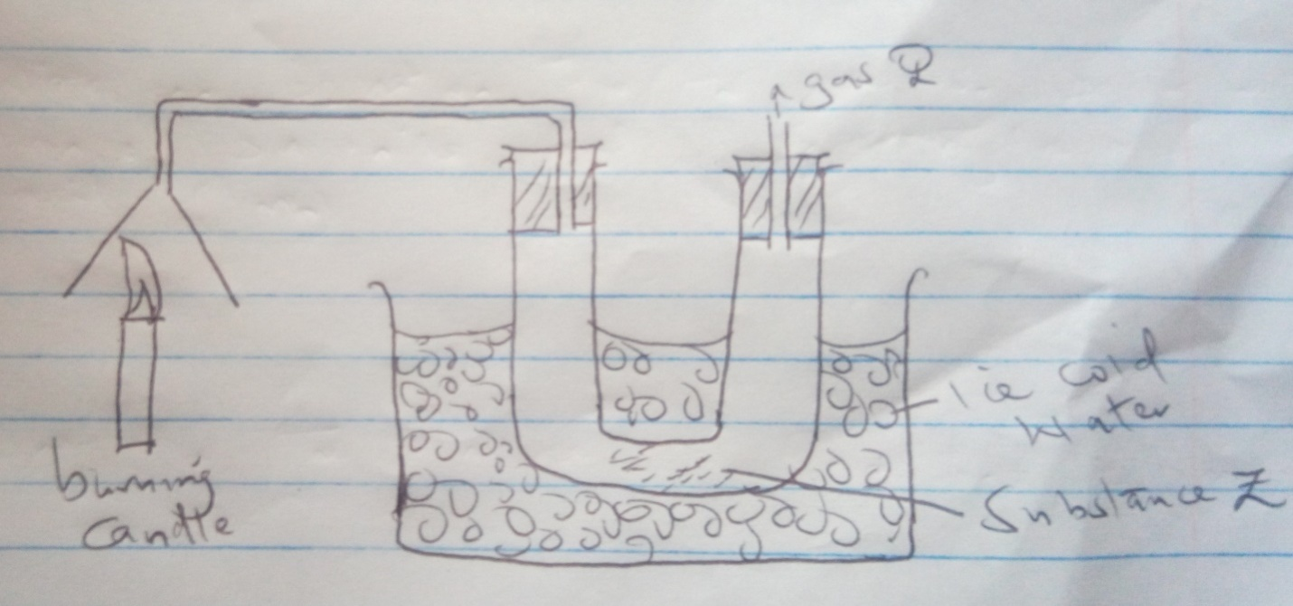
a) What would be observed if three drops os substance Z are added to anhydrous copper(ii) sulphate in a test tube (1mk)

b) How can you confirm the purity of substance Z (1mk)

c) State one environmental effect of gas Q when it gets into the environment (1mk)

25. Water is a polar molecule.
a) What’s meant by a polar molecule (1mk)

b)By using molecules of water show the covalent bonds and the inter molecular forces

26.Use the thermal chemical equations’ below to answer the questions that follow
C₂ H 6(q) + 7/2 0_{2(q)} _______ 2CO_{29q)} + 3H₂ O = 1560kg/mol
CO + O_{29q)} _________ CO_{2(q)} = -394kg/mol
H₂ + ½ 0_{2(Q)} _______ H ₂ 0 _{(I)} DH = -286kg/mol
- Draw an energy cycle diagram to show the enthalpy of formation of ethane (2mks)

- Calculate the enthalpy of formation of ethane (2mks)

27. Study the reaction below and answer the questions that follow
2SO _{2(q)} + O₂ --------- 2SO_{3(q)} + Heat
Explain the effect on equilibrium on
- Increasing pressure (1mk)

- Increasing temperature (1mk

