3KNT ALLIANCE JOINT EXAMINATIONS – 2017 FORM FOUR
GEOGRAPHY PP 1 MARKING SCHEME
SECTION A (25MKS)
1.a) - The sun
- The planets
- Heavenly bodies (meteors, meteorites, satellites, asteroids) 3 x 1 = 3mks

b) - Layers of discounuity
- Mohorovicic or Moho/M-discontinuity.
- Guternberg discontinuity 2 x 1 = 2mks

2.a) Examples of;
i) Plutonic rocks
- Granite
- Syenite
- Gabbro
- Diorite
- Peridotite 1 x 1 = 1mk

ii) Hypabyssal rocks
- Dolerite
- Porpyrite
- Porphyry
- Lamprophyre 1 x 1 = 1mk

iii) Volcanic rocks
- Andesite
- Pumice
- Tephrite
- Tryachite
- Scoria
- Ryorite
- Phonolite
- Basalt
- Obsidian 1 x 1 = 1mk

b) Rocks resulting from metarmophism of;
i) Granite – Gneiss 1 x 1 = 1mk

ii) Clay – Slate 1 x 1 = 1mk

3.a) Wettest month
May 1 x 1 = 1mk

b)i) Mean annual temperature
16.2 + 16.5 + 17.1 + 17.1 + 16.1 + 15.2 + 15.2 + +15 + +16 + 16.1 + 16.1 + 16.3 = 192.9 and the total dived by 12
= 192.9
12
=16.075 = 16.1⁰C 2mks
ii) Range is highest – lowest

17.1 – 15.0

= 2.1⁰C 2mks

4.a) Stages of volcano
Active volcano
Dormant volcano
Extinct volcano (must be in order) 3 x 1 = 3mks

b) Parts marked
Q – Lava layers

R- Side vent/ Dyke

5. Drawing and labeling (5mks)

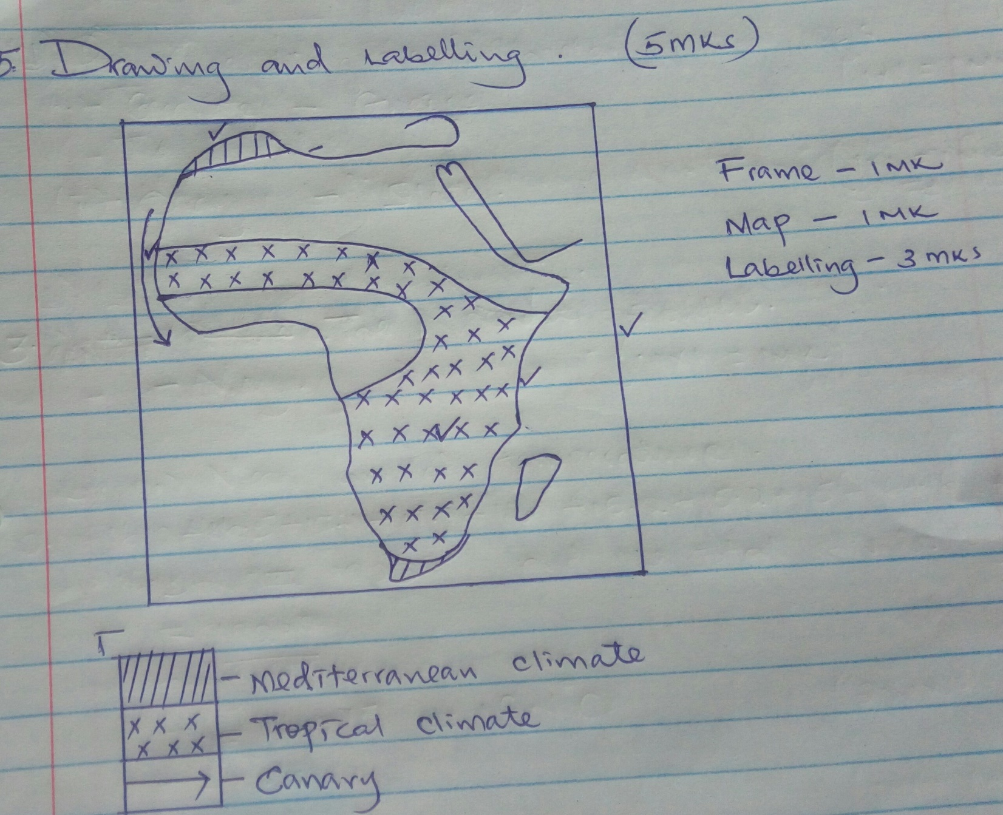

6.a)i) Six figure gird reference of the junction. 2mks

248133

ii) Magnetic variation of the area. 2mks
2⁰25’ – 2⁰23’ = 2’
b.i) Approximate height of the dam.
1880m 2mks

ii) Area of Kitale Municipality

21 = 10.5mk² ± 0.5 2mks
2

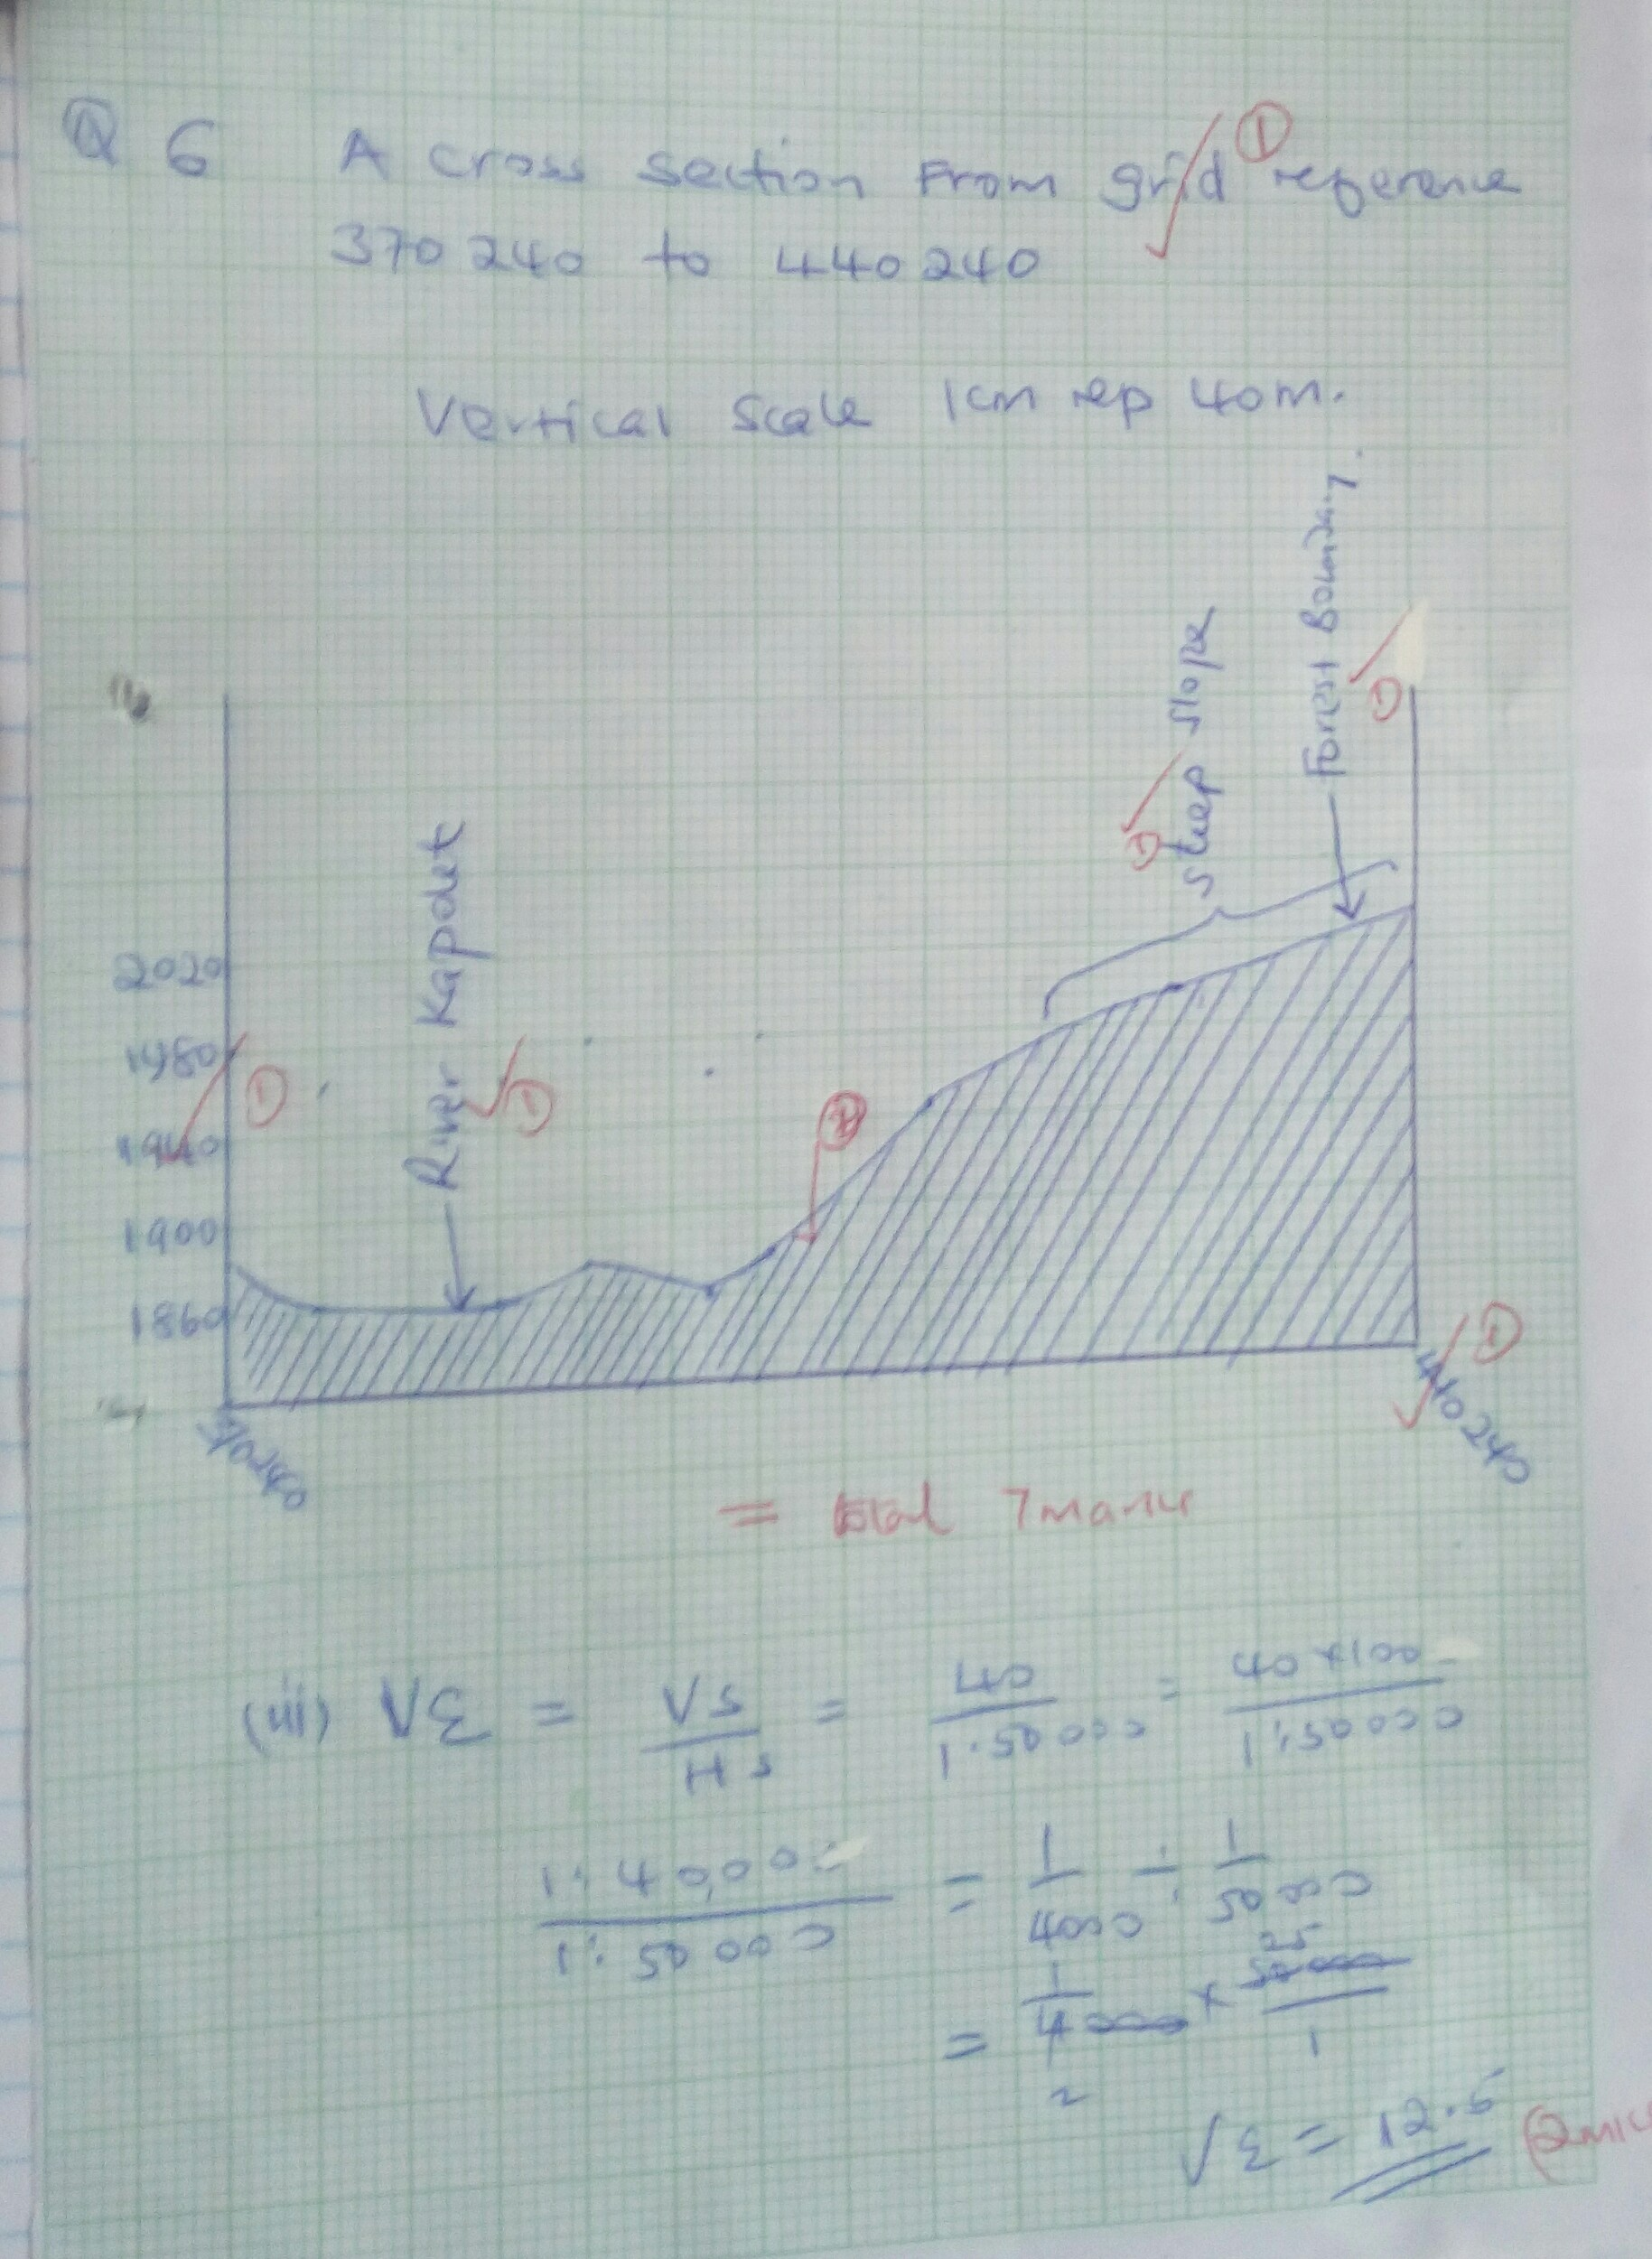

d) Economic activities carried out on the map 1 x 3 = 3mks
- Farming – presence of plantation
- Lumbering – presence of forests.
- Transport – presence of roads, railway line
- Trade – presence of markets, shops etc.

e) Describe the drainage of the area covered by the map. 1 x 5 = 5mks
- There are many permanent rivers.
- There are many dams e.g. grid square 3630.
- There are several water tank e.g. in the grid square 2826.
- River Noigameget forms dendritic drainage patterns.
- Rivers are joint, may tributaries
- There are several ponds e.g. pond on grid square 2813.
- Most rivers are flowing from North East to South.

7.a)i) Weathering is the breaking down and decomposition of solid rocks on sith while mass wasting is the down slope movement of weathered materials by influence of gravity. 2 x 1 = 2mks

ii) Factors influencing the rate of weathering.
- Water
- Heat/Temperature
- Chemicals/dissolved substance 3 x 1 =3mks

iii) Ways in which plants cause weathering.
- Plant roots e.g. trees grow into joints and cracks, widen the joints causing rock blocks to disintegrate.
- Plants like algae, mosses and lichen retain water resulting to chemical weathering processes.
- Decaying plant material produce organic acid that react with some rocks minerals causing decay.
2 x 1 = 2mks

b)i) Types of mass wasting
- Talus creep/Scree creep
- Solifluction 2 x 1 = 2mks

ii) Factors that cause soil creep
- Heating and cooling of soil/
- Freezing of soil
- Ploughing downhill
- Shaking by earthquakes/ heavy tracks
- Alternate drying and wathing of the soil
- Trampling and burrowing of the ground.

c) Effects of mass wasting on the environment.
- Leads to loss of fertile soil
- Leads to loss of life and property
- It may clock the river or stream
- Leads to displacement of people
- It may lead to destruction of infrastructure and buildings
- It may lead to formation of lakes.

8.a)i) This is a ridge/high ground that separates 2 or more river basins. 2 x 1 = 2mks

ii)- Traction process/rolling the large and heavy particles of the river. The load are rolled/dragged along the river bed.
- Saltation process – particles that are not too heavy cannot remain suspended in water are momentarily lifted by the water turbulence and at times dropped onto the river bed.
- Solution – soluble minerals dissolved in water and carried away in solution.
- Suspension – light particles of the load are carried and maintained within the turbulence of the flowing water. 3 x 2 = 6mks

b) The widening of the valley through lateral erosion creates an extensive are where the river deposits its load.
- the speed of the flows of water is low
- the main activity is deposition
- there is pronounced meanders.
- formation of ox-bow lanes is common.
- formation of river terrace bluffs/cliffs.
- braided channels is common.
- raised river bed.
- formation of river levees.
- distributaries are common which form delta any 4 x 2 = 8mks

c)i)- The pattern develops in an area with a central basin.
- river drains into the depression.
- water comes from all direction. 3 x 1 = 3mks

ii)- The main river has tributaries streams that flow parallel to each other.
- The tributaries join the main river at the right angles.
- Mainly occurs in areas that experience faulting. 3 x 1 = 3mks

d) River terrace
- Incised meanders.
- Knick points
- Valley within a valley
- Water fall/rapids.

9.a)i) An ice sheet is a continuous mass of ice covering a large area or surface. 2mks

ii) Reasons why there are no ice sheets in Kenya.
- Kenya experiences high temperatures under which ice sheets cannot form.
- Most parts of Kenya have low altitudes.
- Kenya is found at low latitudes. 2 x 1 = 2mks

iii) Factors that influence movement of ice from the place where it has accumulated.
- Gradient of the land – ice moves faster when the slope is steep.
- Temperatures or seasonal changes – high temperatures result into thawing, leading to faster movement of ice.
- Nature of the surface – rough surface causes friction lowering the speed of ice movement.
- Size or thickness of glaries – large masses of ice exert pressure which lead to melting of ice underneath. This increases the speed of ice movement. 3 x 2 = 6mks

b) Formation of an arête.
Two adjacent cracks or hollows exist on a mountain side. The two hollows or cracks are filled with ice. The ice erodes the sides through plucking and deepens the hollow through abrasion. Through erosion, the back walls of the hollow slowly recede and eventually the hollows or cirques are separated by a knife-edged ridge. The ridge is called on arête. 4 x 1 = 4mks

c)i) S – Medial moraine
T – Lateral moraine
V – Terminal moraine

d) Effects of glaciation in lowland areas.
- Glacial till provides fertile soils which are good for arable farming.
- Ice sheets, in their scouring effect reduce the land surface and depth to expose mineral seams which become easy to extract.
- Outwash plains comprise of sand and gravel which are used as material for building and construction.
- Lakes formed through glariation can be exploited for various economic uses such as fishing, transportation and tourist attraction.
- Ice melts into rivers which can be exploited for domestic use.
- Glaciated lowland features are tourist attraction hence earning the country foreign exchange.
4 x 2 = 8mks
10.a) Define deflution
Deflution is the process where wind picks and blows away unconsolidated materials such as just and fine dust by rolling them on the ground and lifting them up in the air. 2 mks

b) Why wind is more effective (desert)
- the presence of loose unconsolidated dry material.
- Scarcity of vegetation.
- Presence of strong tropical storms.

c) Factors influencing transportation if material
- The speed and the force of the wind determines the amount of load to be transported strong wing such as typhoons and cyclones transport heavier load than normal winds.
- A load that is drier is easier to transport than that which is wet.
- The size of the load, texture and weight influence the mode of transport and amount of load that the wind can transport.
- Occurrence of obstacles such as vegetation rocks, twigs and hills affect the velocity and strength of the wind. 3 x 2 = 6mks

d)i) Formation of
Mesa.
- Found within plateaus that are made of sedimentary rocks.
- Sedimentary rocks are capped with resistant layer of rocks which is not easily eroded by sheet floods.
- Formed through weathering and erosion of plateau surfaces.
- The less resistant surface undergoes physical weathering and is later removed by slect floods.
- The resistant rock protects the soft from erosion. This results in the formation of tabular shaped residual hills referred to as mesas.

Bajada
- During periods of heavy rainstorms, intermittent streams flow from hills to low lands.
- At the foot of the steep slope, the spread of the flowing water suddenly falls causing deposition of large quantities of sediments which were carried by the water.
- Several channels like those of a delta form across the deposited sediments resulting in formation of a cone shaped feature made of coarse material which is known as alluvial fan.
- When several adjacent alluvial fans merge, they form a continuous undulating feature of coarse sand, angular screes, and ground deposits at a foot of steel slopes known as bajada.

e) Significance of desert feature.
- Features resulting from water and wind such as yardan, self dunes, attracts tourists hence earning foreign exchange.
- Loess deposit provide fertile soils suitable for crop farming, especially at wet depositional grounds.
- The desert landscale provide good sites of testing military weapons e.g. nuclear bombs since they are sparsely settled.
- Some deflational hollows contains water used by nomadic communities.
- Salty flats are economically used for salt production especially in North Africa.
Any first 4 x 2 = 8mks

