441/2
CLOTHING AND TEXTILES
PAPER 2
PRACTICAL
JULY 2018
Time: 2½ Hours

MOKASA 2 EXAMINATION 2018
Kenya Certificate of Secondary Education
CLOTHING AND TEXTILES
Paper 2
PRACTICAL
2 ½ Hours

This paper consists of 3 printed pages.
Candidates should check the question paper to ensure that all the pages are printed as indicated and no questions are missing.

CHILD’S DRESS
A pattern of a child’s dress is provided. You are advised to study the sketch, the question paper and the layout before the test.
MATERIALS PROVIDED
- Pattern pieces.
A Dress Front
B Dress Back
C Front Frill
D Back Frill
E Collar
F Pocket
- Plain light weight cotton fabric 75cm long by 91cm wide.
- Zip 15cm zip (6’’) to match colour of fabric.
- Sewing thread to match the colour of fabric .
- One large envelope
THE TEST.
Using the materials provided, cut out and make up the RIGHT HALF of the child’s dress to show the following:
- Cutting out. (15mks)
- The making of pin tucks. (5mks)
- Preparation and attachment of the pocket. (9 mks)
- Making a plain seam at the shoulder. (4¹/₂ mks)
- The making of an open seam at the side. (7mks)
- The attaching of the zip using the concealed method. (6mks)
- Joining of the front and back frill using a double stitched seam. (8¹/₂ mks)
- Joining the dress to the frill using an overlaid seam. DO NOT TRIM DO NOT NEATEN.
(7 mks)
- Preparation and attachment of the interfaced collar using self-neatening method (13mks)
- Manage the hem and hold the back part only using long and short tacking. (9mks)
- Presentation. (6mks)
NOTE:
At the end of the examination, firmly sew on your work on a single fabric, a label bearing your name and index number. Remove the needles and pins from your work, then fold your work neatly and place it in the envelope provided. Do not put scraps of fabric with your work.

LAYOUT NOT DRAWN TO SCALE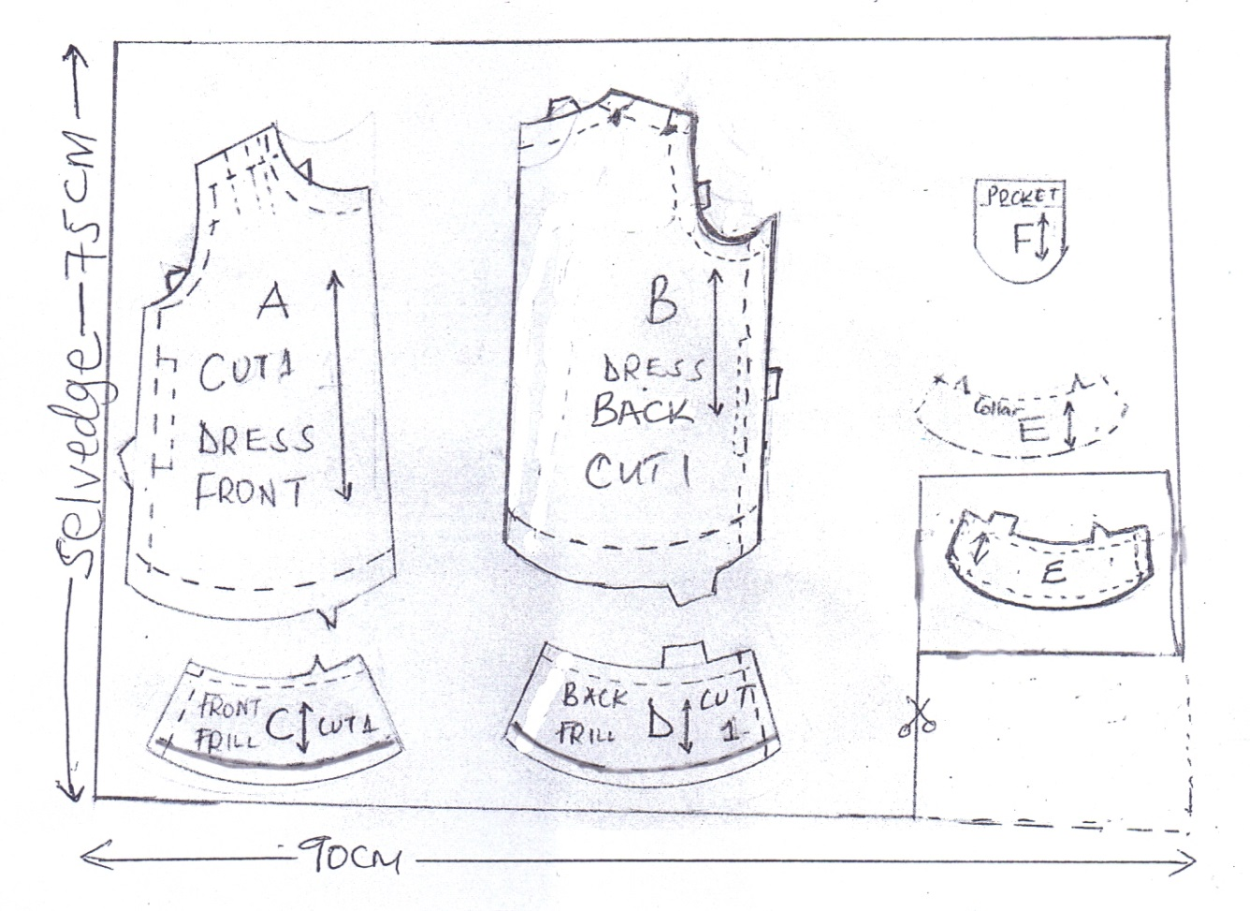

VIEW
