NAME……………..…………………………………………… ADM NO ……...... CLASS ………

232/2
PHYSICS
PAPER 2
JULY 2018
TIME: 2 HOURS

MOKASA II JOINT EXAMINATIONS
232/2
PHYSICS

INSTRUCTIONS TO CANDIDATES:
(a) Write your Name, admission number and class in the spaces provided above.
(b) This paper consists of two Sections; A and B.
(c) Answer ALL the questions in Sections A and B in the spaces provided.
(d) All workings must be clearly shown.
(e) Non-programmable silent electronic calculators and KNEC Mathematical tables and may be used.
(f) This paper consists of 13 printed pages. Candidates should check the question paper to ascertain that all pages are printed as indicated and no questions are missing
FOR EXAMINER’S USE ONLY:
Section | Question | Maximum  Score | Candidate’s  Score
A | 1 – 11 | 25
 | 12 | 08
 | 13 | 09
B | 14 | 08
 | 15 | 09
 | 16 | 12
 | 17 | 09
Total Score |  | 80
SECTION A (25 Marks)
- The graph below shows a decay curve.
Counts per minute

100

80

60

40

20

100
80
60
40
20
Time (s)
From the graph,
a) Determine the half-life of the radioactive substance (1mk)
………………………………………………………………………………………………………
b) If a radioactive sample of this substance has 40g, how long will it take to decay to 5g? (2mks)
…………………………………………………………………………………………………………………………………………………………………………………………………………………………………………………………………………………………………………………………………………………………………………………………………………

- The diagram below shows a setup used to study the behavior of sound.
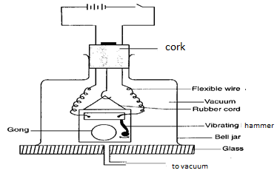
a) What property of sound waves can be studied using this setup? (1mk)
………………………………………………………………………………………………
b) Briefly describe how the property in (a) above is investigated? (2mks)
………………………………………………………………………………………………………………………………………………………………………………………………………………………………………………………………………………………………………………………………………………………………………………………………………………………………3. The diagram below shows a charged body brought close to a spherical pith ball.

A
B
Indicate the charges on the ball in A and B (2mks)
4. Two waves of the same frequency of 10Hz with amplitudes of 1cm and 2cm are 90⁰ out of phase. On the grid below, sketch the two wave forms. Give at least two cycles .(2mks)
1cm

1cm

5. The circuits in the diagram below were set up using a 12V a.c power supply.
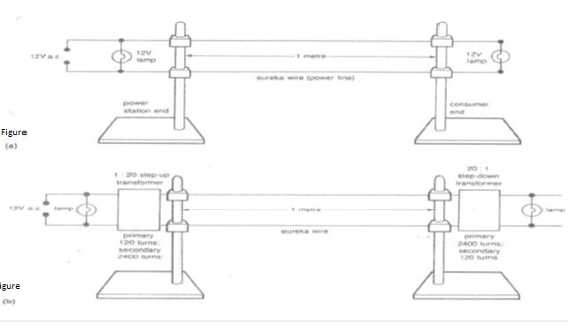
i) How do the brightness of the bulbs in the circuits in figure (a) and figure (b) compare? (1mk)
………………………………………………………………………………………………ii) Give a reason for your answer in (i) above (1mk)
…………………………………………………………………………………………………………………………………………………………………………………………
6. A rectangular coil of wire, attached two slip rings is rotated between the poles of a permanent magnet to form a dynamo.
a) What is the position of the coil when;
i) There is no current generated. (1mk)
………………………………………………………………………………………………
ii) When the current generated is greatest (1mk)
………………………………………………………………………………………………

b) What type of ring(s) must be used to obtain direct current in an external circuit? (1mk)
………………………………………………………………………………………………7.a) 7.What is photoelectric effect? (1mk)
………………………………………………………………………………………………
b) The threshold wavelength λ₀ of a photo emissive surface is 0.90µm. determine its work function in electron volts. (Take C=3.0 X10⁸ms⁻¹, 1ev = 1.6 x10⁻¹⁹J, h= 6.63x10⁻³⁴Js) (2mks)
……………………………………………………………………………………………………………………………………………………………………………………………………………………………………………………………………………………………………………………………………………………………………………………………
8.The diagram below shows an image I formed by a concave mirror. Using ray diagrams show the position of the object. (2mks)
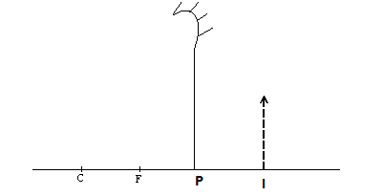
9. Give one advantage and one disadvantage of the small aperture of a pinhole camera. (2mks)
……………………………………………………………………………………………………………………………………………………………………………………………………………………………………………………………………………………
10. Define electric current and give its SI unit (1mks)
……………………………………………………………………………………………………………………………………………………………………………………………………………………………………………………………………………………………
11. Differentiate gamma rays from ultra violet light in terms of;
i) Production (1mk)
……………………………………………………………………………………………..
ii) Detection (1mk)
………………………………………………………………………………………………

SECTION B (55 Marks)
12.The diagram below shows young’s double slit experiment.
S₂
S₁
S
monochromatic
a) What is the purpose of slit S₁ and S₂ (1mk)
……………………………………………………………………………………………
b) State what is observed on the screen (1mk)
…………………………………………………………………………………………….
c) Explain your observation in (b) above (2mks)
………………………………………………………………………………………………………………………………………………………………………………………………………………………………………………………………………………………………
d) The diagram below shows a stationary transverse wave.
B
A
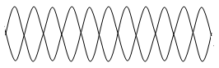
i) Name the parts A and B (2mks)
………………………………………………………………………………………………
ii) Determine the distance AB in terms of wavelengths. (2mks)
………………………………………………………………………………………………………………………………………………………………………………………………

13. a) The graph below shows the voltage-current relationship for a certain conductor.
V
I
i) Is the conductor ohmic or non-ohmic (1mk)
……………………………………………………………………………………………
ii) Explain why the resistance of the conductor is increasing. (2mks)
……………………………………………………………………………………………..
b) A battery whose e.m.f E is 6.0V and internal resistance r is 1.0Ω consists of two resistors of 6Ω and 3Ω connected in parallel. Determine the current through each resistor. (3mks)
…………………………………………………………………………………………………………………………………………………………………………………………………………………………………………………………………………………………………………………………………………………………………………
…………………………………………………………………………………………
c) Sketch the electric field patterns between the charges below (2mks)
+
+++
+

d) On what property does the lightning arrestor operate? (1mk)
………………………………………………………………………………………………14.a)Give the difference between conductors and insulators in terms of the energy band theory (1mk)
…………………………………………………………………………………………………………………………………………………………………………………………
b) Define doping (1mk)
………………………………………………………………………………………………………………………………………………………………………………………………
c) Using a diagram, show how doping produces an n type semiconductor (3mks)

d) The diagram below shows a centre tap transformer using two diodes rectifier circuit.
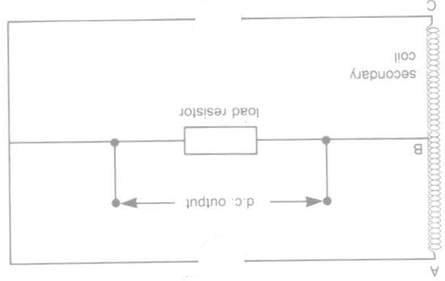
i) Complete the diagram to give full wave rectification in the output (1mk)
ii) on the diagram connect a capacitor c to produce a smoothed output (1mk) iii) Give one disadvantage of the rectifier above to a four diode rectifier (1mk)
………………………………………………………………………………………………15.The figure below shows the essential component of an X-ray tube.
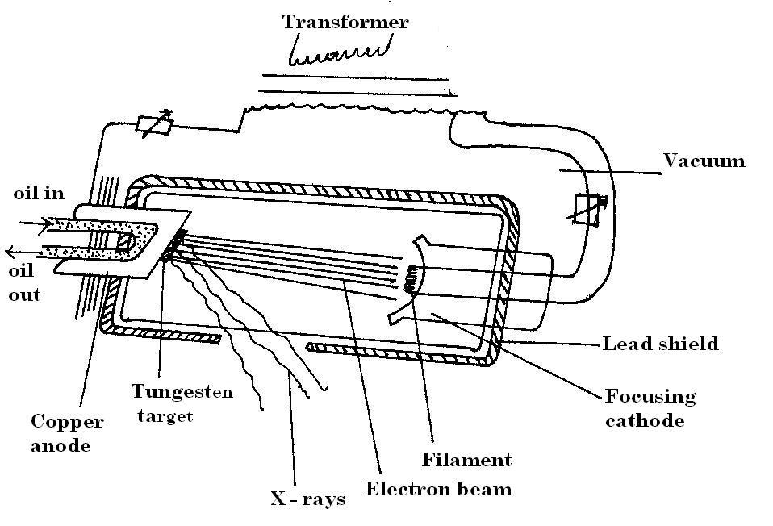
(i) How are the electrons produced accelerated towards the anode? (1mk)
………………………………………………………………………………………………
(ii) Why is the target made of tungsten? (1mk)
………………………………………………………………………………………………
(iii) State two ways in which cooling is achieved in this kind of X-ray machine. (2mks) ………………………………………………………………………………………………………………………………………………………………………………………………
b). If the accelerating potential is 200KV. Determine;
i) The kinetic energy of the electrons arriving at the target. (Take (e=1.6 x10 ⁻¹⁹$C$) (2mks)
……………………………………………………………………………………………………………………………………………………………………………………………………………………………………………………………………………………………..
ii) If 0.1% of the electron energy is converted into X rays, determine the minimum wavelength of the emitted X rays. (h = 6.63 x 10⁻³⁴ Js and C = 3.0 x 10⁸m/s) (3mks)
………………………………………………………………………………………………………………………………………………………………………………………………………………………………………………………………………………………………………………………………………………………………………………………………

16. a) The graph below shows the variation of the sine of angle of incidence and the sine of the angle of refraction for a given medium
Sin i

1.0

0.8

0.6

0.4

0.2

0.6
0.5
0.4
0.3
0.2
0.1
Sin r
i) From the graph determine the refractive index of the medium (3mks)
………………………………………………………………………………………………………………………………………………………………………………………………………………………………………………………………………………………………
ii) If the speed of light in air is 3.0 x10⁸ m/s, what is the speed of light in this medium (2mks)
………………………………………………………………………………………………………………………………………………………………………………………………………………………………………………………………………………………………

iii) The diagram below shows a ray of white light incident to an isosceles glass prism.
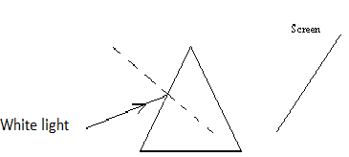

Complete the ray to show what is formed on the screen (2mks)
b) A wire carrying current is placed in a magnetic field as shown below.
Indicate on the diagram the direction of the field and force. (2mks)
S
N

c) Two metal rods, iron and steel are inserted in a circuit as shown in the figure below.
Steel
Iron

i) On the axes below sketch the variation of magnetic strength against the magnetizing current for the two metals indicating clearly the two metals (1mk)
Magnetic strength
Current
ii) Explain the shape of the graphs above (2mks)
………………………………………………………………………………………………………………………………………………………………………………………………………………………………………………………………………………………………
17.a) An illuminated object is placed in front of a convex lens as shown in the setup below.
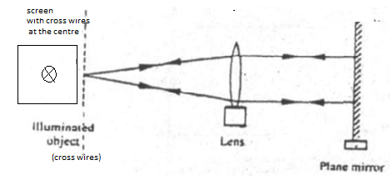
Describe how the set up can be used to determine the focal length of the lens. (3mks)
………………………………………………………………………………………………………………………………………………………………………………………………………………………………………………………………………………………………………………………………………………………………………………………………………………………………………………………………………………………………………………………………………………………………………………………………………………………………………………………………………………………………………………………………………………………………………………………………

b) The diagram below shows an eye defect
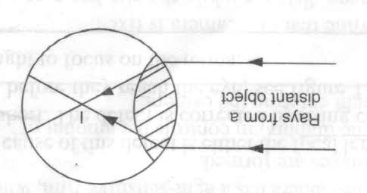
i) Name the defect (1mk)
………………………………………………………………………………………………
ii) State two causes of this defect (2mks)
………………………………………………………………………………………………………………………………………………………………………………………………………………………………………………………………………………………………
iii) On the same diagram, show how this defect can be corrected (1mk)

c) The diagrams below show some magnetic materials
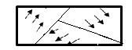

A
B
C

Using the domain theory, differentiate material A from material C (2mks)
………………………………………………………………………………………………………………………………………………………………………………………………………………………………………………………………………………………………

THIS IS THE LAST PRINTED PAGE

