**Name……………………………………………….Adm No………..Class……**

**Index No………………………..** Signature…………………………

**121/2**

**Mathematics Paper 2**

**Form 4**

**2 ½ Hours**

**Term 2, 2018**

**KASSU JET EXAMINATIONS**

***Kenya Certificate of Secondary Education (K.C.S.E)***

**INSTRUCTIONS TO CANDIDATES**

* Write your name and Admission number in the spaces provided at the top of this page.
  + This paper consists of two sections: Section I and Section II.
  + Answer ***ALL*** questions from section I and ***ANY FIVE*** from section II
  + All answers and workings must be written on the question paper in the spaces provided

below each question.

* + Show all the steps in your calculation, giving your answer at each stage in the spaces

below each question.

* + Non – Programmable silent electronic calculators and KNEC mathematical tables may be

used, except where stated otherwise.

**FOR EXAMINERS USE ONLY**

**SECTION I**

|  |  |  |  |  |  |  |  |  |  |  |  |  |  |  |  |  |
| --- | --- | --- | --- | --- | --- | --- | --- | --- | --- | --- | --- | --- | --- | --- | --- | --- |
| **1** | **2** | **3** | **4** | **5** | **6** | **7** | **8** | **9** | **10** | **11** | **12** | **13** | **14** | **15** | **16** | **TOTAL** |
|  |  |  |  |  |  |  |  |  |  |  |  |  |  |  |  |  |

**SECTION II**

|  |  |  |  |  |  |  |  |  |
| --- | --- | --- | --- | --- | --- | --- | --- | --- |
| **17** | **18** | **19** | **20** | **21** | **22** | **23** | **24** | **TOTAL** |
|  |  |  |  |  |  |  |  |  |

**GRAND TOTAL**

**SECTION I 50 MARKS**

1. Solve for in the equation using completing the square method (3 mks)
2. Simplify by rationalizing the denominator in  leaving your answer an the form where a,b and c are integers. (3mks)
3. Find the value of x in the equation  in the range listed below.

0o ≤ x ≤ 360o  (3mks)

1. Draw a line AB=4cm, P is a variable point in the plane of the paper, above AB, such that angle and the area of triangle APB. Using a ruler and a pair of compasses only find the locus of P. (3 marks)
2. Expand and simplify the binomial. Hence use the first four terms of your expansion to find the value of (3mks)
3. The length and breadth of a rectangular floor garden were measured and found to be 4.1m and 2.2m respectively. Find the percentage error in its area. (3 marks)
4. Solve for in the equation (3 marks)

8. Make s the subject of the formulae in the following; (3mks)

9. Each member of a class take one and only one of the three foreign languages: French, German and Spanish. 15 pupils take French, 9 take German and 6 take Spanish. Two pupils are chosen at random. Represent the information in a tree diagram hence find the probability that both pupils take different subjects. (3mks)

1. The amount of oil used by a ship travelling at a uniform speed varies jointly with the distance and the square of the speed. If the ship uses 200 barrels of oil in travelling 200 miles at 36 mile per hour, determine how many barrels of oil are used when the ship travels 360 miles at 18 miles per. (3 marks)
2. Use logarithms to evaluate:

(4 marks)

1. The figure below shows a circle of diameter XY. Chord TZ intersects XY at C. A tangent to the circle at Y meets TZ produced at S.

T y

X Z

S

Given that TC = 14 cm, CY = 4 cm and YS = 7.5 cm. calculate the length of :

1. C S (1 mark)
2. X C (2 marks)
3. Determine the values of for which the matrix has no inverse (3 marks)
4. Mr. Kimbo, a local retailer bought imported rice at sh. 56 per kilogram and local rice at sh. 48 per kilogram. He wants to mix the two types of rice so as to make a profit of 20%. If he sold the mixture at sh.120 per 2 kilogram packet, find the ratio the two types of rice was mixed. (3mks)
5. The sixth term of a geometric progression is 16 and the third term is 2. Determine the common ratio and the first term. (3 marks)

1. The equation of a circle is given by . Determine the centre and radius of the circle. (3 marks)

**SECTION II**

***(Answer ANY FIVE questions in the spaces provided)***

1. The table alongside shows the rates of taxation in a certain year.

|  |  |
| --- | --- |
| Income in | Rate (Sh. Per |
|  |  |
|  |  |
|  |  |
|  |  |
|  |  |
|  |  |

In that year Mr. Kariuki at teacher at Kangaru High School was earning a basic salary of Ksh. 27 000 per month. In addition he was entitled to other taxable allowances totalling to 11 000 per month and a personal relief of Ksh 1056 per month. He lives in teachers’ quarters where he is paying a nominal rent of Ksh. 3 500 per month.

1. Calculate how much income tax Mr. Kariuki is paid per month. (4 marks)
2. Mr. Kariuki’s other deductions per month were co-operative society contribution of sh 2500 and loan repayment of sh. 3000, calculate his net salary per month. (3 marks)
3. Later the same year Mr. Kariuki was transferred to another school where he earned hardship allowance equivalent to 30% of his basic salary. On top of the deduction in (b) above, he also had a deduction of sh 2700 per month to KCT. Calculate the percentage change in his net salary per month (3 marks)
4. Given that y=2xo+ cos ½ xo, complete the table below for the missing values of y, correct to 1 decimal place (2mks)

|  |  |  |  |  |  |  |  |  |  |  |  |  |  |
| --- | --- | --- | --- | --- | --- | --- | --- | --- | --- | --- | --- | --- | --- |
| Xo | 0o | 30o | 60o | 90o | 120o | 150o | 180o | 210o | 240o | 270o | 300o | 330o | 360o |
| Y=sin 2x+ cos ½ x | 1.0 | 1.8 |  |  | -0.4 | -0.6 |  |  | 0.4 | -0.7 |  |  | -1.0 |

(b) On the grid provide below, draw the graph of y=sin 2xo+cos ½ xo for 0≤ x ≤360o Take the scale 1cm for 30o on the x-axis. 2 cm for 0.5 units on the y –axis. (4mks)

(c) Use the graph to estimate

(i) The minimum value of y (1mk)

(ii) The value of X for which ½ sin 2x + ½ cos ½ x≥0.25 (3mks)

1. Quadrilateral **OMNP** is such that **OM** = m **OP**= p and **PN** = m. **PN** is produced to Q such that **PN**: **PQ** = 13:15. T is a point on **MN** such that **MN** = 3**TN**



Show that O, T and Q are collinear. (10 marks)

1. The figure below represents a right pyramid on a square base PQRS of side 12 cm. O is the centre of the base and VO = 14 cm.

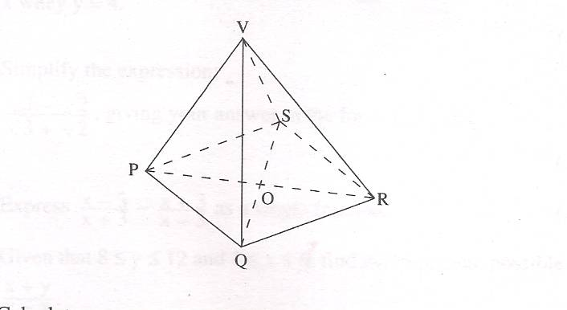Calculate;

1. The length of VP to 1 decimal place (3 marks)
2. The angle which VP makes with the base PQRS (2 marks)
3. The surface area of the pyramid to 1 decimal place (3 marks)
4. The volume of the pyramid (2 marks)

|  |  |  |  |  |  |  |  |
| --- | --- | --- | --- | --- | --- | --- | --- |
| t | 2010 | 2011 | 2012 | 2013 | 2014 | 2015 | 2016 |
| P | 5000 | 6080 | 7400 | 9010 | 10960 | 13330 | 16200 |
|  |  |  |  |  |  |  |  |

1. The table shows the goods ( P) produced by a certain factory in time (t) since 2010 is believed to obey a law of the form P=kAt where k and A are constants and t is time in years.
2. Express the law P=kAt where k and A are constants and t is time in years in the linear form y = mx + c and fill the table appropriately. (3mks)

1. Plot a suitable straight line graph (4mks)
2. Use the graph above to find the values of A and k. (3mks)
3. A small scale farmer wishes to buy some sheep and goats for rearing. A sheep costs sh.400 and a goat costs sh.300. The farmer has enough space for only 20 animals and may spend at most sh.6800. The number of goats should not exceed twice the number of sheep.

a) By letting x and y to represent the number of sheep and goats he can buy respectively, write down all inequalities from the above information. (4mks)

b) Represent the inequalities on the grid provided. (4mks)

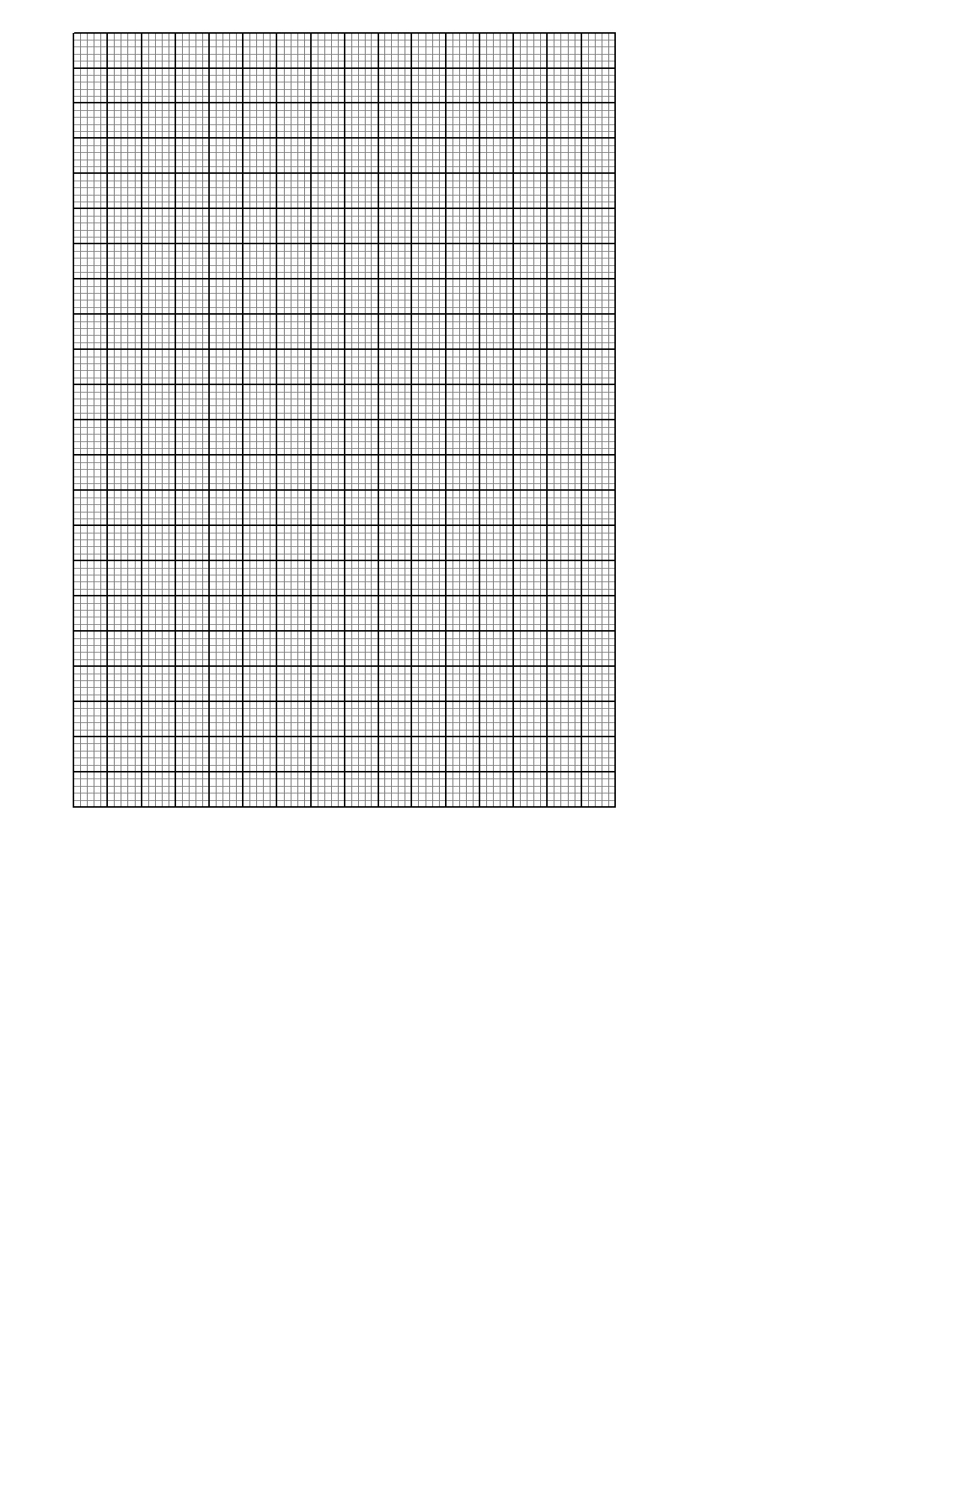

c) From your graph; find the maximum number of animals he can buy at the lowest cost. (2mks)

1. (a) An aeroplane flies from town to town. (Taking R= 6400km, )If it then flies due north from town B to town C, 420km away, calculate correct to the nearest degree, the latitude of town C. (3 marks)

(b) Calculate the shortest distance in km between towns and giving your answer to 2 decimal places (2 marks)

(c) The local time at town is 1045hours. What is the local time at ? (2 marks)

1. Use Trapezoidal rule to find the area between the curve.

y = x2 + 4x + 4, the x-axis and the ordinates x = -2 and x =1 (Use 7 ordinates)

a) Complete the table correct to 2 d.p. (2 marks)

|  |  |  |  |  |  |  |  |
| --- | --- | --- | --- | --- | --- | --- | --- |
| x | -2 | -1.5 | -1 | -0.5 | 0 | 0.5 | 1 |
| y |  |  |  |  |  |  |  |

b) Find the area enclosed by the curve, the x-axis, lines x= -2 and x = 1. (3 marks)

c) Use integration to find the exact area and hence find the percentage error in your approximation. (5 marks)