Name: ……………………………………………... Index no ……..…......................................

School: …………………………………………….. Candidate’s sign …………………….......

Class………………………………………….…..… Adm No…………………...……………...

AGRICULTURE
PAPER 1
JUNE 2018
TIME: 2 HOURS

FORM FOUR KASSU MOCK
Kenya Certificate of Secondary Education (K.C.S.E.)
Agriculture
Paper 1

INSTRUCTIONS TO CANDIDATES:
- Write your name, index number, school, class and admission number in the spaces provided.
- Sign and write the date in the spaces provided above.
- Answer all the questions in section A and B
- Answer any two questions in section C.
- Answers should be written in the spaces provided in this booklet.
For Examiner’s Use Only:
SECTION | QUESTIONS | MAXIMUM SCORE | CANDIDATES SCORE
A | 1-19 | 30
B | 20-23 | 20
C |  | 20
 |  | 20
 | TOTAL | 90

This paper consists of 12 printed pages. Candidates should check to ascertain that all pages are printed as indicated and that no questions are missing.
SECTION A (30MARKS)
- Define the following terms as used in agriculture. (1mk)
- Soil profile
………………………………………………………………………………………..……………………………………………………………………………………………..
- Soil structure
………………………………………………………………………………………..……………………………………………………………………………………………..
- State three disadvantages of small scale farming. $(1\frac{1}{2}mks)$
………………………………………………………………………………………………………………………………………………………………………………………………………………………………………………………………………………………………………………………………………………………………………………………………………………………………………………………………………………………………………………………………………………………………………………………………
- State three symptoms of coffee berry disease. ($1\frac{1}{2}mks)$
………………………………………………………………………………………………………………………………………………………………………………………………………………………………………………………………………………………………………………………………………………………………………………………………
- State four benefits of using organic materials for mulching. (2mks)
………………………………………………………………………………………………………………………………………………………………………………………………………………………………………………………………………………………………………………………………………………………………………………………………………………………………………………………………………………………………………………………………………………………………………………………………………………………………………………………………………………………………………………………………………………………………………………………………

- State four disadvantages of non-capped multiple stem pruning in coffee. (2mks)
………………………………………………………………………………………………………………………………………………………………………………………………………………………………………………………………………………………………………………………………………………………………………………………………………………………………………………………………………………………………………………………………………………………………………………………………
- Give three benefits of processing agricultural produce. $(1\frac{1}{2}mks)$
………………………………………………………………………………………………………………………………………………………………………………………………………………………………………………………………………………………………………………………………………………………………………………………………………………………………………………………………………………………………………………………………………………………………………………………………
- State four factors considered in selecting the site for making compost manure. (2mks)
………………………………………………………………………………………………………………………………………………………………………………………………………………………………………………………………………………………………………………………………………………………………………………………………………………………………………………………………………………………………………………………………………………………………………………………………………………………………………………………………………………………………
- Give two reasons for flooding in the growing of paddy rice. (1mk)
………………………………………………………………………………………………………………………………………………………………………………………………………………………………………………………………………………………………………………………………………………………………………………………………
- Give two appropriate situations under which foliar spraying is most suitable. (1mk)
………………………………………………………………………………………………………………………………………………………………………………………………………………………………………………………………………………………………
- Outline four characteristics of a good rootstock. $(2mks)$
………………………………………………………………………………………………………………………………………………………………………………………………………………………………………………………………………………………………………………………………………………………………………………………………………………………………………………………………………………………………………………………………………………………………………………………………
- State four factors that should be considered when classifying crop pests. (2mks)
………………………………………………………………………………………………………………………………………………………………………………………………………………………………………………………………………………………………………………………………………………………………………………………………………………………………………………………………………………………………………………………………………………………………………………………………
- State two ways of minimising the damage of seedlings when transplanting. (1mk)
………………………………………………………………………………………………………………………………………………………………………………………………………………………………………………………………………………………………………………………………………………………………………………………………
- State four disadvantages of using vegetative materials for planting. (2mks)
………………………………………………………………………………………………………………………………………………………………………………………………………………………………………………………………………………………………………………………………………………………………………………………………………………………………………………………………………………………………………………………………………………………………………………………………
- Name three types of product-product relationship in agricultural economics. $(1\frac{1}{2}mks$)
………………………………………………………………………………………………………………………………………………………………………………………………………………………………………………………………………………………………………………………………………………………………………………………………………………………………………………………………………………………………………………………………………………………………………………………………
- State three disadvantages of using herbicides to control weeds. $(1\frac{1}{2}mks)$
………………………………………………………………………………………………………………………………………………………………………………………………………………………………………………………………………………………………………………………………………………………………………………………………………………………………………………………………………………………………………………………………………………………………………………………………
- Name two types of labour records kept in the farm. (1mk)
………………………………………………………………………………………………………………………………………………………………………………………………………………………………………………………………………………………………
- List four books of accounts kept by a farmer. (2mks)
………………………………………………………………………………………………………………………………………………………………………………………………………………………………………………………………………………………………………………………………………………………………………………………………………………………………………………………………………………………………
- Give the meaning of the following types of imperfect types of markets. (2mks)
- Monopoly
……………………………………………………………………………………………………………………………………………………………………………………
- Oligopoly
……………………………………………………………………………………………………………………………………………………………………………………
- State three types of farmers’ co-operative societies. $(1\frac{1}{2}mks)$
………………………………………………………………………………………………………………………………………………………………………………………………………………………………………………………………………………………………………………………………………………………………………………………………
SECTION B (20MARKS)
- A farmer was advised to apply a fertiliser 20-0-15 on a vegetable plot measuring 40m by 30m at the rate of 300kg per hectare.
- Name two primary macro nutrient elements the soil was defficient in. (1mk)
……………………………………………………………………………………………………………………………………………………………………………………
- What does the numeral 15 in the fertiliser grade represent? (1mk)
……………………………………………………………………………………………………………………………………………………………………………………
- Calculate the amount of fertiliser the farmer would require for the plot. (2mks)

- Apart from uptake by plants, state one other way through which posphorus is lost from the soil. (1mk)
………………………………………………………………………………………..…………………………………………………………………………………………......
- Study the structure below and answer the questions that follow.
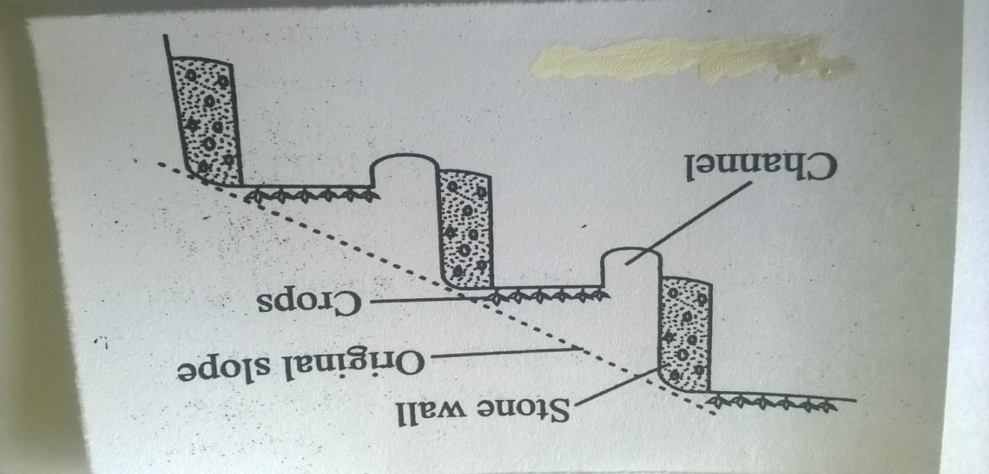

- Identify the type of terrace illustrated above. (1mk)
…………………………………………………………………………………………
- Under what two circumstances should the construction of the above terrace be justified. (2mks)
………………………………………………………………………………………..…………………………………………………………………………………………..……………………………………………………………………………………………..
- Name two other types of terraces. (2mks)
………………………………………………………………………………………………………………………………………………………………………………………………………………………………………………………………………………
- The diagrams below illustrate methods of harvesting trees in agro-forestry.Study them and answer the questions that follow.
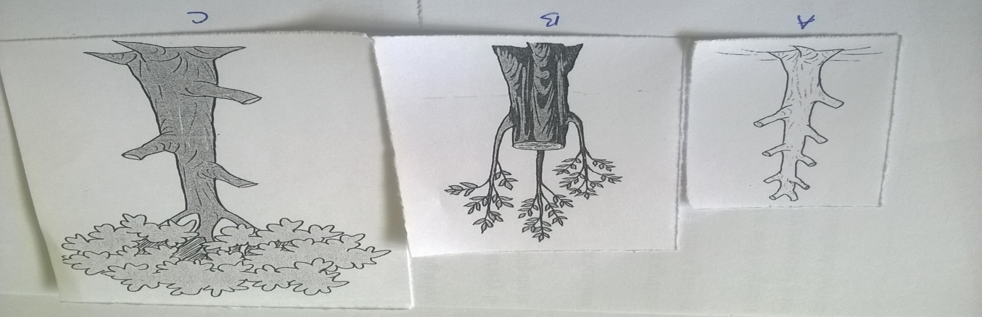
- Identify each of the methods illustrated A, B and C above. (3mks)
A………………………………………………………………………………………...
B………………………………………………………………………………………...
C………………………………………………………………………………………...

- Use the following crops to answer the questions that follow.
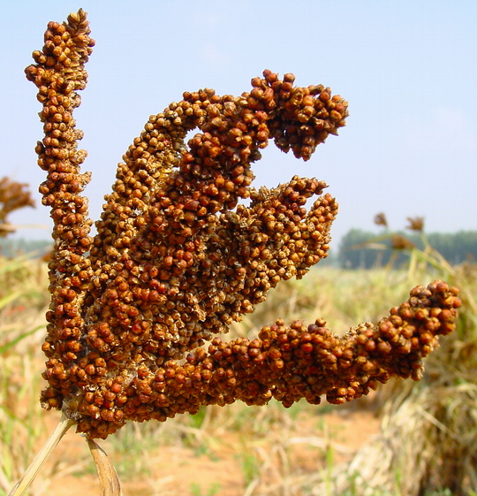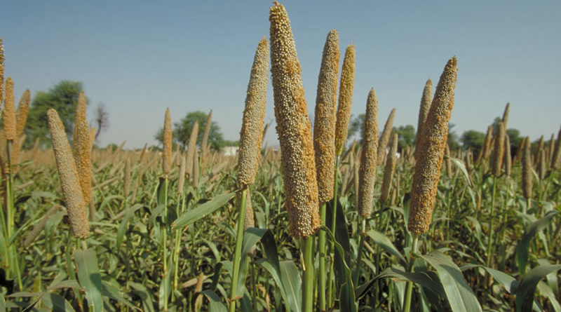
D E
- Name the crops labelled D and E above. (1mk)
D………………………………………………………………………………………...
E………………………………………………………………………………………...
- Why is crop D rarely destroyed by pests in the stores? (1mk)
………………………………………………………………………………………..……………………………………………………………………………………………..
- Name any two diseases that affect crop E. (2mks)
………………………………………………………………………………………..…………………………………………………………………………………………..……………………………………………………………………………………………..
- Calculate the elasticity of supply of maize when 10,000 bags of maize were supplied in oyugis market at a price of Kshs. 800 per bag and 15,000 bags supplied in the same market when the price changed to Kshs. 1,200 per bag. (Show your working) (3mks)

SECTION C (40MARKS)
- a) Explain ten factors influencing soil erosion. (10mks)
b) State five roles of trees in soil and water conservation. (5mks)
c) State five objectives of land tenure reform. (5mks)

- a) State five functions of agricultural society of Kenya. (5mks)
b) Explain ten factors influencing demand for a commodity. (10mks)
c) At the end of the year 31/12/2017 the following information was recorded on Jamii farm: perennial crops shs. 250,000, Bank loan shs. 230,000, Cash at hand shs. 5,000, Bank overdraft shs.35,000, Land 350,000, unpaid wages shs. 23,000, Debts receivable shs. 20,000, stocks in store shs. 25,000 and livestock shs. 200,000. Prepare a balance sheet for the farm. (5mks)

- a) Describe the production of tomatoes under the following:-
- Transplanting: (5mks)
- Field Management practices. (5mks)
b) Give six advantages of drip irrigation. (6mks)
c) Explain four factors that determine the quality of hay. (4mks)

………………………………………………………………………………………………..…………………………………………………………………………………………………..…………………………………………………………………………………………………..…………………………………………………………………………………………………..…………………………………………………………………………………………………..…………………………………………………………………………………………………..…………………………………………………………………………………………………..…………………………………………………………………………………………………..…………………………………………………………………………………………………..…………………………………………………………………………………………………..…………………………………………………………………………………………………..…………………………………………………………………………………………………..…………………………………………………………………………………………………..…………………………………………………………………………………………………..…………………………………………………………………………………………………..…………………………………………………………………………………………………..…………………………………………………………………………………………………..…………………………………………………………………………………………………..…………………………………………………………………………………………………..…………………………………………………………………………………………………..……………………………………………………………………………………………………..
………………………………………………………………………………………………..…………………………………………………………………………………………………..…………………………………………………………………………………………………..…………………………………………………………………………………………………..…………………………………………………………………………………………………..…………………………………………………………………………………………………..…………………………………………………………………………………………………..…………………………………………………………………………………………………..…………………………………………………………………………………………………..…………………………………………………………………………………………………..…………………………………………………………………………………………………..…………………………………………………………………………………………………..…………………………………………………………………………………………………..…………………………………………………………………………………………………..…………………………………………………………………………………………………..…………………………………………………………………………………………………..…………………………………………………………………………………………………..…………………………………………………………………………………………………..…………………………………………………………………………………………………..…………………………………………………………………………………………………..……………………………………………………………………………………………………..
………………………………………………………………………………………………..…………………………………………………………………………………………………..…………………………………………………………………………………………………..…………………………………………………………………………………………………..…………………………………………………………………………………………………..…………………………………………………………………………………………………..…………………………………………………………………………………………………..…………………………………………………………………………………………………..…………………………………………………………………………………………………..…………………………………………………………………………………………………..…………………………………………………………………………………………………..…………………………………………………………………………………………………..…………………………………………………………………………………………………..…………………………………………………………………………………………………..…………………………………………………………………………………………………..…………………………………………………………………………………………………..…………………………………………………………………………………………………..…………………………………………………………………………………………………..…………………………………………………………………………………………………..…………………………………………………………………………………………………..……………………………………………………………………………………………………..
………………………………………………………………………………………………..…………………………………………………………………………………………………..…………………………………………………………………………………………………..…………………………………………………………………………………………………..…………………………………………………………………………………………………..…………………………………………………………………………………………………..…………………………………………………………………………………………………..…………………………………………………………………………………………………..…………………………………………………………………………………………………..…………………………………………………………………………………………………..…………………………………………………………………………………………………..…………………………………………………………………………………………………..…………………………………………………………………………………………………..…………………………………………………………………………………………………..…………………………………………………………………………………………………..…………………………………………………………………………………………………..…………………………………………………………………………………………………..…………………………………………………………………………………………………..…………………………………………………………………………………………………..…………………………………………………………………………………………………..……………………………………………………………………………………………………..
………………………………………………………………………………………………..…………………………………………………………………………………………………..…………………………………………………………………………………………………..…………………………………………………………………………………………………..…………………………………………………………………………………………………..…………………………………………………………………………………………………..…………………………………………………………………………………………………..…………………………………………………………………………………………………..…………………………………………………………………………………………………..…………………………………………………………………………………………………..…………………………………………………………………………………………………..…………………………………………………………………………………………………..…………………………………………………………………………………………………..…………………………………………………………………………………………………..…………………………………………………………………………………………………..…………………………………………………………………………………………………..…………………………………………………………………………………………………..…………………………………………………………………………………………………..…………………………………………………………………………………………………..…………………………………………………………………………………………………..……………………………………………………………………………………………………..
………………………………………………………………………………………………..…………………………………………………………………………………………………..…………………………………………………………………………………………………......
………………………………………………………………………………………………..…………………………………………………………………………………………………..…………………………………………………………………………………………………..…………………………………………………………………………………………………..…………………………………………………………………………………………………..…………………………………………………………………………………………………..…………………………………………………………………………………………………..…………………………………………………………………………………………………..…………………………………………………………………………………………………..…………………………………………………………………………………………………..…………………………………………………………………………………………………..…………………………………………………………………………………………………..…………………………………………………………………………………………………..…………………………………………………………………………………………………..…………………………………………………………………………………………………..…………………………………………………………………………………………………..…………………………………………………………………………………………………..…………………………………………………………………………………………………..…………………………………………………………………………………………………..…………………………………………………………………………………………………..……………………………………………………………………………………………………..
………………………………………………………………………………………………..…………………………………………………………………………………………………..…………………………………………………………………………………………………......
………………………………………………………………………………………………..…………………………………………………………………………………………………………………………………………………………………………………………………………………………………………………………………………………………………………………………………………………………………………………………………………………………………………………………………………………………………………………………………………………………………………………………………………………

