Name ...…………………………………………………………. INDEX. No ………….
Candidate’s signature……………………………………………CLASS……………….

KASSU JET EXAMINATION
Kenya Certificate of Secondary Education
231/3
BIOLOGY
Paper 3
(Practical)
June, 2018
1 ³/₄ Hours
- Write your name, Index Number , class in the spaces provided above
- Write the date of examination in the space provided above
- Answer ALL the questions

- FOR EXAMINER'S USE ONLY

QUESTION | SCORE | CANDIDATES SCORE
1 | 12
2 | 15
3 | 13
TOTAL | 40

1. a)You are provided with specimen labelled Q. Remove the endosperm and crush using a motor and pestle. Add distilled water and obtain a solution. Decant the mixture to obtain solution Q1. Using the reagents provided, test the food present in solution Q1. (8marks)
Food | Procedure | Observation | Conclusion

b) Account for your observation in (a) above (3marks)
………………………………………………………………………………………………………………………………………………………………………………………………………………………………………………………………………………………………………………………………………………………………………………………………………………………………………………………………………………………………………………………………………………………………………………………………………………………………………………………………………………………………………………………………………………………
c) Name the type of germination represented in the specimen above (1 mark)
………………………………………………………………………………………………………………………………………………………………………………………………………………

2. a). You are provided with a photograph with part of human skeleton. Use it to answer questions that follow.
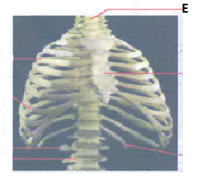
i) Name the first vertebra labelled E and state how it is adapted to its function. (4marks)
Name………………………………………………………………………………………………
Adaptations
………………………………………………………………………………………………………………………………………………………………………………………………………………………………………………………………………………………………………………………………………………………………………………………………………………………………………………………………………………………………………………………………………………………………………………………………………………………………………………………………………………………………………………………………………………………………………………………………………………………………………………………………………………………………………………………………………………………………………
ii) Name the structure in the skull that articulates with the vertebra E (1mark)
………………………………………………………………………………………………………

(iii) Below are two photographs of plants.
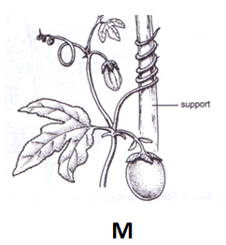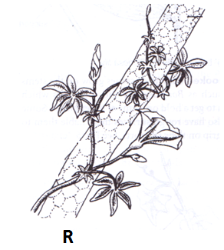
(a) Identify support structures used by the plants in photographs M and R shown above. (2marks)
……………………………………………………………………………………………………………………………………………………………………………………………………………………………………………………………………………………………………………………..
(b) Other than the structures illustrated above, name any one support structure in herbaceous plants. (1 mark)
………………………………………………………………………………………………………
b) The photographs below represent some skeletal materials obtained from a certain mammal.
Study them then answer the questions that follow.
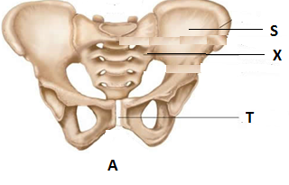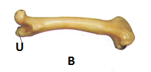

i) Identify fused bone labelled X (1mark)
………………………………………………………………………………………………………
ii) Name parts S and T on photograph A and part U on photograph B (3mrks)
iii) Name the type of joint formed at the proximal and distal end of bone B (2marks)
Proximal end…..……………………………………………………………………………………
Distal end…………………………………………………………………………………………...
iv) Name the type of joint found in structure labelled X (1mark)
………………………………………………………………………………………………………
3. a).You are provided with specimen labelled P. Using a sharp scalpel, cut the specimen longitudinally to obtain two halves. Draw a large well labelled diagram of one of the sections obtained. (5marks)

b) i) Identify the agent of pollination of the above specimen (1mark)
………………………………………………………………………………………………………
ii) Give three reasons for your answer above (3 marks)
………………………………………………………………………………………………………………………………………………………………………………………………………………………………………………………………………………………………………………………………………………………………………………………………………………………………
iii) Describe the floral parts of specimen P (4mark)
………………………………………………………………………………………………………………………………………………………………………………………………………………………………………………………………………………………………………………………………………………………………………………………………………………………………

