Name:………………………………………………………………………………………….Adm No:………….Class:……………..
Index No:……………………….
Date:…….………………………..
Signature:….……………………
MOI HIGH SCHOOL- KABARAK
COMMON 1 EXAMINATIONS
TERM TWO, 2018
FORM FOUR
CHEMISTRY 233/1, 2
Time: 2½ Hrs
INSTRUCTIONS TO CANDIDATES
- Answer ALL questions in the spaces provided.
- All workings must be clearly shown.
- Scientific silent calculators or KNEC mathematical tables may be used.

FOR EXAMINER’S USE ONLY

SECTION | MAXIMUM SCORE | CANDIDATE’S SCORE
A | 50
B | 50
TOTAL | 100

SECTION A (50 marks)

1. Kibelat(K), Laina(L) and Mumbua(M) are long distance international athletes. Paper chromatography was used to test for the presence of illegal drugs in their urine samples. The diagram below shows the chromatogram with the illegal drug labeled N.
- Who among them tested positive for the illegal drug? Explain. 2mks
…………………………………………………………………………………………………………………………………………………………………………………………………………………………………………………………………………………………………………………………………………………………………………………………………………………………………………………………………………………………………………………………………………………………………………………………………………
- Explain what is meant by ‘solvent front’ 1mk

………………………………………………………………………………………………………………………………………………………………………………………………………………………………………………………………………………………………………………………………………………………………………………………………………………………………………………………
2. X g of Potassium hydroxide was dissolved in distilled water to make 400cm³ of solution. 200cm³ of the solution required 200cm³ of 2M nitric (V) acid for complete neutralization. Calculate the value of x (K=39, O=16, H=1) 3mks
………………………………………………………………………………………………………………………………………………………………………………………………………………………………………………………………………………………………………………………………………………………………………………………………………………………………………………………………………………………………………………………………………………………………………………………………………………………………………………………………………………………………………………………………………………………………………………………………………………………………………………………………………………………………………………
3. In the equilibrium given below, identify the ‘acid’ in the backward reaction. Explain your answer. 2mks
NH_{3(g)} + H₂O_{(l)} NH₄⁺_{(aq)} + OH⁻_{(aq)}
………………………………………………………………………………………………………………………………………………………………………………………………………………………………………………………………………………………………………………………………………………………………………………………………………………………………………………………
4. The graph below is a cooling curve of a substance from gaseous state to solid state.
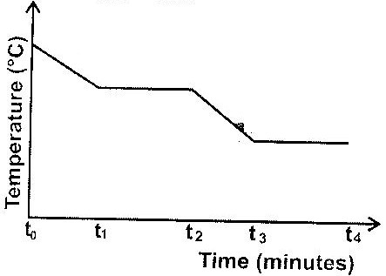

Give the name of the:
a) Process taking place between t₀ and t₁; (1mk)
……………………………………………………………………………………………………………………………………………………………………………………………………………………………………………………………………………………………………
b) Energy change that occurs between t₃ and t₄ (1mk)10
……………………………………………………………………………………………………………………………………………………………………………………………………………………………………………………………………………………………………
5. A solution of hydrogen chloride gas in methylbenzene does not react with metal carbonates. However on adding water and then shaking the resulting mixture, there is vigorous effervescence. Explain each of the above observation. 3mks
…………………………………………………………………………………………………………………………………………………………………………………………………………………………………………………………………………………………………………………………………………………………………………………………………………………………………………………………………………………………………………………………………………………………………………………………………………
6. Ngigi, the laboratory technician at Kapsokwony High school accidentally mixed liquids suspected to be benzene (B.P. 78 ⁰C) and Carbon (IV) sulphide (B.P. 46.24 ⁰C). He has a problem of separating the mixture and seeks your help. Describe to him: (1mk)
a) The method he should use
……………………………………………………………………………………………………………………………………………………………………………………………………………………………………………………………………………………………………
b) At least FOUR major apparatus he should use (2mks)
………………………………………………………………………………………………………………………………………………………………………………………………………………………………………………………………………………………………………………………………………………………………………………………………………………………………………………………
c) The precautions he should take when carrying out the separation. (2mks)
…………………………………………………………………………………………………………………………………………………………………………………………………………………………………………………………………………………………………………………………………………………………………………………………………………………………………………………………………………………………………………………………………………………………………………………………………………
7. The diagram below shows collection of two gases P and Q in the laboratory.
- Name the two methods used
(i) ……………………………………………………………………………… (½ mk)

(ii) …………………………………………………………………………….. (½ mk)

b) Compare the densities of P and Q? (2mks)
……………………………………………………………………………………………………………………………………………………………………………………………………………………………………………………………………………………………………
8. The set-up below was used to prepare a sample of oxygen gas. Study it and answer questions that follow.
Solid A
Water

a) Complete the above diagram to show how oxygen is collected. 2mks
b) Identify solid A. 1mk
……………………………………………………………………………………………………………………………………………………………………………………………………………………………………………………………………………………………………
c) Write the equation for the reaction occurring in the conical flask 1mk
……………………………………………………………………………………………………………………………………………………………………………………………………………………………………………………………………………………………………
9. (i) Copper and graphite conducts electricity. Explain this phenomenon using their structure and bonding. 2mks

…………………………………………………………………………………………………………………………………………………………………………………………………………………………………………………………………………………………………………………………………………………………………………………………………………………………………………………………………………………………………………………………………………………………………………………………………………
- Diamond is an allotrope of carbon and is the hardest known substance. Explain. 1mk
…………………………………………………………………………………………………………………………………………………………………………………………………………………………………………………………………………………………………………………………………………………………………………………………………………………………………………………………………………………………………………………………………………………….
10. A student was provided with the organic samples A and B
A- CH₃CH₂COOH
B- CH₃ CH₂CH₂OH
Describe a chemical method on how the student would distinguish the two. 2mks
……………………………………………………………………………………………………………………………………………………………………………………………………………………………………………………………………………………………………………………………………………………………………………………………………………………………………………………………………………………………………………………………………………………………………………………………………………………………………………………………………………………………………………………………………………………………
11. 10cm³ of gaseous hydrocarbon was mixed with 90cm³ of oxygen and sparked. The resulting volume at r.t.p was 70cm³ which was reduced to 30cm³ on shaking with sodium hydroxide. Find the empirical formula of the hydrocarbon. 3mks
……………………………………………………………………………………………………………………………………………………………………………………………………………………………………………………………………………………………………………………………………………………………………………………………………………………………………………………………………………………………………………………………………………………………………………………………………………………………………………………………………………………………………………………………………………………………
12. a) Write an ionic equation for the reaction between zinc (II) ions in solution and excess ammonia solution. 1mk
……………………………………………………………………………………………………………………………………………………………………………………………………………………………………………………………………………………………………
b) Name the complex ion formed in the reaction (a) above 1mk
……………………………………………………………………………………………………………………………………………………………………………………………………………………………………………………………………………………………………
13. A fixed mass of gas occupies 105cm³ at -14⁰C and 65cmHg pressure. At what temperature in ⁰C will it have a volume of 15cm³ if the pressure is adjusted to 690 mmHg pressure? 3mks
…………………………………………………………………………………………………………………………………………………………………………………………………………………………………………………………………………………………………………………………………………………………………………………………………………………………………………………………………………………………………………………………………………………………………………………………………………
14. Study the information below and answer the questions that follow. A mixture contains the three gases; Ethene, Hydrogen and Ammonia.
 | Water | Concentrated sulphuric acid | Concentrated sodium hydroxide
Ammonia | Very soluble | Very soluble | Very soluble
Hydrogen | Slightly soluble | Insoluble | Insoluble
Ethene | Slightly soluble | Soluble | Insoluble
(i) Explain how you would obtain a sample of hydrogen gas from a mixture of the three gases. 2mks
……………………………………………………………………………………………………………………………………………………………………………………………………………………………………………………………………………………………………………………………………………………………………………………………………………………………………………………………………………………………………………………………………………………………………………………………………………………………………………………………………………………………………………………………………………………………
(ii) Write an equation for the reaction between ethene and concentrated sulphuric acid.
1mk
……………………………………………………………………………………………………………………………………………………………………………………………………………………………………………………………………………………………………
15. (i) When burning magnesium was lowered in a gas jar full of carbon (IV)oxide, It continued to burn but when burning zinc was lowered into a gas jar full of carbon (IV)oxide, It was put off. Explain the above observations. 2mks
…………………………………………………………………………………………………………………………………………………………………………………………………………………………………………………………………………………………………………………………………………………………………………………………………………………………………………………………………………………………………………………………………………………………………………………………………………
16. State and explain the observation you would make when aqueous sulphuric (VI) acid is added to anhydrous copper (II) sulphate. 2mks
…………………………………………………………………………………………………………………………………………………………………………………………………………………………………………………………………………………………………………………………………………………………………………………………………………………………………………………………………………………………………………………………………………………………………………………………………………
17. Dr. Khatialla and her students set up an experiment to determine the solubility of potassium chlorate in water at 23⁰c. They obtained the following results.
Mass of dish 15.86g
Mass of dish + saturated solution at 23⁰c 26.86g
Mass of dish + solid potassium chlorate after evaporation to dryness 16.86g
Calculate the mass of the saturated solution containing 60g of water at 23⁰c. 3mks
………………………………………………………………………………………………………………………………………………………………………………………………………………………………………………………………………………………………………………………………………………………………………………………………………………………………………………………………………………………………………………………………………………………………………………………………………………………………………………………………………………………………………………………………………………………………………………………………………………………………………………………………………………………………………………
18. Consider the following data concerning the compounds AlCl₃ and MgCl₂
 | AlCl₃ | MgCl₂
Action of heat | Sublimes at 453K | Melts at 1690K
R.M.M (Vapour phase) | 267 | 95
Action with water | Reacts (hydrolysed) | Dissolves
Using the data above:
Deduce the type of bonding in
(i) AlCl₃ 1mk
……………………………………………………………………………………………………………………………………………………………………………………………………………………………………………………………………………………………………
(ii) MgCl₂ 1mk
……………………………………………………………………………………………………………………………………………………………………………………………………………………………………………………………………………………………………

SECTION B (50 MARKS)

1. (a) Name chief ore from which copper metal is extracted ( 1mk)
……………………………………………………………………………………………………………………………………………………………………………………………………………………………………………………………………………………………………
(b) The flow chart below shows a sequence of reaction starting with copper. Study it and answer the questions that follows
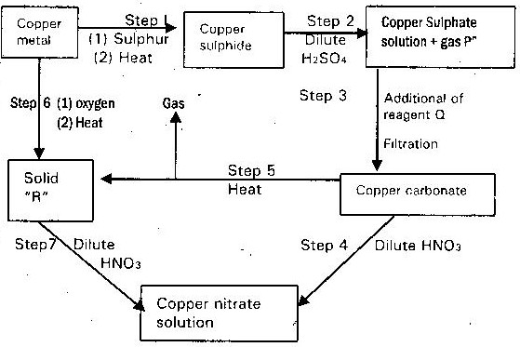

(i) Identify gas “p” and reagent Q and “R” (2 mks)
P…………………………………………………………………………………………………………………………………………………Q………………………………………………………………………………………………………………………………………………
R………………………………………………………………………………………………………………………………………….
(ii) Write an equation for the reaction that takes place in step 5 (1 mk)
……………………………………………………………………………………………………………………………………………………………………………………………………………………………………………………………………………………………………
(iii) State the observation made in steps 4 and 7 (1mk)
Step 4 ………………………………………………………………………………………………………………………………………
Step 7………………………………………………………………………………………………………………………………………..
(c) Bronze is an alloy of copper and another metal
(i) Name the other metal (1 mk)
…………………………………………………………………………………………………………………………………………………
(ii) Give one use of bronze (1 mk)7
……………………………………………………………………………………………………………………………………………………………………………………………………………………………………………………………………………………………………
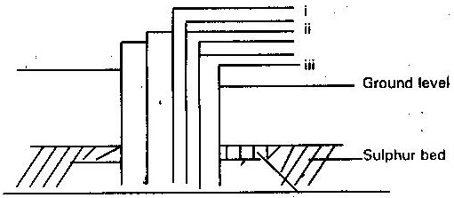
2. The diagram below illustrates how sulphur is extracted by frasch process

- Identify the pipe through which superheated water is pumped in

……………………………………………………………………………………………………………………………… (1 mk)
(b) The equation below shows the oxidation of sulphur (IV) oxide to sulphur (VI) oxide in the contact process
2SO₂ (g) + O₂ (g) →2 SO₃(g) ∆H = - 196KJ
(i) Name the catalyst used in this process (1 mk)
……………………………………………………………………………………………………………………………………………………………………………………………………………………………………………………………………………………………………
(ii) State and explain the effect on the yield of sulphur (VI) oxide when
I. The temperature is increased (2 mks)
………………………………………………………………………………………………………………………………………………………………………………………………………………………………………………………………………………………………………………………………………………………………………………………………………………………………………………………
II. The amount of oxygen is increased (2 mks)
………………………………………………………………………………………………………………………………………………………………………………………………………………………………………………………………………………………………………………………………………………………………………………………………………………………………………………………
(iii) Describe how sulphur (VI) oxide is converted to sulphuric (VI) acid in the contact process. (2 mks)
………………………………………………………………………………………………………………………………………………………………………………………………………………………………………………………………………………………………………………………………………………………………………………………………………………………………………………………
(c) Ammonium sulphate is a fertilizer produced by passing ammonia gas into concentrated sulphuric (VI) acid
(i) Write the equation for the reaction (1 mk)
……………………………………………………………………………………………………………………………………………………………………………………………………………………………………………………………………………………………………
(ii) Calculate the mass in kg of sulphuric (VI) acid required to produce 2.5 tonnes of fertilizer (S= 32.0) (0= 16.0) (N = 14.0) (H. 1.0) (3 mks)12
………………………………………………………………………………………………………………………………………………………………………………………………………………………………………………………………………………………………………………………………………………………………………………………………………………………………………………………
…………………………………………………………………………………………………………………………………………………

3. Use the standard electrode potential for A, B, C, D and F given below to answer the questions that follows. The letters do not represent the actual symbols of the elements

E^{θ} (volts)
A²⁺ (aq) + 2e → A(s) - 2.90V
B²⁺ (aq) + 2e →B(s) - 2.38V
C⁺ (aq) + e→ ½ C₂(g) - 0.00V
D²⁺ (aq) + 2e → D(s) + 0.34V
½ F₂(g) + e → F⁻ (aq) + 2.87V
- Which element is likely to be hydrogen? Give a reason for your answer (2mks)
…………………………………………………………………………………………………………………………………………………………………………………………………………………………………………………………………………………………………….

(ii) What is E^{θ} value for the strongest reducing agent? (1 mk)
……………………………………………………………………………………………………………………………………………………………………………………………………………………………………………………………………………………………………
(iii) In the space provide, draw a labeled diagram of the electrochemical cell that would be obtained when a half cells of element “B” and “D are combined (3mks)

(iv) Calculate the E^{θ} value of the electrochemical cell constructed in (iii) above (1 mk)

……………………………………………………………………………………………………………………………………………………………………………………………………………………………………………………………………………………………………

4. (a) In which homologous series do the following compounds belong?
(i) CH₃CCCH₃ (1 mk)
……………………………………………………………………………………………………………………………………………………………………………………………………………………………………………………………………………………………………
(ii) CH₃CH₂COOCH₂CH₂CH₂CH₃ (1 mk)
……………………………………………………………………………………………………………………………………………………………………………………………………………………………………………………………………………………………………
(b) Raw rubber is vulcanized during manufacture of natural rubber.
(i) What vulcanization? (1mk)
……………………………………………………………………………………………………………………………………………………………………………………………………………………………………………………………………………………………………
(ii) Why is the process necessary? (1 mk)
……………………………………………………………………………………………………………………………………………………………………………………………………………………………………………………………………………………………………
(c) Study the scheme given and answer the questions that follow
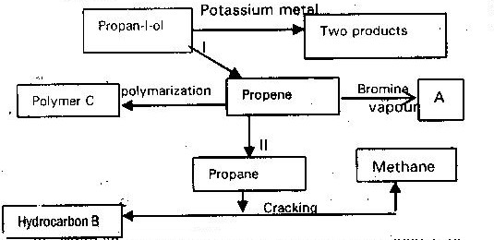

- Write an equation for the reaction between propan-1-ol and potassium metal (1mk)

……………………………………………………………………………………………………………………………………………………………………………………………………………………………………………………………………………………………………
- Name process I and II (2 mks)

I……………………………………………………………………………II ………………………………………………………………
- Identify the products “A” and “B” (2 mks)

“A”………………………………………………………………“B”…………………………………………………………………………
- Name ONE catalyst used in process II (1 mk)
……………………………………………………………………………………………………………………………………………………………………………………………………………………………………………………………………………………………
- Draw the structural formula of the repeating unit in the polymer “C” (1 mk)
……………………………………………………………………………………………………………………………………………………………………………………………………………………………………………………………………………………………………
- State two industrial uses of methane (2 mks)
………………………………………………………………………………………………………………………………………………………………………………………………………………………………………………………………………………………………………………………………………………………………………………………………………………………………………………………
5.a)Give the name of reagent which when heated with concentrated hydrochloric acid produce chlorine gas. (1 mk)
……………………………………………………………………………………………………………………………………………………………………………………………………………………………………………………………………………………………………
b)A student out to prepare iron III chloride using the apparatus shown in the diagram below.

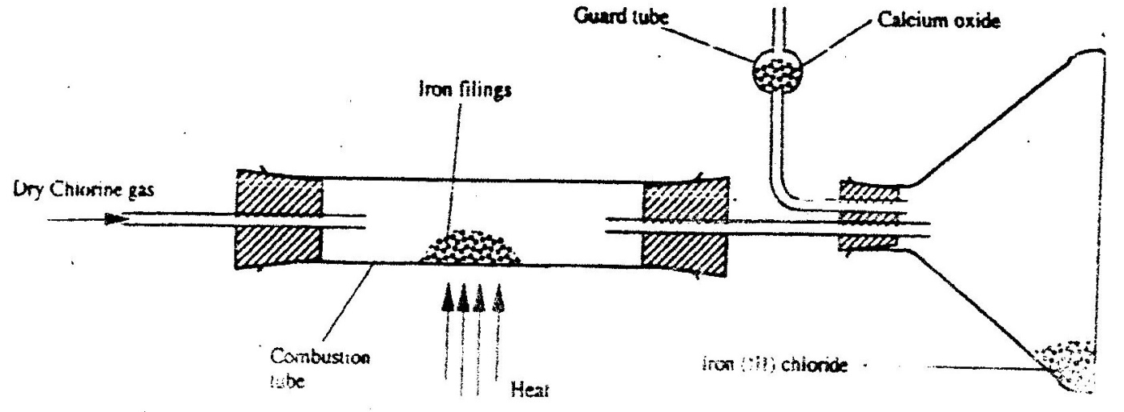

i) Explain why:
I. It is necessary to pass chlorine gas through the apparatus before heating begins. (1 mk)
………………………………………………………………………………………………………………………………………………………………………………………………………………………………………………………………………………………………………………………………………………………………………………………………………………………………………………………
II. Calcium oxide is preferred to anhydrous calcium chloride in the guard tube. (1 mk) ……………………………………………………………………………………………………………………………………………………………………………………………………………………………………………………………………………………………………
ii) What property of iron (III) chloride makes it possible to be collected as shown in the diagram?
(1mk) …………………………………………………………………………………………………………………………………………………
iii) Write an equation form one chemical reaction that took place in the guard tube. (1 mk)
…………………………………………………………………………………………………………………………………………………
iv) The total mass of iron (III) chloride formed was found to be 0.5g.
Calculate the volume of chlorine gas the reacted with iron. (Fe - = 56.0,Cl = 35.5 and Molar gas volume at 298K is 24,000cm³ (2 mks)
…………………………………………………………………………………………………………………………………………………………………………………………………………………………………………………………………………………………………………………………………………………………………………………………………………………………………………………………………………………………………………………………………………………………………………………………………………...C) When hydrogen sulphide gas was passed through a solution of iron (III) chloride, the following observation were made:
i) The colour of the solution changed from reddish – brown to green and a yellow solid was deposit .Explain these observations. (2 mks)
…………………………………………………………………………………………………………………………………………………………………………………………………………………………………………………………………………………………………………………………………………………………………………………………………………………………………………………………………………………………………………………………………………………………………………………………………………...
……………………………………………………………………………………………………………………………………………………………………………………………………………………………………………………………………………………………………...
d) State and explain the observations that would be made if a moist blue litmus paper was placed in a gas jar full of chlorine gas. (2 mks)
……………………………………………………………………………………………………………………………………………………………………………………………………………………………………………………………………………………………………
……………………………………………………………………………………………………………………………………………………………………………………………………………………………………………………………………………………………………...
…………………………………………………………………………………………………………………………………………………...

