NAME____________________________________________ADM.NO._______CLASS_____
INDEX NO. SIGNATURE:____________ DATE:_________________
232/2

PHYSICS

Paper 2

2 Hours

MOKASA JOINT EXAMINATION 2018

Instructions to Candidates
1. Write your name,index number, class and admission number in the spaces provided above.
2. This paper consists of TWO sections: Sections A and B.
3. Answer ALL the questions in sections A and B in the spaces provided.
4. ALL working MUST be clearly shown.
5. Mathematical tables and electronic calculators may be used.

For Examiner’s Use Only
SECTION | QUESTION | MAXIMUM SCORE | CANDIDATE’S SCORE
A | 1-10 | 25
B | 11 | 11
 | 12 | 06
 | 13 | 08
 | 14 | 10
 | 15 | 14
 | 16 | 06
TOTAL SCORE |  | 80

This paper consists of 11 printed pages.
Students should check the question paper to ensure that all the pages are printed as indicated and no questions are missing.

SECTION A,(25MARKS)
Attempt all questions in this section

1. The diagram below represents method of magnetization. Complete the circuit such that both ends become N-pole (1mark)
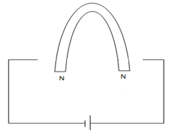

2. A polythene rode may be charged negatively by rubbing with a cloth, but a brass rod held in the hand cannot be charged this way.
(i). State clearly what happens when the polythene is being charged. (1mark)
………………………………………………………………………………………………………………………………………………………………………………………………………………………………………………………………………………………………………………………

(ii) . Explain why the brass cannot be charged by rubbing. (1mark)
……………………………………………………………………………………………………………………………………………………………………………………………………………………………………………………………………………………………………………………

3. A man stands between two walls 200m from one wall. When he claps his hands he hears the first echo after 0.60 seconds and a second echo 0.25 seconds later. Calculate the distance between the two walls. (3marks)
………………………………………………………………………………………………………………………………………………………………………………………………………………………………………………………………………………………………………………………
…………………………………………………………………………………………………………………………………………………………………………………………………………………………………………………………………………………………………………………….

4. Differentiate between transverse wave and longitudinal wave giving example of each. (2mks)
………………………………………………………………………………………………………
…………………………………………………………………………………………………….. ………………………………………………………………………………………………………
5.The figure below shows two mirrors M1 and M2 are inclined at right angles to each other.
Diagram drawn to scale

Trace the reflection of the ray through the two mirrors and find the angle between the incident ray and reflected ray of mirror M2. (2 marks)
…………………………………………………………………………………………………………………………………………………………………………………………………………………………………………………………………………………………
6. A long vertical wire carrying current passes through a horizontal bench. State the rule which gives the relation between the direction of current and that of the field. (2marks)
…………………………………………………………………………………………………………………………………………………………………………………………………………………………………………………………………………………………………………………

7. Draw a semi – circle of radius 2cm to represent the cross section of a spherical concave mirror. A small object is placed on the principal axis of the concave mirror of focal length 10cm. determine the position of the image when the object is 15cm from the mirror. (3marks)
………………………………………………………………………………………………………………………………………………………………………………………………………………………………………………………………………………………………………………………
………………………………………………………………………………………………………
8 A radio station is tuned at 1200MHZ. determine the wavelength of the wave.(Take speed of light to be C = 3x10⁸m/s ) (2marks)
………………………………………………………………………………………………………………………………………………………………………………………………………………………………………………………………………………………………………………………
9. In a young double slit experiment using sodium light, seven bright fringes were viewed through a micrometer eye piece. If the path difference of the fourth bright fringe was 2.8 x 10 ⁻⁴
mm. Determine the frequency of the light. Take the speed of sodium light as 2.8 x10⁸m/s.
(3marks)
P

S2
O
S1

R

……………………………………………………………………………………………………. ………………………………………………………………………………………………………………………………………………………………………………………………………………………………………………………………………………………………………………………
………………………………………………………………………………………………………

10. The figure below shows the diagram of a simple cell.

A
B

(i). state the part labeled A (1mark)
………………………………………………………………………………………………………State the function of the part labeled B (1mark)
………………………………………………………………………………………………………

SECTION B,( 55 MARKS)
11. (a) Define power of a lens (1 mark)
………………………………………………………………………………………………………………………………………………………………….……………………………………………………………
(b) The diagram below shows a compound microscope. The objective lens L₁ has a focal length of 8cm while the eye piece lens L₂ is of focal length 25cm. an object O is placed in front of the objective lens at a distance of 12cm. The system forms a final image I₂ at a distance of 30cm from L₂.

F_{O}
F_{e}
F_{O}
F_{e}
L₁
L₂
O
Determine the
- position of the image formed by the objective lens L₁ (3 marks)
………………………………………………………………………………………………………………………………………………………………………………………………………………………………
……………………………………………………………………………………………………………………………………………………………………………………………………………………………...
……………………………………………………………………………………………………………………………………………………………………………………………………………………………..
- distance of separation of the lenses L₁ and L₂ (2 marks)
……………………………………………………………………………………………………………………………………………………………………………………………………………………………….
……………………………………………………………………………………………………………….
- On the same diagram draw rays and the subsequent final imageI₂ formed by the lens L_{2.} (3marks)

- state the purpose of lenses
(i) L₁ ……………………………………………………….. ( 1mark)

(ii) L_{2……………………………………………………………….} (1 mark)
12. (a) An electrical bulb is rated 240V, 100W. Explain the meaning of this rating. (1 mark)
………………………………………………………………………………………………………………………………………………………………………………………………………………………………..
(b) How many bulbs can be safely lit in the above connection if a current of 5A flows through the circuit (1mark)
………………………………………………………………………………………………………………………………………………………………….……………………………………………………………………………………………………………………………………………………………………………
(c) You are provided with the following apparatus;
A battery of four cells, thick copper connecting wire, variable resistor, stops watch.
A coil of resistance wire, switch, ammeter,
Sketch a circuit to be used to demonstrate heating effect of an electric current (2 marks)
……………………………………………………………………………………………………………………………………………………………………………………………………………………………………………………………………………………………………………………………………………………………………………………………………………………………………………………………………………………………………………………………………………………………………………………………………………………………………………………………………………………………………………………………………………………………………………………………………………..
(d)Explain how heating in the resistance wire is achieved. (1 mark)
………………………………………………………………………………………………………………………………………………………………….
………………………………………………………………………………………………………………
(e)Why are thick wires used in the connection of the circuit? (1 mark)
……………………………………………………………………………………………………………..
…………………………………………………………………………………………………………….

13(a)Show that, the effective capacitance for a series connection is given by; (2 marks)
¹/C_{T} = ¹/C₁ + ¹/C₂ +¹/C₃
……………………………………………………………………………………………………………………………………………………………………………………………………………………………….
……………………………………………………………………………………………………………………………………………………………………………………………………………………………..
……………………………………………………………………………………………………………………………………………………………………………………………………………………………..
………………………………………………………………………………………………………………………………………………………………….
(b)A 6µF capacitor is charged to a potential difference of 200V and separated. It is then connected across a 12 µF capacitor. Determine;
(i) The resultant voltage in the combination. (2 marks)
………………………………………………………………………………………………………………………………………………………………………………………………………………………………..
……………………………………………………………………………………………………………………………………………………………………………………………………………………………..
………………………………………………………………………………………………………………………………………………………………….
(ii) The resultant charge on the capacitors (2 marks)
………………………………………………………………………………………………………………………………………………………………………………………………………………………………
……………………………………………………………………………………………………………………………………………………………………………………………………………………………….
………………………………………………………………………………………………………………………………………………………………….
(iii) The final energy stored in the capacitors (2 marks)
………………………………………………………………………………………………………………………………………………………………………………………………………………………………………………………………………………………………………………………………………………………………………………………………………………………………………………………………………………………………………………………………………………………………………………

14.a)The figure below shows the features of a cathode ray tube
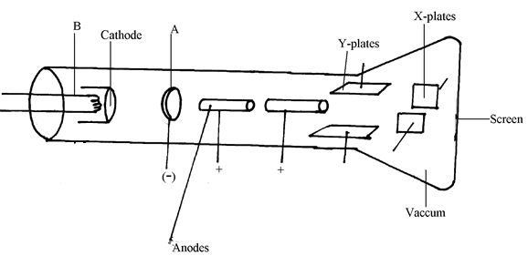
i) Name the parts labeled A and B. (1mark)
A ……………………
B ……………………
ii) Explain how the part labeled A achieves its function. (2mark)
……………………………………………………………………………
…………………………………………………………………………….
……………………………………………………………………………
iii) State Two functions of the anodes. (2marks)
………………………………………………………………………..
…………………………………………………………………………
iv) Giving a reason name one metal oxide used at the cathode. (2marks)
……………………………………………………………………………..
………………………………………………………………………….
b) The time base calibration of the C.R.O was set at 20milliseconds per centimeters and the Y-gain at 5 volts per centimeter. If an a.c signal input produced a wave whose peak voltage was 20V, how many centimeters did it rise. (2 marks)
……………………………………………………………………………………….
………………………………………………………………………………………
…..…………………………………………………………………………………..
c) Give a reason why a T.V screen is wider and the tube is shorter than a C.R.O.
(1 mark)
…………………………………………………………………………………………………………..

15. a) State Lenz’s law of electromagnetic induction (1mk)
……………………………………………………………………………………………………………....………………………………………………………………………………………………………………………………………………………………………………………
b) The diagram below shows an induction coil used to produce sparks.
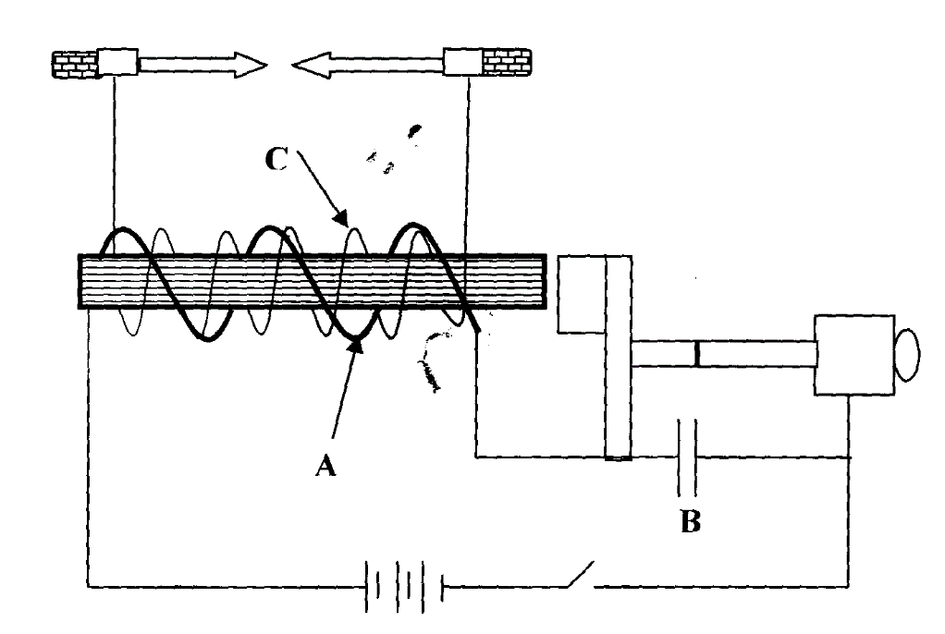

(i) Name parts labeled A and C (2mks)
A…………………………………………………………………
C…………………………………………………………………
(ii) Briefly explain how the induction coil works. (4mks)
……………………………………………………………………………………………………………....……………………………………………………………………………………………………………………………………………………………………………………………....……………………………………………………………………………………………………………………………………………………………………………………………....………………………………………………………………………………………………………………………………………………………………………………………………………………………………………………………………………………………………………………………………………………

d) A transformer is used on a 240V a.c supply to deliver 12A at 120V to a heating coil. If 20% of energy taken from the supply is dissipated in the transformer.
i) Calculate the current in the primary coil. (2mks)
……………………………………………………………………………………………………………....……………………………………………………………………………………………………………………………………………………………………………………………....………………………………………………………………………………………………………………
ii) Account for two causes of the 20% energy dissipation in the transformer above.(2mks)
……………………………………………………………………………………………………………....……………………………………………………………………………………………………………………………………………………………………………………………....………………………………………………………………………………………………………………
e) The diagram below is a simplified illustration of an E.M.F. generator.
(i) Show the direction of induced current through R when the coil is in the position shown in the diagram. (1mk)
(ii) State and explain two ways of increasing the amount of induced current in this set up. (2mks)
……………………………………………………………………………………………………………....……………………………………………………………………………………………………………………………………………………………………………………………....………

16. a) A length of a power transmitting cable has a resistance of 10Ω and is transmitting 11kV and a current of 1A. If the voltage is stepped up to 160kV by a transformer, calculate the power received by the consumer. (2mks)
……………………………………………………………………………………………………………....……………………………………………………………………………………………………………………………………………………………………………………………….……………………………………………………………………………………....……………………………………………………………………………………………………………………………………………………………………………………………....……………………………………
b) The figure below shows a three-pin plug.
Y

Z
X

- Identify the wires X and Z. (2mks)
X………………………………………………………………………………………………
Z………………………………………………………………………………………………
- Give the colour code of the wire connection marked Z. (1mk)
………………………………………………………………………………………………
- Give a reason why the pin marked Y is normally longer than the other two pins. (1mk)
……………………………………………………………………………………………………………....………………………………………………………………………………………………………………………………………………………………………………………

