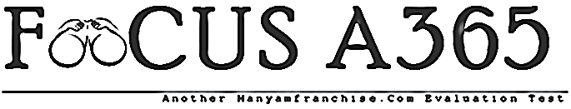

FORM 1 TERM 1 BIOLOGY EXAMINATIONS 2018

NAME__________________________________ADM NO. _____________

Answer all the questions in the spaces provided
- a) Define biology (1mk)

b) Explain the meaning of the following (3mks)

- Zoology

- Taxonomy

- Entomology

- State 3 reasons why living organisms need food. (3mks)

- List 5 characteristics of living things (5mks)

- The diagram below shows an instrument used in the study of biology.

- What is its name? (1mk)

- Name the parts labeled (3mks)
A
B
C
- State the function of the apparatus shown (1mk)

- State 5 external features of plants (5mks)

- A student examined specimen A using a magnifying lens. He then drew the illustrations labeled B.

Calculate the magnification of the drawing of the drawing. (3mks)

- Examine the diagrams below
- Name the organisms. (2mks)

- List the observable features in the organisms in the table below. (3mks)

- a) list 3 types of variations in plant leaves. (3mks)

b)Draw diagrams to illustrate any of the two variations listed in (a) above. (4mks)

9. a) State the root system shown in the diagram X and Y below.

X___________________ Y________________________ (2mks)
b) State the structural difference between the 2 root systems and give an example of
a plant bearing each type of root system. (2mks)

x y

Example of plant : X (2mks)

Y
10.State 3 differences between plants and animals. (3mks)

11. Name 3 observable features found in each of the animals below.
(a) rat (3mks)

(b) Bird (3mks)

12. Name the structures used for locomotion in the following animals. (4mks)
Fish

Insect

Birds

13. draw a well labeled diagram of a dicotyledonous leaf. (4mks)

