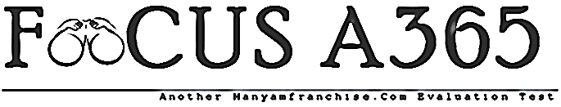

FORM 1 TERM 1 CHEMISTRY EXAMINATIONS 2018

- State four preventive measure of drug –abuse.(4mks)
……………………………………………………………………………………………………………………………………………………………………………………………………………………………………………………………………………………………………………………………………………………………………………………………………………………………………………………………………………………………………………………………………
2. State under which conditions are the following flame formed in the laboratory. 2mks
- Luminous…………………………………………………………………..
- Non- luminous…………………………………………………………..
3 Define the following terms.
- Solute 1mks
……………………………………………………………………………………………………………………………………………………………………………………………………………………………………………………………………………………………………………………..
- Saturated solution 1mks
………………………………………………………………………………………………………………………………………………………………………………………………………………………………………………………………………………………………………………………
4. State 4 differences between luminous and luminous and non luminous flame.
Luminous flame non luminous flame

…………………………………………………………………………………………………………………………………………………………………………………………………………………………………………………………………………………………………………………………………………………………………………………………………………………………………………………………………………………………………………………………………………………………………………………………………………………………………………………………………………………………………………………………………………………………………………………………………………………………………………………………………………………………………………………………………………………………………………………………………………………………………………………………………………………

(8mks)
5 The diagram below shows a Bunsen burner when in use.
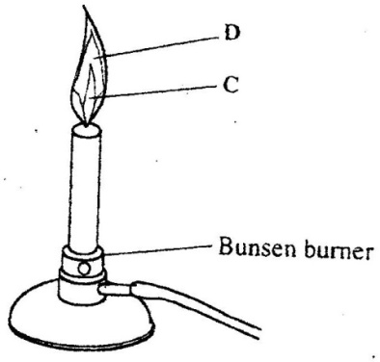

Name the regions labelled C and D. (2 marks)
................................................................................................................................................................................................................................................................................................................................................
6. Define the term chemistry (2mks
…………………………………………………………………………………………………………………………………………………………………………………………………………………………………………………………………………………………………………………………………………………………………………………………………………………………………………………………………………………………………………………………………………….
7 .Name two drugs that commonly abused in Kenya today and in each case give its effect. (4mks
……………………………………………………………………………………………………………………………………………………………………………………………………………………………………………………………………………………………………………………………………………………………………………………………………………………………………………………………………………………………………………………………………………………………………………………………………………………………………………………………………………………………………………………………..
8 .Give the apparator which is used for the following purposes: 3mks
  - Measuring time……………………………………………………………………………………………………..…
  - Measuring weight……………………………………………………………………………………………………..
  - Source of heat……………………………………………………………………………………………………………..
9. State six safety laboratory rule (6mks
…………………………………………………………………………………………………………………………………………………………………………………………………………………………………………………………………………………………………………………………………………………………………………………………………………………………………………………………………………………………………………………………………………………………………………………………………………………………………………………………………………………………………………………………………………………………………………………………………………………………………………………………………………………………………………………………………………………………………………………………………………………………………………………………………………………………………………………………………………………………………………………………………………………………………………………………………………………………………………………………………………………………………………………………………………………………………………………………………………………………………………………………………………………………………………………………………………………………………………………………………………………………………………………………………………………………………………………………………………………………...
10. state the use of the following apparatus (5mks
- Burrete……………………………………………………………………………………………………………………………………………………
- Test tube…………………………………………………………………………………………………………………………………………………
- Mortar and pestle……………………………………………………………………………………………………………………………………
- Test tube holder………………………………………………………………………………………………………………………………………
- Beaker…………………………………………………………………………………………………………………………………………………………….
11 What is a flame? (1mk
……………………………………………………………………………………………………………………………………………………………………..
12. Give four techniques of separating mixtures (4mks
…………………………………………………………………………………………………………………………………………………………………………………………………………………………………………………………………………………………………………………………………………………………………………………………………………………………………………………………………………………………………………………………………………………………………………………………………………………………………………………………………………………………………………………………….

13 .Give the method used in separating the following mixtures (6mks
- Sand and water………………………………………………………………………………………………………………………………..
- Copper sulphate crystals from its aqueous solution………………………………………………………………………..
- Petroleum fom crude oil…………………………………………………………………………………………………………………..
- Oil from nuts…………………………………………………………………………………………………………………………………..
- A mixture of sodium chloride crystals and iodine crystals………………………………………………………………..
14 Draw a well labeled diagram to show how you can separate two miscible liquids that have different boiling points. (10mks
………………………………………………………………………………………………………………………………………………………………………………………………………………………………………………………………………………………………………………………………………………………………………………………………………………………………………………………………………………………………………………………………………………………………………………………………………………………………………………………………………………………………………………………………………………………………………………………………………………………………………………………………………………………………………………………………………………………………………………………………………………………………………………………………………………………………………………………………………………………………………………………………………………………………………………………………………………………………………………………………………………………………………………………………………………………………………………………………………………………………………………………………………………………………………………………………………………………………………………………………………………………………………………………………………………………………………………………………………………………………………………………………………………………………………………………………………………………………………………………………………………………………………………………………………………………………………………………………………………………………………………………………………………………………………………………………………………………………………………………………………………………………………………………………………………………………………………………………………………………………………………………………………………………………………………………………………………………………………………………………………………………………………………………………………………………………………………………………………………………………………………………………………………

