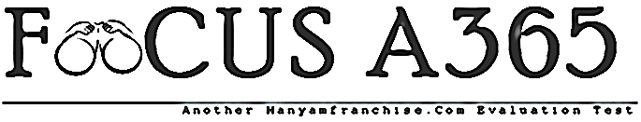

FORM 1 TERM 1 PHYSICS EXAMINATIONS 2018

NAME________________________________________ ADM NO_____________
- What do you understand by the term physics? (1mk)

- Physics as a science is related to may other subjects, how is physics related to the following
- Biology

- Chemistry

- Geography

- Mathematics

- The study of physics is divided into a number of branches, list the 6 branches under which we study physics. (6mks)

- There are many careers that require the knowledge of physics, list any 5 careers that require knowledge of physics. (5mks)

- Outline any 5 basic laboratory rules that a student should observe while in the laboratory. (5mks)

- Differentiate between basic and derived quantities. (2mks)

- The table below shows the basic quantities in physics, symbols and SI units, complete the table
Basic quantity | SI unit | Symbol of unit
Length
Mass
Time
Current
temperature

- Define length and state its SI unit. (1mk)

- Name any 2 instruments that are commonly used to measure length. (2mks)

- Charo found that the perimeter of his farming plot was approximately 200 strides. His stride was at 0.9m long. What was the perimeter of the plot? (2mks)

- Describe how you would measure the length of the curve of an athletics field. (2mks)

- Define area state its SI unit (2mks)

- Work out the areas of each of the following figures.
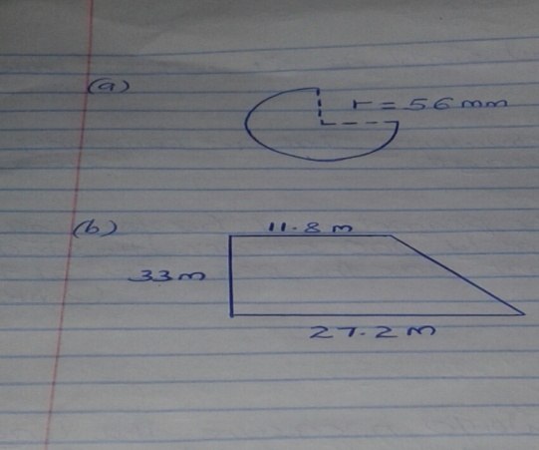

- Define mass and state its SI unit (2mks)

- Convert each of the following as indicated
- 200,000 mg into kg (2mks)

- 256,000 g into tones (2mks)

- 0.000342 tonne into mg (2mks)

- Define density and state its SI unit. (2mks)

- A block of glass of mass 187.5g is 5.0cm long 2.0 cm thick and 7.5cm high. Calculate the density of the glass in kgm⁻³. (3mks)

- A rectangular tank measures 12.5 m long 10.0 wide and 2.0m high. Calculate the mass of water in the tank when it is full.
(Density of water + 1000 kgm⁻³ ) (3mks)

- The figure below shows the reading of a measuring cylinder before and after a stone of mass 20g has been immersed in it.
Determine the density of the stone (3mks

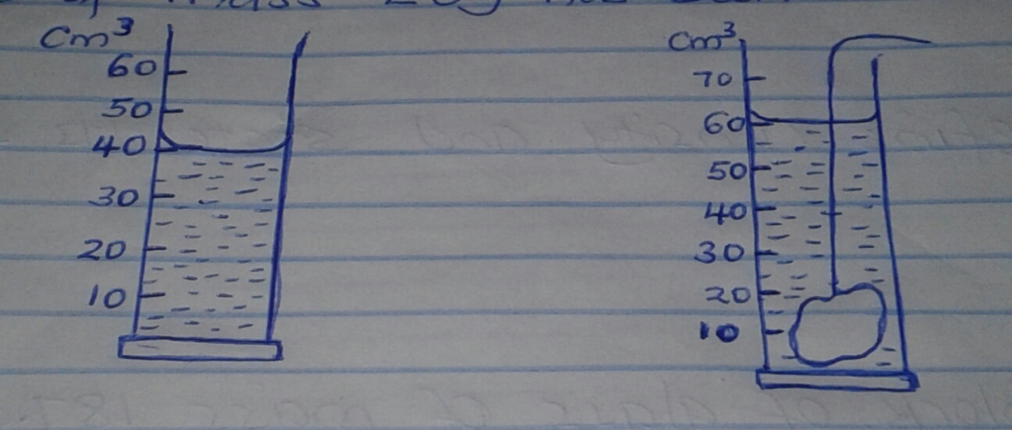

- The water level in a burette is 30 cm³. If 55 drops of water fall from the burette and the average volume of one drop is 0.12cm³, what is the final water level in the burette? (3mks)

- Given the following:
- Mass of solid = 13.6 g
- Volume of water before solid is immersed = 3.1 cm³
- Volume of water after solid is fully immersed= 9.9cm³
Calculate the density of the solid. (3mks)

- a) State 2 precautions to be observed when using a density bottle. (2mks)

b)An empty density bottle has a mass of 10g. When completely filled with water its mass becomes 34g and its mass when completely filled with an acid is 30g. What is the density of the acid. (4mks)

