FORM 1 TERM 2 GEOGRAPHY EXAMINATIONS 2018

NAME……………………………………………………..ADM……………
- a)Name three effects of rotation of the earth (3mks)

b) Study the diagram below and answer the questions which follows.
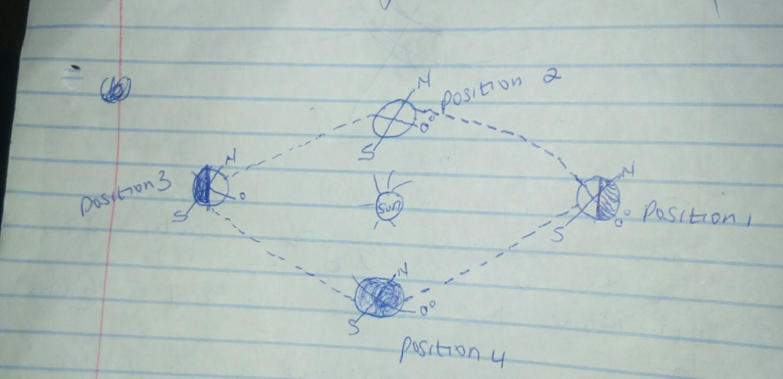

- which movement of the earth is represented by the diagram ? (1mk)

ii)Give three effects of the movement represented by the diagram. (3mks)

- The below diagram represents the structure of the earth. Use it to answer question a
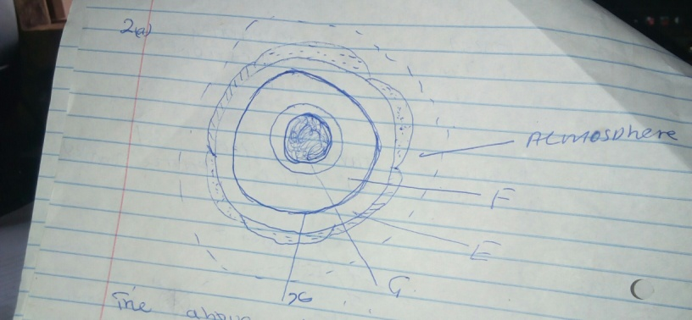

- i)Name the layers F and E. (2mks)

ii)Name the minerals which make up the layer marked G (2mks)

iii)Name the boundary marked X (1mk)

- a) Apart from water vapour name two other substances that are suspended in the atmosphere . (2mks)

- i)Give two factors considered when classifying clouds. (2mks)

ii)Name two types of clouds that give rise to rainfall in the tropical regions (2mks)

- a) i) Name three layers of the atmosphere apart from troposphere. (3mks)

ii)State 3 characteristics of the Troposphere layer. (3mks)

b)Suppose you visited a weather station for field study on weather.
i)Give three methods you would use to collect the data. (3mks)

ii)Name four ways you would prepare for the study. (4mks)

- a) Name types of rocks according to mode of formation. (3mks)

b)Give three examples of metarmophic rocks. (3mks

- a) In which countries are the following fold mountains found
i)Andes (1mk)

ii)Cape ranges (1mk)

iii)Alps (1mk)

iv)Atlas (1mk)

b)Apart from fold mountains name 3 other features formed as a result of folding. (3mks)

c)Explain the significance of fold mountains to human activities . (3mks)

- a)Name three types of faults. (3mks)

b)With aid of a diagram describe how the rift valley was formed through compressional forces. (5mks)

- a)Name four extrusive features of vulcanicity (4mks)

b)Explain three ways in which volcanic features influence human activities. (6mks)

- a)Name the two scales used to measure the intensity of earthquakes. (2mks)

b)Give three causes of earthquakes. (3mks)

- a)Name types of ground photographs. (2mks)

b)State the major divisions of a photograph. (3mks)

- a)i) What is mining? (2mks)

ii)Name two types of underground mining. (2mks)

iii)Name the countries where the following minerals are mined in East Africa.
- Diatomite (1mk)

- Flousphar (1mk)

- Diamond (1mk)

- Copper (1mk)

- Soda ash (1mk)

b)State four benefits of mining soda ash. (4mks)

- a) State types of maps. (3mks)

b)Define bearing (1mk)

c)You are given point A and B.

- A

      - B
Give the direction of
- A from B (1mk)

- B from A (1mk)

- Below are a number of deaths caused by malaria in a certain country.

Name of District | No. of death per day
A | 200
B | 100
C | 300
D | 150
E | 250

i)Draw a divided rectangle measuring 10cm long and show the number of deaths in the country (6mks)

