FORM 1 TERM 1 GEOGRAPHY EXAMINATIONS 2018

Answer all questions on the space provided
1a) Define geography (2mks)

b) What`s environment (2mks)

2a) state branches of geography. (2mks)

b) Name 3 sub-branches of physical geography. (3mks)

3a) Explain relationship between geography and the following disciplines.
i)Geography and Biology. (2mks)

ii)geography and History . (2mks)

4a) Define solar system (2mks)

b) State characteristics of mercury planet. (3mks)

c)Differentiate between meteors and meteorites. (2mks)

5a)Describe the Nebular cloud theory. (3mks)

b) State 5 proofs that the earth is spherical (5mks)

c)What is the shape of the earth? (1mk)

d) State forces which support the shape of the earth. (2mks)

6a) Define rotation and revolution. (2mks)

b) State effects of the earth rotation. (3mks)

c) When is the sun overhead at the following latitudes. (3mks)
i)Tropics of cancer

ii)tropics of capricon

iii) Equator

7a) The diagram below shows the revolution of the earth around the sun. Use it to answer the
Questions that follows.

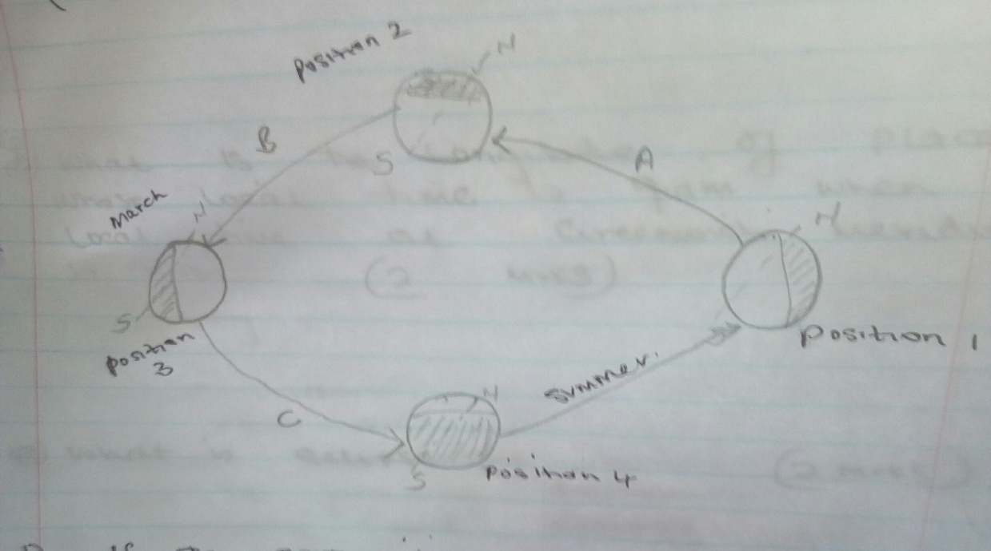
i)If the earth takes 366 days to make a complete revolution during a leap year , how long will it take to move from position 1 to position 3 (3mks)

ii) Name the seasons marked (3mks)
A
B
C
8a)the time at town A which is at longitude 15⁰E is 10.00am what time is at town B 0⁰ (2mks)

b)What is the longitude of place Q whose local time at Greenwich meridian b noon. (2mks)

c) What is eclipse. (2mks)

