NAME:………………………………………………….. INDEX NO:………………………………

CANDIDATE’S SIGNATURE:…………………………DATE…………………………………….

443/2
AGRICULTURE
JULY, 2019
PAPER 2
TIME: 2 HOURS

BUURI EAST STANDARDS
Kenya Certificate of Secondary Education
AGRICULTURE 443/2
2 Hours

Instructions to Candidates:

- Write your name and index number in the spaces provided above.
- Sign and write the date of examination in space provided.
- This paper consists of three sections; A, B and C.
- Answer all the questions in section A and B.
- Answer any two questions in section C.
- All answers should be written in spaces provided in question paper.

FOR EXAMINER’S USE ONLY

SECTION | Question | Maximum score | Candidates score
A | 1 - 15 | 30
B | 16 - 19 | 20
C |  | 20
 |  | 20
 | Total score 90

SECTION A: (30MKS)

Answer all the questions in this section in the spaces provided.

1. Give four categories of infections diseases in livestock. (2mks)

2. a) Name 4 methods of identification used by livestock farmers. (2mks)

b) State 4 reasons for carrying out identification of animals. (2mks)

3. Distinguish between the following breeds of livestock. (2mks)

a) Large white and landrace

b) Newzeland white and California white

4. a) Define the term digestability. (1mk)

b) State two factors that determine the amount of food given to an animal (1mk)

5. State 4 causes of vices in poultry (2mks)

6. Name 4 notifiable diseases in cattle. (2mks)

7. State 4 a routes through which disease causing micro – organisms enter the animals body. (2mks)

8. State 4 structural features of ideal calf pen. (2mks)

9. Name three types of lubrication systems. ( 1 ½ mks)

10. Name the tool required for each of the following operation. (2mks)

i) Cutting wool from sheep

ii) Castrating piglet
iii) Cutting threads of metallic pipes

iv) placing mortar between construction stones.

11. State 4 effects of external parasite attack to livestock. (2mks)

12. a) Name two causes of chicken laying soft – shelled eggs or eggs without
Shells. (1mk)

b) How can the above problem be overcomed in birds. ( 1 ½ mk)

13. Name four qualities of clean milk. (2mks)

14. Give three methods used in selection of livestock. ( 1 ½ mks)

15. State the functions of the following in a petrol engine. ( 1 ½ mks)

i) Carburetor

ii) radiator

iii) thermostat

SECTION B: (20MKS)

Answer all the questions in this section in the spaces provided.

16. The diagram below is an illustration of an egg. Study if carefully and answer the questions that follow.

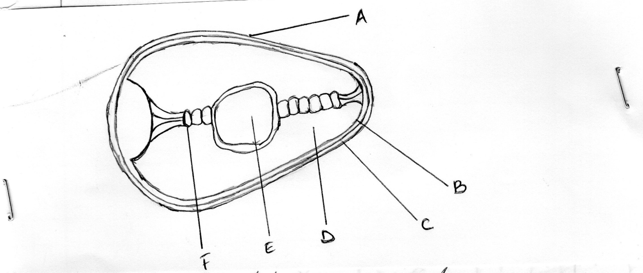

a) Name the parts labellled B, C, D and F (2mks)

B
C
D
F

b) State two qualities of the part labeled A that should be considered when selecting eggs for incubation. (2mks)

c) What is the function of the part labelled E in a fertilized egg? (1mk)

17. The diagram below represents an important farm structure study it and answer the questions that follow.

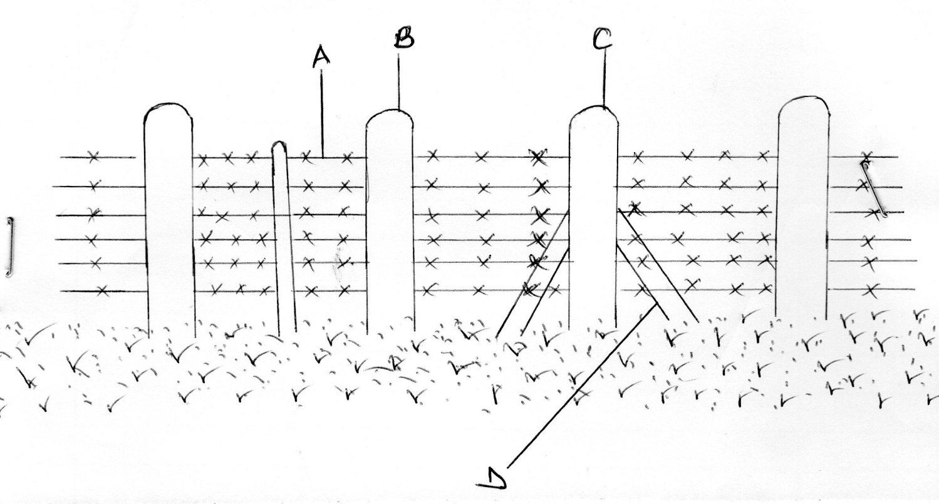

i) Identify the farm structure. (1mk)

ii) label the parts A, B, C, D (2mks)

A
B
C
D

iii) State two maintenance practices carried out in the structure above (2mks)

18. Study the diagram of the digestive system of a farm animal shown below and answer the question that follow.

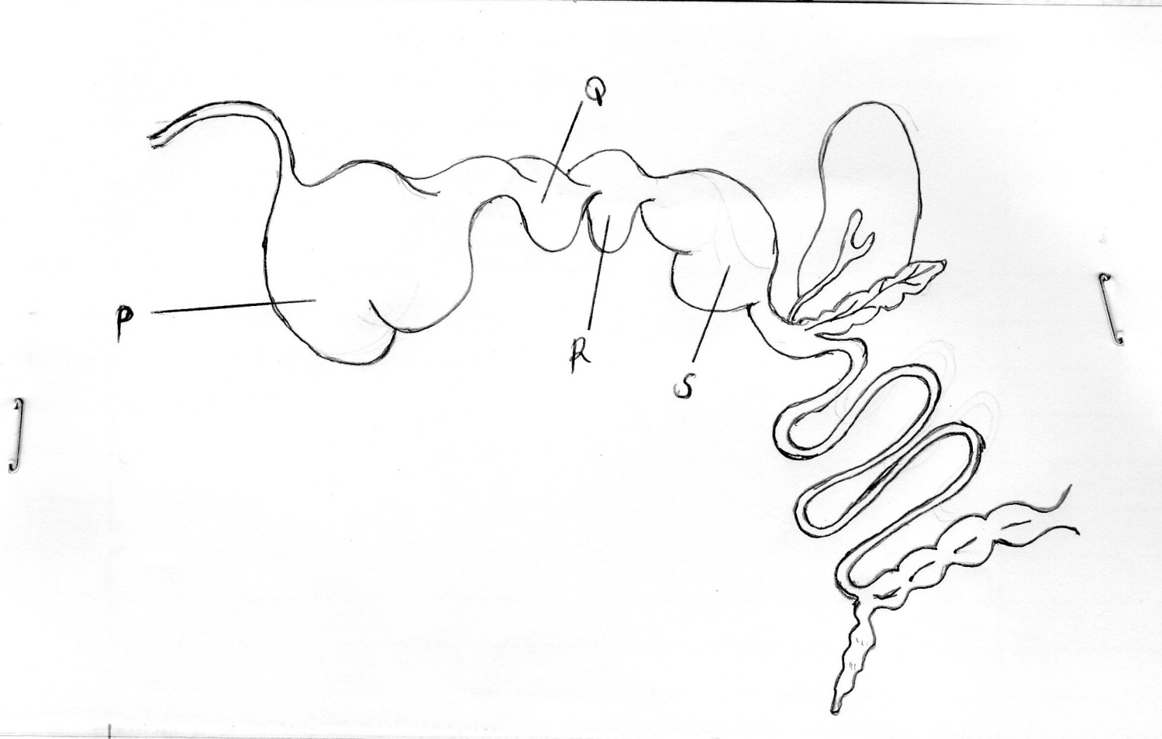

a) Name the parts labelled (2mks)

P
Q
R
S

b) State the function of the part labelled R (1mk)

c) Give two reasons why livestock with the above parts are able to digest cellulose food material. (1mk)

d) In which part would nylon paper be found if fed on by an animal with the above digestive system. ((1mk)

19. a) A dairy cow weighing 400kg live weight requires 3% of its body weight dry matter ( Dm per day). However the cow only gets 50% of its daily Dm requirements from grazing field. How much concentrates (80% dm) should the farmer supplement to its dairy requirements. Show your workings. (3mks)

b) Give two effects of overstocking in pasture management . (2mks)

SECTION C : (40 MARKS)

Answer any two questions in this section.

20. a) Explain five factors to consider when selecting a breeding stock. (10mks)

b) Describe the general methods of disease control in livestock. (10mks)

21. a) Discuss foot and mouth disease under the following headings:

i) Casual organisms (1mk)

ii) Livestock species attacked (2mks)

iii) Sympotms of attack (4mks)

iv) Control measures (3mks)

b) Describe the life cycle of one host tick. (10mks)

22. a) Differentiate between Disc plough and mould board plough. (5mks)

b) State five disadvantages of animal – drawn implements as compared to tractor – drawn implements. (5mks)

c) Explain five reasons for maintaining farm tools and equipments. (10mks)

*** E N D ***

