NAME:………………………………………………….. INDEX NO:………………………………

CANDIDATE’S SIGNATURE:…………………………DATE…………………………………….

231/3
BIOLOGY
(Practical)
JULY, 2019
PAPER 3
TIME: 1 ¾ Hours

BUURI EAST STANDARDS
Kenya Certificate of Secondary Education
BIOLOGY 231/3
1 ¾ Hours

Instructions to candidates.

- Answer all questions in the spaces provided.
- You are required to spend the first 15 minutes of the 1 ¾ hours allowed for this paper reading the whole paper before commencing your work.
- Additional pages must not be inserted.
- Candidate’s may be penalized for recording irrelevant information and for incorrect spelling especially of technical terms.

FOR EXAMINER’S USE ONLY

Question | Maximum score | Candidates score
1 | 12
2 | 12
3 | 16
Total | 40

1. You are provided with liquid L1 and L2 and pieces of visking (dialysis) tubing.
Spare about 1ml of each of the liquids for part (a) of this question.

Using a piece of thread, tightly tie one end of the visking tubing.

Open the other end of the visking tubing and half fill it with liquid L1.

Tightly tie this end. Ensure there is no leakage at both ends.

Immerse the tubing in a beaker containing liquid L2.

Leave the set up for at least 30 minutes.

a) Using iodine and Benedict’s solution provided test for the food substances in liquid L1 and L2. Record your observation in the table below. (4mks)

Liquid | Food substance | Procedure | Observation | Conclusion
L1
L2

After 30 minutes, remove the visking tubing from the beaker and wash the outside
of the tubing thoroughly to remove traces of liqud L2.

b) Using the same reagents, test for food substances in liquid L1 in the visking tubing.

Record your observation in the table below. (2mks)

Food substance | Procedure | Observation | Conclusion

c) Account for the results obtained after carrying out tests for liquid L1 before and after immersion into liquid L2. (4mks)

d) State two roles of the physiological process involved above in animals (2mks)

2. a) Study the photographs below for specimen R and S.

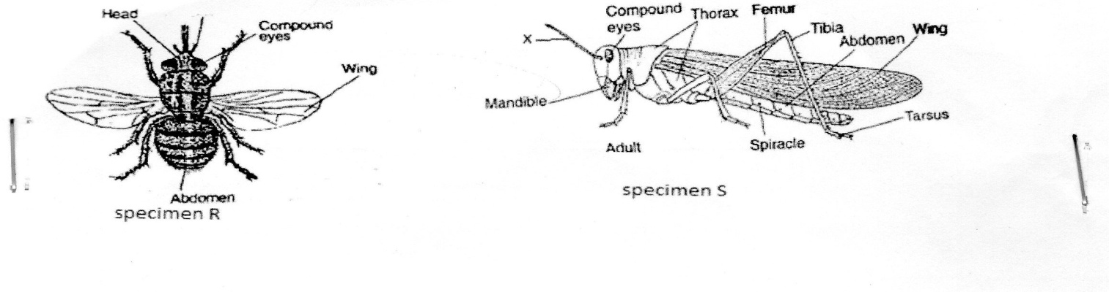

i) State two observable differences between the specimen R and S. (2mks)

Specimen R | Specimen S
ii) Suggest the advantage of the adaptations on the limbs of specimen S (2mks)

b) i) Name the phylum and the class to which the specimens belong

Phylum (2mks)

Class

ii) State two distinguishing features found in the members of the phylum and class stated in b (i) above. (2mks)

c) i) Give two differences between complete and incomplete metamorphosis (2mks)

ii) State the specimen that exhibits.
i) Complete metamorphosis (1mk)

ii) Incomplete metamorphosis (1mk)

3. Below are photographs of a skeleton of a mammal.
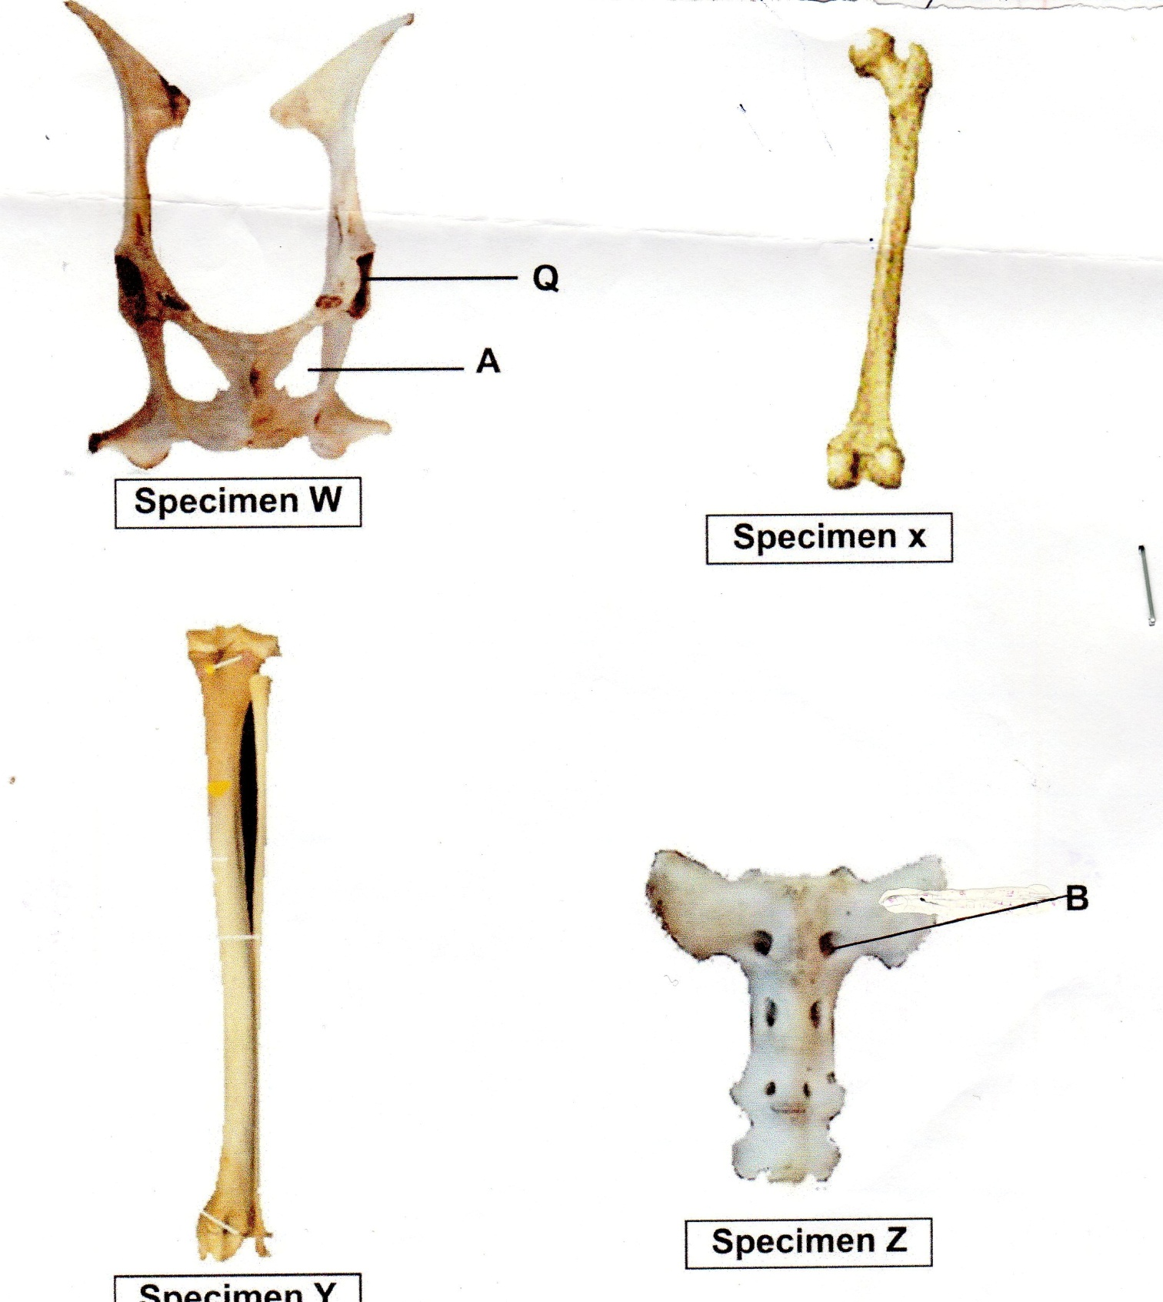

a) With a reason, identify the specimens in the photographs. (8mks)

Specimen | Identify | Reasons
W
X
Y
Z

b) i) Name the part labeled Q on photograph W. (1mk)

ii) State the type of joint formed between the anterior end of specimen X and the part labeled in b (i) above. (1mk)

iii) Name the part labelled A on the photograph W. (1mk)

iv) What is the function of the part labelled A. (1mk)

c) i) Name the part labelled B on photograph Z. (1mk)

ii) What is the role of part labeled B. (1mk)

d) i) Name the cartilage between the bones of the vertebral column. (1mks)

ii) State the function of the cartilage in d(i) above. (1mk)

*** E N D ***

