**233/1**

**CHEMISTRY**

**JULY, 2018**

**PAPER 1**

**Marking scheme**

**BUURI EAST STANDARDS**

***Kenya Certificate of Secondary Education***

**CHEMISTRY 233/1**

1. a) burette

b) Measuring accurate volumes

2. a) Generate steam that pushes out the air

b) Magnesium would react with air hence no gas would be formed.

3. SO2 = 64 √½ CO2 = 44 √½

TCO2 = RMM CO2

TSO2  RMM SO2

TCO2 = 44 √½ TCO2 = 6.6332

96 64 96 8

TCO2 =96 6.6332√½ = 79.5984 √ 1

8

NB: penalize ½ mk for wrong units in answer

4. a) 3 and 4

b) Sugar (3) is made up of molecules hence cannot conduct in 4 ions are not mobile to conduct electric current.

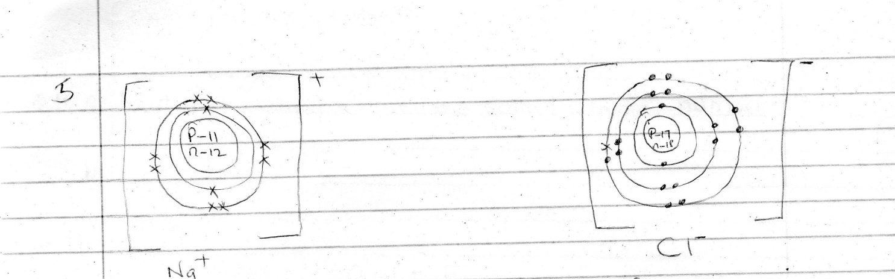

NB: Number of protons in the nucleus should be indicated correctly.

6. a) K

b) M

7. It changes from blue to a white solid; because the acid is a dehydrating agent and remove water from the hydrated copper (ii) sulphate.

8. Acid for forward reaction is H2O2 since it donates a proton/acid for backward reaction is H3O+  since it donates a proton.

9. a) i) Oxygen /O2(g)

ii) Nitric (v) acid/ HNO3

b) Catalyst/speed up the reaction

10. a) D and F √½ they have the same atomic number √½

b) 7 – 3 = 4

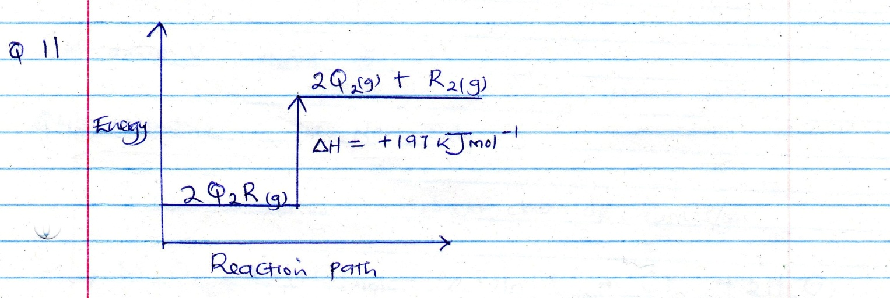

12. a)  + 

b) 12.8g 1st t1/2 6.4g 2nd t1/2 3.2g 3rd t1/2 1.6g 4th t1/2 0.8g ½

number of halflifes = 4 √½

one half life = 280√½ = 70 days√½

4

 Alternatively

Remaining amount = ( ½ )n original amount

0.8 = ( ½ )n 12.8 √½

0.8 =( ½ )n

12.8

n log 0.5 = 0.0625

n = log 0.0625

log 0.5

n = 4 √½

One half life = 280 √½ = 70 days √½ 4

13. a) 2F + 5 ( -2) = 0 √½

2F = + 10

F = +5 √½

b) Group V (***reject* 5**)

14. a) Chlorine NB: ***name only***

b) To remove traces of hydrogen chloride fumes/gas

c) MnO2(s) + 4HCl(aq) MnCl2(aq) + Cl2(g) + 2H2 O(l)

15. High temperature increases the kinetic energy of the reacting particles hence they collide more frequently and effectively.

16. a) Magnetite/haematite/siderite

b) CaO(s) + SiO2(s) ________ CaSiO3(s)

17. a) i) X – calcium carbonate /CaCO3

ii) Y- Calcium oxide/CaO

b) Mix sodium carbonate solution with calcium nitrate solution √½filter √½ wash √½ the residue with distilled water, filter and dry it between filter papers √½ (any other soluble carbonate and any other soluble calcium salt

18. a) i) The solution changed from pale green to yellow

ii) Brown precipitate was formed insoluble in excess sodium hydroxide.

b) Fe3+(aq) + 3OH-(aq) Fe(OH)3(s)

19. a) Nitrogen

b) Copper turnings changed from brown to black

20. a) The enthalpy change that occurs when one mole of a substance is formed from its constituent elements in their standard states.

b) 4C(s)  + 5H2 (g) C4 H10(g)

4CO2(g) + 5 H2O(l)

Hf (C4H10) = 4(-394) + 5(- 286) – (- 2881) $√$ (1)

= -1576 – 1430 + 2881 $√$ (1)

= -125kJmol-1  (1)

21. a) Ammonia

b) Ca(OH)2(s) + 2NH4Cl(s) CaCl2(s) + 2H2O(l) + 2NH3(g)

c) 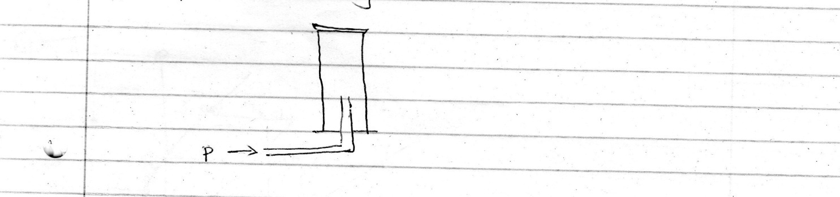

22. a) Evaporation

b) Fractional distillation

H H H

23. a) i)

H - C – C – C – H

H CH3 H

H H

ii) H – C – C = C – C – H

H H H H

b) ethylethanoate

24. a) Electrode A ½ , positive charge ½

b) it remains the same ½ ; because the anode dissolves to give Cu2+ and Cu2+ are discharged at the cathode to form copper metal.

c) Cu2+(aq) + 2e- Cu(s)

25. i) Manganeze (iv) oxide/MnO2

ii) - Used to aid breathing in hospitals

- Used in oxyacetyene flame

- Used by mountain climbers

- Used by sea divers/accept other commercial uses

26. a) Iron (ii) sulphide

b) - 2/3 atmospheres

- 4500C

- Vanandium (V) oxide catalyst

27. - Increasing the pressure

- lowering the temperature

28. a) 1000cm3 NaoH _____ 0.25ml

23cm3 ----------- ?

23 x 0.25 ½

1000

= 0.00575mol ½

Reaction ratio 1:1

Moles of HCl reacted = 0.00575

0.2mol _____1000

0.00575 ___ ?

= 0.00575 x 1000 ½

0.2

= 28.75 ½

29. Si H

8 1.12

28 1

Mol ratio 0.286: 1.12 (1)

0.286 : 1.12

0.286 0.286

1 : 3.916

1 : 4

SiH4 (1)

30. a) Zn(s) + 2Ag+(aq)  Zn2+(aq) + 2Ag(g) (1)

b) e.m.f 0.76V + 0.8V (1)

= + 1 .56V (1)

31. a) Carbon (ii) oxide

b) absorb CO2

c) 2CO(g) + O2(g) 2CO2(g)

32. a) halogen

b) 17

33. i) CuSO4 ( 1) solubility of CUSO4 at 350C if 28g/100g of water

ii) CuSO4 38 – 28 = 10g of crystals formed (1) more soluble

*** E N D ****