NAME:………………………………………………….. INDEX NO:………………………………

CANDIDATE’S SIGNATURE:…………………………DATE…………………………………….

312/1
GEOGRAPHY
JULY, 2019
PAPER 1
TIME: 2 ¾ HOURS

BUURI EAST STANDARDS
Kenya Certificate of Secondary Education
GEOGRAPHY 312/1
2 ¾ Hours

Instruction:
- Answer ALL the questions in section A.
- In Section B answer question 6 and any other two.

SECTION A:

1. a) Name two branches of geography. (2mks)

b) Give three reasons why it is importance to study geography. (3mks)

2. a) What is solar insolation? (2mks)

b) Outline three importance of moisture in the atmosphere. (3mks)

3. a) State two effects of the rotation of the earth on its axis. (2mks)

b) The local time at manual 60⁰W is 11.30 am. What is the time in Nairobi
37⁰E? (3mks)

4. a) What is an ice sheet? (2mks)

b) State three positive effects of glaciations in lowland areas. (3mks)

5. a) Name the two types of waves experienced in the coastal area. (2mks)

b) List three coastal features which result from wave deposition. (3mks)

SECTION B:

Answer question 6 and any other two questions.

6. Study the map of Kitale 1:50 000 (sheet 75/3) provided and answer the following questions.

a) i) Give the longitudinal extent of the area covered by the map. (2mks)

ii) Identify the two physical features found at grid square 2320. (2mks)

iii) What is the magnetic inclination shown on the map. (2mks)

b) What is the altitude of the highest point in the East of Easting 40. (2mks)

c) Describe the drainage of the area covered by the map. (5mks)

d) i) Give two methods used to represent relief on the map. (2mks)

ii) Measure the distance of all weather road loose surface road from the grid point 370/40 to where it ends towards cheragani. Give your answer in kilometers. (2mks)

e) i) Citing evidence from the map, identify five social services offered in Kitale municipality. (5mks)

ii) Give three types of natural vegetation found in the area covered by the map. (3mks)

7. a) State two factors which influence the occurrence of underground water (2mks)

b) Differentiate between a well and spring. (2mks)

c) The diagram below represent an artesian basin. Use it to answer question C (i) and (ii) .

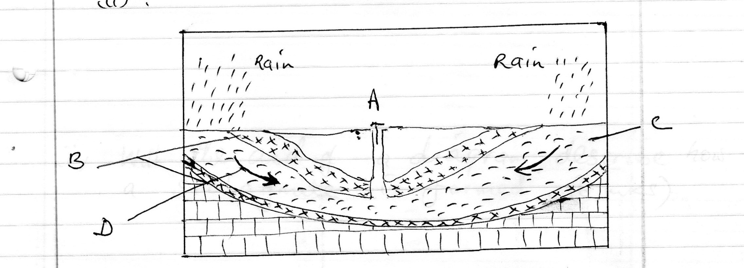

i) Name the parts marked A, B, C (3mks)

ii) Identify the process marked D. (1mk)

iii) State three factors which favour the location of an artesian well (3mks)

d) i) Apart from stalagmites name three other underground features formed in limestone areas. (3mks)

ii) With the aid of a diagram describe how a stalagmite is formed (6mks)

e) i) State three reasons why there are few settlements in Karst Landscapes. (3mks)

ii) Name two surface features found in limestone areas. (2mks)

8. a) i) What is secondary vegetation? (2mks)

ii) State five ways in which vegetation is of importance to the physical and human environments. (5mks)

b) Describe three characteristics of the Mediterranean type of vegetation. (6mks)

c) Explain three factors which influence the distribution of vegetation in Kenya. (6mks)

d) The students of Kaburia secondary are to carry out a field study of vegetation across a slope.

i) Formulate two hypotheses they could have made for the study. (2mks)

ii) Give four characteristics of vegetation which they would study. (4mks)

9. a) Describe podzolization as a process of leaching. (4mks)

b) State three ways in which mulching helps in soil conservation. (3mks)

c) Explain how the following factors influences the formation of soils.

i) Climate (4mks)

ii) Topography (4mks)

d) i) What is soil catena? (2mks)

ii) Draw a well labelled diagram to show a well – developed soil profile. (3mks)

e) Explain five causes of soil degeneration. (5mks)

10. i) Define the term faulting. (2mks)

ii) Name 2 types of faults. (2mks)

iii) Use the diagram below to answer the question that follows:-
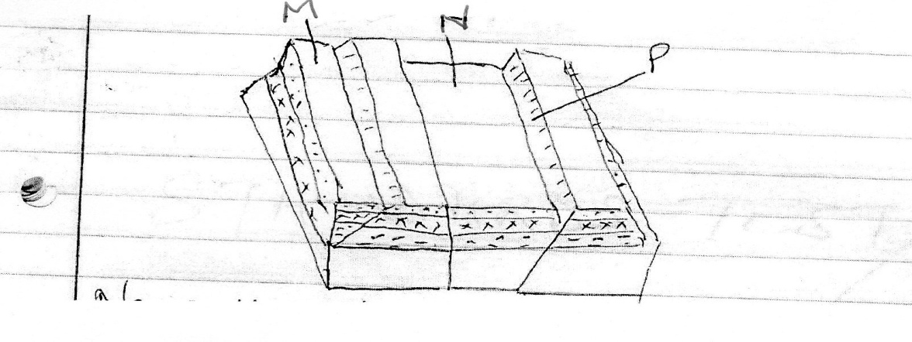
a) Name the features marked M, N and P (3mks)

b) With well labelled diagrams explain the formation of the Rift valley through tensional forces. (8mks)

c) Explain five positive effects of faulting. (10mks)

<<< E N D >>>

