NAME:………………………………………………….. INDEX NO:………………………………

CANDIDATE’S SIGNATURE:…………………………DATE…………………………………….

441/2
HOME SCIENCE
JULY, 2019
PAPER 2
(Practical)
(Clothing Construction)
TIME: 2 ½ HOURS

BUURI EAST STANDARDS
Kenya Certificate of Secondary Education
HOME SCIENCE 441/2
2 ½ Hours

Instructions to Candidates:
- This paper consists of 2 printed pages.
- Candidates should check the question paper to ascertain that al the pages are printed as indicated and that no questions are missing.

A pattern of a blouse is provided. You are adviced to study the sketches the question and the layout carefully before you begin the test.

MATERIALS PROVIDED
1. A - Front bodice
B - Back bodice
C - Back yoke
D - Collar
E - Back neck facing

2. Plain light weight cotton fabric 50cm long by 91 cm wide.
3. Sewing thread to match the fabric.

THE TEST.
Using the material provided, cut out and make the right half of the blouse to show the following:

- Making of the bust dart.
- Making of the inverted pleat at the back bodice.
- Attachment of the back yoke to the back bodice using an overlaid seam. Neatening half with loop stitches.
- Making of machine fell seam at the shoulder.
- Making a French seam on the side of the bodice.
- Joining the back and front neck facings at the shoulders.
- Preparation of an interfaced collar and attaching it to the bodice.
h) Working of the buttonhole.

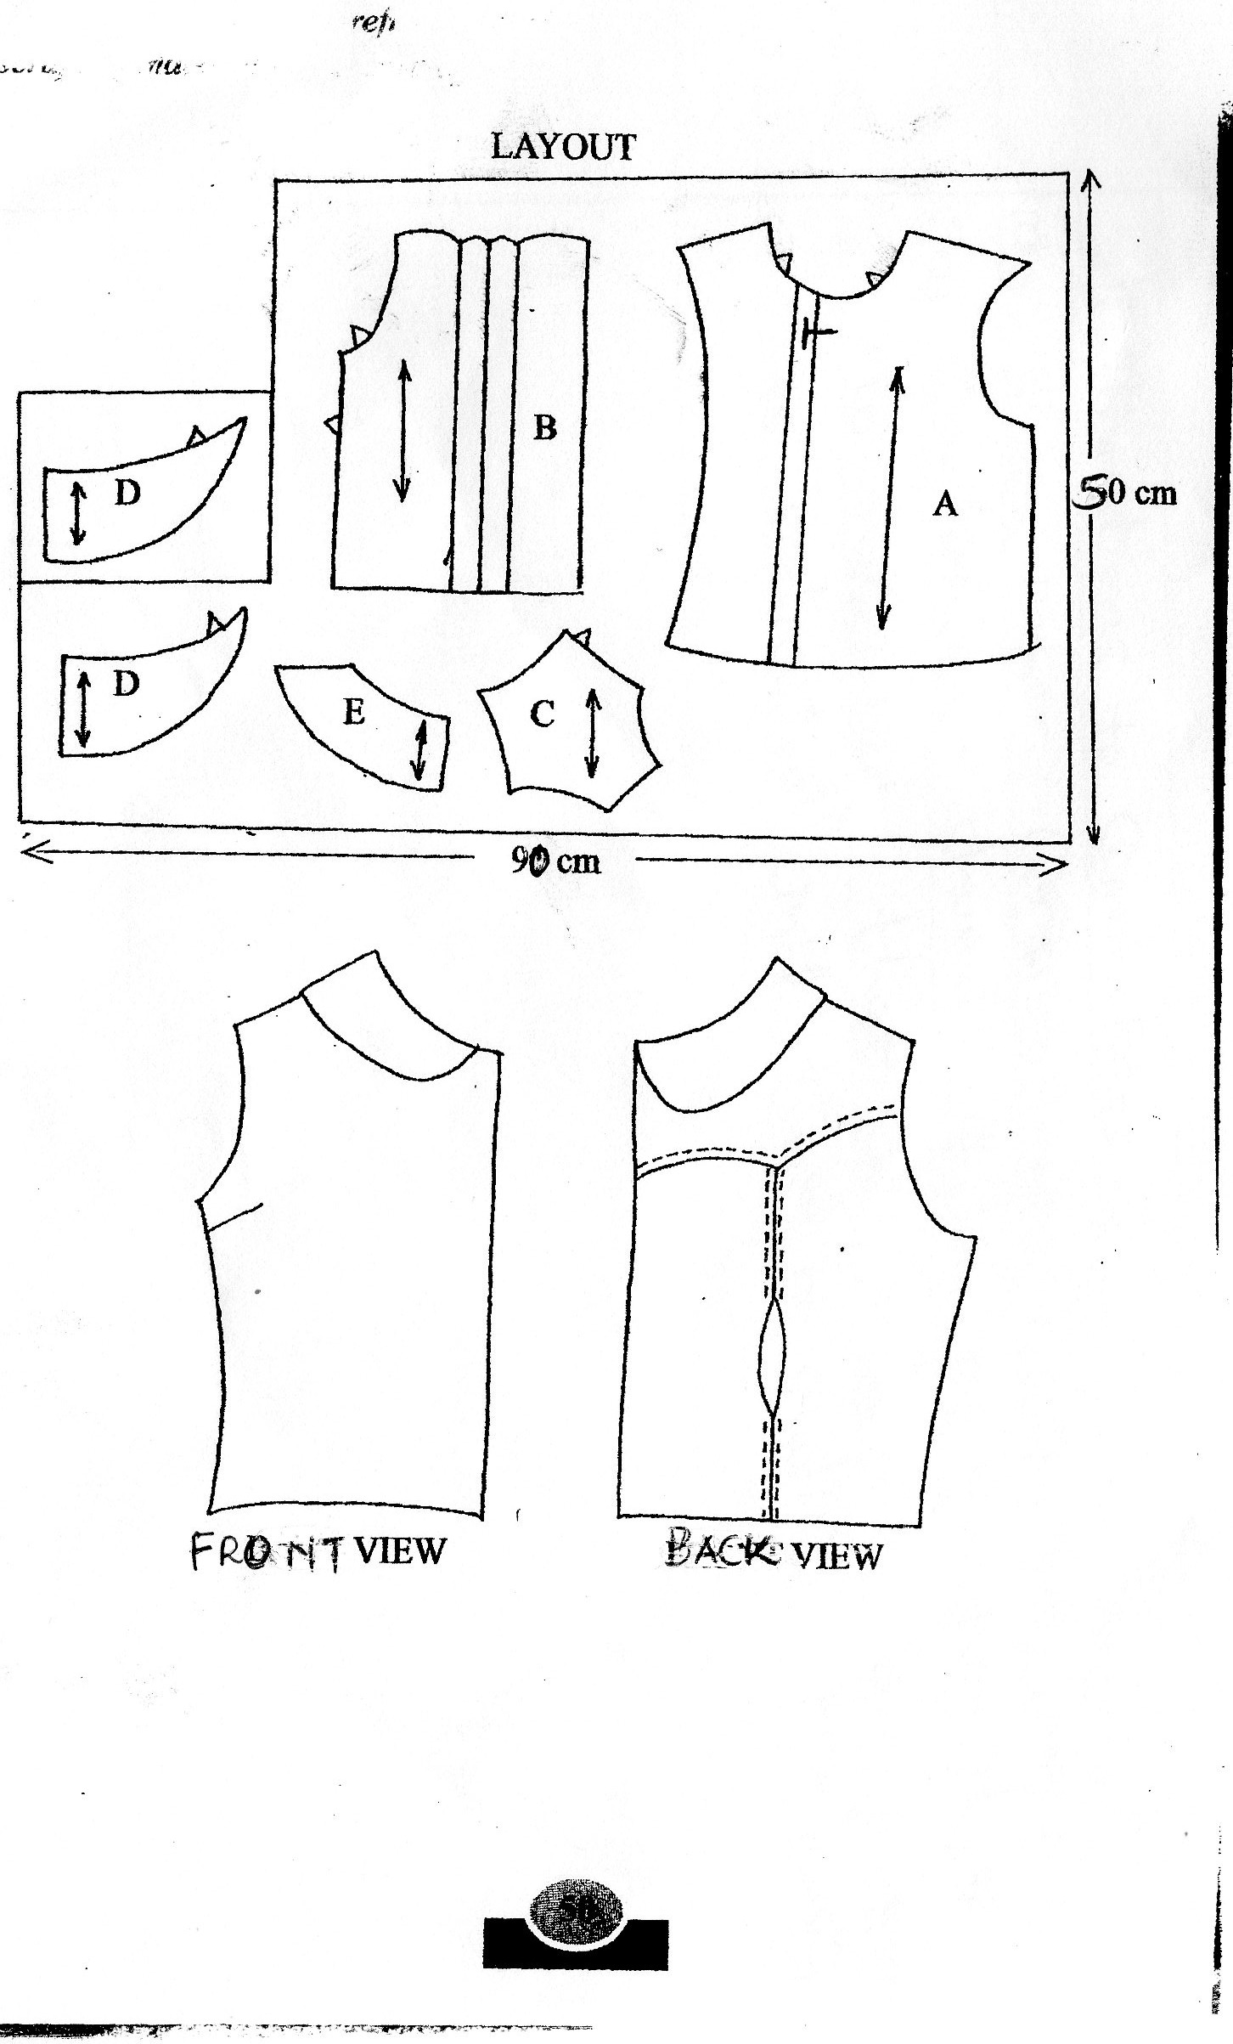

*** E N D ***

