Name: ……………………………………………... Index no ……..…......................................

School: …………………………………………….. Candidate’s sign …………………….......

Class………………………………………….…..… Adm No…………………...……………...

AGRICULTURE
PAPER 1(Marking scheme)
JUNE 2018
TIME: 2 HOURS

FORM FOUR KASSU MOCK
Kenya Certificate of Secondary Education (K.C.S.E.)
Agriculture
Paper 1

INSTRUCTIONS TO CANDIDATES:
- Write your name, index number, school, class and admission number in the spaces provided.
- Sign and write the date in the spaces provided above.
- Answer all the questions in section A and B
- Answer any two questions in section C.
- Answers should be written in the spaces provided in this booklet.
For Examiner’s Use Only:
SECTION | QUESTIONS | MAXIMUM SCORE | CANDIDATES SCORE
A | 1-19 | 30
B | 20-23 | 20
C |  | 20
 |  | 20
 | TOTAL | 90

This paper consists of 12 printed pages. Candidates should check to ascertain that all pages are printed as indicated and that no questions are missing.
SECTION A (30MARKS)
- Define the following terms as used in agriculture. (1mk)
- Soil profile
This is the vertical cross section on the earth’s crust which exposes a succession of different layers/horizons of the soil.
- Soil structure
It is the physical appearance of the soil according to the way the individual soil particles are aranged, packed or aggregated.
- State three disadvantages of small scale farming. $(1\frac{1}{2}mks)$
-High operational costs.
-Provision of technical advice by extension workers is not easy because of the large number of farmers.
-Lack of organised market for the produce (of the small quantities of the different types of produce).
- State three symptoms of coffee berry disease. ($1\frac{1}{2}mks)$
-Flowers have a dark brown blotch or streak on the white petal.
-Green berries have small dark sunken patches or lesions which spread rapidly and eventually cover the whole berry.
-Ripe berries have dark sunken patches with minute black dots spreading rapidly to cover the whole berry.
-Twig die back.
-Falling off of flowers and berries at pin head stage.
- State four benefits of using organic materials for mulching. (2mks)
-It conserves soil moisture by discouraging evaporation.
-It suppresses/ smothers weeds.
-It controls soil erosion.
-Improves soil structure upon decomposition.
-It adds nutrients to the soil on decomposition.
-Improves water infiltration rate.
-Increases water holding capacity of the soil upon decomposition.
- State four disadvantages of non-capped multiple stem pruning in coffee. (2mks)
-There is higher rate of breaking of stems and branches.
-There is difficulty in picking the berries from the top points.
-The crop grows much taller hence spraying is difficult.
-Pruned stumps tend to rot as the plant grows older.

- Give three benefits of processing agricultural produce. $\left(1\frac{1}{2}mks\right)$
-Improve the flavour of the produce as in tea and tobacco.
-Improve the keeping quality as in fruits when canned or made into juices or sauces.
-Reduce bulkiness in order to lower transportation and storage costs as in sugarcane when crushed into sugar.
-With vegetables the leaves can be dried and stored in air tight containers to be used during scarcity periods.
- State four factors considered in selecting the site for making compost manure. (2mks)
-A well drained place to avoid waterlogging which leaches nutrients from the manure.
-Direction of the prevailing wind to prevent bad odour from being blown to the homestead.
-Size of the farm ie should be centrally placed.
-Accessibility for easy transportation of the materials needed.
- Give two reasons for flooding in the growing of paddy rice. (1mk)
-Controls weeds
-Controls soil borne pests.
-Provides good conditions for the growing of rice.
- Give two appropriate situations under which foliar spraying is most suitable. (1mk)
-During prolonged dry season.
-When top dressing closely spaced crops eg wheat.
- Outline four characteristics of a good rootstock. $(2mks)$
-It should be compatible with scions of different crops.
-It should be disease and pest tolerant.
-It should be healthy and vigorously growing.
-It should be adaptable to different soils and soil conditions.
- State four factors that should be considered when classifying crop pests. (2mks)
-Their mode of feeding.
Crops attacked
-Stage of development of the pest.
-Stage of growth of the crop attacked.
-Scientific classification
-The level of damage.
-The place where they are found or habitat.
- State two ways of minimising the damage of seedlings when transplanting. (1mk)
-Watering the nursery 2-3 hours before lifting the seedlings.
-Lifting the seedlings with a lump of soil (using a garden trowel)
- State four disadvantages of using vegetative materials for planting. (2mks)
-Does not result in new crop varieties.
-Keeping the materials free of disease is difficult.
-Materials cannot be stored for long.
-The materials are bulky and therefore difficult to store and transport.
- Name three types of product-product relationship in agricultural economics. $(1\frac{1}{2}mks$)
-Joint products
-Competitive products
-Supplementary products.
-Complementary products.
- State three disadvantages of using herbicides to control weeds. $(1\frac{1}{2}mks)$
-It requires skilled labour in mixing and application.
-There are many risks to the environment and to the user.
-Some herbicides have long residual effects which may interfere with future crops.
- Name two types of labour records kept in the farm. (1mk)
-Muster roll.
-Labour utilisation records.
- List four books of accounts kept by a farmer. (2mks)
-Ledger
-Inventory
-Cash book
-Journal
- Give the meaning of the following types of imperfect types of markets. (2mks)
- Monopoly-This is where the market has a sole seller or supplier.
- Oligopoly-This is where there are only a few producers dealing with a given product.
- State three types of farmers’ co-operative societies. $(1\frac{1}{2}mks)$
-Farmer/producer co-operatives
-Marketing co-operatives
-Consumer co-operative societies
SECTION B (20MARKS)
- A farmer was advised to apply a fertiliser 20-0-15 on a vegetable plot measuring 40m by 30m at the rate of 300kg per hectare.
- Name two primary macro nutrient elements the soil was defficient in. (1mk)
-Nitrogen
-Potassium
- What does the numeral 15 in the fertiliser grade represent? (1mk)
The amount of potassium oxide in the fertiliser bag.
- Calculate the amount of fertiliser the farmer would require for the plot. (2mks)
If 300kg= 10000msq
? = 1200msq
300x1200
10000
=36kg
- Apart from uptake by plants, state one other way through which posphorus is lost from the soil. (1mk)
Fixation
- Study the structure below and answer the questions that follow.
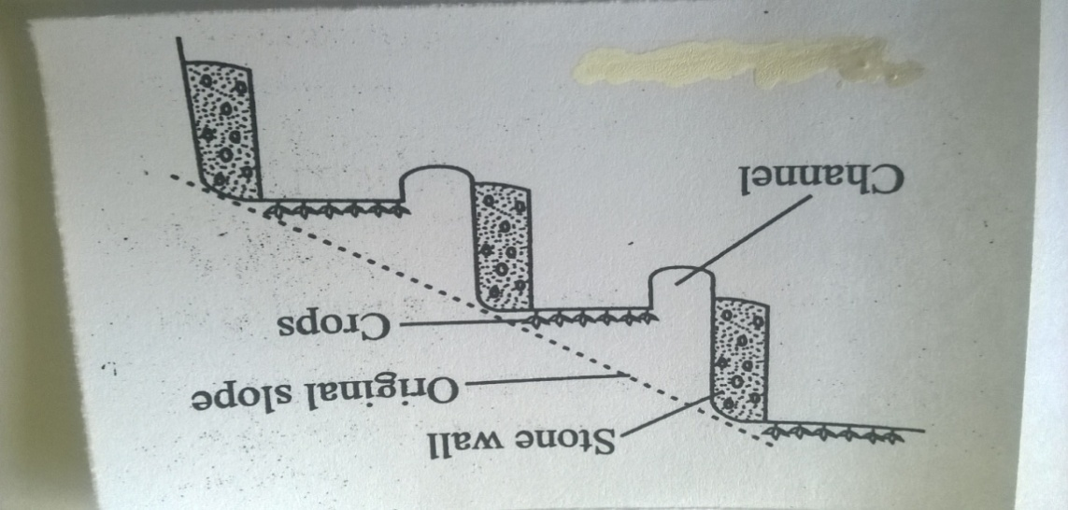
- Identify the type of terrace illustrated above. (1mk)
Bench terrace.
- Under what two circumstances should the construction of the above terrace be justified. (2mks)
-When high value crops are grown.
-When there is an acute shortage of suitable land.
- Name two other types of terraces. (2mks)
-Broad based terraces
-Narrow based terraces
-Fanya juu terraces
- The diagrams below illustrate methods of harvesting trees in agro-forestry.Study them and answer the questions that follow.
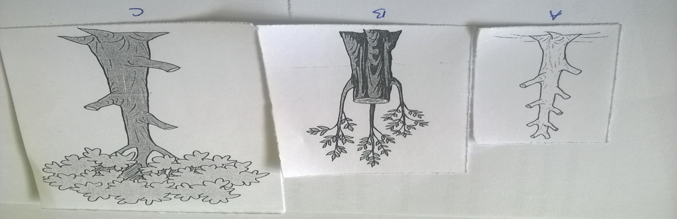

- Identify each of the methods illustrated A, B and C above. (3mks)
A-Pollarding
B-Coppicing
C-Lopping
- Use the following crops to answer the questions that follow.
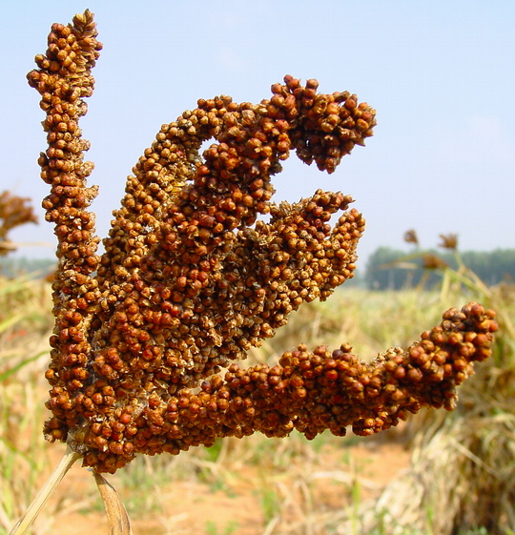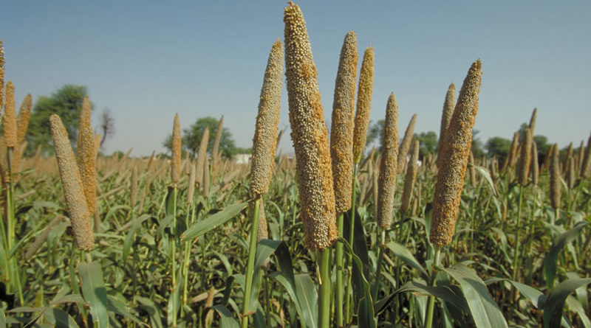

- Name the crops labelled D and E above. (1mk)
D-Finger millet.
E-Bulrush millet.
- Why is crop D rarely destroyed by pests in the stores? (1mk)
Because of their small size.
- Name any two diseases that affect crop E. (2mks)
-Downy mildew
-Rust
-Ergot
- Calculate the elasticity of supply of maize when 10,000 bags of maize were supplied in oyugis market at a price of Kshs. 800 per bag and 15,000 bags supplied in the same market when the price changed to Kshs. 1,200 per bag. (Show your working) (3mks)
Elasticity of supply = % change in quantity supplied
% change in price
% change in quantity supplied=5000x100 =50
10000
% change in price = 400 x100 =50
800
= 50
50
= 1

SECTION C (40MARKS)
- a) Explain ten factors influencing soil erosion. (10mks)
- The amount and intensity of rainfall-The ability of rainfall to detach and dislodge soil particles out of their structures is termed as the erosivity of rainfall.Rainfall of high intensity saturates the top soil very quickly resulting in high surface run-off.
- The slope of the land/topography-The steeper the land the higher thevelocity of running water and its erosive power.
- The type of soil-The ability of soil particles to be detached and carried away is referred to as its erodability.Sandy soils are quickly satuated withwater thus easily eroded than clay.
- Soil depth-Shallow soils become saturated with water very quickly and are easily eroded.
- Vegetation cover-Forests protect the soil against erosion because the trees act as barriers, preventing direct exposure of soil to agents of erosion.
- Overstocking-This causes the grass cover to be destroyed leaving the soil surface bare.
- Deforestation-This exposes soil to both high temperatures and heavy rainfall.
- Planting of annual crops on steep slopes-This leads to frequent cultivation hence exposure to soil erosion.
- Clean weeding-This leaves the soil more or less unprotected against water erosion.
- Indiscriminate burning of vegetation before cultivation-This exposes the soil to the agents of soil erosion.
- Ploughing up and down the slope-This create channels/rills which increase the velocity of running water hence its erosive power.
(Stating- 1/2mk and explaining- 1/2mk x 10= 10mks)

b) State five roles of trees in soil and water conservation. (5mks)
- They protect the soil below from raindrop erosion by reducing the force with which it falls onto the ground.
- They provideshade and reduce loss of moisture through evaporation
- They act as windbreaks.
- The roots of trees bind soil particles together.
- They reduce the speed of running water thus reducing its erosive power.
- Their leaves decay to supply humus to the soilwhich improves the infiltration rate of the soil.
- Trees create a suitable micro-climate for rainfall formation.

c) State five objectives of land tenure reform. (5mks)
- To encourage conservation measures on the land and general improvement on the land.
- To achieve increasing productivity of both land and labour.
- To encourage commercial instead of subsistence production.
- To encourage farmers to invest more through offering security of tenure.
- To achieve flexibility in farming patterns to meet changing national market demand.
- To achieve effective utilisation of national land resources including settlement of unused land and introduction of irrigation schemes where applicable.

- a) State five functions of agricultural society of Kenya. (5mks)
- Holding competitive agricultural shows and exhibitions of livestock, crops and farm produce.
- Encouraging breeding and importation of pure breeds of livestock and improvement of useful indigenous animals.
- Encouraging and assisting in official milk recording scheme.
- Organising the running of young farmers clubs.
- Organising the national ploughing contests.
- Awarding bursaries forlocal and overseas studies/tours for its members.

b) Explain ten factors influencing demand for a commodity. (10mks)
- Population-As population increases the demand for a given good or service at a given price will increase and vice versa.A high population demands more goods and services than a small population.
- Income-A change in the income of consumers will result in a change of the purchasing power and subsequently change in demand for certain goods and services.
- Preferences and tastes-These cause demand to change from time to time.It may also affect other products which may be substitutes for those under consideration.
- Prices of related goods-The demand of a commodity increases if there is an increase in price of a substitute eg margarine and butter.
- Advertisement-This promotes the sale of a given good or service by creating awareness of its presence in the market.This increases demand.
- Beliefs, customs and taboos-Religious beliefs may forbid the consumption of certain items eg pork among Muslims.
- Price expectations-If in the future the prices of certain commodities are likeiy to go up then the demand of such goods may go up currently or vice versa.
- Level of taxation-If the government increases tax on certain goods, their prices will increase hence reducing their demand.
- Perishability-When agricultural goods eg meat, milk, tomatoes etc deteriorate in quality their demand falls.
- Future expectation or uncertainity-When there is fear of shortage of a given commodity in future; consumers will tend to buy more of the commodity for the purpose of stocking thus increasing its demand.

c) At the end of the year 31/12/2017 the following information was recorded on Jamii farm: perennial crops shs. 250,000, Bank loan shs. 230,000, Cash at hand shs. 5,000, Bank overdraft shs.35,000, Land 350,000, unpaid wages shs. 23,000, Debts receivable shs. 20,000, stocks in store shs. 25,000 and livestock shs. 200,000. Prepare a balance sheet for the farm. (5mks)
JAMII FARM
BALANCE SHEET AS AT 31/12/17
Liabilities | Sh | Assets | Sh
Current liabilities  Bank overdraft  Unpaid wages  Long term liabilities  Bank loan  Total liabilities  Net worth | 35000  23000  230000  288000  562000 | Current assets  Cash at hand  Debts receiveable  Stock in store  Fixed assets  Perennial crops  Land  Livestock | 5000  20000  25000  250000  350000  200000
Total | 850000 |  | 850000

- a) Describe the production of tomatoes under the following:-
- Transplanting: (5mks)
-The nursery should be watered before lifting the seedlings.
-Healthy and vigorously growing seedlings are lifted using a garden trowel.
-One seedling is planted per hole and soil firmed around the seedling.
-Transplanting should be done on a cool day or late in the evening.
-Seedlings are mulched and watered regularly.

- Field Management (5mks)
Gapping-Any seedlings that dries after transplanting should be gapped to maintain the correct plant population.
Top dressing-At 25-30cm high tomato plants should be top dressed with nitrogenous fertilisers at the rate of 100kg CAN or SA per ha.
Weeding-The field should be kept weed free.Hand cultivation is done to control weeds.Care must be taken not to injure tomato roots and stems during weeding.Too much shaking is also avoided as it may cause immature fruit fall.
Staking-This is the practise ofsupporting tomatoes especially tall varieties using sticks which are about 2m high.
Pruning-Tomato plantsoften have many shoots growing from the main stem.1-3 main shoots per plant give the best yield.In tall varieties terminal buds are removed when the plant reaches 1.5-1.8m high.This encourages the development of large fruits and controls upward growth.

b) Give six advantages of Drip irrigation. (6mks)
- Economical in the use of water.
- Water under low pressure can be used.
- Minimizes the outbreak of leaf fungal diseases.
- Reduces growth of weeds between the rows.
- Fertilisers may be applied with water.
- Suitable for both slopy and flat land.
- Minimises water loss through evaporation
- Accumulation of salts around plants is avoided.

c) Explain four factors that determine the quality of hay. (4mks)

- Forage species used – legumes usually have high crude protein hence are of high quality.
- Stage of harvesting hence leaf: stem ratio (the higher the ratio the higher the quality). Forage has higher nutrients if harvested when 50% of the plants have flowered. Delay lowers the nutritive value since the nutrients would have been used in seed setting.
- Length of the drying period – prolonged exposure leads to bleaching of nutrients and breakdown of carotenes and chlorophyll.
- Weather conditions during the drying process-Rains spoil dry hay. Where occasional showers are expected, the forage may be dried on tripods.

