Name……………………………………….Index Number…………………….. Adm………..
Signature……………………….. Date……………………………..

233/2
CHEMISTRY PAPER 2
(THEORY)
JUNE, 2018
2 hours KASSU EXAMINATION 2018
CHEMISTRY
(Kenya Certificate of Secondary Education)
Instructions
- Write your name and index number in the spaces provided above.
- Sign and write the date of examination in the spaces provided above.
- Answer all the questions in the spaces provided in the question paper.
- Electronic calculators may be used.
- All working must be clearly shown where necessary.
- This paper consists of 13 printed pages. Confirm this and that no questions are missing.
For Examiner’s Use Only
Question | Maximum Score | Candidate’s score
1 | 11
2 | 14
3 | 11
4 | 12
5 | 09
6 | 12
7 | 11
Total | 80

- Study the information below given about elements A, B, C, D, E, F, G and H which form part of the Periodic Table. Letters are not actual symbols of the elements.
    - Element A is in period 2 group VI. D is atomic number 15.
    - Element F forms a cation having an oxidation state of +1. The ion of F has three occupied energy levels.
    - B and G belong to the same chemical family but G has one more energy level than B. B loses two electrons to form an ion with electronic configuration 2.8
    - Element C belongs to the same period as B and has one more proton than B.
    - E and H belong to the same group and react by gaining one electron. H has a larger atomic radius than E.
.
Use the information above to answer the questions that follow.

- Which element forms ions with a charge of 2-? Explain. (2 marks)
………………………………………………………………………………………………………
………………………………………………………………………………………………………
- What is the nature of the oxide formed by element C.? (1 mark)
………………………………………………………………………………………………………
- How does the reactivity of H compare with that of E? Explain. (2 marks)
………………………………………………………………………………………………………
………………………………………………………………………………………………………
- Write down a balanced chemical equation for the reaction between B and chlorine. (1 mark)
………………………………………………………………………………………………………
- Compare the atomic radii of elements F and G. Compare. (2 marks)
………………………………………………………………………………………………………………………………………………………………………………………………………………
- If the oxides of F and D are separately dissolved in water, state and explain the effects of their aqueous solutions on litmus. (3 marks)
………………………………………………………………………………………………………
………………………………………………………………………………………………………
………………………………………………………………………………………………………
- (a) Study the reduction potentials below.
Half cell E^{θ}(Volts)
A²⁺(aq) + 2e- ⇌ A _{(s)} +0.34
B⁺(aq) + e- ⇌B _{(s)} -2.92
½C₂ (g) + e- ⇌C⁻ _{(aq)} +2.87
(i) Identify the weakest oxidizing agent. (1 marks) …………………………………………………………………………………………………..… (ii) Calculate the e.m.f of the cell that would produce the highest output of voltage. (2 marks)
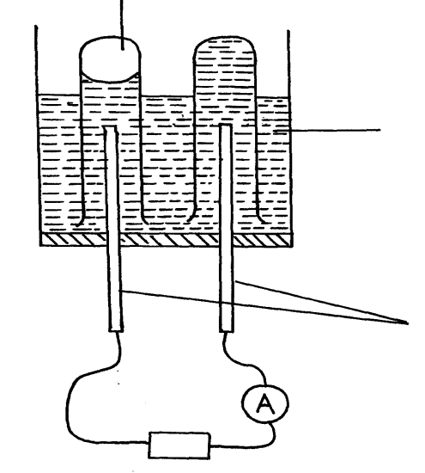
(iii) Write the cell diagram for the cell formed in (ii) above. (1 mark) …………………………………………………………………………………………………..… (b) Study the electrolytic cell below.
Gas A
Graphite electrodes
DC source
Copper (II) sulphate Solution

(i) Identify the anode and cathode on the diagram. (1 mark) (ii) Write an equation to show how gas A is formed. (1 mark) …………………………………………………………………………………………………..…..
(iii) State two changes that occur in the electrolyte after the experiment. (2 marks)
…………………………………………………………………………………………………..….
…………………………………………………………………………………………………..….. (iv) Draw a well labelled diagram showing how impure zinc can be purified by electrolysis. (2 marks)

(v) Write the equation at the anode if copper electrodes were used. (1 mark) …………………………………………………………………………………………………..…..
(vi) In electrolysis of dilute magnesium sulphate, using inert electrodes, a current of 2A was passed for 1¼ hours. Calculate the volume of the gas produced at the anode at s.t.p.
(1F=96500 C, M.G.V=22.4 Litres) (3 marks)

- The scheme below shows various reactions starting with ammonia. Study it and answer the questions that follow
(a)Name the catalyst used in step I (1 mark)
………………………………………………………………………………………………………
(b) Write any two equations for the reactions that take place in step I. (2 marks)
………………………………………………………………………………………………………
………………………………………………………………………………………………………
(c) Name the process that takes place in step II. (1 mark)
………………………………………………………………………………………………………
(d) Explain what happens in step III. (2 marks) ………………………………………………………………………………………………………………………………………………………………………………………………………………
(e) Write the formula of compound J. …………………………………………………… (1 mark )
(f) Calculate the percentage of nitrogen by mass that is present in compound J. (N=14, H=1,O=16) (2 marks)
………………………………………………………………………………………………………
………………………………………………………………………………………………………
(g) Give one advantage that ammonium phosphate has over ammonium sulphate as a fertilizer. (1 mark)
………………………………………………………………………………………………………
(h) Give one disadvantage of using artificial fertilizer. (1 mark)
………………………………………………………………………………………………………
- (a) (i) What is a fuel? (1 mark)
………………………………………………………………………………………………………
(ii) Calculate the heating value of propane, C₃H₈, given that its molar enthalpy of combustion is -2200 kJ mol⁻¹. (C=12, H=1) . (2 marks)

(b) (i) Define molar enthalpy of combustion. (1 mark)
………………………………………………………………………………………………………
………………………………………………………………………………………………………
(ii) Use the information provided by the thermochemical equations below to calculate the
molar enthalpy of combustion of ethyne. (3 marks)
C_{(s)} + O_{2 (g)} CO_{2 (g)} ∆H= -394 kJ mol⁻¹
H_{2 (g)} + ½O_{2 (g)} H₂O _{(g)} ∆H= -286 kJ mol⁻¹
2C_{(s)} + H_{2 (g)} C₂H_{2 (g)} ∆H= +226 kJ mol⁻¹

(c) Study the data given below and answer the questions that follow.
Substance/ion | Enthalpy change
CaCl₂(s) | Lattice energy = -2237 kJ mol⁻¹
Ca²⁺(g) | Hydration energy = -1650 kJ mol⁻¹
Cl⁻(g) | Hydration energy = -364 kJ mol⁻¹

- Determine the molar enthalpy of solution of calcium chloride in water. (2 marks)

- Draw an energy level diagram for the dissolution of calcium chloride in water. (3marks)

- Study the scheme below and answer the questions that follow.

Mixture S
White Precipitate

H₂O Step I Ca(OH)_{2 (aq)}

Gas V

Solution T Solid U HNO_{3 (aq)}

Solution in W
Acidified
BaCl_{2 (aq)}
HCl_{(aq)} Excess NaOH

White ppt R White ppt soluble
White in excess
Precipitate

step II step III
Excess Excess
NaOH NH₄OH

White ppt White ppt
Soluble in soluble in
excess excess

(a) What property of mixture S is shown in step 1. (1 mark) ………………………………………………………………………………………………………(b) Name the following. (3 marks)
Solid U …………………………………………………………
Gas V …………………………………………………............
Write the formula of precipitate R …………………………………………….
(c) Identify the ions present in solution T. (1mark)
………………………………………………………………………………………………
(d) Write an ionic equation for the reaction between.
(i) Solution T and Barium chloride solution. (1 mark)
………………………………………………………………………………………………………
(e) Identify mixture S. (1 mark)
………………………………………………………………………………………………………
(f) Write balanced chemical equations for reactions in which the white precipitates dissolves in excess reagents in steps II and II (2 marks)
Step II………………………………………………………………………………………………

Step III……………………………………………………………………………………………

- The flow chart below shows some chemical reactions. Study it and answer the questions that follow.
NaOH_{(aq)}
CH₃COONa
CH₃COOH

Ethanol
CH₃CH₂OH
Na_{(s)}
S
Compound P
CH₃COOH
Cl_{2(g)}
T
CH₄

H₂
Br_{2(g)}
W
CH₂ = CH₂
V

CH₂ - CH₂
U n

a) Write the name and formula of the organic compounds P,V and W. (3 marks)

Compound | Name | Formula
P
V
W

b) Name the process that leads to the formation of substance:
V (1 mark)
………………………………………………………………………………………………
T (1 mark)
………………………………………………………………………………………………
P (1 mark)
………………………………………………………………………………………………

c) Give one necessary condition for the formation of compound P. (1 mark)

………………………………………………………………………………………………

d) If the relative molecular mass of compound U is 84,000 , determine the value of n. ( C = 12, H= 1.0) (2 marks)

e) Write an equation for the reaction leading to the formation of substance S. (1 mark)

………………………………………………………………………………………………
………………………………………………………………………………………………

f) State and explain the observations made when the following substances are burnt in
excess air. (2 marks)
W
………………………………………………………………………………………………………………………………………………………………………………………………………………………………………………………………………………………………………………………
C₂H₄ …………………………………………………………………………………………….……………………………………………………………………………………………..………………………………………………………………………………………………………………………

- I (a) Below is a diagram of a process used for the production of sodium.
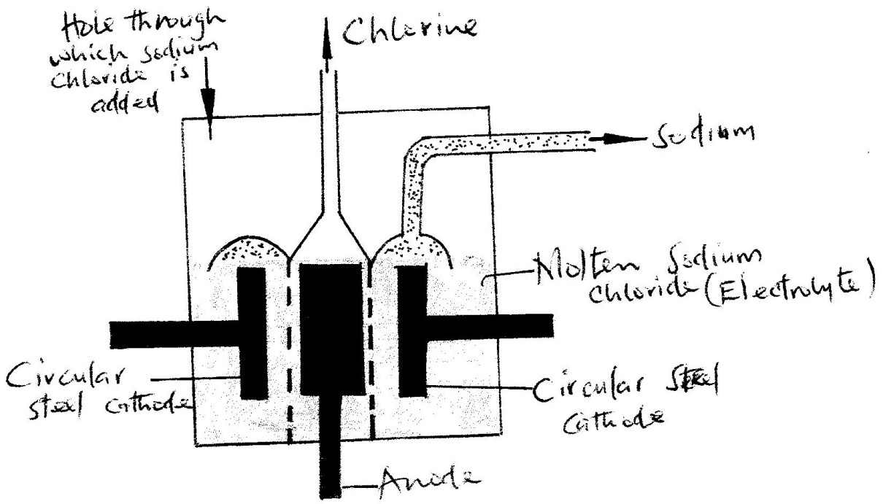
Study it and answer the questions that follow.

(i) Name the process. (1 mark)
………………………………………………………………………………………………………
(ii) What is the role of the steel gauze diaphragm? (1 mark)
………………………………………………………………………………………………………
(iii) Write an equation for the reaction at the anode. (1 mark)
………………………………………………………………………………………………………
(b) The electrolyte is a molten mixture containing Na⁺ and Ca²⁺ cations.
(i) What is the source of Ca²⁺ ions? (1 mark)
………………………………………………………………………………………………………
……………………………………………………………………………………………………… (ii) Give a reason why Ca²⁺ ions are not discharged. (1 mark)
………………………………………………………………………………………………………
II. (a) The diagram below represents a mercury cathode cell that can be used to manufacture sodium hydroxide. Study it and answer the questions that follow.
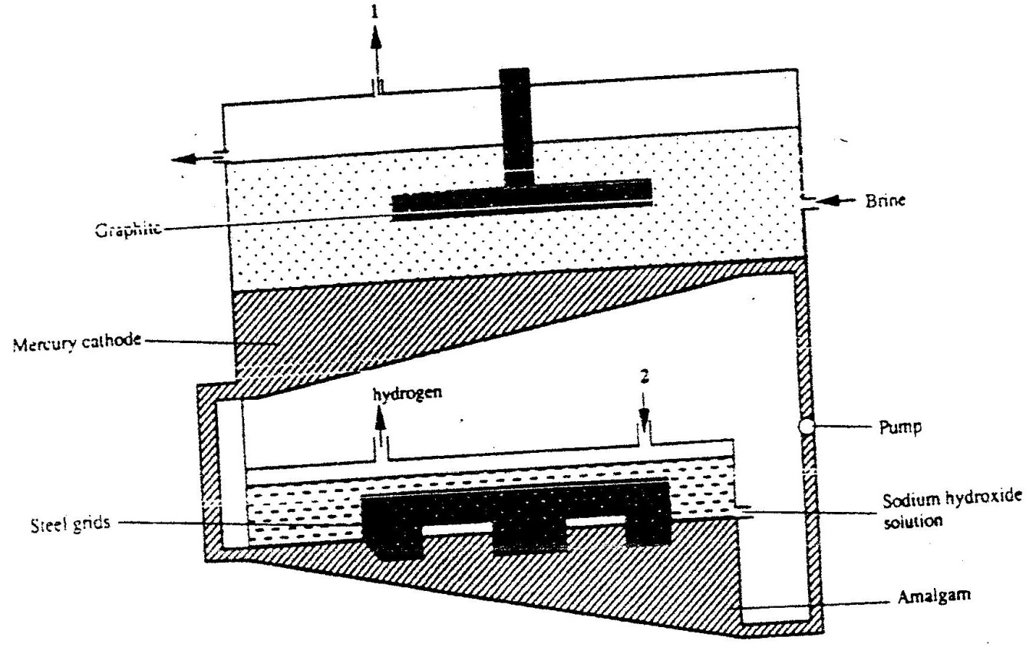

(i) Name the substance:
I. labelled 2. ………………………………………………………. (1 mark)
II. labelled 1. …………………………………………………………… (1 mark)
(ii) Give two reasons why mercury is recycled. (2 marks)
………………………………………………………………………………………………………
………………………………………………………………………………………………………(iii) Write an equation for the reaction that occurs at the mercury cathode. (1 mark)
………………………………………………………………………………………………………(b) State one use of sodium hydroxide. (1 mark)
………………………………………………………………………………………………………

