KASSU JOINT EXAMINATION - 2018
Kenya Certificate of Secondary Education (K.C.S.E.).
312/1
Paper 1
GEOGRAPHY.
MA R K I N G S C H E M E

SECTION A
1. (a) The diagram below shows the internal structure of the earth.
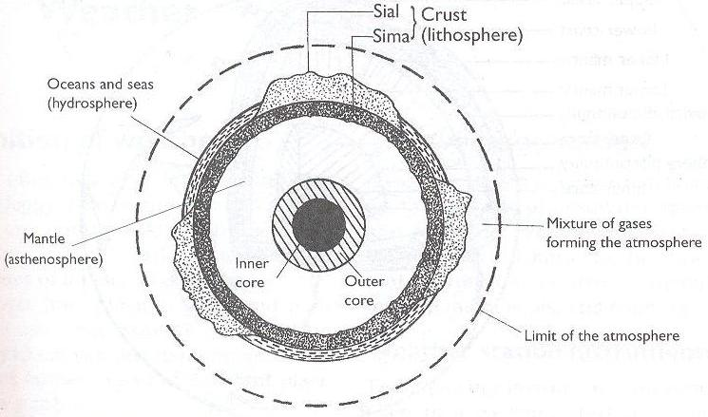

- Name the parts marked X and Y. (2 marks)
X - Ocean crust/SIMA
Y - Inner core

- State three characteristics of the upper mantle. (3 marks)
- Is elastic and solid/semi-molten in nature.
- Has lower temperature than lower mantle.
- Extends from more discontinuity to a depth of 100km

2. The map below shows the climatic regions of Kenya
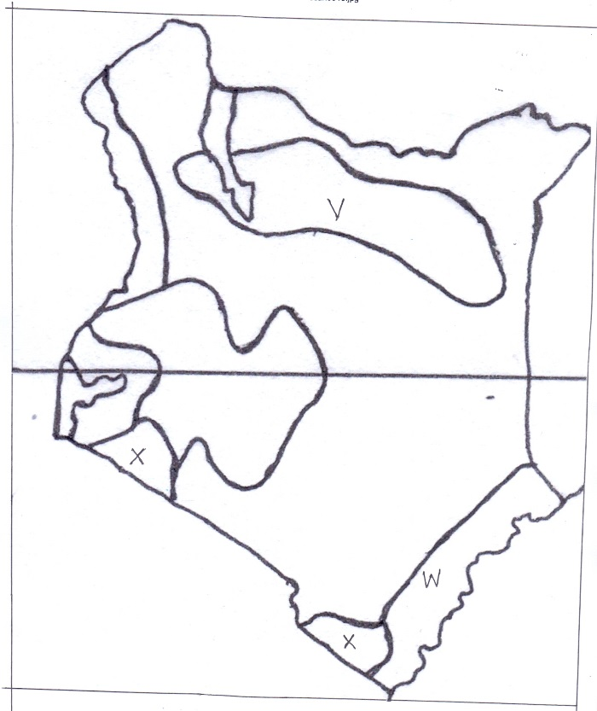
(i) Name the climatic region marked V, W. (2 marks)
V – Desert climate / Desert climate of central Northern areas.
W – Modified equatorial climate of the coast.

(ii) State three characteristics of the climatic region marked X. (3 marks)
- Temperatures are high / 23⁰C – 31⁰C
- Rainfall is low to moderate about 670mm
- Receives rain one season
- Rainfall mainly convectional
- Have low humidity

3. (a) Differentiate between earthquake intensity and magnitude (2 marks)
Earthquake intensity is the measure of how hard/strong the earthquake waves / seismic waves shakes the earth surface while earthquake magnitude is the measure of the amount of energy given off by an earthquake.

(b) Name three earthquake zones in the world (3 marks)
- Circum – pacific
- Mediterranean – East Indies Belt / The Tethyam Belt / The Alpine – Himalay GS Belt.
- Mid-Atlantic Ocean Belt
- The great Rift Valley

4. (a) Distinguish between oceans and seas. (3 marks)
Oceans are large and extensive body of saline water occupying basis between continents while seas are small and extensive body of saline water occupying margins of continents.

(b) State three factors causing the development of ocean currents. (3 marks)
- Prevailing wind causing a frictional drag on the Ocean water surfaces.
-Rotation of the earth affecting the direction of wind both in North and Southern
poles.
-The shape of the coastline
-Differences in Ocean water temperature.

5. (a) The diagram below shows a river braid. Identify the features marked X
and Y. (2 marks)

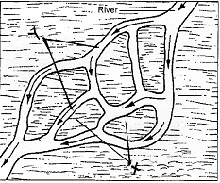

X - shoals / Eyots / Isles
Y - Braids

(b) State three conditions for the formation of a delta. (3 marks)
- The river must have a large load of sediments at the river mouth
- Absence of obstacles / filters in the river course.
- The river should be flowing slowly on entering its mouth / Low velocity of the river at the river mouth.
- The strength of the Ocean waves should be weaker to allow deposition of sediments.
- High rate of deposition than removal of silt at the river mouth.

6. (a) (i) Convert the ratio scale of the map into a statement scale. (2 marks)

Map ratio scale 1 : 50,000
1 cm represents 50,000 cm

$\frac{50,000}{100,000} =0.5km$

Statement scale is 1cm represents 0.5km / 1cm represents ½ km

- What is the name of the adjoining map to the south of Migwani?

151/3 Kitui

(iii) Give the longitudinal extent of the map. (2 marks)

Approximately from 38⁰ 01¹E to 38⁰ 13¹E

(iv) Calculate the bearing of the trigonometric station at grid reference 9264 from Usiani School. (2 marks)

218⁰
(b) (i) Using a vertical scale of 1cm to represent 100metres, draw a cross section along the line J-K. (4 marks)

(ii) On it mark and label the following: (4 marks)
- Footpath
- Road
- Water pipeline
- Steep slope

(c) Describe the relief of the area covered by the map. (5 marks)
- There are many hills in the area covered by the map.
- There are ridges to the Eastern Part of the Easting OO.
- There are river valleys which are occupied by rivers i.e. River Ngoo.
- There are steep slopes at Mutito forest.
- The area to the East of Easting 08 is flat as evidenced by spaced contours.
- The lowest atitude is 660m while the highest altitude is 1600m above sea level.
- The land rises from East to West.
- There are many interlocking spur along the river valleys.
- The landscape is dissected by many river valleys.
- There are many narrow river valleys.
- There are gentle slopes.

(d) Citing evidence from the map, give two economic activities carried out in the area covered by the map. (4 marks)
- Transport business – Evidenced by presence of roads e.g. all weather road bound surface. (C 94)
- Communication – Evidenced by Post Office.
- Trading – Evidenced by presence of shops / markets e.g. GR. 9274.

7. (a) (i) Identify two features formed by vertical earth movements.
(2 marks)
- Basins
- Plateaus
- Fault scarps/escarpments
- Tilt blocks
- Rift valleys
- Submerged coasts
- Emerged coasts

(ii) Explain how the following factors cause earth movements:
- Gravitative pressure. (2 marks)
- When large amounts of magma escape to the surface of the earth, large cavities or voids are left behind.
- The force of gravity exerts pressure on the crustal rocks from the voids causing them to move inwards hence causing vertical movements.
- Isostatic adjustment. (4 marks)
- If ice sheets melt over the highlands or soil erosion occurs and deposition of water or soil in the sea or depression.
- A vertical isostatic uplift will occur on the highland because it is light while isostatic sinking will occur on the depression because it is heavier.
- The adjustment which is meant to maintain isostacy is called isostatic adjustment.

(b) Describe the plate tectonics theory. (5 marks)
- It is the study of the movement of plates and the resultant landforms.
- The theory suggests that the earth’s lithosphere is made of semi-rigid blocks called plates.
- These plates are fractured and constantly moving relative to each other along their plate margins forming various physical features.
- Their movements are caused by convectional currents within the mantle.
(c) (i) What is faulting? (2 marks)
The process through which the brittle crustal rocks fracture or break due to tectonic forces.
- Study the diagram below and answer the questions that follow:
F

Upthrow
G

Hade
Downthrow

Fault

Name the parts marked;
F - Heave
G - Throw

- Apart from the above type of fault, name two other types of faults.

- Reversed fault
- Shear/tear fault
- Thrust fault
- Anticlinal fault

(d) Explain three ways in which faulting influences drainage.
- If rift faulting occurs in an enclosed area, a basin may be formed when rivers flow into the basin a lake may be formed.
- Some rivers may end up flowing along fault lines thus forming a fault-guided drainage pattern.
- Uplifting of land which follows faulting may block a river. This may cause it to reverse/change its direction of flow.
- When faulting occurs across a river valley, it may cause the river to disappear into the ground through fault lines.
- When faulting occurs across a river valley, vertical displacement of land may occur causing the river to form a waterfall where it descends an escarpment.
- Faulting may lead to the formation of escarpments with springs forming at the base due to exposure of the water table.
- Faulting across a river or escarpment may cause a river to descend forming a waterfall.

8. (a) What is secondary vegetation? (2 marks)
It is the plant cover existing naturally in a place/area but has been interfered by human activities and being in the processes of recovering.

(b) Explain how the following factors influence vegetation distribution in Kenya.
- Soil fertility (2 marks)
- Deep soils -Supports large/huge trees because it gives a firm anchorage.
- Well drained soils lead to growth of a variety of plants because of plenty of nutrients.
- Thin soils support shallow rooted plants /grasses/shrubs

- Sunlight (2 marks)
Regions/areas/places experiencing long hours of sunshine/sunlight have support for variety of plant species.
- Aspect (2 marks)
The slopes facing the sun are warmer and therefore support wide variety of plant species.
(c) State six uses of savanna grassland vegetation in Kenya. (6 marks)
  - The grass acts as soil cover reducing occurrence of soil erosion.
  - Grassland areas are habitats of variety of wildlife for tourist attraction.
- Grasses heavily provide humus enriching the soil fertility for arable farming.
- Some trees in the grasslands are habitats for bees providing honey.
- Grasslands provide grazing grounds for livestock hence cattle rearing.
- Some trees in the grasslands may provide wood for domestic and industrial use.
- Some of the trees may have wild fruits and berries consumed as food.

(d) The world map below shows world major vegetation zones use it to answer the questions below.

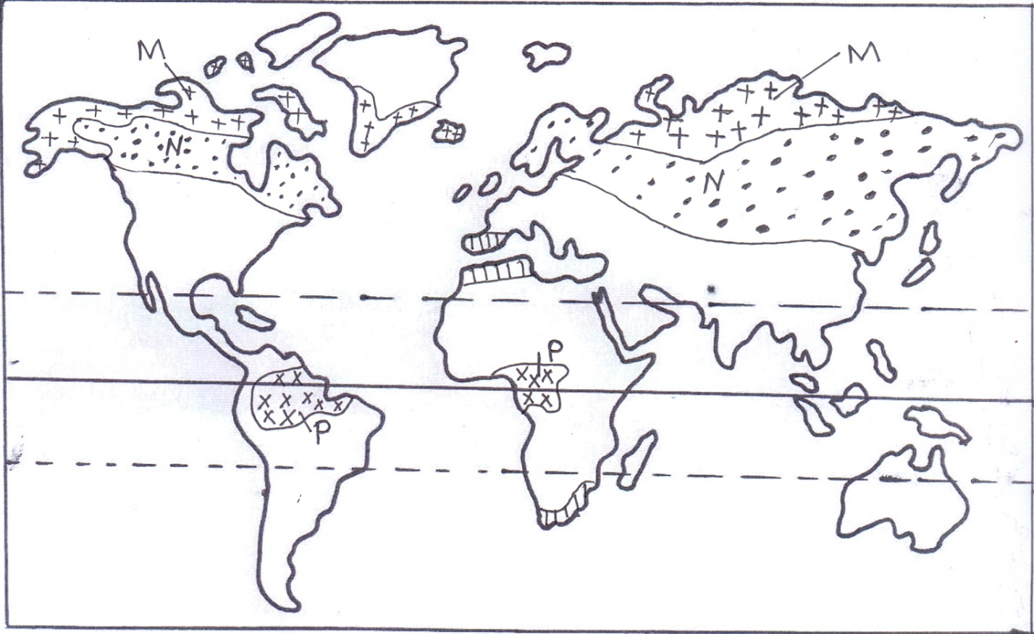
(i) Name the vegetation zones marked N, P, and M. (3 marks)
N - Coniferous vegetation / Taiga / Boreal
P - Equatorial rain forests / Tropical rain forests / Selva
M - Tundra desert vegetation

(ii) State the characteristics of Mediterranean vegetation. (8 marks)
- Some plants may have long tap roots
- Some plants are evergreen
- Some trees are deciduous
- Some trees may be thick barks
- Some plants may have spiny leaves
- Some plants have waxy leaves
- Some plants species have large fleshly bulbous roots
- Some plants may have thick stems
- Many of the plants have sweet smelling scent.
- Grasses dry off during summers and germinate during winter.
- Some plants have fleshy leaves
- Woody scrubs are common in very dry areas.
9. (a) What is the difference between weathering and mass wasting? (2 marks)
Weathering is the breakdown and decomposition of solid rocks at or near the earth’s surface by physical or chemical processes without movement while mass wasting is the displacement / movement of weathered materials downslope under the influence of gravity.

(b) Give three factors that influence the rate of weathering. (3 marks)
- Climate of the area
- Nature of the rock
- Topography/angle of the slope
- Time taken
- Human activities

(c) (i) A part from block disintegration and granular disintegration name
three other processes of physical weathering (3 marks)
- Alternate weather and drying
- Pressure release / unloading / sheeting
- Exfoliation /onion skin weathering / spalling
- Frost action/congelifraction
- Crystal growth

(ii) Describe the following processes of weathering. (3 marks)
- Granular disintegration
- This is a process where the rocks break up into small particles / grains
- It is common in areas where rocks are made up of different types of minerals particles.
- These minerals grains expand and contract at different rates when subjected to high temperatures and low temperatures respectively.
- Internal stress is created which then result into rocks crumbling and disintegrating into small grains.

      - Hydrolysis
- This is reaction that takes place between hydrogen ions of water and and the ions of water and the ions of the feldspar mineral found in granite rocks.
- Water combines with rock minerals.
- A reaction between the hydrogen ions of water and the ions of minerals takes place.
- The minerals in the rocks are broken down to form completely new insoluble precipitation that is clay in a process called hydrolysis.
(d) You are planning to carry out a field study of types of mass wasting.
(i) Identify three methods you would use to collect data. (3 marks)
- Observing the resultant features of mass wasting.
- Taking photographs
- Interviewing resource persons.
- Counting
- Filming

(ii) Give three types of rapid mass wasting that you are likely to
observe during the study. (3 marks)
- Earth flows
- Mud flows
- Land slides
- Rain wash / down wash.
(iii) State two follow-up activities you are likely to do. (2 marks) Holding group discussion
- Group leader presentation
- Reading more on the topic
- Asking and answering questions
- Labeling samples
- Displaying photographs

(e) Explain the effects of mass wasting on the following.
      - Tourism. (2 marks) -Features created through mass wasting are tourism attraction.

- Soil fertility. (2 marks)
-Mass wasting facilitates soil erosion leading to soil degeneration.
-May lead to formation of fertile soils where such soils are deposited.
10. (a) What is glaciation? (2 marks)
It is the process by which moving ice erodes, transports and deposits materials on the earth’s surface.

(b) Describe the following processes by glacial erosion.
Plucking (3 marks)
- Pressure from the overlying mass of ice cause freeze and thaw action.
- Melting water fills the cracks / joints in the bedrocks.
- When temperature falls, water in cracks freezes, it increases in volume, exerting pressure on the cracks thus enlarging them.
- The enlarged cracks lead to disintegration of the rocks.
- The disintegrated rocks eventually gets embedded within the ice.
- As the ice moves, it pulls/gorges out the embedded rock from the parent rock.
- This is called plucking.

Abrasion (3 marks)
- As the ice moves, it collects rocks and boulders on the path of glacier.
- The stories and boulders are then frozen in the moving ice.
- They are dragged over the underlying rocks polishing/scrubbing/scratching the surface.
- They wear away the rocks on the surface, smoothing it.
- This is called abrasion.

(c) (i) Identify the features marked L, M, and N.

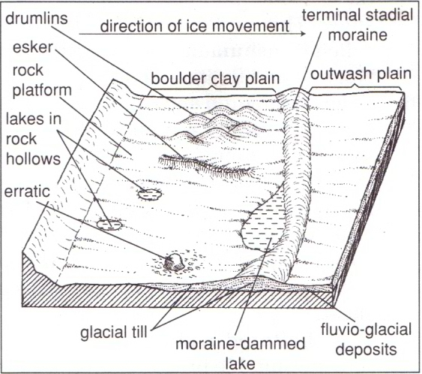
Esker
N
M
L
Y
(i) Identify the features marked L, M, and N. (3 marks)
L – Terminal moraine.
M - Rock Basin Lakes/ Kettle Lakes.
N - Erratic.

(ii) State three characteristics of drumlins. (3 marks) - Made up of unratified materials.
- Low rounded hills/egg-shaped/ oval shaped.
- Occur in groups/ hills/swarms
- Steep on the upstream and downstream is long and gentle sloping.
- Upstream is smoothened by abrasion.
- They are elongated mounds of moraines.
- Vary in size between 50 m- 1 km.

(iii) Describe how esker are formed. (4 marks)
- A mass of ice stops moving in a lowland area.
- The ice starts melting at the base.
- Streams are formed beneath the ice and form permanent sub—glacial tunnels.
- Water flows through the tunnels under hydrostatic pressure.
- The water thus flows rapidly hence the amount of load carried is quite large.
- When the ice melts, the tunnel collapse and materials are deposited there.
- This results in formation of a long winding steep-sided ridge of deposits called an esker.

(d) Explain three significance of erosional features in a glaciated upland.
(6 marks)

  - Hanging valleys form waterfalls which are ideal sites for generation of HEP.
  - Glacial lakes provide natural route-ways and can also be used for fishing.
  - Glacial features like pyramidal peaks, Arêtes and Cirques form beautiful sceneries which act as tourist attraction sites thus earning the country foreign exchange.
  - Fiords formed in glaciated upland coasts form suitable sites for harbor and fish breeding grounds.
  - Glaciated highlands are source of rivers that provide water for irrigation, domestic and industrial use.
  - Glaciated highlands covered by snow are good sites for winter sports.
  - Glacial troughs provide good sites for grazing of animals.

