451/1 -COMPUTER STUDIES– Paper 1
(THEORY)
July 2018
TIME: 2 ½ HRS

MOKASA II EVALUATION EXAMINATION
Kenya certificate of secondary education
(K.C.S.E)

Name……………………………………………….………Adm. No……….…….……Class………………
Date:…………………………………………….Signature:…………………………………………………..

Instructions to candidates
- Write your name and index number in the spaces provided above.
- Sign and write the date of examination in the spaces provided above.
- This paper consists of TWO sections; A and B
- answer all questions in sections A.
- Answer question 16 and any other THREE questions from section B.
- This paper consists of 14 printed pages.
- Do not remove any pages from this booklet.
- Candidates should check to ensure that all pages are printed as indicated and that no question is missing.
- Candidates should answer the questions in English.

For Examiner’s Use Only

Section | Question | Candidate’s score
A | 1 – 15
B | 16
 | 17
 | 18
 | 19
 | 20
Total marks

SECTION A (40 MARKS)
ANSWER ALL QUESTIONS IN THIS SECTION

- What is a dedicated computer? (1 mark)

…..……………………………………………………………………………………………………………………….
…..……………………………………………………………………………………………………………………….
…..……………………………………………………………………………………………………………………….
- (a) Parallel computer technology is highly applicable in modern organizations. Explain how a parallel computer works. (2 marks)

…..……………………………………………………………………………………………………………………….
…..……………………………………………………………………………………………………………………….
…..……………………………………………………………………………………………………………………….
…..……………………………………………………………………………………………………………………….
(b)The figure displayed below was used as amajorcomponent to implement the processor technology in the third generation computers. Identify its name. (1 mark)
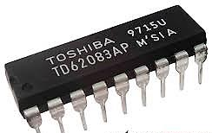
…..……………………………………………………………………………………………………………………….
- Explain how analog computers are used in industries that manufacture steel products. (2 marks)

…..……………………………………………………………………………………………………………………….
…..……………………………………………………………………………………………………………………….
…..……………………………………………………………………………………………………………………….
…..……………………………………………………………………………………………………………………….
- A computer controlled simulator can be used to help train aircraft pilots.
- Give two reasons why such a system is used. (1 mark)

…..……………………………………………………………………………………………………………………….
…..……………………………………………………………………………………………………………………….
…..……………………………………………………………………………………………………………………….
…..……………………………………………………………………………………………………………………….
- Anexpert system is defined as a computer system that mimics the thought process and reasoning of experts in specific areas such as medical diagnosis, complex financial decisions, weather forecasting, mining & exploration, complex geographical analysis etc.

State three components of anexpert system. (3 marks)

…..……………………………………………………………………………………………………………………….
…..……………………………………………………………………………………………………………………….
…..……………………………………………………………………………………………………………………….
…..……………………………………………………………………………………………………………………….
- A well-lit lab is important to avoid eyestrain that causesheadache, fatigue and stress.
- State any two safety precautions that can be observed to prevent eye-related issues. (2 marks)

…..……………………………………………………………………………………………………………………….
…..……………………………………………………………………………………………………………………….
…..……………………………………………………………………………………………………………………….
…..……………………………………………………………………………………………………………………….
…..……………………………………………………………………………………………………………………….
- List any two tools required when replacing a computer processor with a new one. (2 marks)

…..……………………………………………………………………………………………………………………….
…..……………………………………………………………………………………………………………………….
…..……………………………………………………………………………………………………………………….
- State two reasons why a computer needs more RAM (2 marks)

…..……………………………………………………………………………………………………………………….
…..……………………………………………………………………………………………………………………….
…..……………………………………………………………………………………………………………………….
…..……………………………………………………………………………………………………………………….
- Differentiate between the following terms as used in spreadsheet application
- Statistical analysis and forecasting (2 marks)

…..……………………………………………………………………………………………………………………….
…..……………………………………………………………………………………………………………………….
…..……………………………………………………………………………………………………………………….
…..……………………………………………………………………………………………………………………….
…..……………………………………………………………………………………………………………………….
- Absolute referencing and relative referencing (2 marks)

…..……………………………………………………………………………………………………………………….
…..……………………………………………………………………………………………………………………….
…..……………………………………………………………………………………………………………………….
…..……………………………………………………………………………………………………………………….
…..……………………………………………………………………………………………………………………….
- (i) State four categories of input devices. (2 marks)

…………………………………………………………………………………………………………………………………………………………………………………………………………………………………………………………………………………………………………………………………………………………………………………………………………………………………………………………………………………………………………………
(ii) The diagram below represents a printer dialogue box used when you want to print.
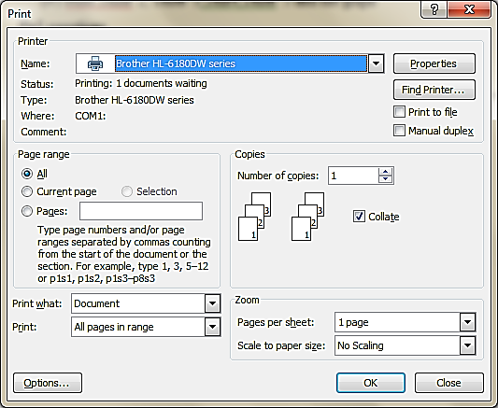

State the functions of the following labels in the diagram (2 marks)
- Collate
…..……………………………………………………………………………………………………………………….
…..……………………………………………………………………………………………………………………….
- Pages per sheet
…..……………………………………………………………………………………………………………………….
…..……………………………………………………………………………………………………………………….
- State three types of Action queries as used in databases. (3 marks)

…..……………………………………………………………………………………………………………………….
…..……………………………………………………………………………………………………………………….
…..……………………………………………………………………………………………………………………….
- (i) Organizations can use proprietary or open source software. Describe what is meant by the term ‘proprietary software’. (2 marks)

…..……………………………………………………………………………………………………………………….
…..……………………………………………………………………………………………………………………….
…..……………………………………………………………………………………………………………………….
(ii) Definedisk defragmentation software. (1 mark)

…..……………………………………………………………………………………………………………………….
…..……………………………………………………………………………………………………………………….
…..……………………………………………………………………………………………………………………….
- A family’s home network consists of several computers linked together wirelessly through a router which also provides access to the Internet.

- Briefly explain, any TWOsecurity threats to this network (At least one threat should be from inside the home and one threat from outside.) (2 marks)

…..……………………………………………………………………………………………………………………….
…..……………………………………………………………………………………………………………………….
…..……………………………………………………………………………………………………………………….
…..……………………………………………………………………………………………………………………….
…..……………………………………………………………………………………………………………………….
…..……………………………………………………………………………………………………………………….
…..……………………………………………………………………………………………………………………….
- Explainone security measure that the family could take to protect their network from the external threat, given in your answers above in (a). (1 mark)

…..……………………………………………………………………………………………………………………….
…..……………………………………………………………………………………………………………………….
…..……………………………………………………………………………………………………………………….
…..……………………………………………………………………………………………………………………….
- (a) Differentiate between fill and stroke as used in desktop publishing (2 marks)
…..……………………………………………………………………………………………………………………….
…..……………………………………………………………………………………………………………………….
…..……………………………………………………………………………………………………………………….
…..……………………………………………………………………………………………………………………….
(b)Margaret claims that DTP is superior to a word processor. Give a reasons why this true. (1mark)
…..……………………………………………………………………………………………………………………….
…..……………………………………………………………………………………………………………………….
…..……………………………………………………………………………………………………………………….
- HDMI, Bluetooth, SCSI, WIFI are some of interface connection technologies that are emerging in most electronic and computing devices. Mention any other two interface connections (cable or wireless) that are used with modern devices in transmitting data in computers. (2 marks)

…..……………………………………………………………………………………………………………………….
…..……………………………………………………………………………………………………………………….
…..……………………………………………………………………………………………………………………….
- Backup is a vital aspect in secondary storage; they include Cloud storage, hard disk, flash drives, Optical discs, SD cards, Memory cards, etc.

- Define what is meant by cloud storage. (1 mark)

…..……………………………………………………………………………………………………………………….
…..……………………………………………………………………………………………………………………….
…..……………………………………………………………………………………………………………………….
- Statetwo benefits of cloud storage in computing. (1 mark)

…..……………………………………………………………………………………………………………………….
…..……………………………………………………………………………………………………………………….
…..……………………………………………………………………………………………………………………….
- (a)Differentiate between first-line indent and hanging indent as used in word processing. (2marks)
…..……………………………………………………………………………………………………………………….
…..……………………………………………………………………………………………………………………….
…..……………………………………………………………………………………………………………………….
…..……………………………………………………………………………………………………………………….
(b)The figure below show an extract of a page setup dialog box. Use it to answer questions that follow.
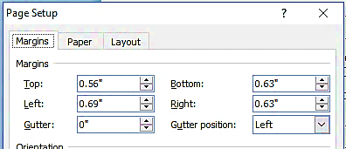
- What is the function the part marked with a circle? (1 mark)
…..……………………………………………………………………………………………………………………….
…..……………………………………………………………………………………………………………………….

SECTION B (60 MARKS)
Answer question 16 and any other THREE questions from this section B

- (a) Define the term encapsulation as used in programming (1 mark)

…..……………………………………………………………………………………………………………………….
…..……………………………………………………………………………………………………………………….
…..……………………………………………………………………………………………………………………….
…..……………………………………………………………………………………………………………………….
(b)Study the languages below then answer the questions that follow;
1101 1101
1110 001
111 000

LDA B,10
ADD B,20
STOP A,B
NOP

(i) (ii)

Identify the two programming languages (i) and (ii) above. (2 marks)

…..……………………………………………………………………………………………………………………….
…..……………………………………………………………………………………………………………………….
…..……………………………………………………………………………………………………………………….
Explain what each line in code (ii) does (2 marks)

………………………………………………………………………………………………………………………………..……………………………………………………………………………………………………………………….
…..……………………………………………………………………………………………………………………….
…..……………………………………………………………………………………………………………………….
…..……………………………………………………………………………………………………………………….
(c). Determine the output of the algorithm below. (4 marks)
FOR X = 1 to 6 Do
R=X
WHILE R >= 1 DO
PRINT R
R=R-1
ENDWHILE
ENDFOR
…..……………………………………………………………………………………………………………………….
…..……………………………………………………………………………………………………………………….
…..……………………………………………………………………………………………………………………….
…..……………………………………………………………………………………………………………………….
…..……………………………………………………………………………………………………………………….
…..……………………………………………………………………………………………………………………….
…..……………………………………………………………………………………………………………………….

(d)Study the flowchart below then answer the questions that follow
START
P = 2
L = 4
N = P + 2
IS N <20?
PRINT N
P = L
L = N
N = P + L
STOP
Yes
No

- Identify the control structure used in the flowchart above (1 mark)

…..……………………………………………………………………………………………………………………….
……………………………………………………………………………………………………………………………
- Write a pseudocode for the flowchart above (5 marks)
………………………………………………………………………………………………………………………………………………………………………………………………………………………………………………………………………………………………………………………………………………………………………………………………………………………………………………………………………………………………………………………………………………………………………………………………………………………………………………………………………………………………………………………………………………………………………………………………………………………………………………………………………………………………………………..……………………………………………………………………………………………………………………….
…..……………………………………………………………………………………………………………………….
…..……………………………………………………………………………………………………………………….
……………………………………………………………………………………………………………………………
- (a)Explainthe following data representationcodingschemes. (3 marks)
- Enhanced BCD
…..……………………………………………………………………………………………………………………….
…..……………………………………………………………………………………………………………………….
- EBCDIC
…..……………………………………………………………………………………………………………………….
…..……………………………………………………………………………………………………………………….
- ASCII-8
…..……………………………………………………………………………………………………………………….
…..………………………………………………………………………………………………………………………. (b) (i) Convert the binary number 0111110111000000 to its base 16 equivalent. (2 marks)

…..……………………………………………………………………………………………………………………….
…..……………………………………………………………………………………………………………………….
…..……………………………………………………………………………………………………………………….
…..……………………………………………………………………………………………………………………….
(ii) Using eight bits and twos complement, subtract 78₁₀ from 17₁₀. Give your answer in decimal notation.
(4 marks)
…..……………………………………………………………………………………………………………………….
…..……………………………………………………………………………………………………………………….
…..……………………………………………………………………………………………………………………….
…..……………………………………………………………………………………………………………………….
…..……………………………………………………………………………………………………………………….
…..……………………………………………………………………………………………………………………….
…..……………………………………………………………………………………………………………………….
(iii) Subtract 12₁₀ from 19₁₀ using direct binary subtraction. (3 marks)
…..……………………………………………………………………………………………………………………….
…..……………………………………………………………………………………………………………………….
…..……………………………………………………………………………………………………………………….
…..……………………………………………………………………………………………………………………….
…..……………………………………………………………………………………………………………………….
(c)What is the decimal equivalent of the binary number 110.101₂ (2 marks)

…..……………………………………………………………………………………………………………………….
…..……………………………………………………………………………………………………………………….
…..……………………………………………………………………………………………………………………….
- (a)Requirement specification is a stage where the system analyst comes up with the detailed requirements. List five requirement specifications in a system development. (5 marks)

…..……………………………………………………………………………………………………………………….
…..……………………………………………………………………………………………………………………….
…..……………………………………………………………………………………………………………………….
…..……………………………………………………………………………………………………………………….
…..……………………………………………………………………………………………………………………….
(b)State three areas that must be addressed during the implementation of a system. (3 marks)

…..……………………………………………………………………………………………………………………….
…..……………………………………………………………………………………………………………………….
…..……………………………………………………………………………………………………………………….
…..……………………………………………………………………………………………………………………….
(c) Differentiate between technical feasibility and operational feasibility (2 marks)

…..……………………………………………………………………………………………………………………….
…..……………………………………………………………………………………………………………………….
…..……………………………………………………………………………………………………………………….
…..……………………………………………………………………………………………………………………….
…..……………………………………………………………………………………………………………………….
…..……………………………………………………………………………………………………………………….
(d) (i) Define the structured approach theory of system development. (1 mark)

…..……………………………………………………………………………………………………………………….
…..……………………………………………………………………………………………………………………….
…..……………………………………………………………………………………………………………………….
(ii) Differentiate between modular flowchart and system flowchart. (2 marks)

…..……………………………………………………………………………………………………………………….
…..……………………………………………………………………………………………………………………….
…..……………………………………………………………………………………………………………………….
…..……………………………………………………………………………………………………………………….
…..……………………………………………………………………………………………………………………….
(iii) Name the flowchart symbols below. (2 marks)

…..……………………………………………………………………………………………………………………….

…..……………………………………………………………………………………………………………………….
- (a) State fourexamples of bounded communication media. (2 marks)

…..……………………………………………………………………………………………………………………….
…..……………………………………………………………………………………………………………………….
…..……………………………………………………………………………………………………………………….
…..……………………………………………………………………………………………………………………….
(b)Unsolicited bulk e-mail messages are known as ‘spam’ or ‘junk’ mail. Give one reason why these mails are a problem for users. (1 mark)

…..……………………………………………………………………………………………………………………….
…..……………………………………………………………………………………………………………………….
…..……………………………………………………………………………………………………………………….
(c)The office has a fast Internet connection for transferring information. However, sometimes the Internet runs slowly. Give two reasons why this could be the case. (2 marks)

…..……………………………………………………………………………………………………………………….
…..……………………………………………………………………………………………………………………….
…..……………………………………………………………………………………………………………………….
…..……………………………………………………………………………………………………………………….
…..……………………………………………………………………………………………………………………….
(d)The diagram below shows a networking device called a bridge used in networking.
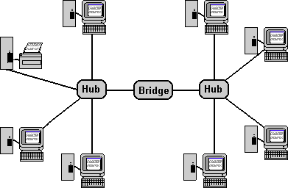

- State threefunctions performed by a bridge. (3 marks)

…..……………………………………………………………………………………………………………………….
…..……………………………………………………………………………………………………………………….
…..……………………………………………………………………………………………………………………….
…..……………………………………………………………………………………………………………………….
- The device labeled A represents a device that is used to connect multiple computers in the same network or a singleLAN. It transmits signals by broadcasting them to all the computers on the network.

Name the device labeled A (1 mark)

…..……………………………………………………………………………………………………………………….

- State any threefactors to consider when choosing data transmission media. (3 marks)

…..……………………………………………………………………………………………………………………….
…..……………………………………………………………………………………………………………………….
…..……………………………………………………………………………………………………………………….
- Define the following terms as used in networking.
- Physical topology (1 mark)

…..……………………………………………………………………………………………………………………….
…..……………………………………………………………………………………………………………………….
…..……………………………………………………………………………………………………………………….
- Logical topology. (1 mark)

…..……………………………………………………………………………………………………………………….
…..……………………………………………………………………………………………………………………….
…..……………………………………………………………………………………………………………………….
- Network protocol (1 mark)

…..……………………………………………………………………………………………………………………….
…..……………………………………………………………………………………………………………………….
…..……………………………………………………………………………………………………………………….
- (a) Differentiate between multiprogramming and multiprocessing as used in data processing. (2 marks)
…..……………………………………………………………………………………………………………………….
…..……………………………………………………………………………………………………………………….
…..……………………………………………………………………………………………………………………….
…..……………………………………………………………………………………………………………………….
…..……………………………………………………………………………………………………………………….
(b) State two ways of minimizing treats to data integrity (2 marks)
…..……………………………………………………………………………………………………………………….
…..……………………………………………………………………………………………………………………….
…..……………………………………………………………………………………………………………………….
…..……………………………………………………………………………………………………………………….
…..……………………………………………………………………………………………………………………….
(c) Differentiate between computational errors and transcription errors (2 marks)
…..……………………………………………………………………………………………………………………….
…..……………………………………………………………………………………………………………………….
…..……………………………………………………………………………………………………………………….
…..……………………………………………………………………………………………………………………….
…..……………………………………………………………………………………………………………………….
(d) Explain the following terms: (2 marks)
- Disk compression

…..……………………………………………………………………………………………………………………….
…..……………………………………………………………………………………………………………………….
…..……………………………………………………………………………………………………………………….
- Logical drive

…..……………………………………………………………………………………………………………………….
…..……………………………………………………………………………………………………………………….
…..……………………………………………………………………………………………………………………….
(e) Differentiate between Kernel and shell as used in operating systems. (2 marks)

…..……………………………………………………………………………………………………………………….
…..……………………………………………………………………………………………………………………….
…..……………………………………………………………………………………………………………………….
…..……………………………………………………………………………………………………………………….
…..……………………………………………………………………………………………………………………….
…..……………………………………………………………………………………………………………………….
(f)The diagram below represents the hierarchical arrangement of files in a computer. Use it answer the questions that follow.

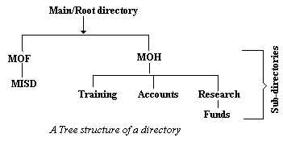
C:/>

Write a full file pathname used to locate the file namedFunds. (2 marks)

…..……………………………………………………………………………………………………………………….
…..……………………………………………………………………………………………………………………….

(g)(i) Identify the type of operating system shown by the figure below. (1 mark)

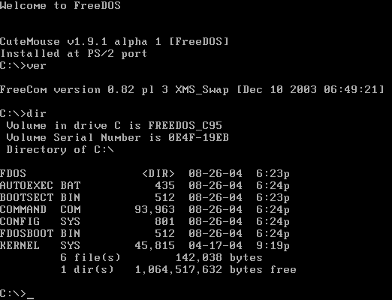

…..……………………………………………………………………………………………………………………….

(ii) State two disadvantages of using the above operating system (2 marks)

…..……………………………………………………………………………………………………………………….
…..……………………………………………………………………………………………………………………….
…..……………………………………………………………………………………………………………………….
…..……………………………………………………………………………………………………………………….

